U.S. Department of Health and Human Services
Public Health Service

SF424 (R&R)

Application Guide
for NIH and Other PHS
Agencies
A guide developed and maintained by NIH for preparing and submitting applications via Grants.gov to NIH and other PHS agencies using the SF424 (R&R)

Adobe Forms Version B Series (to be used with FOAs specifying
use of Adobe-Forms-B-1 and B-2 application packages)

Updated June 18, 2012
Table of Contents

Part I. Instructions for Preparing and Submitting an Application
1. Foreword I-1
1.1 Application Guide Format I-2
1.2 NIH Extramural Research and Research Training Programs I-3
1.3 Research Grant Activity Codes and Program Guidelines I-3
1.4 Interactions with PHS Staff I-4
1.5 Grants Policy Statements I-7
1.6 References I-7
1.7 Authorization I-8
1.7.1 Collection of Personal Demographic Data I-9
1.8 Paperwork Burden I-9
2. Process for Application Submission via Grants.gov I-9
2.1 Overview I-10
2.2 Registration Processes I-10
2.2.1 Grants.gov Registration I-10
2.2.2 eRA Commons Registration I-11
2.3 Software Requirements I-13
2.3.1 Adobe Reader I-13
2.3.2 Creating PDFs for Text Attachments I-13
2.3.3 Special Instructions for Macintosh Users I-13
2.4. Funding Opportunities I-13
2.4.1 NIH Guide for Grants and Contracts I-14
2.4.2 Grant and Cooperative Agreement Announcements I-14
2.4.3 Finding a Funding Opportunity Announcement (FOA) for Grants.gov
Submission I-15
2.5 Components of an Application to NIH or Other PHS Agencies I-19
2.6 Format Specifications for Text (PDF) Attachments I-20
2.7 “Resubmission” Applications I-22
2.8 “Revision” Application I-24
2.9 Similar, Essentially Identical, or Identical Applications I-24
2.10 Submitting Your Application Via Grants.gov I-25
2.11 After You Submit Your Application Via Grants.gov I-25
2.12 Correcting Errors I-28
2.13 Post-Submission Application Materials I-30
2.14 Application Submission Dates I-31
2.15 Submission, Review and Award Cycles I-33
2.16 Resources for Finding Help I-34
2.16.1 Finding Help for Grants.gov Registration or Submissions I-34
2.16.2 Finding Help for the eRA Commons Registration or eRA Commons
Validation Processes I-34
2.16.3 Finding Help for Application Preparation I-35
3. Using the Grant Application Package I-35
3.1 Verify Grant Information I-35
3.2 Enter the Name for the Application I-36
3.3 Open and Complete Mandatory Documents I-37
3.4 Open and Complete Optional Documents I-37
3.5 Submitting the Application via Grants.gov I-37
4. Completing the SF424 Research and Related (R&R) Forms I-38
4.1 Overview I-38
4.2 Cover Component I-39
4.3 Project/Performance Site Locations Component I-53
4.4 Other Project Information Component I-57
4.5 Senior/Key Person Profile (Expanded) Component I-64
4.6 Selecting the Appropriate Budget Component I-73
4.7 R&R Budget Component I-73
4.7.1 Section A and B I-74
4.7.2 Sections C through E I-80
4.7.3 Sections F through K I-83
4.7.4 Cumulative Budget I-88
4.8 Special Instructions for Preparing Applications with a Subaward/Consortium I-89
5. Completing PHS 398 Components I-91
5.1 Overview I-91
5.2 Cover Letter Component I-92
5.3 Cover Page Supplement Component I-94
5.4 Modular Budget Component I-99
5.4.1 Periods 1 through 4 I-100
5.4.2 Period 5 and Cumulative I-104
5.5 PHS 398 Research Plan Component I-107
5.6 Checklist Component I-120
6. Peer Review Process I-123
7. Supplemental Instructions to the SF 424(R&R) for Preparing an Individual Research
Career Development Award (CDA) Application (“K” Series) I-127
7.1 Introduction I-127
7.2 Individual Career Development Award Programs I-127
7.3 Letters of Reference (must be submitted electronically through the eRA Commons) I-128
7.4 K- Specific Instructions for K Applications using the SF424 (R&R) Application I-131
7.4.1 Special Instructions for 4.2 Cover Component I-131
7.4.2 Special Instructions for 4.3 Research & Related Project/Performance Site
Locations Component I-131
7.4.3 Special Instructions for 4.4 Other Project Information Component I-131
7.4.4 Special Instructions for 4.5 Senior/Key Person Profile(s) Component I-132
7.4.5 Special Instructions for 4.6 Selecting the Appropriate Budget Component I-134
7.4.6 Special Instructions for 4.7 R&R Budget Component I-135
7.4.7 Special Instructions for 5. Completing PHS 398 Components I-136
7.5 PHS 398 Career Development Award Supplemental Form I-138
7.6 Career Development Award Peer Review Process I-156
8. Supplemental Instructions to the SF424 (R&R) for Preparing Institutional Ruth L.
Kirschstein National Research Service Award (NRSA) Application I-157
8.1 Introduction I-157
8.2 Institutional Research Training Programs I-158
8.3 Reserved I-159
8.4 Specific Instructions for Institutional Training Grant Applications using the SF424
(R&R) Application I-159
8.4.1 Special Instructions for 4.2 Cover Component I-159
8.4.2 Special Instructions for 4.3 Research & Related Project/Performance Site
Locations I-159
8.4.3 Special Instructions for 4.4 Research & Related Other Project Information
Component I-159
8.4.4 Special Instructions for 4.5 Senior/Key Person Profile (Expanded)
Component I-161
8.4.5 Special Instructions for 4.7 Research & Related Budget I-161
8.4.6 Special Instructions for 4.6 PHS 398 Cover Page Supplement I-162
8.4.7 Special Instructions for 5.6 PHS 398 Checklist I-162
8.5 PHS 398 Training Budget I-162
8.6 PHS 398 Training Subaward Budget Attachment(s) Form I-168
8.7 Research Training Program Plan Component I-171
8.8 Training Grant Peer Review Process I-186

Part II. Supplemental Instructions for Preparing the Human Subjects Section of the Research Plan
1. Introduction II-1
2. Scenarios II-1
3. Instructions for Preparing the Section on Protection of Human Subjects II-3
4. Instructions Pertaining to Non-Exempt Human Subjects Research II-7
4.1 Protection of Human Subjects II-7
4.1.1 Risks to Human Subjects II-7
4.1.2 Adequacy of Protection Against Risks II-8
4.1.3 Potential Benefits of the Proposed Research to Human Subjects and Others II-9
4.1.4 Importance of the Knowledge to be Gained II-9
4.1.5 Data and Safety Monitoring Plan II-10
4.1.6 ClinicalTrials.gov Requirements II-10
4.2 Inclusion of Women and Minorities II-12
4.2.1 Additional Instructions and Requirements When NIH-Defined Phase III
Clinical Trials Are Proposed II-13
4.3 Instructions for Completing the Targeted/Planned Enrollment Tables for Reporting
Race and Ethnicity Data for Subjects in Clinical Research II-14
4.4 Inclusion of Children II-15
5. Human Subjects Research Policy II-17
5.1 Protection of Human Subjects II-17
5.2 Vulnerable Populations II-18
5.3 Data and Safety Monitoring Plans for Clinical Trials II-18
5.4 IRB Approval II-18
5.5 Required Education in the Protection of Human Research Participants II-19
5.6 NIH Policy on the Inclusion of Women and Minorities in Clinical Research II-19
5.7 NIH Policy on Inclusion of Children II-20
5.8 NIH Policy on Reporting Race and Ethnicity Data: Subjects in Clinical Research II-20
5.9 Research on Transplantation of Human Fetal Tissue II-21
5.10 Research Using Human Embryonic Stem Cells II-22
5.11 ClinicalTrials.gov Requirements II-22

Part III. Policies, Assurances, Definitions, and Other Information
1. Policy III-1
1.1 Applications That Include Consortium/Contractual Facilities and Administrative Costs III-1
1.2 Resubmission of Unpaid RFA Applications and Resubmission of Applications with a
Changed Grant Activity Code III-1
1.3 NIH Policy on Resubmission Applications III-2
1.4 Policy on the Acceptance for Review of Unsolicited Applications That Request
$500,000 or More in Direct Costs III-3
1.5 Sharing Research Resources III-4
1.5.1 Data Sharing Policy III-4
1.5.2 Sharing Model Organisms III-5
1.5.3 Policy for Genome-Wide Association Studies (GWAS) III-5
1.6 Inventions and Patents III-5
1.7 Just-In-Time Policy III-6
1.8 Other Support III-6
1.9 Graduate Student Compensation III-10
1.10 DUNS Number & CCR Registration III-11
1.11 Public Access Policy III-11
1.12 PHS Metric Program III-12
1.13 NIH Plans to Transition to the SF424 (R&R) Application and Electronic Submission
through Grants.gov III-12
1.14 Multiple Program Director/Principal Investigator Policy III-12
1.15 New, Including Early Stage, Investigators III-13
1.16 Policy on Instruction in the Responsible Conduct of Research III-13
1.17 Transparency Act Reporting III-15
2. Assurances and Certifications III-16
2.1 Human Subjects Research III-16
2.1.1 Research on Transplantation of Human Fetal Tissue III-18
2.1.2 Research Using Human Embryonic Stem Cells III-18
2.1.3 NIH Policy on the Inclusion of Women and Minorities as Subjects in
Clinical Research III-18
2.1.4 NIH Policy on Reporting Race and Ethnicity Data: Subjects in Clinical
Research III-19
2.1.5 NIH Policy on Inclusion of Children III-19
2.1.6 ClinicalTrials.gov III-20
2.2 Vertebrate Animals III-20
2.3 Debarment and Suspension III-21
2.4 Drug-Free Workplace III-21
2.5 Lobbying III-22
2.6 Non-Delinquency on Federal Debt III-22
2.7 Research Misconduct III-23
2.8 Assurance of Compliance (Civil Rights, Handicapped Individuals, Sex Discrimination,
Age Discrimination) III-24
2.9 Research Involving Recombinant DNA, including Human Gene Transfer Research III-24
2.10 Financial Conflict of Interest III-24
2.11 Smoke-Free Workplace III-25
2.12 Prohibited Research III-25
2.13 Select Agent Research III-27
2.14 Program Director/Principal Investigator Assurance III-27
2.15 Impact of Grant Activities on the Environment and Historic Properties III-27
2.16 Institutions Receiving Awards for Training of Graduate Students for Doctoral Degrees III-28
3. Definitions III-30
4. General Information III-40
4.1 Research Grant Activity Codes III-40
4.2 Government Use of Information Under Privacy Act III-43
4.3 Information Available to the PD/PI(s) III-44
4.4 Information Available to the General Public III-44
4.5 Access to Research Data III-44

PART I
Instructions for Preparing and Submitting
an Application

1. Foreword

Adobe B Application Guide — Released November 13, 2009
This application includes changes to SF424 Research & Related (R&R) form instructions necessitated by the June, 2008 OMB renewal of the forms, which includes changes to assist agencies implementing the Federal Funding Accountability and Transparency Act. Changes have also been made to various PHS 398 forms as part of the NIH initiative to enhance peer review. Changes to the PHS 398 forms were approved by OMB in June, 2009.
Modifications related to changes in the SF424 (R&R) forms include:
- A new Agency Routing Identifier field has been added to the Cover Component.
- A document upload field has been added to the Cover Component for attaching the SFLLL or other explanatory documents.
- A new field has been added to the Project/Performance Site Location(s) form for the Congressional District of the project. The Areas affected by Project and Congressional Districts of Project fields on the Cover component have been deleted.
- Fields requesting the type and year of degree have been added to the senior/key personnel forms.
- Questions on Human Subjects Research on the Other Project Information form have been re-ordered and a new question, whether the project is exempt from Federal regulations, has been added.
The PHS 398 application components have been modified by realigning the structure and content of applications with new review criteria. Additionally, page limits for many applications have been shortened to help reduce the administrative burden placed upon applicants, reviewers, and staff. Specific modifications related to changes in the PHS 398 components include:
- Three sections of the previous Research Plan (Background and Significance, Preliminary Studies/Progress Report, and Research Design and Methods) have been consolidated into a new single section within the Research Plan entitled Research Strategy. The new Research Strategy section will be sub-divided into three parts: Significance, Innovation, and Approach, although this will now be a single upload.
- The Facilities and Other Resources section has been changed to require a description of how the scientific environment will contribute to the probability of success of the project, unique features of the environment, and for Early Stage Investigators, the institutional investment in the success of the investigator (e.g., resources, classes, etc.).
- A new Personal Statement requirement has been incorporated into the Biographical Sketch.
Additional details on all the form changes noted above can be found at: http://grants.nih.gov/grants/ElectronicReceipt/files/Adobe_Forms_B_Summary.pdf.
A description of how these application changes relate to the enhancement of peer review can be found at http://enhancing-peer-review.nih.gov/docs/application_changes.pdf. Additional information on NIH’s efforts to enhance peer review can also be found at http://enhancing-peer-review.nih.gov.
This version of the Application Guide now also includes a separate instruction section for Institutional Training Grants to accommodate their transition to electronic submission effective with submissions on/after January 25, 2010.

This application guide contains instructions and other useful information for preparing grant applications to the National Institutes of Health (NIH) and other Public Health Service (PHS) agencies for:
Public Health Service (PHS) Research Grants
Career Development (K) Awards
Institutional Training (T) Grants
This application guide is used as a companion document to the SF424 Research and Related (R&R) application forms. In addition to the SF424 (R&R) form components, applications to NIH and other PHS agencies will include agency-specific form components, titled “PHS 398.” These PHS 398 components were developed to continue the collection of agency-specific data required for a complete application. While these agency-specific components are not identical to the PHS 398 application form pages, the PHS 398 reference is used to distinguish these additional data requirements from the data collected in the SF424 (R&R) components. A complete application to NIH and other PHS agencies will include SF424 (R&R) components and PHS 398 components. Instructions for all application components, SF424 (R&R) and PHS 398, are found in this document.
The use of these new forms also involves electronic submission of completed applications through Grants.gov. NIH and other PHS agencies will gradually transition all activity codes to the new application forms and Grants.gov submission. Specific Funding Opportunity Announcements (FOAs) will clearly indicate which forms and submission process an applicant should use. NIH will continue to use Requests for Applications (RFAs) and Program Announcements (PAs) as categories of FOAs. See Section 2.4.2 for definitions.
Applicants must carefully review FOAs for guidance on when to use the 424 (R&R) forms, instructions, and electronic submission for a specific activity code (i.e., R13, R15, etc.). This process will apply to all types of submissions for the announced activity code—new, resubmission, renewal, and revision grant applications. Each FOA will include a link to the most current version of these instructions. Applicants are encouraged to check the Web site frequently for the most current version.
For purposes of this document, any references to “NIH” may also mean “NIH and other PHS agencies” such as the Agency for Healthcare Research and Quality (AHRQ), the Centers for Disease Control and Prevention (CDC), and the Food and Drug Administration (FDA).

1.1 Application Guide Format
This application guide is organized into three distinct parts:
Part I: Instructions for Preparing and Submitting the Application. Part I includes specific instructions for completing the application form components as well as information on electronically submitting applications through Grants.gov.
Part II: Supplemental Instructions for Preparing the Human Subjects Section of the Research Plan. Part II is to be used if your proposed research will involve human subjects. These instructions assist in determining whether human subjects are involved and include scenarios and detailed instructions for completing Items 6-9 of the PHS 398 Research Plan component.
Part III: Policies, Assurance, Definitions, and Other Information. Part III includes information on policies, assurances, definitions, and other information relating to submission of applications to the PHS. Applicants should refer to this document as well as the instructional materials, Grants Information (GrantsInfo), and the relevant Grants Policy Statement for additional sources of information. The NIH Grants Policy Statement applies to all NIH awardees; other PHS agencies use the HHS Grants Policy Statement.

1.2 NIH Extramural Research and Research Training Programs
The NIH Office of Extramural Research Grants homepage (http://grants.nih.gov/grants/oer.htm) provides an array of helpful information. Applicants are encouraged to bookmark this site and visit it often.
The Division of Communications and Outreach (DCO) is the central source for general information about NIH extramural research and research training programs, funding activity codes, the peer review system, and application procedures. Grants Information (GrantsInfo) is a communication service within the DCO. Information about the NIH extramural research and research training programs, funding opportunities, and the grant application process, can be obtained by e-mailing your request to: GrantsInfo@nih.gov or by calling (301) 435-0714.

1.3 Research Grant Activity Codes and Program Guidelines
A partial list of research grant activity codes and programs are provided below. As noted in the descriptions in Part III: Policies, Assurances, Definitions, and Other Information, not all awarding components use all activity codes or programs. For a complete listing of program guidelines, visit the OER Grants Web site http://grants.nih.gov/grants/funding/funding_program.htm.

Research Grants
- Basic Research Grant (R01)
- Small Research Grant (R03)
- Academic Research Enhancement Award (AREA) (R15)
- Exploratory/Developmental Grant (R21, R33, R21/R33)
- Small Business Innovation Research Grant (SBIR) (R43/R44)
- Small Business Technology Transfer Grant (STTR) (R41/R42)
- Program Project Grant (P01)
- Research Center Grant (P50)
- Scientific Meeting Support (R13, U13)
- Research Project Cooperative Agreement (U01)
- Research Grants to Foreign Institutions and International Organizations

Training, Fellowships and Career Development Programs
- NIH Institutional Ruth L. Kirschstein National Research Service Award (T32)
- Individual Ruth L. Kirschstein National Research Service Award Fellowships (NRSA) (F30, F31, F32, F33, F34, etc.)
- Research Career Development Award (K Award)

Applications Available from Other Offices
- Health Services Project Application (5161-1)

1.4 Interactions with PHS Staff
The PHS agencies encourage applicants to communicate with staff throughout the entire application, review and award process. Web site addresses and staff phone numbers of relevant NIH awarding components and other PHS agencies are listed in the table below.
Table 1.4-1. PHS Agency Contact Table
phs agency  (link to web site) | awarding component  (link to web site) | telephone number
NATIONAL INSTITUTES OF HEALTH (NIH) | Eunice Kennedy Shriver National Institute of Child Health and Human Development | 301-496-0104
NIH | Fogarty International Center | 301-496-1653
NIH | National Cancer Institute | 301-496-3428
NIH | National Center for Complementary and Alternative Medicine | 301-496-4792
NIH | National Center for Research Resources | 301-496-6023
NIH | National Eye Institute | 301-451-2020
NIH | National Heart, Lung, and Blood Institute | 301-435-0260
NIH | National Human Genome Research Institute | 301-496-7531
NIH | National Institute on Aging | 301-496-9322
NIH | National Institute on Alcohol Abuse and Alcoholism | 301-443-4375
NIH | National Institute of Allergy and Infectious Diseases | 301-496-7291
NIH | National Institute of Arthritis and Musculoskeletal and Skin Diseases | 301-594-2463
NIH | National Institute of Biomedical Imaging and Bioengineering | 301-451-4792
NIH | National Institute on Deafness and Other Communication Disorders | 301-496-1804
NIH | National Institute of Dental and Craniofacial Research | 301-594-4800
NIH | National Institute of Diabetes and Digestive and Kidney Diseases | 301-594-8834
NIH | National Institute on Drug Abuse | 301-443-2755
NIH | National Institute of Environmental Health Sciences | 919-541-7723
NIH | National Institute of General Medical Sciences | 301-594-4499
NIH | National Institute of Mental Health | 301-443-3367
NIH | National Institute on Minority Health and Health Disparities | 301-402-1366
NIH | National Institute of Neurological Disorders and Stroke | 301-496-9248
NIH | National Institute of Nursing Research | 301-594-6906
NIH | National Library of Medicine | 301-496-4621
NIH | Center For Scientific Review | 301-435-0715
AGENCY FOR HEALTHCARE RESEARCH AND QUALITY | Agency for Healthcare Research and Quality | 301-427-1447
CENTERS FOR DISEASE CONTROL AND PREVENTION (CDC) | Coordinating Center for Health Information and Services | 404-498-1186
CDC | Coordinating Center for Infectious Disease | 404-639-3770
CDC | Coordinating Center for Environmental Health & Injury Prevention | 770-488-4668
CDC | Coordinating Center for Health Promotion | 770-488-8390
CDC | Office of Public Health Research | 404-639-4621
CDC | National Institute for Occupational Safety and Health | 404-498-2530
CDC | Procurement and Grants Office | 770-488-2700
FOOD AND DRUG ADMINISTRATION | Food and Drug Administration | 301-827-7185
INDIAN HEALTH SERVICE | Indian Health Service | 301-443-0578
AGENCY FOR TOXIC SUBSTANCES AND DISEASE REGISTRY | Agency for Toxic Substances and Disease Registry | 404-842-6630
OFFICE OF PUBLIC HEALTH AND SCIENCE | Office of Population Affairs | 301-594-4004
OFFICE OF PUBLIC HEALTH AND SCIENCE | Office of Family Planning | 301-594-4008

Before Submission
You may wish to contact NIH staff with a variety of questions before submitting an application.
Contact GrantsInfo and/or the Division of Receipt and Referral, Center for Scientific Review (CSR), NIH:
- To identify Institutes/Centers (ICs) at NIH or other non-NIH agencies and/or a Scientific Review Group (SRG) that might be appropriate for your application. Note requests for assignment to an Institute/Center and/or a SRG may be made in a cover letter at the time of application submission.
- To learn about grant programs.
- To receive advice on preparing and submitting an application (e.g., format, structure).
Contact program staff in the relevant awarding component:
- To determine whether your proposed application topic would fit into the NIH IC’s or other non-NIH agency’s programmatic area.
- To learn about programmatic areas of interest to the IC or other non-NIH agencies.
- To find out about requesting an assignment to an IC.
- To discuss whether you should respond to an RFA.
Contact Scientific Review Officers in the CSR to discuss requesting assignment to a CSR SRG.

After Submission
If the initial assignment to an IC or SRG seems inappropriate, the Program Director/Principal Investigator (PD/PI) may request reassignment. Such requests should be made in writing to:
Division of Receipt and Referral
Center for Scientific Review
National Institutes of Health
6701 Rockledge Drive, Suite 2030, MSC 7720
Bethesda, MD 20892-7720
Fax requests (301-480-1987) are also acceptable.
Although these requests will be carefully considered, the final determination will be made by the PHS agency.
Applicants must never contact reviewers regarding their applications because discussion of the scientific content of an application or an attempt to influence review outcomes will create serious breaches of confidentiality in the review process. Reviewers are required to notify the Scientific Review Officer if they are contacted by an applicant. Communication by the applicant to a reviewer may delay the review or result in the return of the application without review.

After Assignment
Contact your Scientific Review Officer to discuss the review assignment, to request permission to send additional/corrective materials, and/or to discuss any review concerns (e.g., expertise needed on your SRG, conflicts, reviewers that may have bias).

After Peer Review
Feedback to applicants is very important. Once the PD/PI reviews the Summary Statement in the eRA Commons, the appropriate awarding component program official noted in the Summary Statement may be contacted:
- To discuss the review outcome of the application and obtain guidance.
- To get feedback and answers to any questions about the Summary Statement.
- To find out the meaning of a numerical designation pertaining to human subjects or vertebrate animals in the Summary Statement.
- To find out the funding status of an application.
A paper copy of the Peer Review Outcome Letter and Summary Statement will not be mailed to the PI and may only be accessed through the eRA Commons.

1.5 Grants Policy Statements
- The NIH Grants Policy Statement serves as a term and condition of award and is a compilation of the salient features of policies and various policy issues regarding the administration of NIH awards.
- The HHS Grants Policy Statement serves as a term and condition of award and is a compilation of the salient features of policies and various policy issues regarding the administration of grant awards from other PHS agencies, excluding NIH awards.

1.6 References

Applicants New to NIH: Getting Started
http://grants.nih.gov/grants/useful_links.htm

Award Information and Data
http://report.nih.gov/index.aspx
NIH Research Portfolio Online Reporting Tool (RePORT)

Contact Information for an NIH Staff Person
http://ned.nih.gov
NIH locator: (301) 496-4000

Electronic Receipt
For additional information on preparing for electronic receipt, see: http://grants.nih.gov/grants/ElectronicReceipt/preparing.htm

eRA Commons
https://commons.era.nih.gov/commons/index.jsp
Institutions and PD/PIs are required to register with the eRA Commons. Registered PD/PIs can check assignment/contact information, review outcome, and other important information. For more details on Commons registration, see Section 2.2.2.
E-mail: commons@od.nih.gov.
Telephone: 1-866-504-9552 (toll-free) or 301-402-7469; 301-451-5939 (TTY). Business hours are M-F 7am-8pm Eastern Time.

Grant Writing Tips and Sample Applications
http://grants.nih.gov/grants/grant_tips.htm

Grants Information
http://grants.nih.gov/grants/giwelcome.htm
E-mail: GrantsInfo@nih.gov
Telephone: (301) 435-0714; (301) 451-5936 (TTY)

Grants.gov User Guide
The Grants.gov User Guide is a comprehensive reference to information about Grants.gov. Applicants can download the User Guide at the following address: http://www.grants.gov/assets/ApplicantUserGuide.pdf.

NIH Office of Extramural Research Human Subjects Web Site
http://grants.nih.gov/grants/policy/hs/index.htm
This site provides, in one place, DHHS and NIH requirements and resources for the extramural community involved in human subjects research.

Office for Human Research Protections (Department of Health and Human Services)
http://www.hhs.gov/ohrp
Information about human subject protections, Institutional Review Boards, and Federal Wide Assurances
Telephone: 1-866-447-4777 or (301) 496-7005

Office of Laboratory Animal Welfare (OLAW)
http://olaw.nih.gov
Information about animal welfare policy requirements, Institutional Animal Care and Use Committees (IACUC), and Animal Welfare Assurances
Telephone: (301) 496-7163

Receipt/Referral of an Application
http://www.csr.nih.gov/EVENTS/AssignmentProcess.htm
Division of Receipt and Referral
Center for Scientific Review
Telephone: (301) 435-0715
Fax: (301) 480-1987

Specific Application: Before Review
Telephone or e-mail the Scientific Review Officer identified for the application in the eRA Commons.

Specific Application: Post Review
Telephone or e-mail the NIH Program Official named in the Summary Statement for the application.

1.7 Authorization
The PHS requests the information described in these instructions pursuant to its statutory authorities for awarding grants, contained in Sections 301(a) and 487 of the PHS Act, as amended (42 U.S.C. 241a and 42 U.S.C. 288). Therefore, such information must be submitted if an application is to receive due consideration for an award. Lack of sufficient information may hinder the ability of the PHS to review an application and to monitor the grantee’s performance.

1.7.1 Collection of Personal Demographic Data
Federal agencies have a continuing commitment to monitor the operation of its review and award processes to detect, and deal appropriately with, any instances of real or apparent inequities. In addition, section 403 of the 2007 NIH Reform Act requires NIH to report to Congress specifically on postdoctoral individuals supported on research grants, and section 489 of the PHS Act requires NIH to perform a continuing assessment of research personnel needs. Personal demographic data on PD/PIs and those with a postdoctoral role is vital to comply with these requirements.
NIH collects personal data through the eRA Commons Personal Profile. The data is provided one-time by the individual through a secure, electronic system, is confidential, and is maintained under the Privacy Act record system 09-25-0036, “Grants: IMPAC (Grant/Contract Information).” Then completing the data entry in the Commons Personal Profile, the individual is responsible for providing true, accurate, and complete data. All analyses conducted on date of birth, citizenship, gender, race, ethnicity, disability, and/or disadvantaged background data will report aggregate statistical findings only and will not identify individuals. Declining to provide information does not affect consideration of an application; however, for some programs (e.g., Ruth L. Kirschstein National Research Service Awards and Research Career Development Awards) citizenship data is required to determine eligibility.
The PHS also requests the last four digits of the Social Security Number (SSN) for accurate identification of individuals and for management of PHS grant programs. Please be aware that no individual will be denied any right, benefit, or privilege provided by law because of refusal to disclose this portion of the SSN. The PHS requests the last four digits of the SSN under Section 301(a) and 487 of the PHS act as amended (42 U.S.C. 241a and U.S.C. 288).

1.8 Paperwork Burden
The PHS estimates that it will take approximately 22 hours to complete this application for a regular research project grant. This estimate excludes time for development of the scientific plan. Other items such as human subjects are cleared and accounted for separately and therefore are not part of the time estimate. An agency may not conduct or sponsor the collection of information unless it displays a currently valid OMB control number. Nor is a person required to respond to requests for the collection of information without this control number. Send comments regarding this burden estimate or any other aspect of this collection of information, including suggestions for reducing this burden, to: NIH, Project Clearance Office, 6705 Rockledge Drive MSC 7974, Bethesda, MD 20892-7974, ATT: PRA (0925-0001). Do not send applications or any materials related to training or career award applications to this address.

2. Process for Application Submission via Grants.gov
Application submission through Grants.gov involves several steps. Some of the steps need only be done one time. Others are ongoing steps that will be necessary for each application submission. Before beginning the application process, you are encouraged to review Grants.gov and all the resources available there.

2.1 Overview
The following steps must be taken in order to submit a grant application through Grants.gov. Please be sure to complete all steps to ensure that NIH receives the application in a timely manner.
1. Register your organization at Grants.gov. (This is a one-time only registration process for all Federal agencies. If your organization has already completed this step for any Federal agency submission, skip to step #2. If your organization has not completed this step, see Section 2.2 for more details.)
2. Register your organization and Program Director/Principal Investigator (PD/PI) in the eRA Commons. (This is a one-time only registration process. If your organization has already completed this step, skip to step #3. If your organization has not completed this step, see Section 2.2 for more details.)
3. Find a Funding Opportunity Announcement (FOA) using the Grants.gov “Find Grant Opportunities” feature that reflects use of the SF424 (R&R) forms and electronic submission through Grants.gov. (See Section 2.4 for more details.)
4. Download the associated Application Package from Grants.gov. (Adobe Reader required for download. See Section 2.3 for more details.)
5. Complete the appropriate application components, including all text and PDF attachments. Upload all attachments into the appropriate application component (See Section 2.6 for more details on the requirements for text (PDF) attachments).
6. The completed application should be reviewed through your own organizational review process.
7. Coordinate with an Authorized Organization Representative (AOR) at the applicant organization to submit the application by the date specified in the FOA. (Keep a copy locally at the Applicant Organization/Institution.)
8. Receive the Grants.gov tracking number.
9. After agency validation, receive the agency tracking number (accession number).
10. PD/PI and Signing Official (SO) complete a verification process in the eRA Commons. (See Section 2.11 for detailed information.)
The following sections explain each step in more detail.

2.2 Registration Processes

2.2.1 Grants.gov Registration
Grants.gov requires a one-time registration by the applicant organization. PD/PIs do not have to individually register in Grants.gov unless they also serve as the Authorized Organization Representative (AOR) for their institution/organization. If an applicant organization has already completed Grants.gov registration for another Federal agency, they can skip this section and focus on the eRA Commons registration steps noted below. For those applicant organizations still needing to register with Grants.gov, registration information can be found at the Grants.gov Get Registered tab (http://grants.gov/applicants/get_registered.jsp). While Grants.gov registration is a one-time only registration process, it does involve several steps and will take some time. Applicant organizations needing to complete this process are encouraged to start early allowing at least four (4) weeks to complete all the steps before actually submitting an application through Grants.gov. Note that all applicant and grantee organizations must maintain an active registration in the Central Contractor Registry Database (CCR). This requires that you review and update the information at least annually after the initial registration, and more frequently if required by changes in your information or another award term.
For additional information regarding maintaining an active CCR registration, please see NIH Guide Notice NOT-OD-11-004."
The AOR is an individual authorized to act for the applicant organization and to assume the obligations imposed by the Federal laws, requirements, and conditions for a grant or grant application, including the applicable Federal regulations. This individual has the authority to sign grant applications and required certifications and/or assurances that are necessary to fulfill the requirements of the application process. Once this individual is registered, the organization can then apply for any government funding opportunity listed in Grants.gov, including NIH and other PHS agencies grants.
Questions regarding Grants.gov registration should be directed to the Grants.gov Contact Center at telephone: 1-800-518-4726 or by e-mail at support@grants.gov. The Contact Center is available 24 hours a day, 7 days a week.

2.2.2 eRA Commons Registration
The applicant organization, all PD/PIs, and all individuals with a postdoctoral role (see definition of postdoctoral scholar in Part III.3) and one month or more of measurable effort must also complete a one-time registration in the eRA Commons. Access to the Commons is vital for all steps in the process after application submission. An organization and PD/PIs must be registered in the Commons before they can take advantage of electronic submission and retrieval of grant information, such as reviewing grant applications, institute/center assignments, review outcomes, and Summary Statements. Institutional/organizational officials are responsible for registering PD/PIs and individuals with a postdoctoral role in the eRA Commons. PD/PIs and individuals with a postdoctoral role should work with their AOR (also known as the Signing Official in the eRA Commons) to determine their institutional/organizational process for registration.
IMPORTANT: The eRA Commons registration process should be started at least four (4) weeks prior to the submittal date of a Grants.gov submission. Failure to register in the Commons and to include a valid PD/PI Commons ID in the credential field of the Senior/Key Person Profile Component will prevent the successful submission of an electronic application to NIH. Commons user name IDs for those with a postdoctoral role are not required at the time of application submission, but are required as part of the Non-Competing Continuation Progress Report (PHS 2590).

2.2.2.1 Commons Registration for the Organization
Organizations may verify their current registration status by accessing the “List of Grantee Organizations Registered in eRA Commons” (http://era.nih.gov/commons/quick_queries/index.cfm#commons).
To register an Organization in the eRA Commons:
1. Open the eRA Commons homepage (https://commons.era.nih.gov/commons/).
2. Click Grantee Organization Registration (found in “About the Commons” links on the right side of the screen).
3. Follow the step-by-step instructions. Remember to fax in the registration signature page to eRA.
4. Click Submit. The organization is registered when the NIH confirms the information and sends an e-mail notification of registered Signing Official (SO) account (userid/password).
This registration is independent of Grants.gov and may be done at any time.
Organizational data elements, such as Institutional Profile Number (IPF), Entity Identification Number (e.g., 5555555555A5) and DUNS Number must be accurately identified. Note the DUNS number must be included in the Institutional Profile for applications to be accepted. In addition, the DUNS number in the Institutional Profile must match that entered in the SF424 (R&R) Cover Component in Section 5, Applicant Information.
Since eRA has not required a DUNS number during eRA Commons registration, there are many accounts that do not contain valid information in this field. Prior to submission, the AOR/SO should verify that their organization’s eRA Commons profile contains the valid DUNS number that will be used for the submission process. The SO has the ability to edit this field in the organization profile in Commons.
To confirm that your organization has a DUNS number or to find out if the DUNS number you have matches the one in Commons, access the List of Grantee Organizations Registered in eRA Commons (http://era.nih.gov/commons/quick_queries/index.cfm#commons). This listing of grantee organizations registered in Commons and their DUNS numbers can be accessed without logging into Commons.

2.2.2.2 Commons Registration for the Program Directors/Principal Investigators (PD/PIs) and Individuals with a Postdoctoral Role
The individual(s) designated as PD/PI(s) on the application must be registered in the Commons. A PD/PI must hold a PI account. This registration must be done by an organizational official (or delegate) who is already registered in the Commons. If submitting an application reflecting Multiple PD/PIs, the individual designated as the contact PI must be affiliated with the applicant organization. To register PD/PIs in the Commons, refer to the eRA Commons System Users Guide (http://era.nih.gov/Docs/COM_UGV2630.pdf). For applications reflecting Multiple PD/PIs, all such individuals must be assigned the PI role, even those at organizations other than the applicant organization.
Once a PD/PI has received e-mail confirming his/her registration within the Commons, the PD/PI must verify that all Personal Information located within the Personal Profile tab in the eRA Commons System is accurate. Please have the PD/PI review and update, as needed, data elements such as first name, middle initial, last name, prefix and/or suffix to PD/PI name (including all embedded punctuation), e-mail, phone, fax, street address, city, state, country, zip and degrees earned. These data must contain the most recent information in order for the application to be processed accurately.
Both PD/PI and SO need separate accounts in Commons since both need to verify the application. If you are the SO for your organization as well as a PD/PI of the grant, you will need two separate accounts with different user names – one with SO authority and one with PI authority. When an organization is registered, an SO account is created. Log on to the account with the SO authority role and create another account with PI authority.
Individuals with a postdoctoral role and one month or more of effort must also be registered in the eRA Commons and should verify that all Personal Information located within the Personal Profile tab in the eRA Commons system is accurate. The Commons user name ID for those with a postdoctoral role is not required at the time of application submission, but will be required as part of the Non-Competing Continuation Progress Report (PHS 2590).
For additional information on how to prepare for electronic submission, see: http://grants.nih.gov/grants/ElectronicReceipt/preparing.htm.

2.3 Software Requirements

2.3.1 Adobe Reader
In order to access, complete and submit applications, applicants need to download and install the Adobe Reader, version 8.1.1 or later. For minimum system requirements and download instructions, please see the Grants.gov User Guide or visit http://grants.gov/help/download_software.jsp.

2.3.2 Creating PDFs for Text Attachments
NIH and other PHS agencies require all text attachments to the SF424 (R&R) application forms to be submitted as PDF files.
Applicants should prepare text attachments using any word processing program (following the format requirements in Section 2.6) and then convert those files to PDF before attaching the files to the appropriate component in the application package. (The PDF format is used to preserve document formatting.) Save all files with descriptive file names of 50 characters or less and be sure to only use standard characters in file names: A through Z, a through z, 0 through 9, and underscore (_). Do not use any special characters (example: “&”, “-“, “*”, “%”, “/”, and “#”) or spacing in the file name, and for word separation use underscore (example: “My_Attached_File.pdf”) in naming the attachments.
Some type of PDF-creation software is necessary to create the PDF. (The free Adobe Reader will not create a PDF.) To assist applicants searching for free PDF-creation software, Grants.gov has published a list of available tools and software, see Grants.gov’s Download Software page at http://www.grants.gov/help/download_software.jsp.
Note that all PDF attachments must be submitted as individual files. Although some software packages allow bundling of multiple PDFs into a single file, eRA systems cannot support “Bundling” or “Portfolio” features at this time. Use of these features may result in delays in the review of an application or an application not being reviewed.
It is recommended that, as much as possible, applicants avoid scanning text documents to produce the required PDFs. Instead, NIH recommends producing the documents electronically using text or word-processing software and then converting documents to PDF. Scanning paper documents, without the proper Optical Character Recognition (OCR) process, will hamper automated processing of your application for NIH analysis and reporting.
DISCLAIMER: References to software packages or Internet services neither constitute nor should be inferred to be an endorsement or recommendation of any product, service, or enterprise by the NIH or other PHS agencies, any other agency of the United States Government, or any employee of the United States Government. No warranties are stated or implied.

2.3.3 Special Instructions for Macintosh Users
With the conversion to Adobe Reader application submissions there are no longer special instructions for Macintosh users.

2.4. Funding Opportunities
Grants for health-related research and research training projects or activities make up the largest category of funding provided by the NIH Institutes/Centers (ICs) and other non-NIH agencies. Most applications for support are unsolicited and originate with individual investigators who develop proposed plans for research or research training within an area that is relevant to the NIH. Research project grants are awarded to organizations/institutions on behalf of PD/PIs to facilitate the pursuit of a scientific objective when the idea for the research is initiated by the investigator. If the funding agency anticipates substantial program involvement during the conduct of the research, a cooperative agreement will be awarded rather than a grant. The NIH awards grants and cooperative agreements for terms ranging from one to five years. Organizational/institutional sponsorship assures that the awardee organization will provide the facilities and the financial stability necessary to conduct the research, and be accountable for the funds. For a list and brief description of grant activity codes, see Part III: Policies, Assurances, Definitions, and Other Information.

2.4.1 NIH Guide for Grants and Contracts
The NIH Guide for Grants and Contracts (http://grants.nih.gov/grants/guide), a weekly electronic publication, contains announcements about funding opportunities, such as Requests for Applications (RFAs) and Program Announcements (PAs), including Parent Announcements, from NIH and other PHS agencies. The NIH Guide also contains vital information about policies and procedures. To subscribe to the NIH Guide, visit http://grants.nih.gov/grants/guide/listserv.htm.

2.4.2 Grant and Cooperative Agreement Announcements
To hasten the development of a program or to stimulate submission of applications in an area of high priority or special concern, an awarding component will encourage applications through the issuance of a PA to describe new, continuing, or expanded program interests, or issuance of an RFA inviting applications in a well-defined scientific area to accomplish a scientific purpose.
Definitions are as follows:
Parent Announcements: Electronic grant applications must be submitted in response to a Funding Opportunity Announcement (FOA). For applicants who wish to submit what were formerly termed “investigator-initiated” or “unsolicited” applications, NIH and other PHS agencies have developed Parent Announcements. Responding to such an omnibus or umbrella Parent FOA ensures that the correct application package is used and enables NIH to receive the application from Grants.gov. Additional information about, as well as links to published Parent Announcements, can be found at: http://grants.nih.gov/grants/guide/parent_announcements.htm.
Program Announcement (PA): A formal statement about a new or ongoing extramural activity or program. It may serve as a reminder of continuing interest in a research area, describe modification in an activity or program, and/or invite applications for grant support. Most applications in response to PAs may be submitted to a standing submission date and are reviewed with all other applications received at that time. NIH may also make funds available through PARs (Program Announcements with special receipt, referral, and/or review considerations) and PASs (Program Announcements with set-aside funds).
Request for Applications (RFA): A formal statement that solicits grant or cooperative agreement applications in a well-defined scientific area to accomplish specific program objectives. An RFA indicates the estimated amount of funds set aside for the competition, the estimated number of awards to be made, and the application submission date(s). Applications submitted in response to an RFA are usually reviewed by a Scientific Review Group (SRG) specially convened by the awarding component that issued the RFA.
PAs (including Parent Announcements) and RFAs are published in the NIH Guide for Grants and Contracts (http://grants.nih.gov/grants/guide), the Federal Register (http://www.gpoaccess.gov/nara/index.html), and on Grants.gov under Find Grant Opportunities (http://www.grants.gov/applicants/find_grant_opportunities.jsp). Read the announcement carefully for special instructions. The instructions in the announcement may differ from these general instructions, and the instructions in the announcement always supersede these general instructions. Each announcement published in the NIH Guide for Grants and Contracts, the Federal Register, Grants.gov Find, or other public document contains contact information under Inquiries in addition to information specific to the announcement.
While individual announcements will continue to carry an announcement number reference to “PA” or “RFA”, all announcements are “Funding Opportunity Announcements (FOAs).” This general term will be used to reference any type of funding announcement. NIH will continue to use the PA and RFA references in the actual announcement number to distinguish between the various types of announcements.
In reading any FOA in the NIH Guide for Grants and Contracts:
- A “Release Date” refers to the date the FOA is posted on Grants.gov. An applicant can download the application package on that date and begin filling it out. However, the applicant has to wait until the FOA’s “opening date” to submit the application.
- An application can be submitted anytime between the “opening date” and the “application submission date(s)” noted for AIDS and non-AIDS applications. (Standard dates may apply; check http://grants.nih.gov/grants/funding/submissionschedule.htm for details.)
- When you download an application package from Grants.gov, the “expiration date” is pre-populated. Do not go strictly by this date since it may not apply to your particular situation; for instance, it may reflect the submission date for AIDS applications and you may be submitting a non-AIDS application that is due earlier. In this case, the pre-populated date has no bearing on your application and you should not be concerned by it.
All applications submitted to the NIH must be submitted in response to a FOA published in the NIH Guide for Grants and Contracts.

2.4.3 Finding a Funding Opportunity Announcement (FOA) for Grants.gov Submission
Implementation of the SF424 (R&R) application and electronic submission through Grants.gov will be announced through specific FOAs posted in the NIH Guide for Grants and Contracts and on Grants.gov under “Find Grant Opportunities” (a.k.a. “Find”) and “Apply for Grants” (a.k.a. “Apply”). From the ‘For Applicants’ section of the Grants.gov home page, select “Apply for Grants” and follow the steps provided. FOAs posted in Grants.gov Apply reflect those the agency is prepared to receive through electronic Grants.gov submission. Applicants are encouraged to read each FOA carefully for specific guidance on the use of Grants.gov submission.
There are several ways a prospective applicant can find a FOA on Grants.gov.

Using the NIH Guide for Grants and Contracts
FOAs in the NIH Guide for Grants and Contracts that reference electronic submission via Grants.gov now include a link from the FOA directly to the Grants.gov site where you can download the specific application package. The Apply for Grants Electronically button is found in the NIH Guide FOA directly under the announcement number. This link is only provided in those announcements involving electronic submission through Grants.gov.

Using “Find Grant Opportunities” (Find) Feature
Grants.gov Find provides general search capabilities. From the “Find Grant Opportunity” page, you will find options for: 1) Basic Search; 2) Browse by Category; 3) Browse by Agency; and 4) Advanced Search. To perform a basic search for a grant, complete the “Keyword Search”; the “Search by Funding Opportunity Number”; OR the “Search by CFDA Number” field; and then click the Search button below.
Note that NIH has made it easier for applicants by adding a button (Apply for Grant Electronically) to the NIH Guide for Grants and Contracts announcements that allows applicants to access the Grants.gov application package directly from the NIH Guide. See the preceding paragraph “Using the NIH Guide for Grants and Contracts” for more details.
Once you find an opportunity for which you wish to apply, you may initiate the application download process by selecting the “Link to Full Announcement” link that appears on the FOA synopsis page. Then click the "Apply for Grant Electronically" button on the FOA. You are encouraged to view the full FOA before applying for the award. Or you may elect to initiate the application download at a later time. In this case, you should record the Funding Opportunity number or CFDA number and enter it manually later on the Download Application Package screen in the "Apply for Grants" section of this site.

Using “Apply for Grants” (Apply) Feature
If you know the specific funding opportunity number, a more direct route is to use the “Apply for Grants” feature. From the Grants.gov home page, select “Apply for Grants” and follow the steps provided. “Step 1” allows you to download an application package by inserting a specific Funding Opportunity Number (FOA). If you do not know the specific Funding Opportunity Number there is a link that will take you back to the Find Grant Opportunities page.
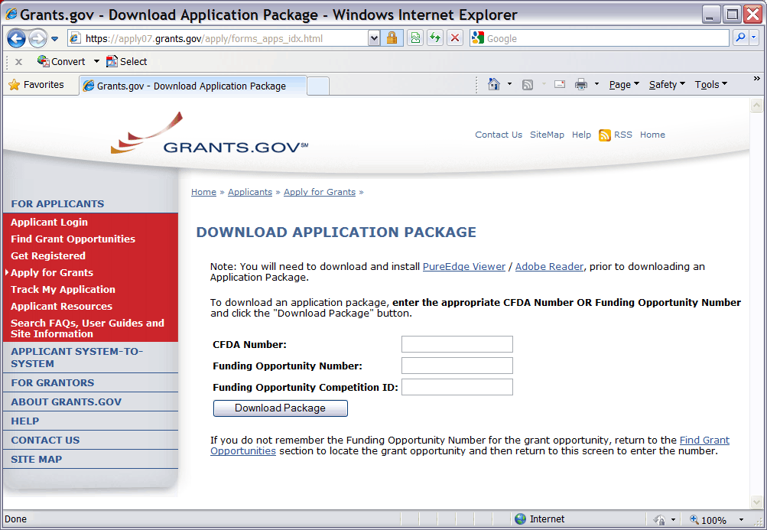
A Funding Opportunity Number is referenced in every announcement. It may be called a Program Announcement (PA) Number or a Request for Application (RFA) Number. Enter this number in the Funding Opportunity Number field and click Download Package. This takes you to a “Selected Grant Applications for Download” screen.
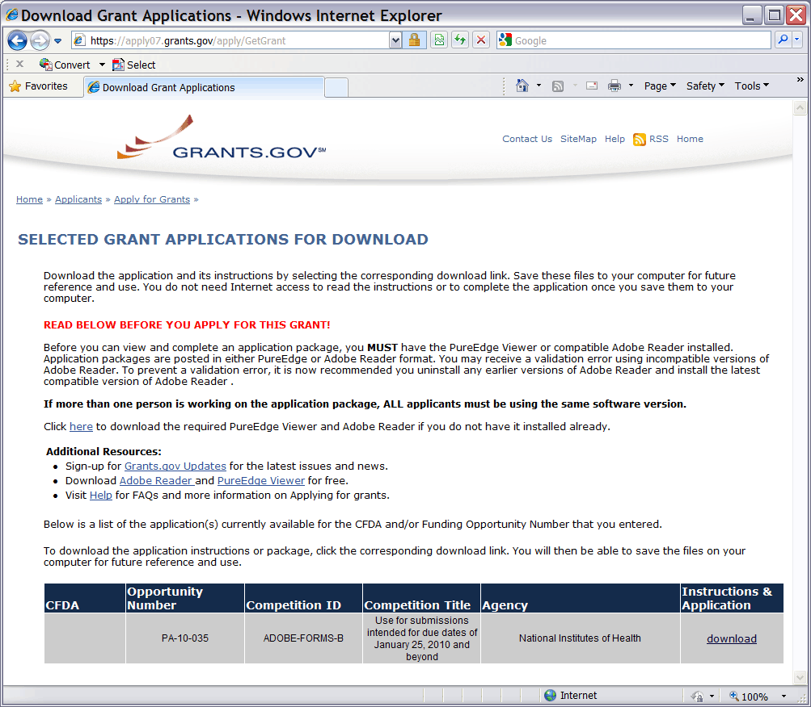
If you searched only on a specific opportunity number, only one announcement is provided in the chart. Click the corresponding download link to access the actual application form pages and instruction material. The following screen appears:
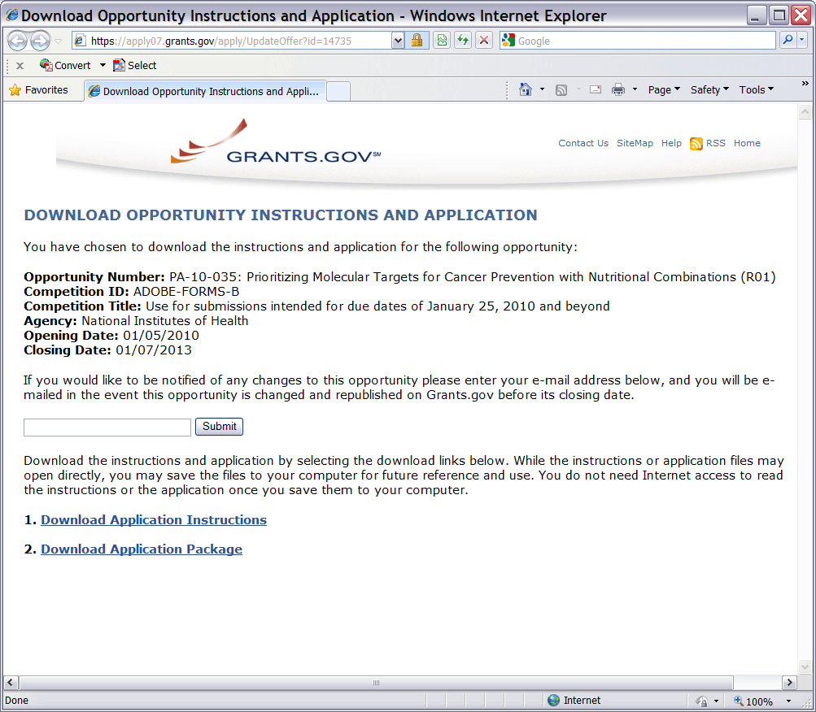
To access the instructions, click Download Application Instructions. For NIH opportunities and other PHS agencies using this Application Guide, this action will download a document containing a link to the NIH Web site where the most current set of application instructions is available (http://grants.nih.gov/grants/funding/424/index.htm). Applicants are encouraged to check this site regularly for the most current version.
To access the form pages, click Download Application Package. Section 2.5 provides specific information regarding the components of an Application Package. Section 3 provides additional instructions for properly using a package.
On the Download Opportunity Instructions and Applications screen you will be given an opportunity to provide an e-mail address if you would like to be notified of any changes to this particular opportunity. Applicants to NIH and other PHS agencies are strongly encouraged to complete this information. The agency can then use it to provide additional information to prospective applicants.
Note: if multiple CFDA numbers are cited in the FOA, the Download Opportunity Instructions and Applications screen may pre-fill a CFDA number and description that may not correspond to the Institute/Center of interest to you; or the CFDA information may not appear at all. In either case, do not be concerned since the CFDA number is not used for assignment of the application. Be assured the correct CFDA number will be assigned to the record once the appropriate IC assignment has been made.

2.5 Components of an Application to NIH or Other PHS Agencies
The SF424 (R&R) form set is comprised of a number of components, each listed in the table below as a separate “document.” In addition to these components, NIH and other PHS agencies applicants will also complete supplemental components listed as “PHS 398” components in the table below.
Table 2.5-1. Components of an NIH or Other PHS Agencies Application
document | required | optional | instructions
SF424 (R&R) Cover | x |  | Section 4.2
SF424 (R&R) Project/Performance Site Locations | x |  | Section 4.3
SF424 (R&R) Other Project Information | x |  | Section 4.4
SF424 (R&R) Senior / Key Person Profile(s) | x |  | Section 4.5
SF424 (R&R) Budget  (Use when required or allowed by the FOA) | * |  | Section 4.7
SF424 (R&R) Subaward Budget Attachment Form  (Use when required or allowed by the FOA) |  | x | Section 4.8
PHS Cover Letter |  | x | Section 5.2
PHS 398 Cover Page Supplement | x |  | Section 5.3
PHS 398 Modular Budget  (Use when required or allowed by the FOA) | * |  | Section 5.4
PHS 398 Research Plan  (Not required for Career Development Award (K) or  Institutional Training Award (T) applications) | x |  | Section 5.5
PHS 398 Career Development Award Supplemental Form  (Required only for Career Development Award (K)  applications) | x |  | Section 7.5
PHS 398 Research Training Program Plan  (Required only for Institutional Training Award (T)  applications) | x |  | Section 8.7
PHS 398 Training Budget  (Use when required or allowed by the FOA) | * |  | Section 8.5
PHS 398 Training Subaward Budget Attachment  (Use when required or allowed by the FOA) |  | * | Section 8.6
PHS 398 Checklist | x |  | Section 5.6
* The application forms package associated with most NIH research grant funding opportunities includes two optional budget components: (1) SF424 (R&R) Budget and (2) PHS 398 Modular Budget. NIH application submissions must include either the SF424 (R&R) Budget Component or the PHS 398 Modular Budget Component, but never both. (Note AHRQ does not accept modular budgets.) Unless otherwise stated in a funding announcement, an application must always be submitted with a budget component. For those programs where either form is a possibility, the budget forms will be considered “optional” by the Grants.gov package. Nonetheless, it is still required that you select and submit one of these budget forms for an application to be accepted by the NIH.
To determine which budget component to use for NIH applications, consult the modular budget guidelines found in Section 5.4. Additional guidance may also be provided in the specific funding opportunity announcement.
Some funding opportunities will explicitly state the use of only one of the budget components. In this case, the application package will only include the accepted budget form which will appear in the list of “mandatory” forms (not in the optional list).
All required and optional forms for electronic submission listed above are available through Grants.gov and should be downloaded from the FOA being applied to. Do not use any forms or format pages from other sources; these may include extraneous headers/footers or other information that could interfere with the electronic application process.

2.6 Format Specifications for Text (PDF) Attachments
Designed to maximize system-conducted validations, multiple separate attachments are required for a complete application. When the application is received by the agency, all submitted forms and all separate attachments are combined into a single document that is used by peer reviewers and agency staff.
NIH and other PHS agencies require all text attachments to the Adobe application forms be submitted as PDFs and that all text attachments conform to the agency-specific formatting requirements noted below. Failure to follow these requirements may lead to rejection of the application during agency validation or delay in the review process. (See Section 2.3.2 for more information on creating PDFs.)
Text attachments should be generated using word processing software and then converted to PDF using PDF generating software. Avoid scanning text attachments to convert to PDF since that causes problems for the agency handling the application. Additional tips for creating PDF files can be found at http://grants.nih.gov/grants/ElectronicReceipt/pdf_guidelines.htm.
When attaching a PDF document to the actual forms, please note you are attaching an actual document, not just pointing to the location of an externally stored document. Therefore, if you revise the document after it has been attached, you must delete the previous attachment and then reattach the revised document to the application form. Use the View Attachment button to determine if the correct version has been attached.
File Name
Save all files with descriptive file names of 50 characters or less and be sure to only use standard characters in file names: A through Z, a through z, 0 through 9, and underscore (_). Do not use any special characters (example: “&”, “-“, “*”, “%”, “/”, and “#”) or spacing in the file name, and for word separation use underscore (example: “My_Attached_File.pdf”) in naming the attachments.
Font
Use an Arial, Helvetica, Palatino Linotype, or Georgia typeface, a black font color, and a font size of 11 points or larger. (A Symbol font may be used to insert Greek letters or special characters; the font size requirement still applies.)
Type density, including characters and spaces, must be no more than 15 characters per inch.
Type may be no more than six lines per inch.
Paper Size and Page Margins
Use standard paper size (8 ½" x 11).
Use at least one-half inch margins (top, bottom, left, and right) for all pages. No information should appear in the margins, including the PI’s name and page numbers.
Page Formatting
Since a number of reviewers will be reviewing applications as an electronic document and not a paper version, applicants are strongly encouraged to use only a standard, single-column format for the text. Avoid using a two-column format since it can cause difficulties when reviewing the document electronically.
Do not include any information in a header or footer of the attachments. A header will be system-generated that references the name of the PD/PI. Page numbers for the footer will be system-generated in the complete application, with all pages sequentially numbered.
Figures, Graphs, Diagrams, Charts, Tables, Figure Legends, and Footnotes
You may use a smaller type size but it must be in a black font color, readily legible, and follow the font typeface requirement. Color can be used in figures; however, all text must be in a black font color, clear and legible.
Grantsmanship
Use English and avoid jargon.
If terms are not universally known, spell out the term the first time it is used and note the appropriate abbreviation in parentheses. The abbreviation may be used thereafter.
Page Limits
Although many of the sections of this application are separate text (PDF) attachments, page limits referenced in these instructions and/or funding opportunity announcement must still be followed. Agency validations will include checks for page limits. Some accommodation will be made for sections that when combined must fit within a specified limitation. Note that while these computer validations will help minimize incomplete and/or non-compliant applications, they do not replace the validations conducted by NIH staff. Applications found not to comply with the requirements may lead to rejection of the application during agency validation or delay in the review process.
All applications for NIH and other PHS agency funding must be self-contained within specified page limits. Unless otherwise specified in an NIH solicitation, Internet Web site addresses (URLs) may not be used to provide information necessary to the review because reviewers are under no obligation to view the Internet sites. Moreover, reviewers are cautioned that they should not directly access an Internet site as it could compromise their anonymity.
Observe the page number limits given in Table 2.6-1. Only when specifically allowed in a FOA, such as in cases involving interdependent multiple subprojects (e.g., Program Projects and Multi-Center Clinical Trials) will the PHS accept applications that exceed the page number limitations. However, specific page number limits may apply to each subproject. For information pertaining to page number limits for such projects, contact the awarding component to which the application may be assigned. (See Table 1.4-1. Agency Contact Table.) The page number limitations may also be different for other specialized grant applications. Consult and follow the additional instructions for those applications. Applicants are prohibited from using the Appendix to circumvent page limitations in any section of the application for which a page limit applies. For additional information regarding Appendix material and page limits, please refer to the NIH Guide Notice NOT-OD-11-080, http://grants.nih.gov/grants/guide/notice-files/NOT-OD-11-080.html.
Table 2.6-1. Page Limits
Please visit http://grants.nih.gov/grants/forms_page_limits.htm for a more detailed Table of Page Limits.

section of application  Also refer to the relevant section of the application instructions and the FOA. | page limits *
Introduction to Resubmission Application  (3 pages for R25 on PHS 398 Research Plan and 3 pages for K12, T and D Training Grants on PHS 398 Training Program Plan) | 1 page
Introduction to Revision Application | 1 page
Specific Aims | 1 page
Research Strategy (Item 5.5.3 of Research Plan) | 6 pages  or 12 pages  or Follow FOA instructions
Research Education Program Plan  For R25 Research Education Grant Applications | 25 pages
Plan for Instruction in the Responsible Conduct of Research  Required for all Training Grant Activity Codes  Required for all Individual Career Development Grant Activity Codes | 3 pages  1 page
Biosketch (per person)  (2 pages for DP1 and DP2 Activity Codes) | 4 pages
Career Development Award (K) Application  Upload to PHS 398 Career Development Award Supplemental Form: Combined Candidate Information (Items 2-4: Candidate’s Background, Career Goals and Objectives, and Career Development/Training Activities During Award Period) and Research Strategy (Item 11) | 12 pages
Institutional Research Training and Career Development Applicants, Including Ruth L. Kirschstein NRSA Application  Research Training Program Plan: Combined Sections 8.7.2.2 – 8.7.2.4 (Background, Program Plan, and Recruitment and Retention Plan to Enhance Diversity) | 25 pages
* FOA instructions always supersede these instructions.

2.7 “Resubmission” Applications
For all original new (i.e. never submitted) and competing renewal applications submitted for the January 25, 2009 due date and beyond, NIH will accept only a single amendment (A1) to the original application (called a resubmission application). A lengthy hiatus after the initial submission may be marked by significant advances in the scientific field and the comments of the reviewers may no longer be relevant. Therefore, a resubmission application must be submitted within 37 months after the date of receipt ("receipt date") of the initial New, Renewal, or revision application (see NOT-OD-10-140). After 37 months, you may submit a New application. Any second resubmission will be administratively withdrawn and not accepted for review.
For original new and competing applications submitted prior to January 25, 2009, applicants are permitted two resubmissions (A1 and A2). For these “grandfathered” applications, any second resubmission (A2) must be submitted no later than the appropriate due date for Cycle III; NIH will not accept any A2 resubmissions after that date. See NIH Policy on Resubmission Applications in Part III, 1.3.
NIH has established policies for application resubmissions of certain categories. See Resubmission of Unpaid RFA Applications and Resubmission of Applications with a Changed Grant Activity Code in Part III, 1.2.
There are five requirements for a Resubmission application:
- The Summary Statement must be available in the eRA Commons (http://commons.era.nih.gov/commons).
- The PD/PI(s) must make significant changes to the application.
- An Introduction must be included that summarizes the substantial additions, deletions, and changes to the application. The Introduction must also include a response to the issues and criticism raised in the Summary Statement. The Introduction is separate from the Cover Letter. Use Item 2.1 Introduction of the PHS 398 Research Plan Component to provide this information. The page limit for the Introduction may not exceed one page unless indicated otherwise. Please refer to the relevant section of the application instructions and the FOA.
- The substantial scientific changes must be marked in the text of the application by bracketing, indenting, or change of typography. Do not underline or shade the changes. Deleted sections should be described but not marked as deletions. If the changes are so extensive that essentially all of the text would be marked, explain this in the Introduction. The Preliminary Studies/Progress Report section should incorporate work completed since the prior version of the application was submitted.
- For Mentored Career Development Award applications, new Letters of Reference must be submitted providing an up-to-date evaluation of the applicant’s potential to become an independent researcher, and the continued need for additional supervised research experience.
See NOT-OD-11-057 for special conditions and due dates for new investigator resubmission applications submitted for consecutive review cycles. Note this applies only to new investigator R01s submitted for standard receipt dates and reviewed in recurring study sections in CSR.
Acceptance of a resubmission application will not automatically withdraw the prior version. eRA keeps all versions (e.g., 01, A1) of a grant application active and provides an internal Multiple Active Applications (MAA) flag for each application in an active cluster. The cluster allows applicants to identify quickly all versions of one application. If any version in a cluster is awarded, all other applications within the cluster will be automatically withdrawn without any additional action by applicants or staff.
Investigators who have submitted two versions of an application and have not been successful often ask NIH what constitutes a “new application.” It is recognized that investigators are trained in a particular field of science and are not likely to make drastic changes in their research interests. However, a new application following three reviews is expected to be substantially different in content and scope with more significant differences than are normally encountered in a Resubmission application. Simply rewording the title and Specific Aims or incorporating minor changes in response to comments in the previous Summary Statement does not constitute a substantial change in scope or content. Changes to the Research Strategy should produce a significant change in direction and approach for the research project. Thus, a new application would include substantial changes in all portions of the Specific Aims and Research Strategy. Requests for review by a different review committee or funding consideration by a different NIH IC are not sufficient reasons to consider an application as new.
In the referral process, NIH staff look at all aspects of the application, not just the title and Description (abstract). Requesting review by a different review committee does not affect the implementation of this policy. When necessary, previous applications are analyzed for similarities to the present one. Thus, identical applications or those with only minor changes will not be accepted for review. If identified after assignment or review, identical applications will be withdrawn.

2.8 “Revision” Application
A competing supplemental application (now known as a “Revision” application) may be submitted to request support for a significant expansion of a project’s scope or research protocol. Applications for revisions are not appropriate when the sole purpose is to restore awards to the full SRG-recommended level if they were administratively reduced by the funding agency. A revision application should not be submitted until after the original application has been awarded and must not extend beyond the term of the current award period.
Provide a one-page “Introduction” that describes the nature of the supplement and how it will influence the specific aims, research design, and methods of the current grant. Use Item 2.1, Introduction to application, of the PHS 398 Research Plan component to provide this information. The body of the application should contain sufficient information from the original grant application to allow evaluation of the proposed supplement in relation to the goals of the original application. Note that all revision applications must be submitted by the same PD/PI (or Contact PD/PI for multi-PI grants) as listed on the current award and applicants must use the same budget format (i.e. R&R Budget Component or PHS 398 Modular Budget Component) as the current award. Also, any budgetary changes for the remainder of the project period of the current grant should be discussed in the Budget Justification.
If the revision application relates to a specific line of investigation presented in the original application that was not recommended for approval by the SRG, then the applicant must respond to the criticisms in the prior Summary Statement, and substantial revisions must be clearly evident and summarized in the “Introduction.”
Administrative Supplements
An administrative supplement provides additional funding to meet increased costs that are within the scope of an approved application, but that were unforeseen when the new or competing renewal application was submitted. If considering administrative supplement funding, you must consult in advance with your designated Grants Management Officer and Program Official. It is important to submit a request before the grant expires. To be considered for an administrative supplement, you must submit a request in writing to the IC (not to the Division of Receipt and Referral, Center for Scientific Review). The request must be signed by the authorized Business Official and describe the need for additional funding and the categorical costs. In the letter, point out what will NOT be able to be accomplished if such a request is denied. At this time administrative supplements may not be submitted through Grants.gov.

2.9 Similar, Essentially Identical, or Identical Applications
Submissions of identical applications to one or more components of the PHS are not allowed.
Submissions of identical applications to one or more components of the PHS are not allowed, and the NIH will not accept similar grant applications with essentially the same research focus from the same applicant organization. This includes derivative or multiple applications that propose to develop a single product, process or service that, with non-substantive modifications, can be applied to a variety of purposes. Likewise, identical or essentially identical grant applications submitted by different applicant organizations will not be accepted. Applicant organizations should ascertain and assure that the materials they are submitting on behalf of the principal investigator are the original work of the principal investigator and have not been used elsewhere in the preparation and submission of a similar grant application. Applications to the NIH are grouped by scientific discipline for review by individual Scientific Review Groups and not by disease or disease state. The reviewers can thus easily identify multiple grant applications for essentially the same project. In these cases, application processing may be delayed or the application(s) may not be reviewed.
Essentially identical applications will not be reviewed except for: 1) individuals submitting an application for an Independent Scientist Award (K02) proposing essentially identical research in an application for an individual research project; and 2) individuals submitting an individual research project identical to a subproject that is part of a program project or center grant application.

2.10 Submitting Your Application Via Grants.gov
The Authorized Organization Representative (AOR) registered in Grants.gov is the only official with the authority to actually submit applications through Grants.gov. Therefore, PD/PIs will need to work closely with their AOR to determine that all the necessary steps have been accomplished prior to submitting an application. This includes any internal review process required by the applicant organization.
Before starting the final submission step, applicants are encouraged to save a copy of the final application locally. Once you have properly completed all required documents and attached any required or optional documentation, click on the Check Package for Errors button to ensure that you have successfully completed all required data fields. If any of the required fields are not completed you will receive an error notice which will indicate where revision is needed within your package. Correct any errors or if none are found, save the application package. The Save & Submit button will now become active and clicking this button will begin the application submission process. Only after the package has been saved with no errors will the Save & Submit button become active. The application package must then be saved once more before the submission process begins. Only an AOR will be able to perform the submit action, and they will be taken to the applicant login page to enter the Grants.gov username and password that was established in the Register with Grants.gov process (if not connected to the internet you will be instructed to do so).
Once logged in, the application package will be automatically uploaded to Grants.gov. A confirmation screen will appear once the upload is complete and a Grants.gov Tracking Number will be provided on this screen. Applicants should record this number so that they may refer to it should they need to contact Grants.gov Customer Support or the eRA Commons Help Desk.
For additional information, see http://www.grants.gov/applicants/apply_for_grants.jsp.
Applicants should be aware that on-time submission means that an application is submitted error free (of both Grants.gov and eRA Commons errors) before 5 p.m. on the receipt date, local time of the applicant organization. Applicants are encouraged to submit their applications to Grants.gov several days early to ensure enough time to correct any errors and to comply with the deadline.

2.11 After You Submit Your Application Via Grants.gov
The Authorized Organization Representative (AOR) can use Grants.gov to check the status of an application at any time. Note that Grants.gov requires a user login and password. To check the status of an application, go to https://apply07.grants.gov/apply/checkApplStatus.faces.
Once an application has been submitted via Grants.gov, several e-mails are generated by Grants.gov and sent to the AOR (known at NIH/in eRA Commons as the Signing Official [SO]) named in the grant application indicating a Grants.gov tracking number that is assigned to the submission:
1) Submission Receipt: An e-mail is sent indicating your application has been received by Grants.gov and is currently being validated.
2) Submission Validation Receipt: An e-mail is sent indicating your application has been received and validated by Grants.gov and is being prepared for Grantor agency retrieval.
3) Grantor Agency Retrieval Receipt: An e-mail is sent indicating your application has been retrieved by the Grantor agency.
4) Agency Tracking Number Assignment for Application: An e-mail is sent indicating your application has been assigned an Agency Tracking Number.
If the AOR/SO has not received a confirmation message from Grants.gov within 48 hours of submission, please contact:
Grants.gov Contact Center
Telephone: 1-800-518-4726
E-mail: support@grants.gov
At that point, the application will be scheduled for download into the eRA system for agency validation. It is imperative that the e-mail address provided in blocks 14 for the PD/PI and 19 for the AOR/SO on the SF424 (R&R) Cover component be current and accurate. Once agency validation is completed, an agency notification (not Grants.gov) will be e-mailed to the PD/PI, AOR/SO, and the Applicant Contact e-mail in block 5 (if provided) named in the application.
This e-mail notification will inform the PD/PI, AOR/SO, and the Applicant Contact (if named) that the application has been received and processed by the agency and will indicate whether any errors or warnings resulted during the validation process. The PD/PI, AOR/SO, and the Applicant Contact will be invited to log on the eRA Commons to view the assembled application or review the list of warnings/errors that were encountered during the validation process.
If there were no validation errors, this e-mail notification will also inform the PD/PI, AOR/SO, and the Applicant Contact of an agency accession number, which represents the “agency tracking number.” This number replaces the Grants.gov tracking number that was assigned when the application was first submitted. The Grants.gov system will indicate that the agency tracking number has been assigned, and will reflect both numbers. In subsequent interaction with the eRA Commons, however, it is the agency accession number that will be used to refer to the application, not the Grants.gov tracking number.
The eRA system will make every effort to send an e-mail to the PD/PI, AOR/SO, and the Applicant Contact summarizing download and validation results. However, since e-mail can be unreliable, applicants are responsible for checking on their application status in the Commons.
Once an application package has been successfully submitted through Grants.gov, any encountered errors have been corrected by the applicant, and an application image has been assembled by the eRA Commons, PD/PIs and AORs/SOs will have two business days (Monday – Friday, excluding Federal holidays) to view the application image. This window is known as the application viewing window. If everything is acceptable, no further action is necessary. The application will automatically move forward to NIH staff for further processing and funding consideration after the application viewing window elapses.
If, however, the applicant determines that he or she needs to make a change to the application, or wishes to address warnings that are applicable to the application, the AOR/SO has the option to “Reject” the application and submit a Changed/Corrected application before the deadline. Applications received after the deadline will be subject to the NIH Policy on Late Submission of Grant applications. Remember, warnings do not stop further application processing. If an application submission results in warnings (but not errors), the application will automatically move forward after the application viewing window if no action is taken. Some warnings may need to be addressed later in the process.
In addition, if the applicant determines that some part of the application was lost or did not transfer correctly during the submission process, this may be due to a system issue. In these cases, applicants must contact the eRA Help Desk within the application viewing window to document that a system issue beyond their control may be threatening their on-time submission. Only the eRA Help Desk can confirm whether a system issue has taken place and provide instructions on how to resolve the issue. Applications affected by confirmed system issues will not be considered late as long as the applicant works diligently with the eRA Help Desk on a resolution. If the application needs to be Rejected and resubmitted, applicants should follow the instructions for correcting errors in Section 2.12, including the requirement for cover letters on late applications.
PIs should work with their AOR/SO to determine when the “Reject” feature is appropriate.
To view the assembled application the AOR/SO should:
1. Login to the eRA Commons (https://commons.era.nih.gov/commons/) with your Signing Official (SO) account.
2. Click the Status tab on the Commons menu bar.
3. Click Recent/Pending eSubmissions on the left-hand side of the screen.
4. Search for your application by date received, Grants.gov tracking number, or accession number, to view a hit list of available applications.
5. When you find the appropriate application, click the accession number in the Application ID column to view the Status Information screen.
6. Click e-Application from the Other Relevant Documents section to view the assembled application.
Note: The SO can Reject the application by clicking on the Reject eApplication hypertext link from the Action column of the search hit list.
To view the assembled application the PD/PI should:
1. Login to the eRA Commons (https://commons.era.nih.gov/commons/) with your Principal Investigator (PI) account.
2. Click the Status tab on the Commons menu bar.
3. Click Recent/Pending eSubmissions near the top of the screen to view a hit list of available applications.
4. When you find the appropriate application, click the accession number in the Application ID column to view the status information screen.
5. Click e-Application from the Other Relevant Documents section to view the assembled application.

2.12 Correcting Errors
Prior to a specified submission date, applicants may make corrections and resubmit an application through Grants.gov. After a specified submission date, if applicants make corrections and resubmit, the application will be considered late. In this case, applicants must include a cover letter explaining the reasons for the delay. Also see Section 2.14 for additional information on submission dates.
If errors or warnings result from the validation process, the PD/PI, AOR/SO and Applicant Contact will be issued an e-mail instructing them to log on to the eRA Commons to review the list of warnings/errors that were encountered during the validation process. The eRA system will make every effort to send an e-mail to the PD/PI, AOR/SO and Applicant Contact indicating whether errors or warnings were detected. However, since e-mail can be unreliable, applicants are responsible for periodically checking on their application status in the eRA Commons, so that any errors or warnings can be resolved in the timeliest manner possible, before the deadline.
Please be aware of the distinction between errors and warnings. The word error is used to characterize any condition which causes the application to be deemed unacceptable for further consideration. Generally, errors will indicate significant inaccuracies, inconsistencies, omissions, or incorrect formatting that have been identified in the body of the application. Conversely, the word warning characterizes any condition that is acceptable, at least for the time being, but worthy of bringing to the applicant’s attention. It is at the applicant’s discretion whether a warning condition requires any action, but some warnings may need to be addressed later in the process.
Error conditions must be corrected, and then the application must be submitted as a Changed/Corrected application (as outlined below) in order for the application to be accepted. Please note that if validation has identified warnings only, then the PD/PI and SO will be allowed to view the application in the eRA Commons. Warnings do not require any action or submission of a Changed/Corrected application, unless the applicant chooses to address them. However, please be aware that some warnings may need to be addressed later in the process or review stages. Failure to comply with stated NIH policies can also result in a submitted application being returned to the applicant without being reviewed. For this reason, applicants are strongly encouraged to review all warnings, to ensure that they require no further attention and that they are satisfied with the validation results. If desired, warnings can be corrected in the same manner as errors.
A Changed/Corrected application may also be submitted if the PDF image, as viewed in the eRA Commons, is incomplete or inaccurate from that submitted.
Errors and warnings may be reviewed in the Commons by performing the following steps:
1. After the application has been downloaded from Grants.gov and validated by the system, login to the eRA Commons (https://commons.era.nih.gov/commons/) using your username and password.
2. Click the Status tab on the Commons menu bar.
3. Click Recent/Pending eSubmissions.
4. Search for your application by date received, Grants.gov tracking number, or accession number, if you are the SO. SO’s can select the Show eSubmission Errors checkbox to display only the applications that did not pass eRA Commons error checking. If you are the PI, clicking Recent/Pending eSubmissions will automatically display a hit list of your applications.
5. A hit list of applications is displayed. If the application was validated with warnings only, or without encountering any problems whatsoever, then it is identified in the hit list by its NIH accession number (e.g., “AN:2911064”). This is the same number that Grants.gov displays, and refers to as the “agency tracking number.”
If any errors were identified during validation, then the application still appears in the hit list, but in this case it is identified by its Grants.gov tracking number (e.g., “GRANT87654321”). This is the number that Grants.gov assigned to your application at the time of submission.
6. When you find the appropriate application in the hit list (Application Status will read “eSubmission Error” if errors were received), click its Application ID link to view the list of errors/warnings.
7. The error/warning page appears, and you are then able to review all conditions that were identified during validation. If only warnings were identified, you may elect to take action and resubmit; however you may also disregard the warnings and proceed to view the application, as described earlier.
To correct errors and resubmit the application:
1. Make whatever corrections are necessary, wherever appropriate, to your local copy of the application. Most often this means that you have to edit the data within the application forms to correct whatever problem or inconsistency that was noted. Be as careful as possible when correcting your application; NIH’s post-submission materials policy does not allow for applicants to correct oversights in their application after the due date.
2. Check the “Changed/Corrected Application” box in Item 1 of the SF424 (R&R) Cover component.
- If you are submitting this Changed/Corrected application after the due date, be sure to document the reason for the late submission in the form of a cover letter. NIH makes no guarantees that applications submitted after the due date will be accepted. See the NIH late policy for more information.
- When you check the Changed/Corrected Application box, Item 4a. Federal Identifier becomes a required field.
- When submitting a Changed/Corrected Application for a “New” Type of Application (Item 8 = New), in the Federal Identifier field (Item 4) enter the Grants.gov tracking number for the previous application that you are correcting. If you are unable to recall the Grants.gov tracking number, enter “N/A.”
- When submitting a Changed/Corrected Application for a “Resubmission”, “Renewal”, or “Revision” Type of Application (Item 8 = Resubmission, Renewal, or Revision), in the Federal Identifier field (Item 4) enter the IC and serial number of the previously assigned application/award number (e.g., CA987654).
- Do not use the Changed/Corrected Application box to denote a submission of a revised or amended application. This should be indicated in Item 8, Type of Application.
- When you have made all of your corrections, save the Changed/Corrected application to your computer.
3. The AOR will have to submit the Changed/Corrected application package to Grants.gov. The applicant will have to follow the Changed/Corrected application through Grants.gov to the eRA Commons to view the application image or the list of errors/warnings received during the validation process. It is the applicant’s responsibility to track the application through to the eRA Commons. If you cannot view your application image in the Commons, NIH can’t review your application! Successful submission may take several rounds of Changed/Corrected applications, since correcting one error may reveal or create an additional error.
The same e-mail notifications will be issued once the agency has downloaded and validated the re-submitted application and the PD/PI, AOR/SO, and Applicant Contact will once again be required to log on to the Commons either to view the application or to review the errors that were encountered during validation.
The application will only be assigned for scientific review once errors are resolved.
In addition to the validations performed by the eRA system, further administrative review will be conducted by agency staff. The PD/PI and/or the applicant organization may be contacted for further corrections/clarifications.

2.13 Post-Submission Application Materials
Grant application materials will only be accepted after submission of the application but before the initial peer review if they result from unforeseen administrative issues. Exceptions to this policy are indicated below. See NOT-OD-10-091 for additional information.
The materials should be sent as a PDF attachment to an e-mail. E-mail communication is preferred. If e-mail is not feasible, please send in a hard copy.
The original application is kept intact; any application material sent post-submission is sent separately to reviewers. Updated or supplemental grant application materials used in the peer review process will be retained as part of the official grant file and remain part of the permanent record for that application.
Acceptable post-submission materials include:
- Revised budget page(s) (e.g., change in budget request due to new funding or institutional acquisition)
- Biographical sketches (e.g., change in senior/key personnel due to the loss of an investigator)
- Letters of support or collaboration resulting from a change in senior/key personnel due to the loss of an investigator
- Adjustments resulting from natural disasters (e.g., loss of an animal colony)
- Adjustments resulting from change of institution (e.g., PI moved to another university)
- News of an article accepted for publication
Unacceptable post-submission materials [for all applications but those under Exceptions below] include:
- Updated Specific Aims or Research Strategy pages
- Late-breaking research findings
- Supplemental pages - information not contained in the existing application
- New letters of support or collaboration that do not result from a change in senior/key personnel due to the loss of an investigator
Exceptions to this policy include:
- Applications submitted in response to Requests for Applications (RFAs) that have only one due date. Post-submission materials for these applications will be accepted as outlined in NOT-OD-10-070
- Applications for training grants (see NOT-OD-10-104)
- Certain NIH Funding Opportunity Announcements (FOAs) may allow certain other types of post-submission materials to facilitate the goals of the program. Such stipulations must be explained in the FOA in the NIH Guide for Grants and Contracts
Page limits for post-submission materials under the new policy:
- All post-submission materials must conform to NIH policy on font size, margins, and paper size as referenced in Part I.2.6 of the applicable application instructions
- NIH additional form pages such as budget, biographical sketches, and other required forms must follow NIH standards for required NIH form pages.
- If post-submission material is not required on a form page, each explanation or letter is limited to one page (see Acceptable post-submission materials above)
- If the application has subprojects or cores, each subproject or core is allowed explanations or letters (see Acceptable post-submission materials above), but each explanation or letter is limited to one page
The additional materials must be submitted to the NIH SRO with the concurrence of the applicant organization’s designated AOR/SO. Although the content of post-submission materials may originate from the PD/PI, Contact PD/PI for multiple PD/PI applications, or organizational officials, the AOR must send the materials directly to the SRO, or must send his/her concurrence to the PD/PI who will forward the materials and concurrence to the SRO. A communication from the PD/PI only or with a “cc” to the AOR will not be accepted.
The deadline for receipt of additional materials is one month (30 calendar days) prior to the peer review meeting.
After the initial peer review phase is completed, the NIH Chief Grants Management Officer is the NIH official responsible for accepting additional materials. Most of the materials submitted after the initial peer review can be submitted as part of the Just-In-Time process (see Part III.1.7).

2.14 Application Submission Dates
For submission of applications to NIH, each FOA includes an Opportunity Open Date and an Opportunity Close Date. Many announcements, including those using the “Standard Submission Dates” noted in Table 2.15-1 below, include multiple submission/receipt dates and are active for several years. These announcements are posted in Grants.gov and the NIH Guide to Grants and Contracts showing an Open/Close period that spans the entire active period of the announcement. Applicants should read the Funding Opportunity Announcement carefully for specific submission/receipt dates. If specific dates are not referenced in the announcement, applicants should refer to the Standard Submission Dates for Competing Applications noted in Table 2.15-1.
Applications submitted for the Standard Submission Dates listed in Table 2.15-1 are considered on time if they are submitted to Grants.gov on or before 5 p.m. local time on the appropriate date listed. Applications submitted to FOAs with a single submission date are considered on time if they are submitted to Grants.gov on or before 5 p.m. local time on the appropriate date listed. Applications submitted for Special Receipt Dates are considered on time if they are submitted to Grants.gov on or before 5 p.m. local time on the Grants.gov posted Closing Date. Requests for Applications (RFAs) and Program Announcements with Special Referral Considerations (PARs) with special receipt dates always must be received by Grants.gov on the dates designated in the announcement.
Weekend/Federal Holiday Submission Dates. If a submission date falls on a weekend, it will be extended to the following Monday; any time the date falls on a Federal holiday, the submission date will be extended to the following business day. The application will be on time if it is submitted on or before the following business day.
Modified Application Submission and Review Policy. A continuous submission process is available to appointed members of chartered standing NIH Study Sections, Boards of Scientific Counselors, Advisory Boards or Councils, Program Advisory Committees, and peer reviewers who have served as regular or temporary members of peer review committees six times in 18 months. This alternative submission and review process is limited to R01, R21, and R34 application that would normally be received on standard submission dates. See the Peer Review Policies & Practices, Continuous Submission web page for additional information on the continuous submission process and eligibility requirements.
Late Applications. Permission for a late submission is not granted in advance. In rare cases, late applications will be accepted but only when accompanied by a cover letter that details the compelling reasons for the delay. While the reasons are sometimes personal in nature, an objective evaluation of their merit requires that some details be provided. Late applications have been accepted for reasons such as: death of an immediate family member of the PD/PI, sudden acute severe illness of the PD/PI or immediate family member, or large scale natural disaster.
NIH will consider accepting late applications based on the acceptability of the explanation and the processing time required for two different kinds of submission/receipt dates.
- Regular Standard Submission/Receipt Dates: To be considered applications must be received at the NIH within two weeks of the standard submission date.
- Expedited Standard Submission/Receipt Dates: To be considered applications must be received at the NIH within one week of the standard submission date.
- NIH will not consider late applications for the Special Receipt Dates for RFAs and PARs. This includes the special receipt dates (March 20, July 20, and November 20) for resubmission applications that are part of the New Investigator Initiative (http:grants.nih.gov/grants/guide/notice-files/NOT-OD-07-083.html).
- NIH does not expect to accept any applications received beyond the window of consideration.
The windows of time for consideration of late applications have been carefully chosen so that the late applications can be processed with the cohort of on-time applications. In all cases, when the regular standard submission date or expedited submission date falls on a weekend or federal holiday and is extended to the next business day, the window of consideration for late applications will be calculated from that business day. Note that the late window always ends in a receipt (not submission) date.
If an application is submitted late, use the optional PHS Cover Letter component to provide specific information on the timing and nature of the cause of the delay and include this component with the completed application. No other documentation is expected. Late applications are evaluated on an individual basis considering the reasons provided. Contacting the Division of Receipt and Referral, Center for Scientific Review (CSR), NIH in advance will not influence the acceptance of a late application.
Related Guide Notices include:
- NOT-OD-09-155 Extension of Modified Application Submission, Referral and Review for Reviewers at http://grants.nih.gov/grants/guide/notice-files/NOT-OD-09-155.html;
- NOT-OD-08-027 NIH Policy on Submission of Late Applications at http://grants.nih.gov/grants/guide/notice-files/NOT-OD-08-027.html;
- NOT-OD-07-083 Full Implementation to Shorten the Review Cycle for New Investigator R01 Applications Reviewed in Center for Scientific Review (CSR) Recurring Study Sections at http://grants.nih.gov/grants/guide/notice-files/NOT-OD-07-083.html;
- NOT-OD-10-090 Extension of Modified Application Submission, Referral and Review to Members of NIH Program Advisory Committees (PACs) at http://grants.nih.gov/grants/guide/notice-files/NOT-OD-10-090.html;
- NOT-OD-11-035 NIH Policy on Late Submission of Grant Applications at http://grants.nih.gov/grants/guide/notice-files/NOT-OD-11-035.html; and
- NOT-OD-11-093 Change in the NIH Continuous Submission Policy for Reviewers with Recent Substantial Service at http://grants.nih.gov/grants/guide/notice-files/NOT-OD-11-093.html.

2.15 Submission, Review and Award Cycles
The PHS submission, review, and award schedule is provided at this Web site: http://grants.nih.gov/grants/dates.htm. For specialized grant applications, consult with the appropriate PHS agency prior to the preparation of an application.
The SF424 (R&R) should only be used for those activity codes where the Application Form is identified as the SF424 (R&R). Applicants should refer to the OER Electronic Submission of Grant Applications Web site: http://grants.nih.gov/grants/ElectronicReceipt/ for details on the transition to electronic submission.

Application Assignment Information
Competing grant applications that have been successfully submitted through Grants.gov (including correcting all errors and the grant application assembled by the eRA Commons system) will be processed through the Division of Receipt and Referral, CSR, NIH unless otherwise stated. The application will be assigned to an appropriate Scientific Review Group and awarding component(s). Assignment is based on the scientific content of the application using established referral guidelines. Business rule validations are conducted by the system as well as NIH staff.
Assignment to Review Group. The Center for Scientific Review (CSR) will assign appropriately completed applications to the Scientific Review Groups (commonly referred to as “SRGs” or “study sections”) that will perform the scientific/technical merit review. The CSR lists the recurring review panels (http://cms.csr.nih.gov/PeerReviewMeetings/CSRIRGDescription/), and you may suggest a specific group in the PHS Cover Letter component. See Part I, Section 5.2 of this Guide for a suggested format for requesting a specific SRG in the Cover Letter.
Assignment to Relevant Potential Awarding Component(s) (ICs). In addition, CSR will assign each application to the agency awarding component that is the potential funding component. When the scientific areas and the research proposed in a grant application are sufficiently relevant to the program responsibilities of two or more awarding components, CSR may assign your application to all such components. The component that has the most relevant program responsibility is designated as the primary assignee. The other components that have an interest in your application are designated as secondary assignees. If your application is eligible for funding and the primary assignee does not intend to make an award, the secondary assignees will be given the opportunity to do so. Although these suggestions will be taken into consideration, the final determination will be made by the agencies participating in this solicitation.
After the submission date, usually within two (2) weeks, the PD/PI and the applicant organization will be able to access in the eRA Commons and view the following information regarding the grant application:
- Application assignment number;
- Name, address, and telephone number of the Scientific Review Officer (if the review takes place in CSR) of the Scientific Review Group to which the application has been assigned for peer review; and
- Assigned Institute/Center information.
Review outcome and other important information are also available in the Commons.
If assignment information is not available in the eRA Commons within two weeks of the submission date, contact the Division of Receipt and Referral, Center for Scientific Review (CSR), National Institutes of Health, Bethesda, MD 20892-7720, (301) 435-0715; TTY (301) 451-5936. If there is a change in assignment, you will receive a notification and the change will be reflected in the eRA Commons.
Applicant investigators must not communicate directly with any review group member about an application either before or after the review. Failure to strictly observe this policy will create serious breaches of confidentiality and conflicts of interest in the peer review process. From the time of assignment to the time the review of your application is complete, applicant investigators must direct all questions to the Scientific Review Officer. This individual is in charge of the review group and is identified in the eRA Commons.

2.16 Resources for Finding Help

2.16.1 Finding Help for Grants.gov Registration or Submissions
If help is needed with the Grants.gov registration process or with the technical aspects of submitting an application through the Grants.gov system, check first the resources available at Grants.gov (http://grants.gov/).
Grants.gov customer support is also provided by the following office:
Grants.gov Program Management Office
200 Independence Avenue, SW
HHH Building, Room 739F
Washington, DC 20201
Grants.gov Help Desk: support@grants.gov
Grants.gov Contact Center Phone Number: 1-800-518-4726
The Contact Center is available 24 hours a day, 7 days a week.

2.16.2 Finding Help for the eRA Commons Registration or
eRA Commons Validation Processes
If help is needed with the eRA Commons registration process for the applicant organization and PD/PIs or with the application validation process in the Commons after submission through Grants.gov, check first the resources available at Electronic Submission of Grant Applications (http://grants.nih.gov/grants/ElectronicReceipt/).
eRA Commons customer support is also provided by the eRA Commons Help Desk:
eRA Web site: http://era.nih.gov
eRA Commons Web site: https://commons.era.nih.gov/commons/index.jsp
eRA Commons Help Desk E-mail: commons@od.nih.gov
eRA Commons Phone: 301-402-7469
866-504-9552 (Toll Free)
301-451-5939 (TTY)
The eRA Commons Help Desk hours of operation are Monday-Friday from 7:00 a.m. to 8:00 p.m. Eastern Time.
NOTE: To help expedite your Help Desk request, we recommend that you have the following information readily available (NOTE: Additional details may be required depending upon the type of issue/request):
- Full Name of Affected User
- Full Name of Institution/Organization
- Grants.gov Tracking Number
- Submission Date
- Funding Opportunity Announcement (FOA)
- Principal Investigator’s (PI) Username
- Signing Official’s (SO) Username

2.16.3 Finding Help for Application Preparation
If after reviewing this application instruction guide, help is still needed in preparing the application, contact GrantsInfo:
GrantsInfo Phone: 301-435-0714
301-451-5936 (TTY)
GrantsInfo E-mail: GrantsInfo@nih.gov

3. Using the Grant Application Package
This section describes the steps an applicant takes once the appropriate FOA (see Section 2.4) has been located and the corresponding grant application package has been successfully downloaded.

3.1 Verify Grant Information
When you select a funding opportunity in Grants.gov Apply, verify that the information shown in the Grant Application Package screen corresponds to the funding opportunity for which you wish to apply. Grants.gov auto-populates the following information:
- Opportunity Title
- Offering Agency
- CFDA Number
- CFDA Description
- Opportunity Number
- Competition ID
- Opportunity Open Date
- Opportunity Close Date
- Agency Contact
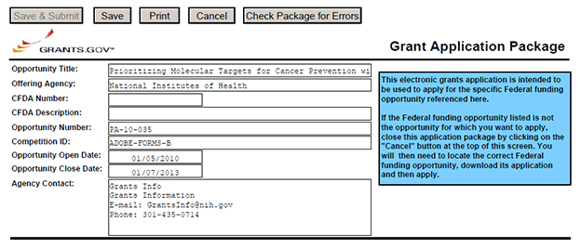
CFDA Number Field: Many FOAs include multiple CFDA (Catalog for Domestic Assistance) numbers. When this is the case, the CFDA Number and CFDA Description fields will appear blank in the Grants.gov Grant Application Package screen shown above. The appropriate CFDA number will be automatically assigned once the application is assigned to the appropriate agency awarding component.
Opportunity Open Date & Close Date Fields: Many FOAs posted by NIH and other PHS agencies include multiple submission/receipt dates and are active for several years. These announcements are posted in Grants.gov showing an Open/Close period that spans the entire active period of the announcement. Applicants should read the funding opportunity announcement carefully for specific submission/receipt dates. If specific dates are not referenced in the announcement, applicants should refer to the PHS submission, review, and award schedule at http://grants.nih.gov/grants/dates.htm. Applications submitted after a posted submission date will normally not be held over into the next review cycle. Instead, the PD/PI will be notified and will have to submit the application again. See Part I, Section 2.14 of this Guide for more information on the late application policy.

3.2 Enter the Name for the Application
Enter a name for the application in the Application Filing Name field (this is a required field). This name is for use solely by the applicant for tracking the application through the Grants.gov submission process. It is not used by the receiving agency.

3.3 Open and Complete Mandatory Documents
Open and complete all of the documents listed in the Mandatory Documents box. Complete the component titled SF424 (R&R) first. Data entered in this component populates other mandatory and optional forms where applicable.
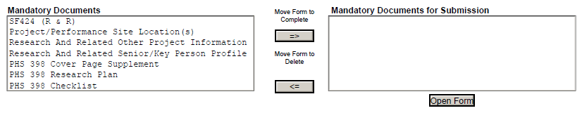
To open an item:
1. Click the document name in the Mandatory Documents box.
2. Click Move Form to Complete.
3. Click the document name in the Mandatory Documents for Submission box and click Open Form.
4. To remove a document from the Mandatory Documents for Submission box, click the document name to select it and then click the Move Form to Delete box. This returns the document to the Mandatory Documents box.

3.4 Open and Complete Optional Documents
These documents can be used to provide additional information for the application or may be required for specific types of grant activities. Information on each of these documents is found later in these instructions. In some application packages applicants will see two budget options; e.g., Research & Related Budget and PHS 398 Modular Budget in the Optional Documents section. While both appear as Optional Documents, one or the other will always be required. See Section 4.6 Selecting the Appropriate Budget Component for additional details.

3.5 Submitting the Application via Grants.gov
Once you have properly completed all required documents and attached any required or optional documentation, click on the Check Package for Errors button to ensure that you have successfully completed all required data fields. If any of the required fields are not completed you will receive an error notice which will indicate where revision is needed within your package. Correct any errors or if none are found, save the application package. The Save & Submit button will now become active and clicking this button will begin the application submission process. Only after the package has been saved with no errors will the Save & Submit button become active. The application package must then be saved once more before the submission process begins. Only an AOR will be able to perform the submit action, and they will be taken to the applicant login page to enter the Grants.gov username and password that was established in the Register with Grants.gov process (if not connected to the internet you will be instructed to do so).

4. Completing the SF424 Research and Related (R&R) Forms

4.1 Overview
This section contains all of the instructions you will need to complete the SF424 (R&R) forms.
Any agency-specific instructions are denoted by the DHHS logo displayed to the left of the paragraph, as illustrated here.
Conformance to all instructions is required and strictly enforced. Agencies may withdraw any applications from the review process that are not consistent with these instructions.
As you navigate through the forms, required fields are highlighted in yellow, outlined in red, and noted with an asterisk (*). Optional fields and completed fields are displayed in white. Data entered into a specific field is not accepted until you have navigated to the next field. If you enter invalid or incomplete information in a field, you will receive an error message.
Note the highlighted fields required for submissions, and the Check Package for Errors button, only refer to requirements and errors in the actual Adobe Reader forms. They do not refer to requirements or data errors against PHS business processes. Those validations will be performed by the eRA Commons system after the application has been submitted.
For those form components that are more than one page, click the Next button at the top of the form or scroll down (using the scroll bar on the right hand side of the screen) to navigate to a subsequent page. Once all data have been entered scroll up using the scroll bar to return to the Grant Application Package Screen.

4.2 Cover Component
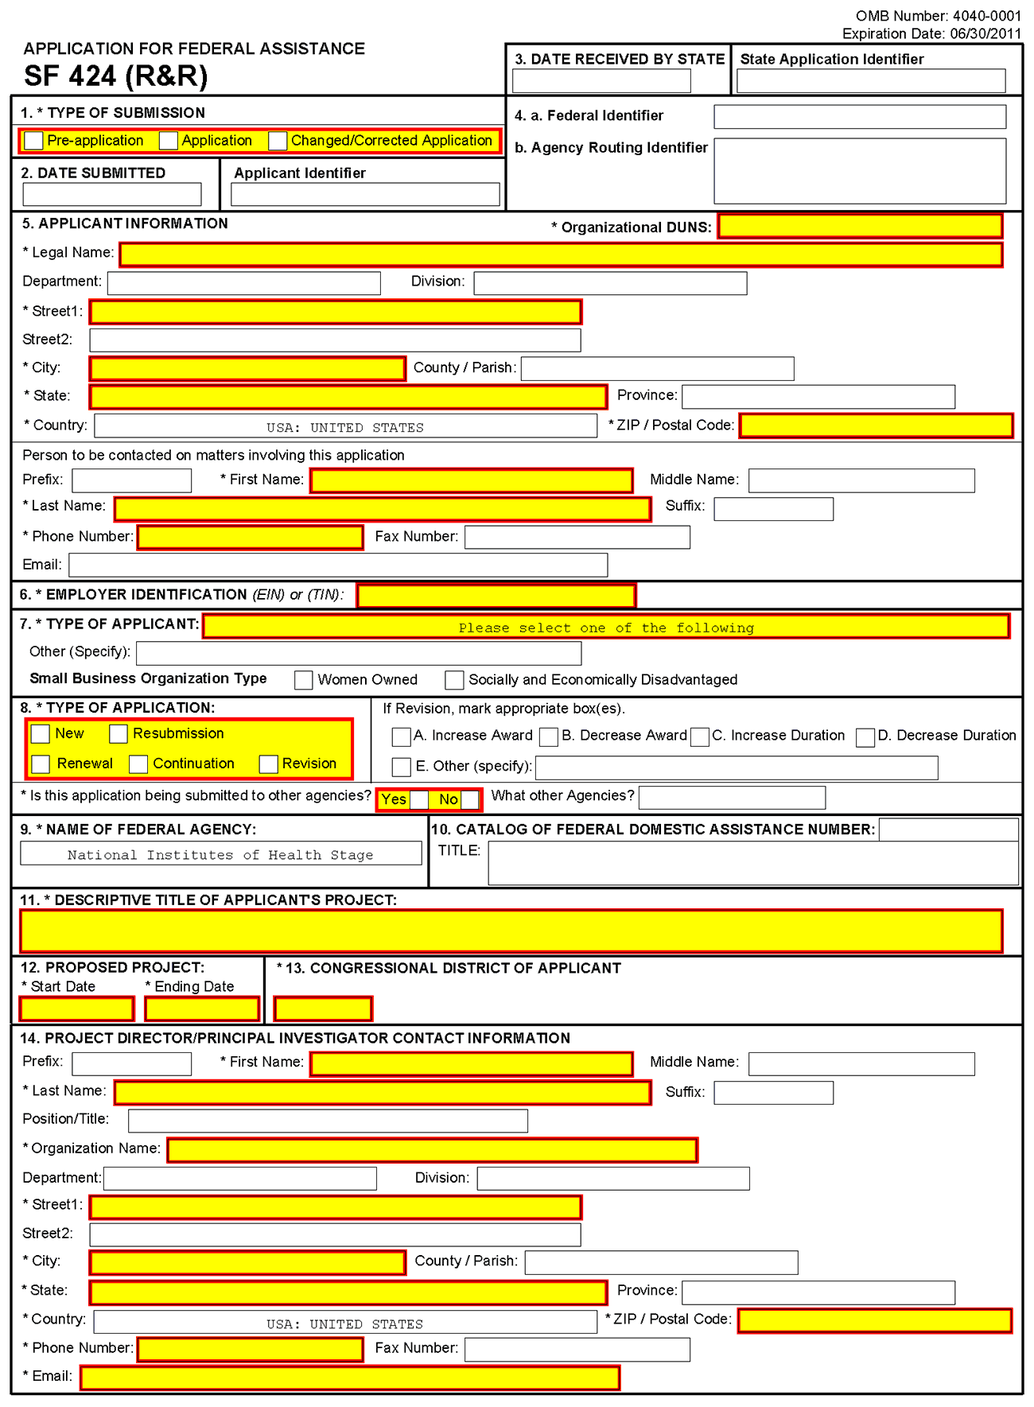
1. Type of Submission
Check one of the Type of Submission boxes. If this submission is to change or correct a previously submitted “New” application, click the Changed/Corrected Application box and enter the Grants.gov tracking number in the Federal Identifier field. If this submission is to change or correct a “resubmission,” “renewal,” “continuation,” or “revision” application, leave the Federal Identifier field as previously filled with the existing identifier (e.g., Award number). Do NOT insert the Grants.gov tracking number in these cases.
Unless requested by the agency, applicants may not use this to submit changes after the closing date. This field is required.
Pre-Application: Unless specifically noted in a program announcement, the Pre-application option is not used by NIH and other PHS agencies.
Changed/Corrected Application: This box must be used if you need to submit the same application again because of corrections for system validation errors or if a portion of the application was lost or distorted during the submission process. This option is for correcting system validation errors only and may not be used to include last minute changes to any of the PDF attachments. When submitting a Changed/Corrected Application:
  - If submitting after the submission date, include an explanation in the Cover Letter Component. Note that if you are submitting additional grant application materials after the submission date some special guidelines may apply. See NIH Guide Notice NOT-OD-08-082 (http://grants.nih.gov/grants/guide/notice-files/not-od-08-082.html) for the NIH Policy on Submission of Additional Grant Application Materials.
  - When you check the Changed/Correct Application box, Item 4. Federal Identifier becomes a required field.
  - When submitting a Changed/Corrected Application for a “New” Type of Application (Item 8 = New), in the Federal Identifier field (Item 4)) enter the Grants.gov tracking number for the previous application that you are correcting. If you are unable to recall the Grants.gov tracking number, enter “N/A.”
  - When submitting a Changed/Corrected Application for a “Resubmission”, “Renewal”, or “Revision” Type of Application (Item 8 = Resubmission, Renewal, or Revision), in the Federal Identifier field (Item 4) enter the IC and serial number of the previously assigned application/award number (e.g., CA987654).
  - Do not use the Changed/Corrected Application box to denote a submission of a resubmission or amended application. That will be indicated in item 8. Type of Application.
2. Date Submitted and Applicant Identifier
Enter the date the application is submitted to Federal agency (or State if applicable). In the applicant identifier field enter the applicant’s control number (if applicable).
Note the Applicant Identifier field is a control number created by the applicant organization, not the Federal agency.
3. Date Received by State and State Application Identifier
Enter the date received by state (if applicable). In the State Application Identifier field, enter the state application identifier, if applicable.
For submissions to NIH and other PHS agencies, leave these fields blank.

4.a. Federal Identifier
New project applications should leave this field blank unless you are submitting a Changed/Corrected application or a New application following a Pre-Application. When submitting a Changed/Corrected “New” application, enter the Grants.gov tracking number. When a New Application is being submitted following a Pre-Application, enter the agency-assigned pre-application number, if applicable. If this is a continuation, revision, or renewal application, enter the assigned Federal Identifier number (for example, award number)--even if submitting a Changed/Corrected application.
For submissions to NIH and other PHS agencies, include only the IC and serial number of the previously assigned application/award number (e.g., CA987654).
Existing definitions for NIH and other PHS agencies applications are somewhat different:
- New is the same; i.e., an application that is submitted for the first time. See also the policy Resubmission of Unpaid RFA Applications and Resubmission of Applications with a Changed Grant Activity Code.
- Resubmission is equivalent to NIH and other PHS agencies Revision; i.e., a revised or amended application. See also the NIH Policy on Resubmission Applications.
- Renewal is equivalent to NIH and other PHS agencies Competing Continuation.
- Continuation is equivalent to NIH and other PHS agencies Progress Report. For the purposes of NIH and other PHS agencies, the box for Continuation will not be used.
- Revision is somewhat equivalent to NIH and other PHS agencies Competing Supplement. Applicants should contact the awarding agency for advice on submitting any revision/supplement application.
Applicants to NIH and other PHS agencies should complete this field when submitting a resubmission, renewal or revision application. When submitting a “New” application, this field should remain blank unless you are submitting a Changed/Corrected Application. In this case, where Item 1 = Changed/Corrected Application and Item 8 = New, the Federal Identifier field becomes a required field. Therefore you must enter the Grants.gov tracking number assigned to the application that you are correcting. If you are unable to recall the tracking number, enter “N/A.” See instructions for “8. Type of Application.”
4.b. Agency Routing Identifier
Enter the agency-assigned routing identifier per the agency-specific instructions. Unless specifically noted in a program announcement, the Agency Routing Identifier is not used by NIH or other PHS agencies.
5. Applicant Information
This information is for the Applicant Organization, not a specific individual.

Field Name | Instructions
Organizational DUNS | Enter the DUNS or DUNS+4 number of the applicant organization. This field is required.  For submission to NIH and other PHS agencies, this DUNS must match the number entered in the eRA Commons Institutional Profile for the applicant organization. The applicant AOR is encouraged to confirm that a DUNS has been entered in the eRA Commons Institutional Profile prior to submitting an application. If your organization does not already have a DUNS number, you will need to go to the Dun & Bradstreet Web site at http://fedgov.dnb.com/webform to obtain the number.
Legal Name | Enter the legal name of the applicant which will undertake the assistance activity, enter the complete address of the applicant (including county/parish and country), and name, telephone number, e-mail, and fax of the person to contact on matters related to this application.
Department | Enter the name of the primary organizational department, service, laboratory, or equivalent level within the organization that will undertake the assistance activity.
Division | Enter the name of the primary organizational division, office, or major subdivision which will undertake the assistance activity.
Street1 | Enter the first line of the street address for the applicant in “Street1” field. This field is required.
Street2 | Enter the second line of the street address for the applicant in “Street2” field. This field is optional.
City | Enter the city for address of applicant. This field is required.
County /Parish | Enter the county or parish for address of applicant.
State | Enter the State where the applicant is located. This field is required if the applicant is located in the United States.
Province | Enter the Province.  If “Country” is not Canada, please leave blank.
Country | Select the country for the applicant address. This field is required.
ZIP Code | Enter the nine-digit Postal Code (e.g., ZIP code) of applicant. This field is required if the applicant is located in the United States. This field is required if a State is selected; optional for Province.

Person to be contacted on matters involving this application:
This information is for the Administrative or Business Official, not the PD/PI. This person is the individual to be notified if additional information is needed and/or if an award is made. To avoid potential errors and delays in processing, please ensure that the information provided in this section is identical to the AO profile information contained in the eRA Commons.
Field Name | Instructions
Prefix | Enter the prefix (e.g., Mr., Mrs., Rev.) for the person to contact on matters related to this application.  See also the PHS 398 Cover Page Supplement for additional required contact information.
First Name | Enter the first (given) name of the person to contact on matters related to this application. This field is required.
Middle Name | Enter the middle name of the person to contact on matters related to this application.
Last Name | Enter the last (family) name of the person to contact on matters related to this application. This field is required.
Suffix | Enter the suffix (e.g., Jr., Sr., Ph.D.) for the person to contact on matters related to this application.
Phone Number | Enter the daytime phone number for the person to contact on matters related to this application. This field is required.
Fax Number | Enter the fax number for the person to contact on matters related to this application.
E-mail | Enter the e-mail address for the person to contact on matters related to this application.  Provide only one e-mail address. This is a required field for applications submitted to NIH and other PHS agencies.
6. Employer Identification
Enter either TIN or EIN as assigned by the Internal Revenue Service. If your organization is not in the U.S., enter 44-4444444. This field is required.
If you have a 12-digit EIN established for grant awards from NIH or other PHS agencies, enter all 12digits (e.g., 1123456789A1).
7. Type of Applicant
This information is for the Applicant Organization, not a specific individual AOR or PD/PI.

Field Name | Instructions
Type of Applicant | Select from the menu or enter the appropriate letter in the space provided. If “Small Business” is selected as “Type of Applicant,” then note if the organization is “Woman-owned” and/or “Socially and Economically Disadvantaged.”  For eligible Agencies of the Federal Government, select X: Other (specify), and then indicate the name of the appropriate Federal agency in the space below.
Other (Specify) | Complete only if “Other” is selected as the Type of Applicant.
Woman Owned | Check if you are a woman-owned small business – a small business that is at least 51% owned by a woman or women, who also control and operate it.
Socially and Economically Disadvantaged | Check if you are a socially and economically disadvantaged small business, as determined by the U.S. Small Business Administration pursuant to Section 8(a) of the Small Business Act U.S.C. 637(a).
8. Type of Application
Field Name | Instructions
Type of Application | Select the type from the following list. Check only one. This field is required.  - New: An application that is being submitted to an agency for the first time.  - Resubmission: An application that has been previously submitted, but was not funded, and is being resubmitted for new consideration.  - Renewal: An application requesting additional funding for a period subsequent to that provided by a current award. A renewal application competes with all other applications and must be developed as fully as though the applicant is applying for the first time.  - Continuation: A non-competing application for an additional funding/budget period within a previously approved project period.  - Revision: An application that proposes a change in  1) the Federal Government’s financial obligations or contingent liability from an existing obligation, or  2) any other change in the terms and conditions of the existing award.  Existing definitions for NIH and other PHS agencies Type of Application are somewhat different:  - New is the same. Check this option when submitting an application for the first time. See also the policy Resubmission of Unpaid RFA Applications and Resubmission of Applications with a Changed Grant Activity Code.  - Resubmission is equivalent to NIH and other PHS agencies Revision. Check this option when submitting a revised (altered or corrected) or amended application. See also the NIH Policy on Resubmission Applications. Institutions submitting revision or renewal applications that are also resubmissions (A1 or A2 if allowed, see NIH Grant Notice NOT-OD-09-003, http://grants.nih.gov/grants/guide/notice-files/not-od-09-003.html) are instructed to select “Resubmission.” For additional information, see NIH Guide Notice NOT-OD-10-052, http://grants.nih.gov/grants/guide/notice-files/not-od-10-052.html).  - Renewal is equivalent to NIH and other PHS agencies Competing Continuation.  - Continuation is equivalent to NIH and other PHS agencies Progress Report. For the purposes of NIH and other PHS agencies, the box for Continuation will not be used and should not be checked.  - Revision is somewhat equivalent to NIH and other PHS agencies Supplement, but would also include other changes as noted in the definition above. In general, changes to the “terms and conditions of the existing award” (as noted in example 2 above) would not require the submission of another application through Grants.gov. Applicants should contact the awarding agency for advice on submitting any revision/supplement application.  This field also affects how you complete Item 4. Federal Identifier. If “Type of Application” is “New”, you can leave the Federal Identifier field blank on the first submission attempt. However, the Federal Identifier field becomes a required field when submitting a Changed/Corrected application to address errors/warnings. When submitting a Changed/Corrected “New” application, enter the Grants.gov tracking number of the previous submission attempt (e.g. GRANT87654321). If you are unable to find the tracking number, enter “N/A”.  If “Type of Application” is “Renewal,” “Revision,” or “Resubmission,” enter the IC and serial number of the previously assigned application/award number (e.g., CA987654). For these types of applications, do not change the Federal Identifier field when submitting Changed/Corrected applications.
If Revision, mark appropriate box(es) | If Revision, mark appropriate box(es). May select more than one:  A. Increase Award  B. Decrease Award  C. Increase Duration  D. Decrease Duration  E. Other  If “Other” is selected, please specify in the text box provided.  For the purposes of NIH and other PHS agencies, the boxes for options B, C, D, and E will generally not be used and should not be selected unless specifically addressed in a particular FOA.
Other | If “Other” is selected for Revision, add text to explain.
Is this application being submitted to other agencies? | Check applicable box. This field is required.  In the field “Is this application being submitted to other agencies?,” please check the box “yes” if one or more of the specific aims submitted in your application are also contained in a similar, identical, or essentially identical application submitted to another Federal agency. Indicate the agency or agencies to which the application has been submitted. For additional information, please see NIH Guide Notice NOT-OD-09-100, Reminder and Clarification of NIH Policies on Similar, Identical, or Essentially Identical Applications, Submission of Applications Following RFA Review, and Submission of Applications with a Changed Activity Code, http://grants.nih.gov/grants/guide/notice-files/NOT-OD-09-100.html.
What Other Agencies? | Enter Agency name.
9. Name of Federal Agency
Name the Federal agency from which assistance is being requested with this application. This information is pre-populated by Grants.gov.
10. Catalog of Federal Domestic Assistance (CFDA) Number and Title (CFDA)
Use the Catalog of Federal Domestic Assistance number and title of the program under which assistance is requested. This information is pre-populated by Grants.gov.
This field may be blank if you are applying to an opportunity that references multiple CFDA numbers. When this field is blank, leave it blank; the field will not allow any data entry. The appropriate CFDA number will be automatically assigned by the agency once the application is assigned to the appropriate awarding component.
11. Descriptive Title of Applicant’s Project
Enter a brief descriptive title of the project. This field is required.
A “new” application must have a different title from any other PHS project with the same PD/PI. A “resubmission” or “renewal” application should normally have the same title as the previous grant or application. If the specific aims of the project have significantly changed, choose a new title.
A “revision” application must have the same title as the currently funded grant.
NIH and other PHS agencies limit title character length to 81 characters, including the spaces between words and punctuation. Titles in excess of 81 characters will be truncated. Be sure to only use standard characters in the descriptive title: A through Z, a through z, 0 through 9, and underscore (_).
12. Proposed Project
Start Date: Enter the proposed start date of the project. This field is required.
Ending Date: Enter the proposed ending date of the project. This field is required.
13. Congressional District of Applicant
Enter the Congressional District in the format: 2 character State Abbreviation – 3 character District Number. Examples: CA-005 for California’s 5th district, CA-012 for California’s 12th district.
If outside the U.S., enter 00-000.
To locate your congressional district, visit the Grants.gov Web site.
For States and U.S. territories with only a single congressional district enter “001” for the district code. For jurisdictions with no representative, enter “099”. For jurisdictions with a nonvoting delegate, enter “098” for the district number. Example: DC-098, PR-098.
14. Program Director/Principal Investigator (PD/PI) Contact Information
If submitting an application reflecting Multiple PD/PIs, the individual designated as the Contact PI must be affiliated in the Commons with the applicant organization and should be entered here. See Section 4.5 Senior/Key Person Profile Components for additional instructions for Multiple PD/PIs. To avoid potential errors and delays in processing, please ensure that the information provided in this section is identical to the PD/PI profile information contained in the eRA Commons.
Field Name | Instructions
Prefix | The Project Director/Principal Investigator (PD/PI) is the individual responsible for the overall scientific and technical direction of the project. Enter the prefix of the PD/PI.  See also the PHS 398 Cover Page Supplement for additional PD/PI required data.
First Name | Enter the first name of the PD/PI. This field is required.
Middle Name | Enter the middle name of the PD/PI.
Last Name | Enter the last name of the PD/PI. This field is required.
Suffix | Enter the suffix of the PD/PI.  Do not use this field to record degrees. Degrees for the PD/PI are requested separately in the PHS 398 Cover Page Supplement.
Position/Title | Enter the position/title of the PD/PI.
Organization Name | Enter the organization name of the PD/PI.
Department | Enter the department of the PD/PI.
Division | Enter the division of the PD/PI.
Street1 | Enter first line of the street address for the PD/PI in the “Street1” field. This field is required.
Street2 | Enter the second line of the street address for the PD/PI in the “Street2” field. This field is optional.
City | Enter the City for address of the PD/PI. This field is required.
County/Parish | Enter the county or parish for address of the PD/PI.
State | Enter the State where the PD/PI is located. This field is required if the PD/PI is located in the United States.
Province | Enter the province for PD/PI.  If “Country” is not Canada, please leave blank.
Country | Select the country for the PD/PI address.
ZIP/Postal Code | Enter the nine-digit Postal Code (e.g., ZIP Code) of the PD/PI. This field is required if the PD/PI is located in the United States.
Phone Number | Enter the daytime phone number for the PD/PI. This field is required.
Fax Number | Enter the fax number for the PD/PI.
E-mail | Enter the e-mail address for the PD/PI. This field is required.

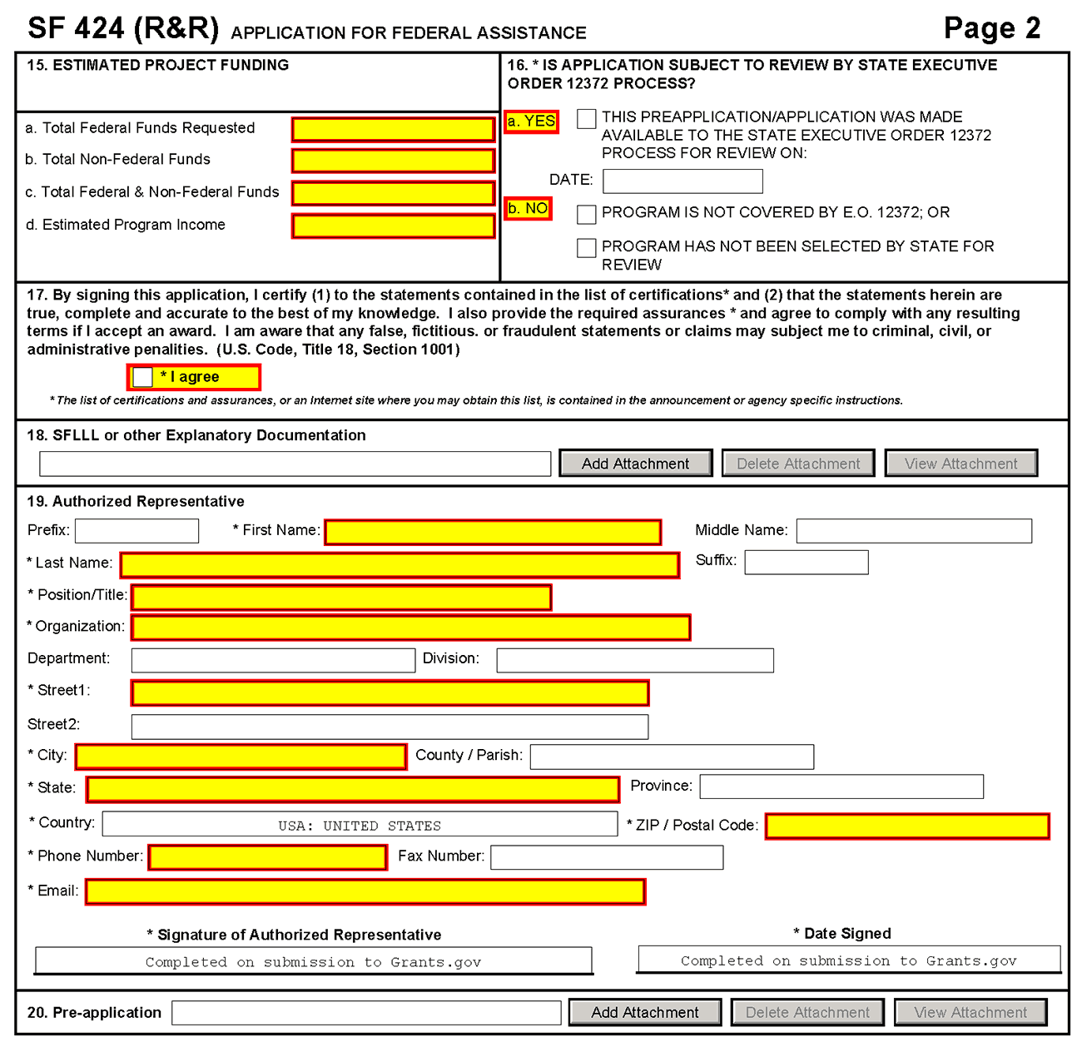
15. Estimated Project Funding
Field Name | Instructions
a. Total Federal Funds Requested | Enter total Federal funds requested for the entire project period. This field is required.  Please ensure number(s) complies with application requirements.
b. Total Non-Federal Funds | Enter total non-Federal funds proposed for the entire project period.  For NIH and other PHS agencies, enter “0” in this field unless cost sharing is a requirement for the specific announcement.
c. Total Federal & Non-Federal Funds | Enter total estimated funds for the entire project period, including both Federal and non-Federal funds. This is required information.  For NIH and other PHS agencies applicants, this field will be the same as item 15a unless the specific announcement indicates that cost sharing is a requirement.
d. Estimated Program Income | Identify any Program Income estimated for this project period if applicable. This field is required.
16. Is Application Subject to Review by State Executive Order 12372 Process?
If yes, check box. If the announcement indicates that the program is covered under Executive Order 12372, applicants should contact the State Single Point of Contact (SPOC) for Federal Executive Order 12372. If no, check appropriate box.
If block 16a is checked, insert date application was submitted to State.
For NIH and other PHS agencies submissions using the SF424 (R&R), applicants should check “No, Program is not covered by E.O. 12372.”
17. Certification
Check “I agree” to provide the required certifications and assurances. This field is required.
The list of NIH and other PHS agencies Assurances, Certifications, and other Policies is found in Part III, Policies, Assurances, Definitions, and Other Information.
The applicant organization is responsible for verifying its eligibility and the accuracy, validity, and conformity with the most current institutional guidelines of all the administrative, fiscal, and scientific information in the application, including the Facilities and Administrative rate. Deliberate withholding, falsification, or misrepresentation of information could result in administrative actions, such as withdrawal of an application, suspension and/or termination of an award, debarment of individuals, as well as possible criminal penalties. The signer further certifies that the applicant organization will be accountable both for the appropriate use of any funds awarded and for the performance of the grant-supported project or activities resulting from this application. The grantee institution may be liable for the reimbursement of funds associated with any inappropriate or fraudulent conduct of the project activity.
18. SFLLL or Other Explanatory Documentation
If applicable, attach the SFLLL or other explanatory document per agency instructions.
If unable to certify compliance in Item 17 (above), attach an explanation. Additionally, as applicable, attach the SFLLL (Standard Form LLL, Disclosure of Lobbying Activities) or other documents in this item. A fillable version of the SFLLL form is available at http://www.whitehouse.gov/omb/assets/omb/grants/sflllin.pdf.
19. Authorized Representative
This is equivalent to the individual with the organizational authority to sign for an application; otherwise known as the Authorized Organization Representative or the Signing Official.
Field Name | Instructions
Prefix | Enter the prefix (Mr., Mrs., Rev.) for the name of the Authorized Representative.
First Name | Enter the first (given) name of the Authorized Representative. This field is required.
Middle Name | Enter the middle name of the Authorized Representative.
Last Name | Enter the last (family) name of the Authorized Representative. This field is required.
Suffix | Enter the suffix (e.g., Jr., Sr., Ph.D.) for the name of the Authorized Representative.
Position/Title | Enter the title of the Authorized Representative. This field is required.
Organization | Enter the name of the organization for the Authorized Representative. This field is required.
Department | Enter the name of the primary organizational department, service, laboratory, or equivalent level within the organization of the Authorized Representative.
Division | Enter the name of the primary organizational division, office, or major subdivision of the Authorized Representative.
Street1 | Enter the first line of the street address for the Authorized Representative in the “Street1” field. This field is required.
Street2 | Enter the second line of the street address for the Authorized Representative in the “Street2” field. This field is optional.
City | City for address of the Authorized Representative. This field is required.
County/Parish | Enter the county or parish for address of the Authorized Representative.
State | Enter the state where the Authorized Representative is located. This field is required if the Authorized Representative is located in the United States.
Province | Enter the province for the Authorized Representative.  If “Country” is not Canada, please leave blank.
Country | Select the country for the Authorized Representative address.
ZIP/Postal Code | Enter the nine-digit postal code (e.g., ZIP code) of the Authorized Representative. This field is required if the Authorized Representative is located in the United States.
Phone Number | Enter the daytime phone number for the Authorized Representative. This field is required.
Fax Number | Enter the fax number for the Authorized Representative.
E-mail | Enter the e-mail address for the Authorized Representative. This field is required.
Signature of Authorized Representative | It is the organization’s responsibility to assure that only properly authorized individuals sign in this capacity and/or submit the application to Grants.gov. If this application is submitted through Grants.gov, leave blank. If a hard copy is submitted, the AOR must sign this block.
Date Signed | If this application is submitted through Grants.gov, the system will generate this date. If submitting a hard copy, enter the date the AOR signed the application.
20. Pre-Application
If you are submitting a pre-application, provide a summary description of the project in accordance with the announcement and/or agency specific instructions, and save the file in a location you remember. Click Add Attachment, browse to where you saved the file, select the file, and then click Open.
Unless specifically noted in a program announcement, NIH and other PHS agencies do not use Pre-applications.

Once all data have been entered use the scroll bar to scroll up. You will be returned to the Grant Application Package screen. To remove a document from the Submission box, click the document name to select it and then click the Move Form to Delete button. This will return the document to the Mandatory Documents Submission List or Optional Documents Submission List.

4.3 Project/Performance Site Locations Component
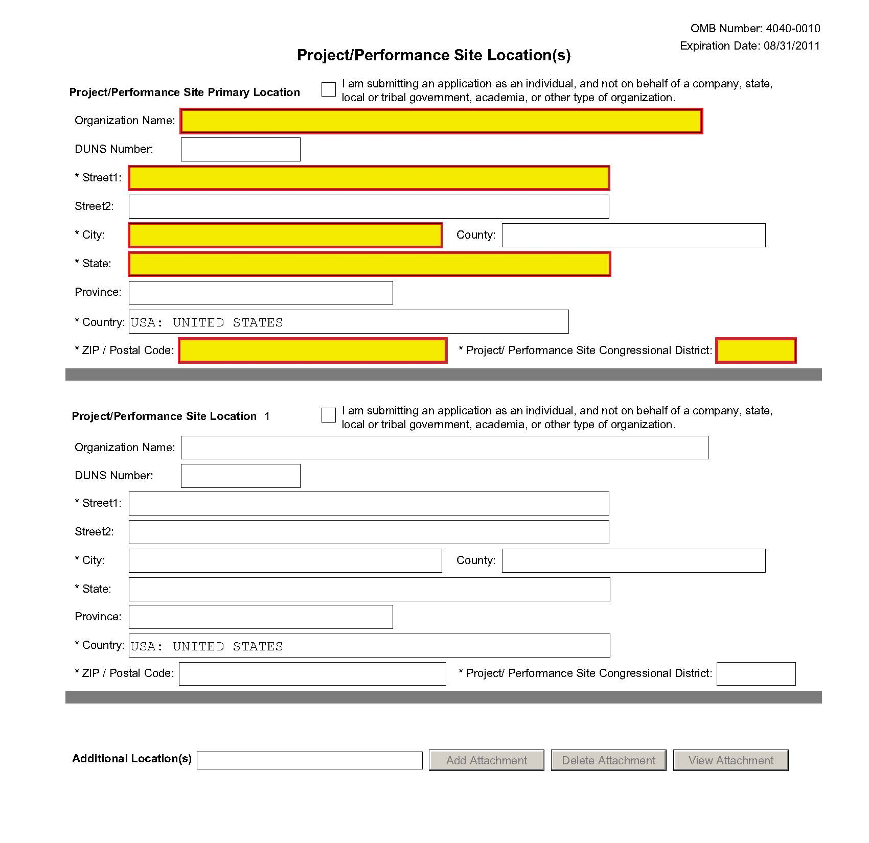
Indicate the primary site where the work will be performed. If a portion of the project will be performed at any other site(s), identify the site location(s) in the blocks provided.
Project/Performance Site Primary Location
Generally, the Primary Location should be that of the applicant organization or identified as off-site in accordance with the conditions of the applicant organization’s negotiated Facilities and Administrative (F&A) agreement. This information must agree with the F&A information on the Checklist Form Page of the application. If there is more than one performance site, including any Department of Veterans Affairs (VA) facilities and foreign sites, list them in the fields provided for Location 1 - # below. Applicants should also provide an explanation of resources available from each Project/Performance Site in Item 10, Facilities and Resources of the Other Project Information form, and describe any consortium/contractual arrangements in Item 13 of the PHS 398 Research Plan.
Unless otherwise instructed in a FOA, do not check the “I am submitting an application as an individual, and not on behalf of a company, state, local or tribal government, academia, or other type of organization” box.
If a Project/Performance Site is engaged in research involving human subjects, the applicant organization is responsible for ensuring that the Project/Performance Site operates under and appropriate Federal Wide Assurance for the protection of human subjects and complies with 45 CFR part 46 and other NIH human subject related policies described in Part II of this Application Guide and in the NIH Grants Policy Statement.
For research involving live vertebrate animals, the applicant organization must ensure that all Project/Performance Sites hold OLAW-approved Assurances. If the applicant organization does not have an animal program or facilities and the animal work will be conducted at an institution with an Assurance, the applicant must obtain an Assurance from OLAW prior to an award.
Field Name | Instructions
Organization Name | Indicate the organization name of the primary site where the work will be performed.
DUNS Number | Enter the DUNS number associated with the organization where the project will be performed.  The DUNS Number is a required field for the Primary Performance Site.
Street1 | Enter first line of the street address of the primary performance site location. This field is required.
Street2 | Enter second line of the street address of the primary performance site location, if applicable.
City | Enter the city for address of the primary performance site location. This field is required.
County/Parish | Enter the county or parish of the primary performance site location.
State | Select the state of the primary performance site location. This field is not active until USA has been selected for the country. This field is required if the performance site location is in the United States.
Province | Enter the province of the primary performance site location.  If “Country” is not Canada, please leave blank.
Country | Select the country of the primary performance site location. This field is required.
ZIP Code | Enter the nine-digit postal code (e.g., ZIP code) of the performance site location. This field is required if the performance site location is in the United States.
Project/Performance Site Congressional District | Enter the Congressional District in the format: 2 character State Abbreviation – 3 character District Number. Examples: CA-005 for California’s 5th district, CA-012 for California’s 12th district.  If all districts in a state are affected, enter “all” for the district number. Example MD-all for all congressional districts in Maryland.  If nationwide (all districts in all states), enter US-all.  If the program/project is outside the U.S., enter 00-000.  To locate your congressional district, visit the Grants.gov Web site. Note it is likely this field will be identical to the “Congressional District of Applicant” field provided elsewhere in the application.  For States and U.S. territories with only a single congressional district enter “001” for the district code. For jurisdictions with no representative, enter “099”. For jurisdictions with a nonvoting delegate, enter “098” for the district number. Example: DC-098, PR-098.
Project/Performance Site Location 1
Field Name | Instructions
Organization Name | Enter the name of organization of the performance site location.
DUNS Number | Enter the DUNS number associated with the organization where the project will be performed.
Street1 | Enter first line of the street address of the performance site location. This field is required.
Street2 | Enter second line of the street address of the performance site location, if applicable.
City | Enter the city of the performance site location. This field is required.
County/Parish | Enter the county or parish of the performance site location.
State | Select the state where the performance site is located. This field is not active until USA has been selected for the country. This field is required if the performance site location is in the United States.
Province | Enter the province of the performance site location.  If “Country” is not Canada, please leave blank.
Country | Select the country for the performance site location. This field is required.
ZIP Code | Enter the nine-digit postal code (e.g., ZIP code) of the performance site location. This field is required if the performance site location is in the United States.
Project/Performance Site Congressional District | Enter the Congressional District in the format: 2 character State Abbreviation – 3 character District Number. Examples: CA-005 for California’s 5th district, CA-012 for California’s 12th district.  If all districts in a state are affected, enter “all” for the district number. Example MD-all for all congressional districts in Maryland.  If nationwide (all districts in all states), enter US-all.  If the program/project is outside the U.S., enter 00-000.  To locate your congressional district, visit the Grants.gov Web site. Note it is likely this field will be identical to the “Congressional District of Applicant” field provided elsewhere in the application.  For States and U.S. territories with only a single congressional district enter “001” for the district code. For jurisdictions with no representative, enter “099”. For jurisdictions with a nonvoting delegate, enter “098” for the district number. Example: DC-098, PR-098.
For additional performance site locations, click Next Site to display the fields for Project/Performance Site Locations 3 through 30.
If you need to add more than thirty locations, enter the information in a separate file. In the Additional Locations section at the bottom of the form, click Add Attachment, select the file, and then click Open. A sample Additional Performance Sites format page for greater than eight locations is found under “Additional Format Pages” at: http://grants.nih.gov/grants/funding/424/index.htm.

Once all data have been entered use the scroll bar to scroll up. You will be returned to the Grant Application Package screen. To remove a document from the Submission box, click the document name to select it and then click the Move Form to Delete button. This will return the document to the Mandatory Documents Submission List or Optional Documents Submission List.

4.4 Other Project Information Component
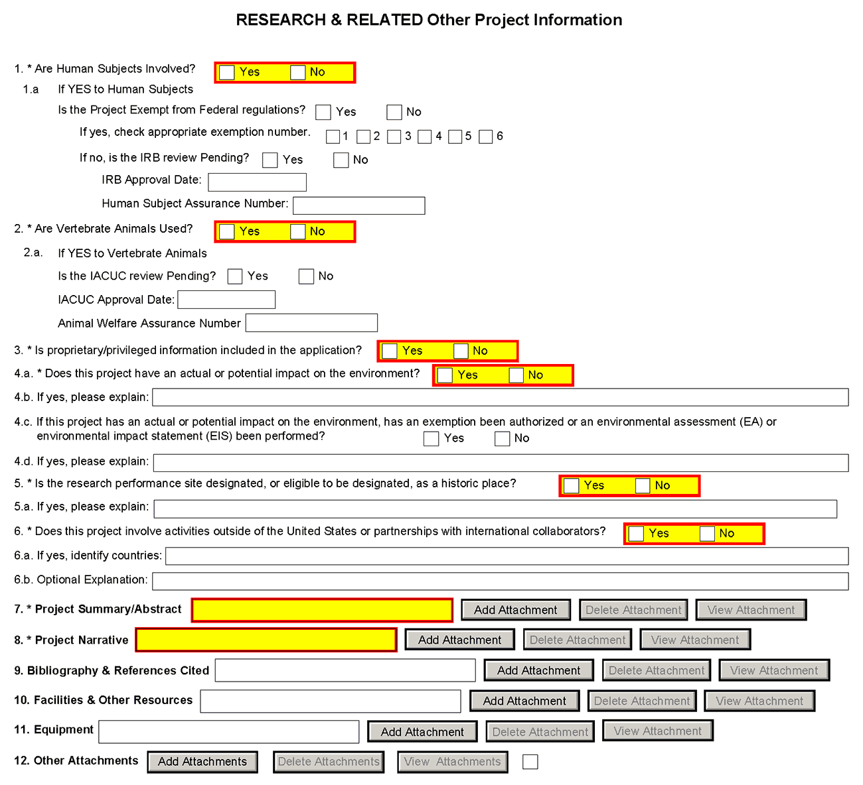
1. Are Human Subjects Involved?
If activities involving human subjects are planned at any time during the proposed project at any performance site, check yes. Check yes even if the proposed project is exempt from Regulations for the Protection of Human Subjects. If activities involving human subjects are not planned at any time during the proposed project at any performance site, select no and skip the rest of block 1. This field is required.
Applications proposing human subjects research may be required to submit additional information, forms, or attachments with the application, in accordance with NIH and PHS policies covering human subjects research. Refer to Part II, Supplemental Instructions for Preparing the Human Subjects Section of the Research Plan.
1.a. If YES to Human Subjects
Is the Project Exempt from Federal Regulations? Yes/No
Yes: If the project is exempt from Federal regulations, check Yes.
No: If the project is not exempt from Federal regulations, check No.
If yes, check appropriate exemption number 1, 2, 3, 4, 5, 6
Select the appropriate exemption number from 1, 2, 3, 4, 5, 6.
If human subject activities are exempt from Federal regulations, provide the exemption numbers corresponding to one or more of the exemption categories. The six categories of research that qualify for exemption from coverage by the regulations are defined in the Common Rule for the Protection of Human Subjects. These regulations can be found at http://www.hhs.gov/ohrp/humansubjects/guidance/45cfr46.html.
OHRP guidance states that appropriate use of Exemptions described in 45 CFR 46 should be determined by an authority independent from the investigators (http://answers.hhs.gov/ohrp/categories/1564). Institutions often designate their IRB to make this determination. Because NIH does not require IRB approval at the time of application, the exemptions designated often represent the opinion of the PD/PI, and the justification provided for the exemption by the PD/PI is evaluated during peer review.
Proposed research may include more than one research project; thus the application may include individual projects that meet the requirements for non-exempt or exempt human subjects research, or are not defined as human subjects research. Human subjects research should be designated as exempt if all of the proposed research meets the criteria for one or more of the six exemptions.
If no, is the IRB review Pending? Yes/No
If IRB review is pending, check Yes. If IRB review is not pending, check No.
IRB Approval Date
Enter the latest Institutional Review Board (IRB) approval date (if available). Leave blank if Pending.
Applicants should check “Yes” to the question “Is the IRB review Pending?” even if the IRB review/approval process has not yet begun at the time of submission. Also note that an IRB Approval Date is not required at the time of submission. This may be requested later in the pre-award cycle as a Just-In-Time requirement.
Human Subject Assurance Number
Enter the approved Federal Wide Assurance (FWA) that the applicant has on file with the Office for Human Research Protections, if available. If the applicant has a FWA number, enter the 8-digit number. Do not enter the FWA before the number.
Insert “None” if the applicant organization does not have an approved assurance on file with OHRP. In this case, the applicant organization, by the signature in item 19 on the SF424 (R&R) Cover component, is declaring that it will comply with 45 CFR part 46 and proceed to obtain a human subjects assurances (see http://www.hhs.gov/ohrp). Do not insert the human subjects assurance number of any collaborating institution in the space provided.
2. Are Vertebrate Animals Used?
If activities involving vertebrate animals are planned at any time during the proposed project at any performance site, check yes. If no, skip the rest of block 2.
Note that the generation of custom antibodies constitutes an activity involving vertebrate animals.

2.a. If YES to Vertebrate Animals
Is the IACUC review Pending?
Indicate if an Institutional Animal Care and Use Committee (IACUC) review is pending.
Yes: Indicate if an Institutional Animal Care and Use Committee (IACUC) review is pending.
No: Indicate if an Institutional Animal Care and User Committee (IACUC) review is pending. Click No, if no review is pending.
IACUC Approval Date
Enter the latest IACUC approval date (if available). Leave blank if Pending.
Animal Welfare Assurance Number
Enter the Federally approved assurance number, if available.
To determine if your organization holds an Animal Welfare Assurance, see http://grants.nih.gov/grants/olaw/olaw.htm#assur. Applicants should check “Yes” to the question “Is the IACUC review Pending?” even if the IACUC review/approval process has not yet begun at the time of submission. Also note that an IACUC Approval Date is not required at the time of submission. However, the approval date and other data may be requested later in the pre-award cycle as a Just-In-Time requirement. If the applicant organization does not have an approved Animal Welfare Assurance on file with the Office of Laboratory Animal Welfare (OLAW), NIH, enter “None” in the Animal Welfare Assurance Number field. Do not enter the Animal Welfare Assurance number of any collaborating institution. By inserting “None” at the time of submission, the applicant organization is essentially declaring that it will comply with the PHS Policy on Humane Care and Use of Laboratory Animals by submitting an Animal Welfare Assurance and verification of IACUC approval when requested to do so by OLAW.
3. Is proprietary/privileged information included in the application?
Patentable ideas, trade secrets, privileged or confidential commercial or financial information, disclosure of which may harm the applicant, should be included in applications only when such information is necessary to convey an understanding of the proposed project. If the application includes such information, check yes and clearly mark each line or paragraph on the pages containing the proprietary/privileged information with a legend similar to: "The following contains proprietary/privileged information that (name of applicant) requests not be released to persons outside the Government, except for purposes of review and evaluation. " This field is required.
4. Environmental Questions
Most NIH research grants are not expected to individually or cumulatively have a significant effect on the environment, and NIH has established several categorical exclusions allowing most applicants to answer ‘No’ to this question unless a specific FOA indicates that the National Environmental Policy Act (NEPA) applies. However, if an applicant expects that the proposed project will have an actual or potential impact on the environment, or if any part of the proposed research and/or project includes one or more of the following categorical exclusions listed below, the box marked “Yes” should be checked and an explanation provided in field 4.b.
1. The potential environmental impacts of the proposed research may be of greater scope or size than other actions included within a category.
2. The proposed research threatens to violate a Federal, State, or local law established for the protection of the environment or for public health and safety.
3. Potential effects of the proposed research are unique or highly uncertain.
4. Use of especially hazardous substances or processes is proposed for which adequate and accepted controls and safeguards are unknown or not available.
5. The proposed research may overload existing waste treatment plants due to new loads (volume, chemicals, toxicity, additional hazardous wasted, etc.)
6. The proposed research may have a possible impact on endangered or threatened species.
7. The proposed research may introduce new sources of hazardous/toxic wastes or require storage of wastes pending new technology for safe disposal.
8. The proposed research may introduce new sources of radiation or radioactive materials.
9. Substantial and reasonable controversy exists about the environmental effects of the proposed research.
4.a. Does this project have an actual or potential impact on the environment?
Indicate if this project has an actual or potential impact on the environment? Click No here if this is not the case. This field is required.
4.b. If yes, please explain
Explanation of the actual or potential impact on the environment.
4.c. If this project has an actual or potential impact on the environment, has an exemption been authorized or an Environmental Assessment (EA) or an Environmental Impact Statement (EIS) been performed?
If this project has an actual or potential impact on the environment, has an exemption been authorized or an environmental assessment (EA) or environmental impact statement (EIS) been performed? - Check yes or no.
4.d. If yes, please explain
Enter additional details about the EA or EIS. If desired, you can provide the information in a separate file, and attach by clicking Add Attachments located to the right of Step 11 - Other Attachments.
5. Is the research performance site designated, or eligible to be designated, as a historic place? Yes/No
If any research performance site is designated, or eligible to be designated, as a historic place, if Yes, check the Yes box and then provide an explanation in the box provided in 5.a. Otherwise, check the No box. This field is required.
5.a. If yes, please explain:
If you checked the Yes box indicating any performance site is designated, or eligible to be designated, as a historic place, provide the explanation here.
6. Does this project involve activities outside of the United States or partnerships with International Collaborators?
Indicate whether this project involves activities outside of the United States or partnerships with international collaborators. Check yes or no. This field is required.
Applicants to NIH and other PHS agencies must check “Yes” if the applicant organization is a foreign institution or if the project includes a foreign component. For a definition of a foreign component, see “Definitions” section of Part III: Policies, Assurances, Definitions, and Other Information.
6.a. If yes, identify countries
Enter the countries with which international cooperative activities are involved.
6.b. Optional Explanation
Enter an explanation for involvement with outside entities (optional). If desired, you can provide the information in a separate file, and attach by clicking Add Attachments located to the right of Item 11, Other Attachments.
If you have checked “Yes” to 6, applicants to the NIH and other PHS agencies must describe special resources or characteristics of the research project (e.g., human subjects, animals, disease, equipment, and techniques), whether similar research is being done in the United States and whether there is a need for additional research in this area. Provide this information in a separate file, attaching it as Item 12, Other Attachments. In the body of the text, begin the section with a heading indicating “Foreign Justification.” When saving this file, please name it “Foreign Justification” as well.
7. Project Summary/Abstract
The Project Summary must contain a summary of the proposed activity suitable for dissemination to the public. It should be a self-contained description of the project and should contain a statement of objectives and methods to be employed. It should be informative to other persons working in the same or related fields and insofar as possible understandable to a scientifically or technically literate lay reader. This Summary must not include any proprietary/confidential information. Please click the Add Attachment button to the right of this field to complete this entry.
The Project Summary is meant to serve as a succinct and accurate description of the proposed work when separated from the application. State the application’s broad, long-term objectives and specific aims, making reference to the health relatedness of the project (i.e., relevance to the mission of the agency). Describe concisely the research design and methods for achieving the stated goals. This section should be informative to other persons working in the same or related fields and insofar as possible understandable to a scientifically or technically literate reader. Avoid describing past accomplishments and the use of the first person. Finally, please make every effort to be succinct. This section must be no longer than 30 lines of text, and follow the required font and margin specifications. An abstract which exceeds this allowable length may be flagged as an error by the agency upon submission. This would require a corrective action before the application will be accepted.
As noted above, do not include proprietary, confidential information or trade secrets in the description section. If the application is funded, the Project Description will be entered into an NIH database and made available on the NIH Research Portfolio Online Reporting Tool (RePORT, available at http://report.nih.gov) and will become public information.
The attachment must be in PDF format. (See Section 2.6 for additional information on preparing attachments.)
8. Project Narrative
Provide Project Narrative in accordance with the announcement and/or agency-specific instructions. Please click the Add Attachment button to the right of this field to complete this entry.
For NIH and other PHS agencies applications, this attachment will reflect the second component of the Project Summary. The second component of the Project Summary/Abstract (i.e., “Description”) is Relevance. Using no more than two or three sentences, describe the relevance of this research to public health. In this section, be succinct and use plain language that can be understood by a general, lay audience.
A separate Research Plan component is required for NIH and other PHS agencies applications. Refer to Section 5.5, Research Plan Component, for separate file uploads and instructions.
9. Bibliography & References Cited
Provide a bibliography of any references cited in the Project Narrative. Each reference must include the names of all authors (in the same sequence in which they appear in the publication), the article and journal title, book title, volume number, page numbers, and year of publication. Include only bibliographic citations. Applicants should be especially careful to follow scholarly practices in providing citations for source materials relied upon when preparing any section of the application. To attach a document for Bibliography and References Cited, click Add Attachment.
Unless otherwise noted in an FOA, this section is required for submissions to NIH and other PHS agencies. This section (formerly “Literature Cited”) should include any references cited in the PHS 398 Research Plan component(see Section 5.5 for details on completing that component). When citing articles that fall under the Public Access Policy, were authored or co-authored by the applicant and arose from NIH support, provide the NIH Manuscript Submission reference number (e.g., NIHMS97531) or the PubMed Central (PMC) reference number (e.g., PMCID234567) for each article. If the PMCID is not yet available because the Journal submits articles directly to PMC on behalf of their authors, indicate “PMC Journal – In Process.” A list of these journals is posted at: http://publicaccess.nih.gov/submit_process_journals.htm.
Citations that are not covered by the Public Access Policy, but are publicly available in a free, online format may include URLs or PubMed ID (PMID) numbers along with the full reference (note that copies of publicly available publications are not accepted as appendix material). The references should be limited to relevant and current literature. While there is not a page limitation, it is important to be concise and to select only those literature references pertinent to the proposed research.
10. Facilities & Other Resources
This information is used to assess the capability of the organizational resources available to perform the effort proposed. Identify the facilities to be used (Laboratory, Animal, Computer, Office, Clinical and Other). If appropriate, indicate their capacities, pertinent capabilities, relative proximity and extent of availability to the project. Describe only those resources that are directly applicable to the proposed work. Provide any information describing the Other Resources available to the project (e.g., machine shop, electronic shop) and the extent to which they would be available to the project. Please click the Add Attachment button to the right of this field to complete this entry.
No special form is required but this section must be completed and attached for submissions to NIH and other PHS agencies unless otherwise noted in an FOA. Describe how the scientific environment in which the research will be done contributes to the probability of success (e.g., institutional support, physical resources, and intellectual rapport). In describing the scientific environment in which the work will be done, discuss ways in which the proposed studies will benefit from unique features of the scientific environment or subject populations or will employ useful collaborative arrangements.
For Early Stage Investigators, describe institutional investment in the success of the investigator, e.g., resources for classes, travel, training; collegial support such as career enrichment programs, assistance and guidance in the supervision of trainees involved with the ESI’s project, and availability of organized peer groups; logistical support such as administrative management and oversight and best practices training; and financial support such as protected time for research with salary support.
If there are multiple performance sites, describe the resources available at each site.
Describe any special facilities used for working with biohazards or other potentially dangerous substances. Note: Information about select agents must be described in the Research Plan, Section 11 (Select Agent Research).
11. Equipment
List major items of equipment already available for this project and, if appropriate identify location and pertinent capabilities. Please click the Add Attachment button to the right of this field to complete this entry.
12. Other Attachments
Attach a file to provide any other project information not provided above or in accordance with the announcement and/or agency-specific instruction.

Once all data have been entered use the scroll bar to scroll up. You will be returned to the Grant Application Package screen. To remove a document from the Submission box, click the document name to select it and then click the Move Form to Delete button. This will return the document to the Mandatory Documents Submission List or Optional Documents Submission List.

4.5 Senior/Key Person Profile (Expanded) Component
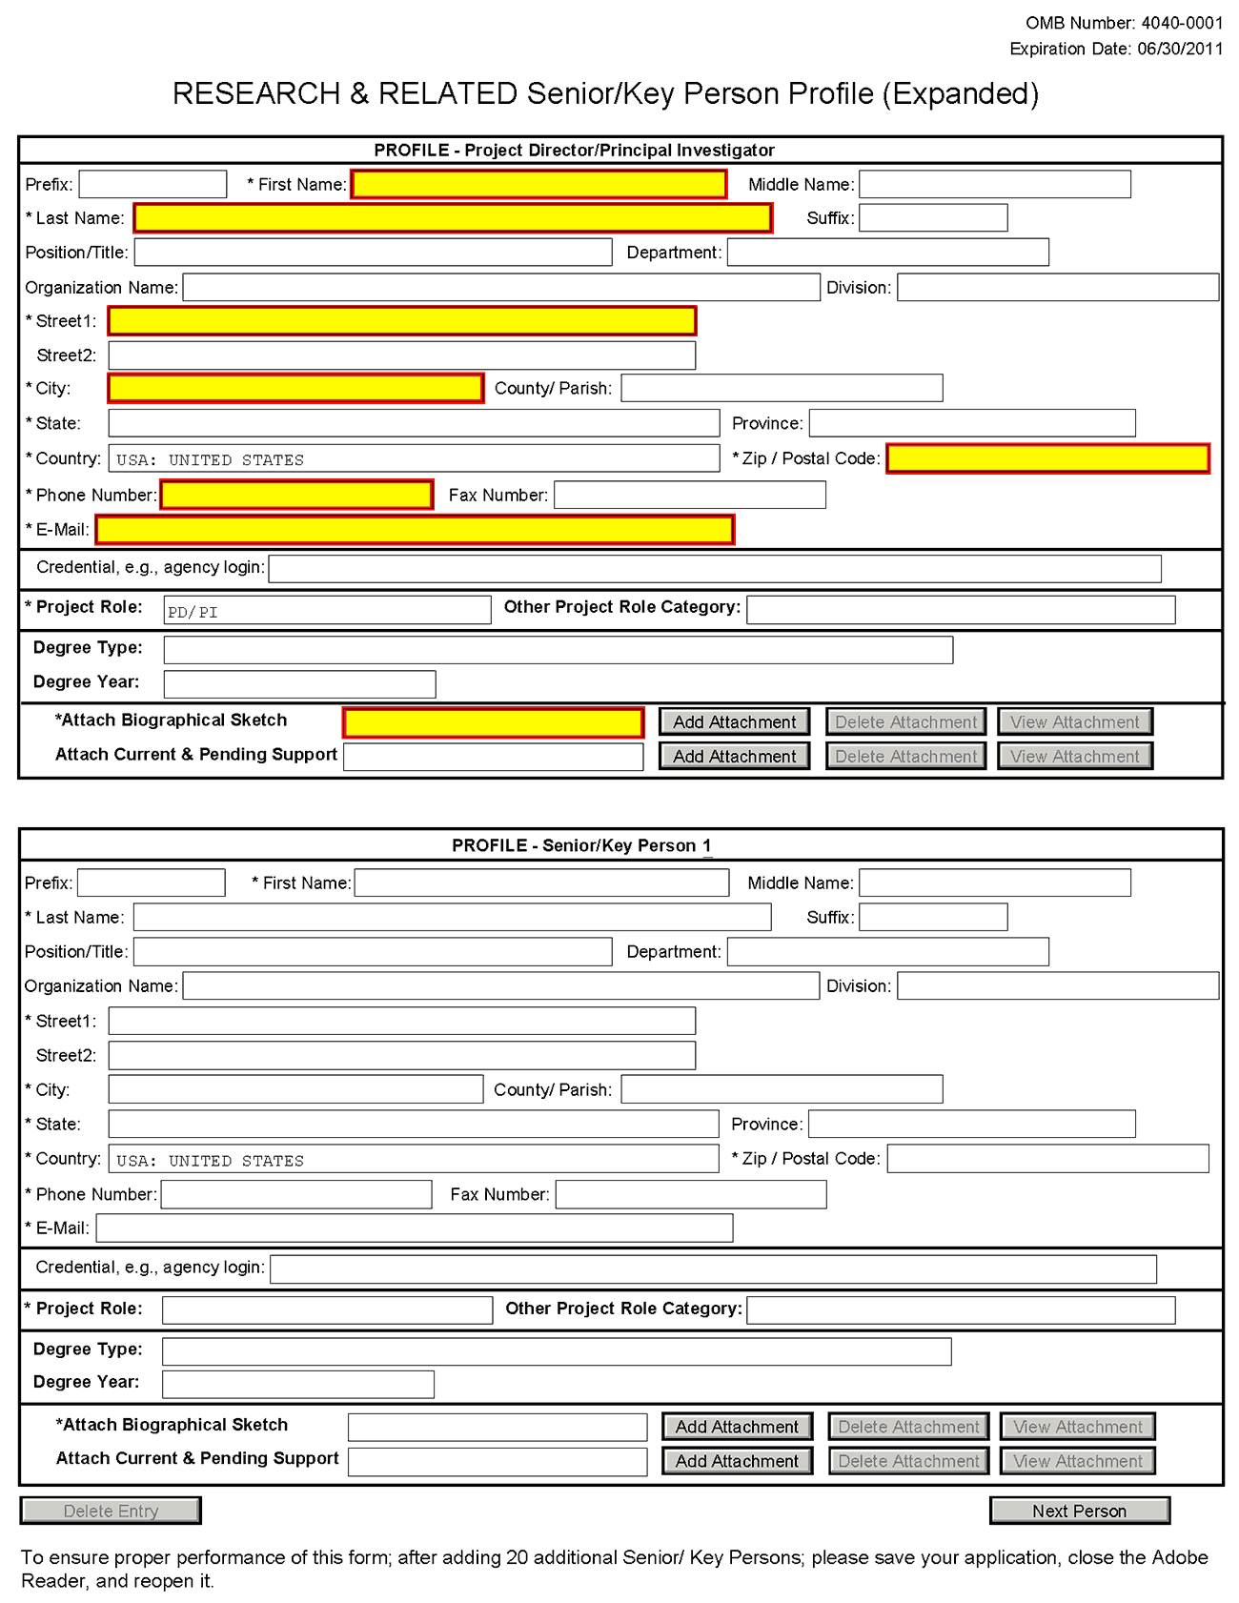
This component provides the ability to collect structured data for up to 40 senior/key persons. Data must be entered for the first 40 individuals (PD/PI + 39 others) before the Additional Senior/Key Person Form Attachments section becomes available. The information for the PD/PI continues to be pre-populated from the SF424 (R&R) Cover component. See instructions in section 4.2 Cover Component if these fields are empty. Unless otherwise specified in an agency announcement, senior/key personnel are defined as all individuals who contribute in a substantive, meaningful way to the scientific development or execution of the project, whether or not salaries are requested. Consultants should be included if they meet this definition.
Multiple PD/PIs
NIH is now accepting applications reflecting Multiple PD/PIs for all grant activity codes using the SF424 (R&R) application. When submitting an application involving Multiple PD/PIs, the Contact PI must be affiliated in the Commons with the applicant organization and should be listed as the PD/PI in the SF424 R&R Cover Component (see Section 4.2.14). That information automatically prepopulates the first senior/key person profile record in this component. For the additional PD/PIs, complete all the requested information. Each PD/PI must be assigned the PD/PI role, even those at subaward/consortium sites when applicable. (Do not use the “Co-PI” role.) For more information, please see Section 4.8 Special Instructions for Preparing Applications with a Subaward/Consortium.
Each PD/PI must also be registered in the eRA Commons and must be assigned the PI Role in that system (note other roles such as SO or IAR will not give PD/PIs the appropriate access to the application records). Each PD/PI must include their respective eRA Commons ID in the Credential field. For more information on NIH Implementation of Multiple PD/PIs, see: http://grants.nih.gov/grants/multi_pi/index.htm.
When completing the detailed budget component for either the prime organization or a subaward/consortium organization, the project roles listed in the budget component should be consistent with those used in the Senior/Key Person Component.
Profile – Program Director/Principal Investigator (PD/PI)
Field Name | Instructions
Prefix | This field is automatically populated from the SF424 (R&R). It is the prefix (e.g., Mr., Mrs., Rev.) for the name of the PD/PI.
First Name | This field is automatically populated from the SF424 (R&R). It is the first (given) name of the PD/PI. This field is required.
Middle Name | This field is automatically populated from the SF424 (R&R). It is the middle name of the PD/PI.
Last Name | This field is automatically populated from the SF424 (R&R). It is the last (family) name of the PD/PI. This field is required.
Suffix | This field is automatically populated from the SF424 (R&R). It is the suffix (e.g., Jr., Sr., PhD) for the name of the PD/PI.
Position/Title | This field is automatically populated from the SF424 (R&R). It is the title of the PD/PI.
Department | This field is automatically populated from the SF424 (R&R). It is the name of primary organizational department, service, laboratory, or equivalent level within the organization of the PD/PI.
Organization Name | This field is automatically populated from the SF424 (R&R). It is the name of the organization of the PD/PI.
Division | This field is automatically populated from the SF424 (R&R). It is the name of primary organizational division, office, or major subdivision of the PD/PI.
Street1 | This field is automatically populated from the SF424 (R&R). It is the first line of the street address of the PD/PI. This field is required.
Street2 | This field is automatically populated from the SF424 (R&R). It is the second line of the street address of the PD/PI, if applicable. This field is optional.
City | This field is automatically populated from the SF424 (R&R). It is the city for the address of the PD/PI.
County/Parish | This field is automatically populated from the SF424 (R&R). It is the county or parish for the address of the PD/PI.
State | This field is automatically populated from the SF424 (R&R). It is the state where the PD/PI is located. This field is required if the PD/PI is located in the United States.
Province | This field is automatically populated from the SF424 (R&R). It is the province where the PD/PI is located.  If “Country” is not Canada, this will be blank.
Country | This field is automatically populated from the SF424 (R&R). It is the country for the PD/PI address.
ZIP Code | This field is automatically populated from the SF424 (R&R). The nine-digit Postal Code (e.g., ZIP Code) of the PD/PI. This field is required if the PD/PI is located in the United States.
Phone Number | This field is automatically populated from the SF424 (R&R). It is the daytime phone number for the PD/PI. This field is required.
Fax Number | This field is automatically populated from the SF424 (R&R). It is the fax number for the PD/PI.
E-mail | This field is automatically populated from the SF424 (R&R). It is the e-mail address for the PD/PI. This field is required for the PD/PI.
Credential, e.g., agency login | If you are submitting to an agency (e.g., NIH) where you have an established personal profile, enter the agency ID. If not, leave blank.  For NIH and other PHS agencies, registration in the eRA Commons for all PD/PIs is required. The assigned Commons UserName (the unique name used to log into the system) for anyone assigned the PD/PI role must be entered here. This is a required field for applications submitted to NIH and other PHS agencies. Applications will not pass agency validation requirements without this field.
Project Role | Select one. Use "Other" if a category is not listed in the pick list.  Select Program Director/Principal Investigator for this person.
Other Project Role Category | Complete if you selected “Other Professional” or “Other” as a project role; e.g., Engineer, Chemist.
Degree Type | Enter the highest academic or professional degree or other credentials (e.g., RN). This is optional information.
Degree Year | Enter the year the highest degree or other credential was obtained. This is optional information.
Attach Biographical Sketch | Provide a biographical sketch for the PD/PI. Recommended information includes: Education and Training, Research and Professional Experience, Collaborators and Affiliations (for conflicts of interest), Publications and Synergistic Activities. Save the information in a single file and attach. This is required information.  Biographical sketches should follow the format described below.
Attach Current & Pending Support | Unless otherwise required in a specific FOA, do not use this attachment upload for NIH and other PHS agency submissions. This information is no longer required at the time of application submission. This information may be requested later in the pre-award cycle. When this occurs, you will be instructed to refer to Other Support in Part III, Policies, Assurances, Definitions and Other Information.
Profile – Senior/Key Person [n]
The remaining senior/key person profiles should be listed in alphabetical order. While alphabetical order is preferred, it is not required. However, be aware that these profiles will appear in the application in the order provided by the applicant. Therefore, peer reviewers will see them in the order presented. Those with a postdoctoral role should be included if they meet the definition of senior/key personnel. Also use this section to list any Other Significant Contributors (OSCs). OSCs should be listed after all senior/key persons. OSCs are individuals who have committed to contribute to the scientific development or execution of the project, but are not committing any specified measurable effort (in person months) to the project. These individuals are typically presented at “effort of zero person months” or “as needed” (individuals with measurable effort cannot be listed as Other Significant Contributors). Consultants should be included if they meet this definition.
A biosketch, including Research Support information, will be required for these individuals as this highlights their accomplishments as scientists. Reviewers use these pages to address the “investigator” review criterion. However, if an award is to be made, Other Support information will not be required or accepted since considerations of overlap do not apply to these individuals.
Should the level of involvement change for an individual listed as an OSC, the individual should be redesignated as “senior/key personnel.” This change should be made before any compensation is charged to the project.
After providing data for each individual senior/key person, click the Next Person button at the bottom of the form to enter data for the next senior/key person. Continue in this manner until data has been provided for up to 40 senior/key persons. To ensure proper performance of this form, after adding 20 additional senior/key persons please save your application, close the Adobe reader, and reopen it. For applications involving more than 40 senior/key persons, the “Additional Senior/Key Person Profiles” fields will become available once data for the first 40 senior/key persons has been provided.

Field Name | Instructions
Prefix | Enter the prefix (e.g., Mr., Mrs., Rev.) for the name of the senior/key person.
First Name | Enter the first (given) name of the senior/key person. This field is required.
Middle Name | Enter the middle name of the senior/key person, if applicable.
Last Name | Enter the last (family) name of the senior/key person. This field is required.
Suffix | Enter the suffix (e.g., Jr., Sr., Ph.D.) for the name of the senior/key person.
Position/Title | Enter the title of the senior/key person.
Department | Enter the name of primary organizational department, service, laboratory, or equivalent level within the organization of the senior/key person.
Organization Name | Enter the name of organization of the senior/key person.  This is a required field for applications submitted to NIH and other PHS agencies.
Division | Enter the name of primary organizational division, office, or major subdivision of the senior/key person.
Street1 | Enter first line of the street address for the senior/key person. This field is required.
Street2 | Enter second line of the street address for the senior/key person, if applicable. This field is optional.
City | Enter the city for the address of the senior/key person. This field is required.
County/Parish | Enter the county or parish for the address of the senior/key person.
State | Enter the State where the senior/key person is located. This field is required if the senior/key person is located in the United States.
Province | Enter the Province where the senior/key person is located.  If “Country” is not Canada, please leave blank.
Country | Select the country for the senior/key person address. This field is required.
ZIP Code | Enter the nine-digit Postal Code (e.g., ZIP Code) of the senior/key person address. This field is required if the senior/key person is located in the United States.
Phone Number | Enter the daytime telephone number for the senior/key person. This field is required.
Fax Number | Enter the fax number for the senior/key person.
E-mail | Enter the e-mail address for the senior/key person. This field is required for the senior/key person.
Credential, e.g., agency login | If you are submitting to an agency (e.g., NIH) where you have an established personal profile, enter the agency ID. If not, leave blank.  For NIH and other PHS agencies, registration in the eRA Commons for all PD/PIs is required. The assigned Commons UserName (the unique name used to log into the system) for anyone assigned the PD/PI role must be entered here. This is a required field for applications submitted to NIH and other PHS agencies. Applications will not pass agency validation requirements without this field.  Note for applications reflecting Multiple PD/PIs, the Commons UserName must be provided for all individuals assigned the PD/PI Role.
Project Role | Select one. Use "Other" if a category is not listed in the pick list.  For applications reflecting Multiple PD/PIs, all such individuals must be assigned the PD/PI role, even those at organizations other than the applicant organization. The role of “Co-PD/PI” is not currently used by NIH and other PHS agencies. Assigning an individual(s) the role of "Co-PD/PI" will not identify the application as a Multiple PD/PI application. If applicants wish to use a different role, select “Other” for the Project Role field and then insert the appropriate role descriptor in the Other Project Role Category field.  If including individuals classified as “Other Significant Contributors (OSCs),” use the “Other” category and indicate “Other Significant Contributor” as the role in the “Other Project Role Category.” OSCs should be listed last after all other senior/key persons have been listed.
Other Project Role Category | Complete if you selected “Other Professional” or “Other” as a project role; e.g., Engineer, Chemist.
Degree Type | Enter the highest academic or professional degree or other credentials (e.g., RN). This is optional information.
Degree Year | Enter the year the highest degree or other credential was obtained. This is optional information.
Attach Biographical Sketch | Provide a biographical sketch for the senior/key person. Recommended information includes: Education and Training, Research and Professional Experience, Collaborators and Affiliations (for conflicts of interest), Publications and Synergistic Activities. Save the information in a single file and attach here. This field is required.  Biographical sketches should follow the format described below.
Attach Current & Pending Support | Unless otherwise required in a specific FOA, do not use this attachment upload for NIH and other PHS agency submissions. This information is no longer required at the time of application submission. This information may be requested later in the pre-award cycle. When this occurs, refer to Other Support in Part III, Policies, Assurances, Definitions, and Other Information.

Additional Senior/Key Person Profile(s)
If more than forty senior/key person profiles are proposed, enter the information in a separate file and attach it here.
A sample Additional Senior/Key Person Profiles format page for greater than 40 profiles is found under “Additional Format Pages” at: http://grants.nih.gov/grants/funding/424/index.htm.
Additional Biographical Sketch(es) (Senior/Key Person)
Provide a biographical sketch for each senior/key person. Recommended information includes: Education and Training, Research and Professional Experience, Collaborators and Affiliations (for conflicts of interest), Publications and Synergistic Activities. Save the information in a single file and attach here.
Biographical Sketches should follow the format described below.

Additional Current and Pending Support(s)
Provide a list of all current and pending support for the PD/PI and each senior/key person (even if they receive no salary support from the project(s) for ongoing projects and pending proposals). Show the total award amount for the entire award period (including indirect costs) as well as the number of person months per year to be devoted to the project by the senior/key person, regardless of source of support. Concurrent submission of a proposal to other organizations will not prejudice its review.
Unless otherwise required in a specific FOA, do not use this attachment upload for NIH and other PHS agency submissions. This information is no longer required at the time of application submission. This information may be requested later in the pre-award cycle. When this occurs, refer to Other Support in Part III, Policies, Assurances, Definitions, and Other Information.
Additional NIH and Other PHS Agencies Instructions for a Biographical Sketch
Use the sample format on the Biographical Sketch Format Page to prepare this section for all (modular and other) grant applications. Include biographical sketches of all senior/key personnel and Other Significant Contributors. The Biographical Sketch may not exceed four pages per person. This 4-page limit includes the table at the top of the first page. See the sample of a completed Biographical Sketch.
If the individual is registered in the eRA Commons, include the Commons User Name. This data item is required for the PD/PI but is currently optional for all other senior/key persons. In other federal forms this information is referred to as “Credential, e.g., agency login.” For information on the eRA Commons, see https://commons.era.nih.gov/commons/index.jsp.
Complete the educational block at the top of the format page beginning with baccalaureate or other initial professional education, such as nursing, and include postdoctoral training, separately referencing residency training when applicable. For each entry provide the name and location of the institution; the degree received (if applicable); the month and year the degree was received, and the field of study. For residency entries, the field of study section should reflect the area of residency.
Following the educational block, complete sections A, B, C, and D as described below.
A. Personal Statement. Briefly describe why your experience and qualifications make you particularly well-suited for your role (e.g., PD/PI, mentor, participating faculty) in the project that is the subject of the application. Within this section you may, if you choose, briefly describe factors such as family care responsibilities, illness, disability, and active duty military service that may have affected your scientific advancement or productivity.
B. Positions and Honors. List in chronological order previous positions, concluding with your present position. List any honors. Include present membership on any Federal Government public advisory committee.
C. Selected Peer-reviewed Publications. NIH encourages applicants to limit the list of selected peer-reviewed publications or manuscripts in press to no more than 15. Do not include manuscripts submitted or in preparation. The individual may choose to include selected publications based on recency, importance to the field, and/or relevance to the proposed research. When citing articles that fall under the Public Access Policy, were authored or co-authored by the applicant and arose from NIH support, provide the NIH Manuscript Submission reference number (e.g., NIHMS97531) or the PubMed Central (PMC) reference number (e.g., PMCID234567) for each article. If the PMCID is not yet available because the Journal submits articles directly to PMC on behalf of their authors, indicate “PMC Journal – In Process.” A list of these journals is posted at: http://publicaccess.nih.gov/submit_process_journals.htm. Citations that are not covered by the Public Access Policy, but are publicly available in a free, online format may include URLs or PubMed ID (PMID) numbers along with the full reference (note that copies of publicly available publications are not acceptable as appendix material).
D. Research Support. List both selected ongoing and completed (during the last three years) research projects (Federal or non-Federal support). Begin with the projects that are most relevant to the research proposed in this application. Briefly indicate the overall goals of the projects and responsibilities of the senior/key person identified on the Biographical Sketch. Do not include number of person months or direct costs.
Don’t confuse “Research Support” with “Other Support.” Though they sound similar, these parts of the application are very different. As part of the biosketch section of the application, “Research Support” highlights your accomplishments, and those of your colleagues, as scientists. This information will be used by the reviewers in the assessment of each individual’s qualifications for a specific role in the proposed project, as well as to evaluate the overall qualifications of the research team. In contrast, “Other Support” information is required for all applications that are selected to receive grant awards. NIH staff will request complete and up-to-date “other support” information from you after peer review. This information will be used to check that the proposed research has not already been Federally-funded.

Once all data have been entered use the scroll bar to scroll up. You will be returned to the Grant Application Package screen. To remove a document from the Submission box, click the document name to select it and then click the Move Form to Delete button. This will return the document to the Mandatory Documents Submission List or Optional Documents Submission List.

4.6 Selecting the Appropriate Budget Component
The application forms package associated with most NIH funding opportunities includes two optional budget components—(1) R&R Budget Component; and, (2) PHS 398 Modular Budget Component. NIH applications will include either the R&R Budget Component or the PHS 398 Modular Budget Component, but not both. (Note AHRQ does not accept modular budgets.)
To determine which budget component to use for NIH applications, consult the modular budget and foreign grantee guidelines below. Additional guidance may also be provided in the specific funding opportunity announcement.
Modular Budget Guidelines. Modular budgets are applicable to certain research grant applications requesting $250,000 or less per year for direct costs. Note, consortium/contractual F&A costs are not factored into the direct cost limit. Consortium F&A costs may be requested in addition to the $250,000 limit. Modular budgets are simplified; therefore, detailed categorical information is not to be submitted with the application. The modular budget is applicable only to R01, R03, R15, R21, and R34 applications.
Instructions for completing a Modular Budget Component can be found in Section 5.4. Instructions for completing the R&R Budget Component are provided in the next section.
Foreign Grantee Budget Guidelines. All competing (new, renewal, resubmission, and revision) grant applications from foreign (non-U.S.) institutions must include only detailed (non-modular) budgets. For additional information, see NIH Guide Notice NOT-OD-06-096, http://grants.nih.gov/grants/guide/notice-files/NOT-OD-06-096.html.
Applications from foreign (non-U.S.) institutions submitted via Grants.gov must follow the Research & Related Budget Component instructions and must complete and submit the Research & Related Budget forms. Applications from foreign organizations must request budgets in U.S. dollars.

4.7 R&R Budget Component
The R&R Budget component includes three separate data entry screens: (1) Sections A and B; (2) Sections C through E; and (3) Sections F through K. To navigate between the various screens, use the Previous and Next buttons at the top of the form or use the scroll bar on the side of the screen. Complete the R&R Budget component following the instructions provided. You must complete a separate detailed budget for each year of support requested. The form will generate a cumulative budget for the total project period. You must complete all the required information (i.e., those fields that are highlighted in yellow, outlined in red and noted with an “*”) before the Next Period button is activated. If no funds are requested for a required field, enter “0.”
While the dollar fields allow cents to be entered, all dollar fields should be presented in whole numbers. Please round to the nearest whole number.
NIH and other PHS agencies use the concept of person months as a metric for determining percent of effort. To assist applicants unfamiliar with this concept, resources are available on the web at: http://grants.nih.gov/grants/policy/person_months_faqs.htm. Frequently asked questions and a conversion calculator are available.
If funds are being requested for more than one budget period, click the Next Period button at the top of the third budget screen (Sections F through K) to navigate to screens for the next budget period.
Revision (Supplemental) Application. For a “Revision” (Supplemental) application, show only those items for which additional funds are requested. If the initial budget period of the supplementation application is less than 12 months, prorate the personnel costs and other appropriate items of the detailed budget.

4.7.1 Section A and B
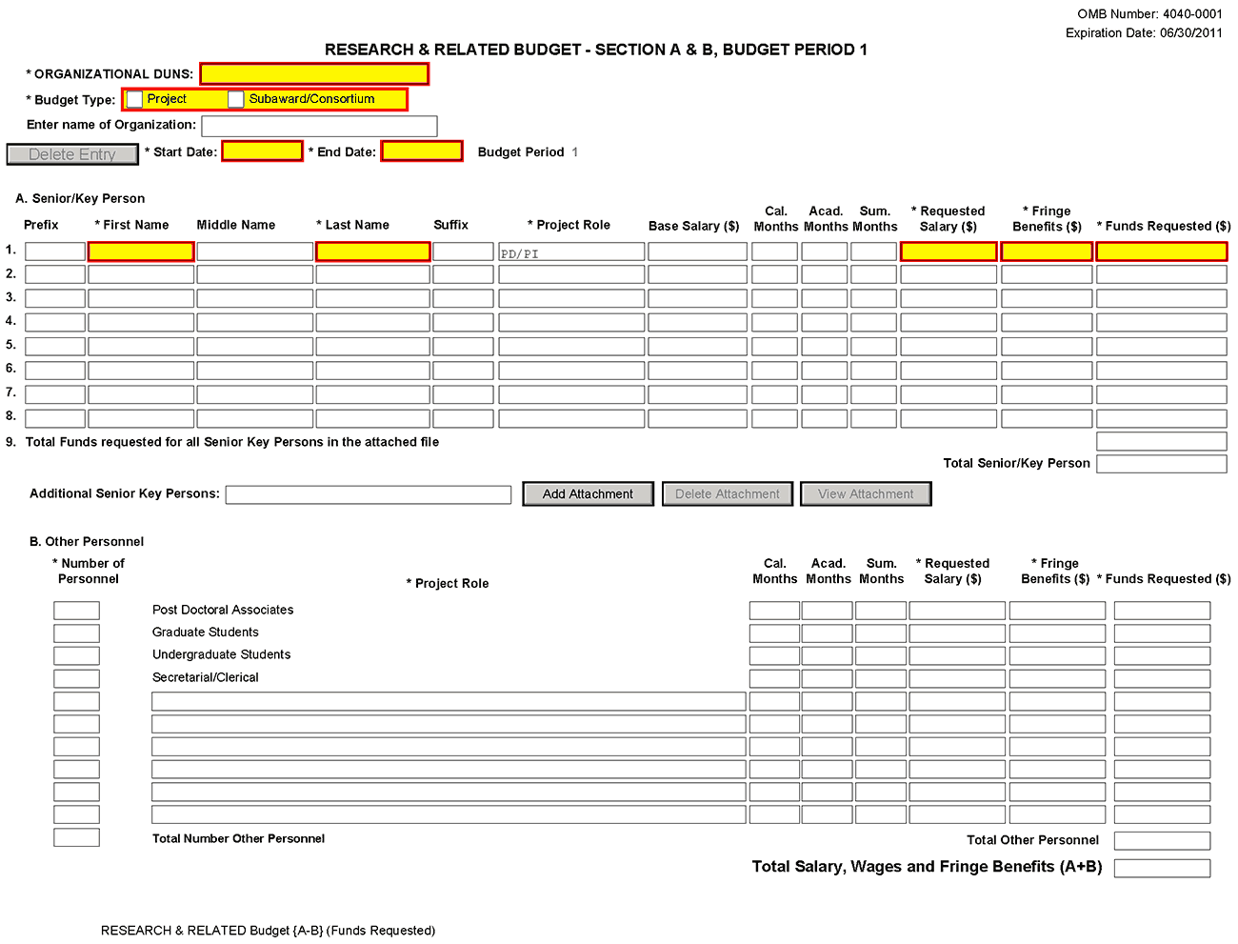
Organizational DUNS
Enter the DUNS or DUNS+4 number of the applicant organization. For project applicant, this field is pre-populated from the R&R SF424 Cover Page. For subaward applicants, this field is a required enterable field.
Budget Type
Project, Subaward/Consortium: Check the appropriate block.
Project: The budget requested for the primary applicant organization.
Subaward/Consortium: The budget requested for subawardee/consortium organization(s). Note, separate budgets are required only for subawardee/consortium organizations that perform a substantive portion of the project.
If creating Subaward Budget, use the R&R Subaward Budget Attachment and attach as a separate file on the R&R Budget Attachment(s) form.
If you are preparing an application that includes a subaward/consortium, see Section 4.8 Special Instructions for Preparing Applications with a Subaward/Consortium.
Enter name of Organization
Pre-populated from the R&R SF424. Enter the name of the organization.
Delete Entry
Reset entries on page.
Start Date
Pre-populated from the R&R SF424. Enter the requested/proposed start date of each budget period. This field is required.
End Date
Enter the requested/proposed end date of each budget period. This field is required.
Budget Period
Identify the specific budget period (for example, 1, 2, 3, 4, 5). If submitting through Grants.gov, the system will automatically generate a cumulative budget for the total project period. This is a required field.
(If the Reset Entries button is pressed, please navigate to previous year to enable the submission of the form.)
A. Senior/Key Person
This section should include the names of all senior/key persons at the applicant organization who are involved on the project in a particular budget year. Include all collaborating investigators, and other individuals meeting the senior/key person definition if they are from the applicant organization. Details of collaborators at other institutions will be provided in the Subaward budget for each subaward/consortium organization. Personnel listed as Other Significant Contributors who are not committing any specific measurable effort to the project should not be included in the Personnel section of the budget since no associated salary and/or fringe benefits should be requested for their contribution. Consultants designated as senior/key persons in the Senior/Key Person Profile Component can be included in Budget Section A only if they are also employees of the applicant organization. Otherwise, consultant costs should be included in F.3 Consultant Services.
Field Name | Instructions
Prefix | Pre-populated from the R&R SF424. Enter the prefix (e.g., Mr., Mrs., Rev.) for the name of each senior/key person.
First Name | Pre-populated from the R&R SF424. Enter the first (given) name of each senior/key person. This field is required.
Middle Name | Pre-populated from the R&R SF424. Enter the middle name of each senior/key person, if applicable.
Last Name | Pre-populated from the R&R SF424. Enter the last (family) name of each senior/key person. This field is required.
Suffix | Pre-populated from the R&R SF424. Enter the suffix (e.g., Jr., Sr., PhD) of each senior/key person.
Project Role | Identify the project role of each senior/key person in this section. This section could also include such roles as Co-PD/PI, Postdoctoral Associates, and Other Professionals.  The role of the PD/PI is auto-populated in the 01 year budget only. Do not change or edit this field for the PD/PI. For future year budgets, use consistent terminology.  Roles should correspond to the roles included on the Senior/Key Person Profile (Expanded) Component.
Base Salary ($) | Enter the annual compensation paid by the employer for each senior/key person. This includes all activities such as research, teaching, patient care, or other. You may choose to leave this column blank.  An applicant organization may choose to leave this blank; however, PHS staff will request this information prior to award.
Cal. Months | Identify the number of months devoted to the project for each senior/key person (i.e., calendar, academic, summer).  If effort does not change throughout the year, it is OK to use only the calendar months column. However, you may use both academic and summer months columns if your institutional business process requires noting each separately even if effort remains constant. If effort varies between academic and summer months, leave the calendar months column blank and use only the academic and summer months columns. Please use either calendar months OR a combination of academic and summer months.
Acad. Months | Identify the number of months devoted to the project for each senior/key person (for example, calendar, academic, summer).  If your institution does not use a 9-month academic year, indicate your institution’s definition of academic year in the budget justification.
Sum. Months | Identify the number of months devoted to the project for each senior/key person (for example, calendar, academic, summer).  If your institution does not use a 3-month summer period, indicate your institution’s definition of summer in the budget justification.
Requested Salary ($) | Regardless of the number of months being devoted to the project, indicate only the amount of salary being requested for this budget period for each senior/key person. This field is required.  Some PHS grant programs are currently subject to a legislatively imposed salary limitation. Any adjustment for salary limits will be made at the time of award. For guidance on current salary limitations, see the Salary Cap Summary on the NIH grants Web site or contact your office of sponsored programs.  NIH grants also limit the compensation for graduate students. Compensation includes salary or wages, fringe benefits and tuition remission. While actual institutional-based compensation should be requested and justified, this may be adjusted at the time of the award. For more guidance on this policy, see: http://grants.nih.gov/grants/ guide/notice-files/NOT-OD-02-017.html.
Fringe Benefits ($) | Enter applicable fringe benefits, if any, for each senior/key person.
Funds Requested ($) | Enter the requested salary and fringe benefits for each senior/key person. This field is required.
Total Funds requested for all senior/key persons in the attached file | Enter the total funds requested for all senior/key persons. This is required information.
Total Senior/Key Persons | The total funds requested for all senior/key persons.
Additional Senior/Key Persons | If funds are requested for more than eight senior/key persons, include all pertinent budget information as identified in this section and attach as a file here. Enter the total funds requested for all additional senior/key persons in line 9 of Section A. This attachment is required if funds are entered in line 9 of Section A.  Use the same format as the budget component and include all required information.

Special Instructions: Joint University and Department of Veterans Affairs (V.A.) Appointments
Individuals with joint university and V.A. appointments may request the university’s share of their salary in proportion to the effort devoted to the research project. The individual’s salary with the university determines the base for computing that request. Signature by the institutional official on the application certifies that: (1) the individual is applying as part of a joint appointment specified by a formal Memorandum of Understanding between the university and the V.A.; and (2) there is no possibility of dual compensation for the same work, or of an actual or apparent conflict of interest regarding such work. Additional information may be requested by the awarding components.
B. Other Personnel
Field Name | Instructions
Number of Personnel | For each project role category identify the number of personnel proposed.  List any additional project role(s) in the blank(s) provided, e.g., Engineer, IT Professionals, etc.  For all Postdoctoral Associates and Graduate Students not already named in Section A. Senior/Key Person, individually list names, roles (e.g., PostDoc or Graduate Student), associated months, and salary & fringe benefits requested in the Budget Justification.
Project Role | If Project Role is other than Post Doctoral Associates, Graduate Students, Undergraduate Students, or Secretarial/Clerical, enter the appropriate project role (for example, Engineer, IT Professional, etc.) in the blanks.  Do not include consultants in this section. Consultants are included below in Section F. Other Direct Costs.
Cal. Months | Identify the number of months devoted to the project in the applicable box for each project role category (i.e., calendar, academic, summer).
Acad. Months | Identify the number of months devoted to the project in the applicable box for each project role category (i.e., calendar, academic, summer).  If your institution does not use a 9-month academic year, indicate your institution’s definition of academic year in the budget justification.
Sum. Months | Identify the number of months devoted to the project in the applicable box for each project role category (i.e., calendar, academic, summer).  If your institution does not use a 3-month summer period, indicate your institution’s definition of summer in the budget justification.
Requested Salary ($) | Regardless of the number of months being devoted to the project, indicate only the amount of salary/wages being requested for each project role.  Some PHS grant programs are currently subject to a legislatively imposed salary limitation. Any adjustment for salary limits will be made at the time of award. For guidance on current salary limitations, see the Salary Cap Summary on the NIH grants Web site or contact your office of sponsored programs.  NIH grants also limit the compensation for graduate students. Compensation includes salary or wages, fringe benefits and tuition remission. While actual institutional-based compensation should be requested and justified, this may be adjusted at the time of the award. For more guidance on this policy, see: http://grants.nih.gov/grants/ guide/notice-files/NOT-OD-02-017.html.
Fringe Benefits ($) | Enter applicable fringe benefits, if any, for this project role category.
Funds Requested | Enter requested salary/wages & fringe benefits for each project role.
Total Number of Other Personnel | This total will auto-calculate. Total Salary, Wages and Fringe Benefits (A+B).
Total Other Personnel | Total Funds requested for all other Personnel.
Total Salary, Wages and Fringe Benefits (A+B) | Total Funds requested for all senior/key persons and all Other Personnel. This total will auto-calculate.
To navigate to the next page (Sections C through E), click the Next button at the top of the form or use the scroll bar on the left-hand side of the screen.

4.7.2 Sections C through E
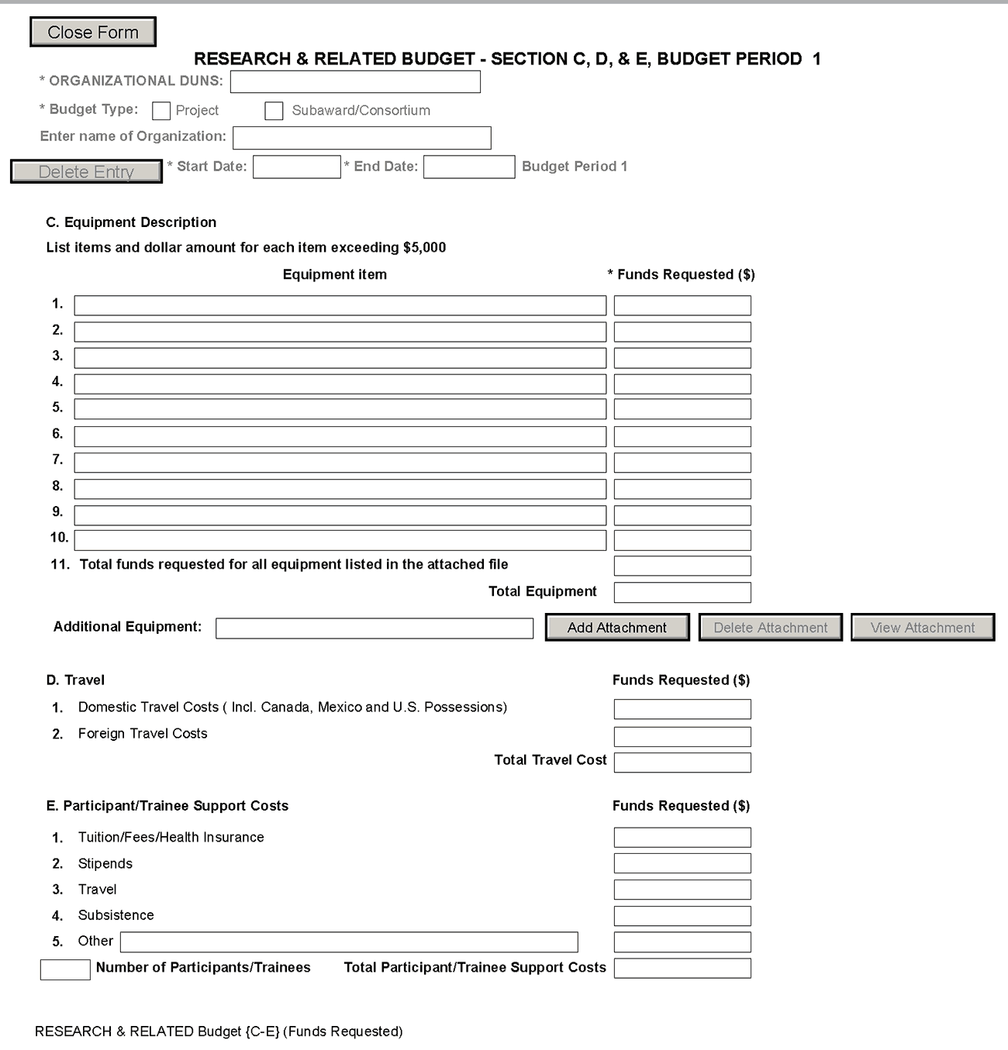
The information for Organizational DUNS, Budget Type, Name of Organization, and Start and End Dates is automatically filled in based on the information entered on the first budget screen. To edit this information, return to the initial budget screen (Sections A and B) by clicking the Previous button.
C. Equipment Description
List of items and dollar amount for each item exceeding $5,000.
Field Name | Instructions
Equipment Item | Equipment is defined as an item of property that has an acquisition cost of $5,000 or more (unless the organization has established lower levels) and an expected service life of more than one year. List each item of equipment separately and justify each in the budget justification section. Allowable items ordinarily will be limited to research equipment and apparatus not already available for the conduct of the work. General-purpose equipment, such as a personal computer, is not eligible for support unless primarily or exclusively used in the actual conduct of scientific research.
Funds Requested | List the estimated cost of each item of equipment including shipping and any maintenance costs and agreements. This is required information.
Total funds requested for all equipment listed in the attached file | Total funds requested for all equipment listed in the attached file. Dollar amount for each item should exceed $5000.
Total Equipment | Total Funds requested for all equipment.
Additional Equipment | If the space provided cannot accommodate all the equipment proposed, attach a file in the block provided. List each additional item and the funds requested. For all additional items in the attached file, list the total funds requested on line 11 of this section.
D. Travel
Field Name | Instructions
Domestic Travel Costs (Incl. Canada, Mexico, and U.S. Possessions) | Identify the total funds requested for domestic travel. Domestic travel includes Canada, Mexico, and U.S. possessions. In the budget justification section, include the purpose, destination, dates of travel (if known), and number of individuals for each trip. If the dates of travel are not known, specify estimated length of trip (e.g., 3 days).
Foreign Travel Costs | Enter the total funds requested for foreign travel. Foreign travel includes any travel outside of North America and/or U.S. possessions. In the budget justification section, include the purpose, destination, dates of travel (if known) and number of individuals for each trip. If the dates of travel are not known, specify estimated length of trip (e.g., 3 days).
Total Travel Cost | Total Funds requested for all travel.
E. Participant/Trainee Support Costs
Unless specifically stated otherwise in an announcement, NIH and other PHS agencies applicants should leave blank Section E. Note: Tuition remission for graduate students should continue to be included in Section F. Other Direct Costs when applicable.
Field Name | Instructions
Tuition/Fees/Health Insurance | List total funds requested for Participant/Trainee tuition / fees / health insurance.
Stipends | List total funds requested for Participant/Trainee stipends.
Travel | List total funds requested for Participant/Trainee travel.
Subsistence | List total funds requested for Participant/Trainee subsistence.
Other | Describe any other participant trainee funds requested. List total funds requested for any other Participant/Trainee costs described.
Number of Participants/Trainees | List total number of proposed Participants/Trainees.
Total Participant/Trainee Support Costs | Total Funds requested for all trainee costs.

4.7.3 Sections F through K
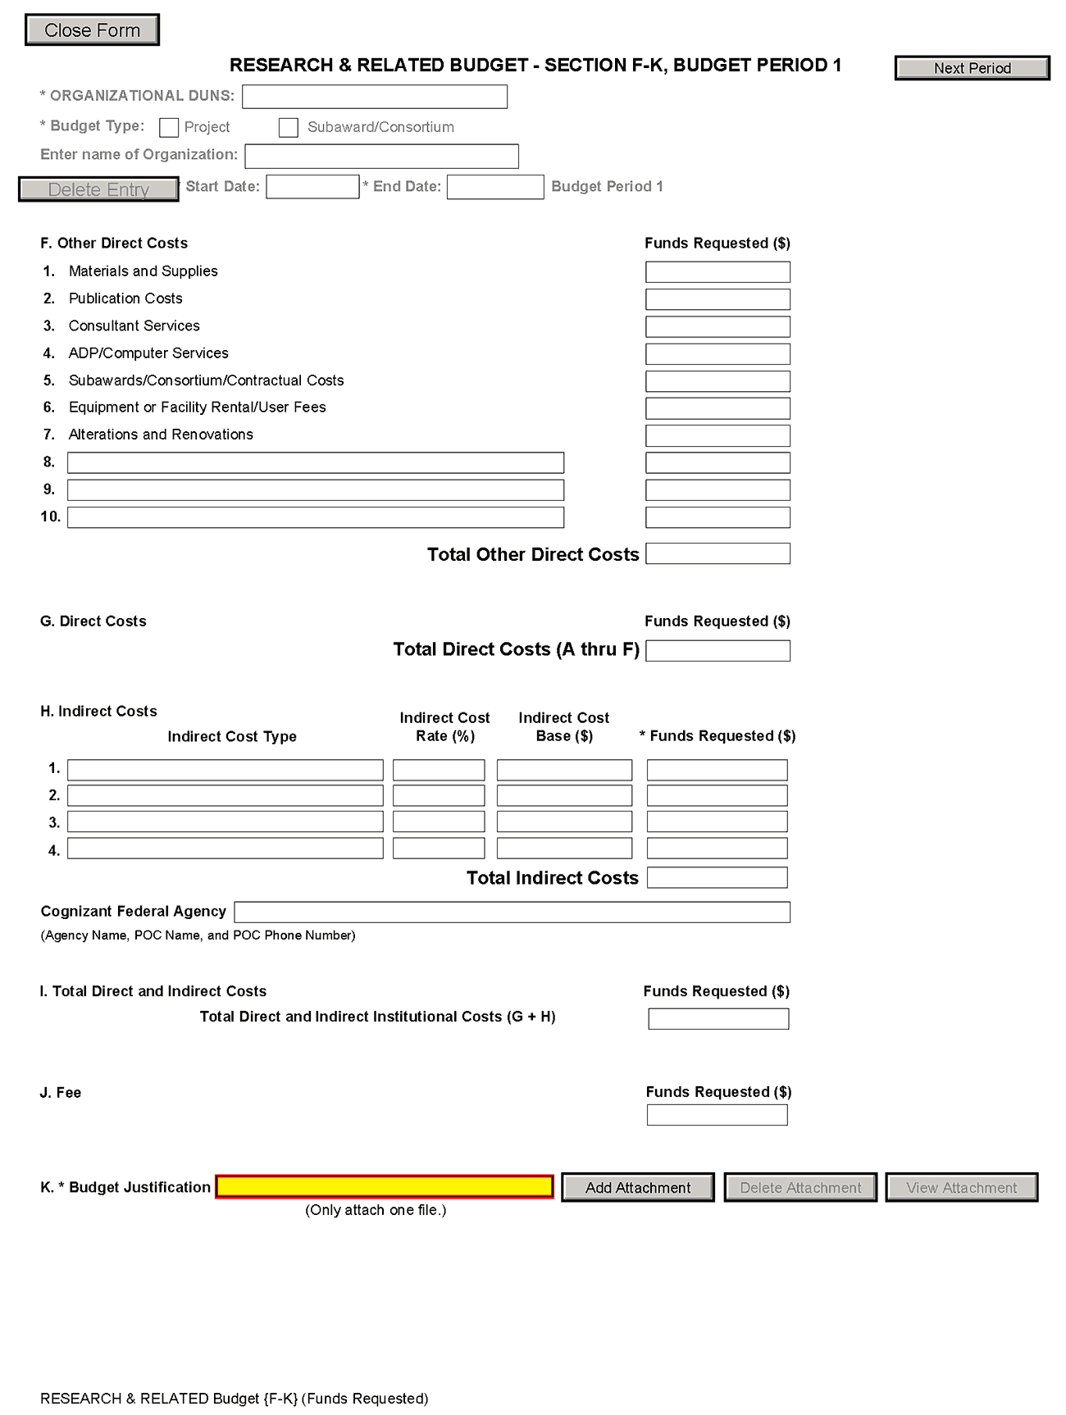
The information for Organizational DUNS, Budget Type, Name of Organization, and Start and End Dates is automatically filled in based on the information entered on the first budget screen. To edit this information, return to the initial budget screen (Sections A and B) by clicking the Previous button.
Special Instructions: Foreign Organizations (Non-domestic [non-U.S. Entities])
Foreign institutions and international organizations may request funds for limited F&A costs (8 percent of modified total direct costs less equipment) to support the costs of compliance with DHHS and NIH requirements including, but not limited to, protection of human subjects, animal welfare, invention reporting, financial conflict of interest and research misconduct.
Foreign organizations may not include any charge-back of customs and import fees, such as consular fees, customs surtax, value-added taxes (VAT) and other related charges.
F. Other Direct Costs
Field Name | Instructions
1. Materials and Supplies | List total funds requested for materials and supplies. In the budget justification, indicate general categories such as glassware, chemicals, animal costs, including an amount for each category. Categories less than $1,000 are not required to be itemized.
2. Publication Costs | List the total publication funds requested. The proposal budget may request funds for the costs of documenting, preparing, publishing, or otherwise making available to others the findings and products of the work conducted under the award. In the budget justification include supporting information.
3. Consultant Services | List the total costs for all consultant services. In the budget justification, identify each consultant, the services he/she will perform, total number of days, travel costs, and the total estimated costs.  In the budget justification also provide the names and organizational affiliations of all consultants, other than those involved in consortium/contractual arrangements. Include consultant physicians in connection with patient care and persons who are confirmed to serve on external monitoring boards or advisory committees to the project. Describe the services to be performed.
4. ADP/Computer Services | List total funds requested for ADP/computer services. The cost of computer services, including computer-based retrieval of scientific, technical and education information may be requested. In the budget justification, include the established computer service rates at the proposing organization if applicable.
5. Subawards/Consortium/ Contractual Costs | List total funds requested for 1) all subaward/consortium organization(s) proposed for the project and 2) any other contractual costs proposed for the project.  This line item should include both direct and indirect costs for all subaward/consortium organizations. Contractual costs for support services, such as the laboratory testing of biological materials, clinical services, or data processing, are occasionally sufficiently high to warrant a categorical breakdown of costs. When this is the case, provide detailed information as part of the budget justification.
6. Equipment or Facility Rental/User Fees | List total funds requested for equipment or facility rental/user fees. In the budget justification, identify each rental user fee and justify.
7. Alterations and Renovations | List total funds requested for alterations and renovations. In the budget justification, itemize by category and justify the costs of alterations and renovations including repairs, painting, removal or installation of partitions, shielding, or air conditioning. Where applicable, provide the square footage and costs.  Under certain circumstances the public policy requirements that apply to construction activities may also apply to A&R activities. Please refer to the NIH Grants Policy Statement section on “Construction Grants – Public Policy Requirements and Objectives” for more information.  Note, costs for any Alterations and Renovations (A&R) were previously unallowable on applications from foreign institutions, international organizations and domestic applications with foreign subawards. However, an HHS policy change now allows for minor A&R (<$500,000) on these applications.  When requesting minor A&R costs under this policy, please provide detailed information on the planned A&R in the budget justification.
8-10 Other | Add text to describe any “other” direct costs not requested above. Use the budget justification to further itemize and justify.  List total funds requested for items 8-10 “Other.”  Use lines 8-10 for such costs as patient care and tuition remission. If requesting patient care costs, request inpatient and outpatient costs separately using lines 8 and 9.
Total Other Direct Costs | Total Funds requested for all other direct costs.

Special Instructions for Patient Care Costs
If inpatient and/or outpatient costs are requested, provide the names of any hospitals and/or clinics and the amounts requested for each in the budget justification.
State whether each hospital or clinic has a currently effective DHHS-negotiated research patient care rate agreement and, if not, what basis is used for calculating costs. If an applicant does not have a DHHS-negotiated rate, the PHS awarding component can approve a provisional rate. Indicate, in detail, the basis for estimating costs in this category, including the number of patient days, estimated cost per day, and cost per test or treatment. If both inpatient and outpatient costs are requested, provide information for each separately. If multiple sites are to be used, provide detailed information by site.
Include information regarding projected patient accrual for the project/budget periods and relate this information to the budget request for patient care costs. If patient accrual is anticipated to be lower at the start or during the course of the project, plan budget(s) accordingly.
Provide specific information regarding anticipated sources of Other Support for patient care costs, e.g., third party recovery or pharmaceutical companies. Include any potential or expected utilization of General Clinical Research Centers.
G. Total Direct Costs (A through F)
Total Funds requested for all direct costs.
H. Indirect Costs
Field Name | Instructions
Indirect Cost Type | Indicate the type of cost (e.g., Salary & Wages, Modified Total Direct Costs, or Other [explain]). Also indicate if Off-site. If more than one rate/base is involved, use separate lines for each. If you do not have a current indirect rate(s) approved by a Federal agency, indicate, “None—will negotiate” and include information for a proposed rate. Use the budget justification if additional space is needed.
Indirect Cost Rate (%) | Indicate the most recent indirect cost rate(s) (also known as Facilities & Administrative Costs [F&A]) established with the cognizant Federal office, or in the case of for-profit organizations, the rate(s) established with the appropriate agency. If you have a cognizant/oversight agency and are selected for an award, you must submit your indirect rate proposal to that office for approval. If you do not have a cognizant/oversight agency, contact the awarding agency.  If this field does not allow a figure greater than 100% to be entered, use two lines to show the entire calculation. This field should be entered using a rate such as “55.5.”
Indirect Cost Base ($) | Enter the amount of the base for each indirect cost type.
Funds Requested | Enter funds requested for each indirect cost type.
Total Indirect Costs | Total Funds requested for indirect costs.
Cognizant Federal Agency | Enter the name of the cognizant Federal Agency, name and phone number of the individual responsible for negotiating your rate. If no cognizant agency is known, enter “None.”
I. Total Direct and Indirect Institutional Costs (G + H)
Total Funds requested for direct and indirect costs.
J. Fee
Generally, a fee is not allowed on a grant or cooperative agreement. Do not include a fee in your budget, unless the program announcement specifically allows the inclusion of a “fee” (e.g., SBIR/STTR). If a fee is allowable, enter the requested fee.
K. Budget Justification
Use the budget justification to provide the additional information requested in each budget category identified above and any other information the applicant wishes to submit to support the budget request. The following budget categories must be justified, where applicable: equipment, travel, participant/trainee support and other direct cost categories. Only one file may be attached.
Use this section to list the names, role (e.g., PostDoc or Graduate Student), associated months, salary and fringe benefits for all Postdoctoral Associates and Graduate Students included in Budget Section B. Other Personnel.
Include a justification for any significant increases or decreases from the initial year budget. Justify budgets with more than a standard escalation from the initial to the future year(s) of support. Also use this section to explain any exclusions applied to the F&A base calculation.
If the application includes a subaward/consortium budget, a separate budget justification is submitted for that budget. See Section 4.8 Special Instructions for Preparing Applications with a Subaward/Consortium.
Completing Budget Periods 2-5
If funds are being requested for more than one budget period, you must complete a separate detailed budget for each year of support requested. To navigate to screens for the next budget period, click the Next Period button at the top of the 3rd budget screen (Sections F through K). You must complete all the required information (i.e., those fields that are highlighted in yellow, outlined in red and noted with an “*”) before the Next Period button is activated. If no funds are requested for a required field, enter “0.” Note the Budget Justification is also a required item and must be attached before the Next Period button is activated.
Supplemental/Revision Application
For a supplemental/revision application, show only those items for which additional funds are requested. If the initial budget period of the supplemental/revision application is less than 12 months, prorate the personnel costs and other appropriate items of the detailed budget.
Submitting Budgets With More Than 5 Budget Periods
When authorized or requested by the appropriate NIH IC, applicants may submit applications with more than 5 budget periods. In these situations complete the detailed budget for periods 1-5 as usual. However, include the same level of detail for Period 6 in the Budget Justification along with an explanation of the situation. Also, be sure to include a cover letter that addresses these extra budget periods, and include the IC Program Official’s preapproval as part of the Cover Letter PDF.

4.7.4 Cumulative Budget
All values on this form are calculated automatically. They present the summations of the amounts that you have entered previously, under Sections A through K, for each of the individual budget periods. Therefore, no data entry is allowed or required, in order to complete this “Cumulative Budget” section.
If any of the amounts displayed on this form appears to be incorrect, you may correct it by adjusting one or more of the values that contribute to that total. To make any such adjustments, you will need to revisit the appropriate budget period form(s), to enter corrected values.
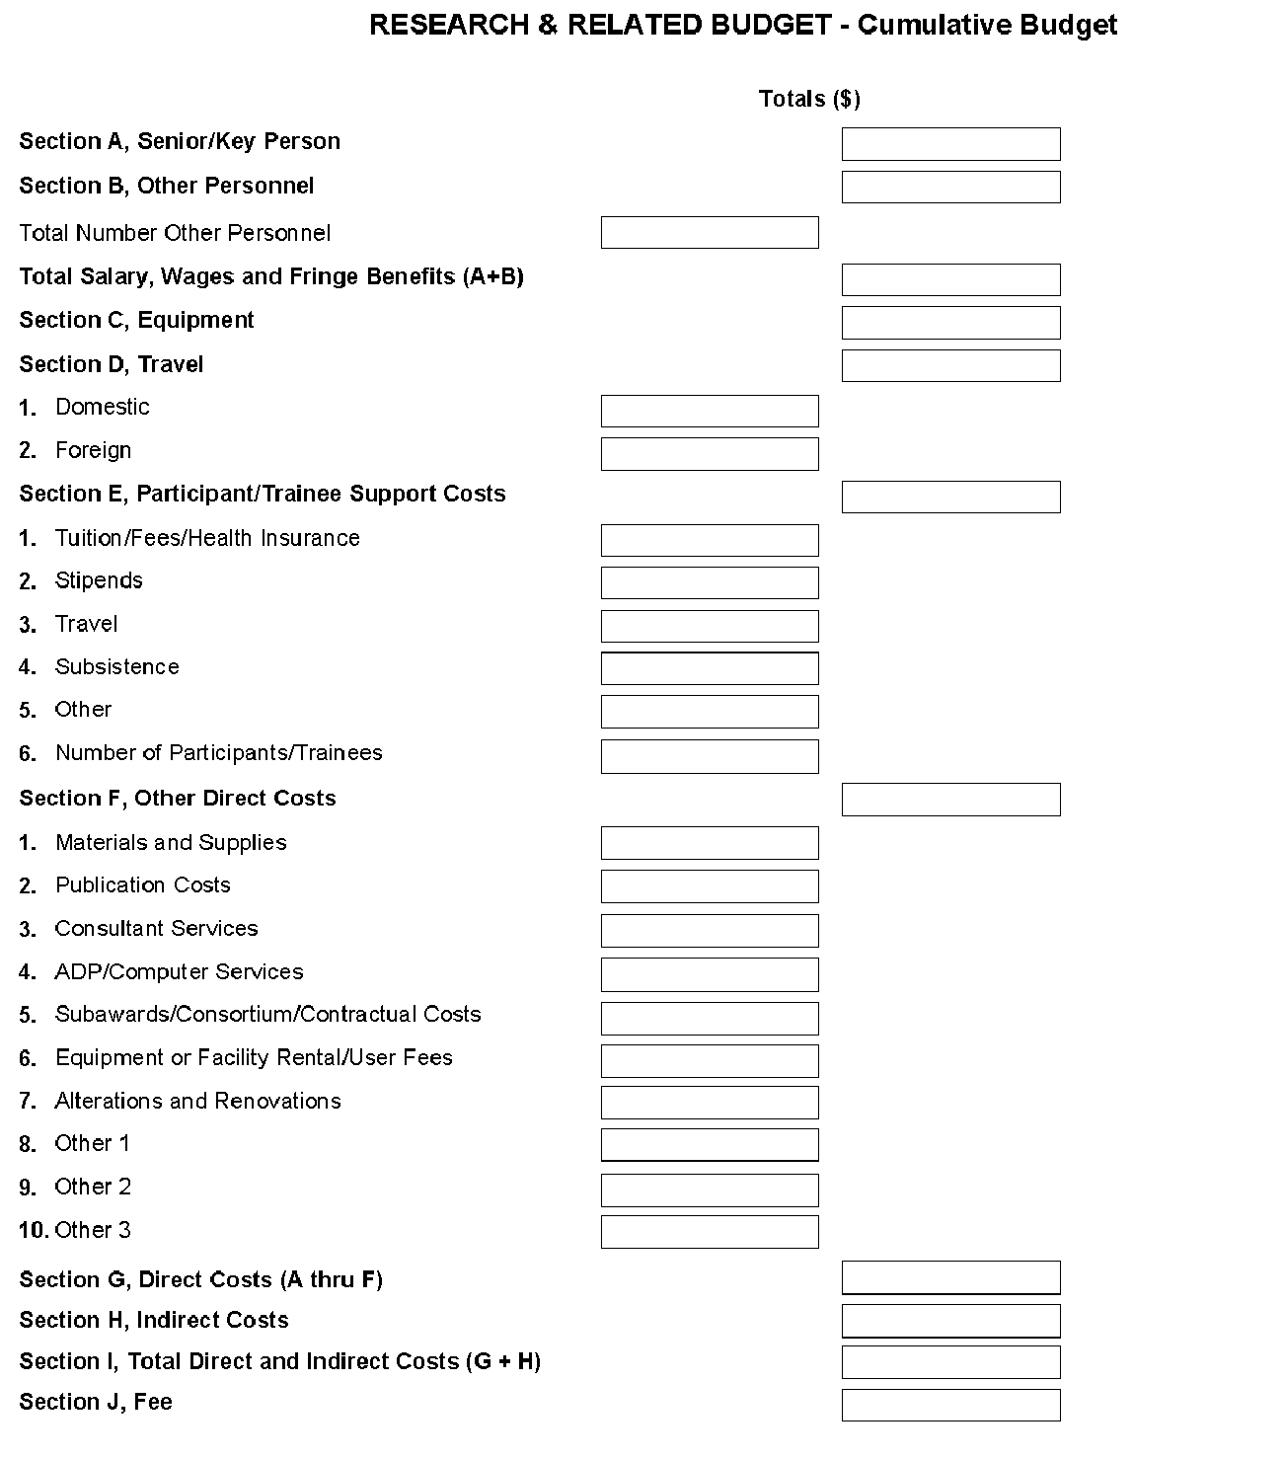

Once all data have been entered use the scroll bar to scroll up. You will be returned to the Grant Application Package screen. To remove a document from the Submission box, click the document name to select it and then click the Move Form to Delete button. This will return the document to the Mandatory Documents Submission List or Optional Documents Submission List.

4.8 Special Instructions for Preparing Applications with a Subaward/Consortium
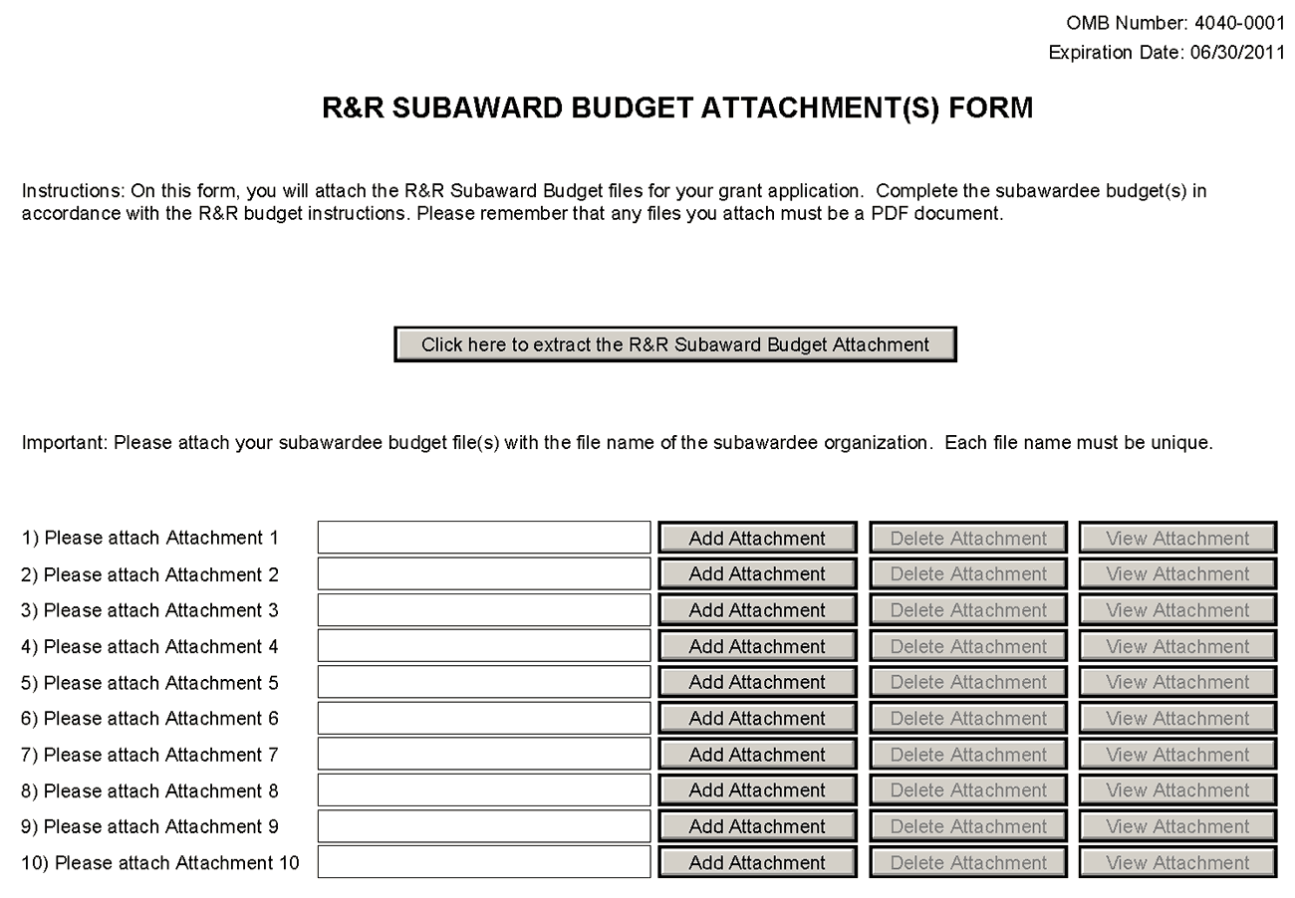
A complete subaward/consortium budget component (including the budget justification section) should be completed by each consortium grantee organization. Separate budgets are required only for subawardee/consortium organizations that perform a substantive portion of the project.
Note, a complete subaward/consortium budget component is only required when the prime grantee is submitting a detailed budget using the R&R Budget Component. Do not use this subaward/consortium budget component for applications using the PHS 398 Modular Budget Component. Applicants using the Modular Budget Component should see Section 5.4 for instructions concerning information on consortium budgets.
For any subaward or consortium sites, it is appropriate and expected that someone may be designated as the consortium lead investigator responsible for ensuring proper conduct of the project or program at that site. However, when completing the Project Role for the consortium lead investigator, the project role of “PD/PI” should only be used if the entire application is being submitted under the Multiple PI policy. Otherwise, this individual should be assigned some other project role in the senior/key personnel section of the application. Also, the role of Co-PD/PI is not currently used by NIH and other PHS agencies. Assigning an individual(s) the role of "Co-PD/PI" will not identify the application as a Multiple PD/PI application. Although NIH now recognizes the role of “Co-Investigator,” if applicants wish to use the role of “Consortium PI” or some other similar role, select “Other” for the Project Role field and then insert the appropriate role descriptor in the Other Project Role Category field.
NIH continues to support the policy established in April 2004, (revised in November 2004) regarding applications that involve consortium/contractual F&A costs (See NOT-OD-05-004). This policy allows applicants to exclude consortium/contractual F&A costs when determining compliance for any application where a direct cost limit applies. The use of the SF424 (R&R) application with separately submitted subaward/consortium budgets allows NIH to take advantage of a system validation for this policy. When an application is submitted in response to a program with a direct cost limit, the eRA system will perform the calculation by taking the total direct costs requested by the prime/parent organization in their detailed budget, and subtracting all subaward/consortium F&A from each and every subaward budget attached. When the validation calculation equals or exceeds the respective direct cost limit, the application will receive a warning.
This component accommodates a set number of separate subaward budgets (i.e., 10 or 30). If you are submitting an application with more subaward budgets than the component allows, the remaining budgets should be converted to PDF and included as part of Section K. Budget Justification of the parent budget. Reminder, the sum of all subaward budgets; e.g., those attached separately and those provided as part of the budget justification, must be included in Line F.5 Subawards/Consortium/Contractual Costs of the parent budget.
To start the process, the applicant organization should:
- Select the Subaward Budget Attachment Form from the Optional Documents in the Grant Application Package.
- Open the form, and click the Click here to extract the R&R Subaward Budget Attachment button in the middle of the form. A “SAVE” dialog box appears.
- Save the file locally using the first ten letters of the consortium organization’s name and use “.pdf” as the file extension. (The extracted file is an Adobe PDF file.) Once you have saved the file there is no need to extract another budget attachment. Doing so may cause you to lose any data already stored in the saved file.
- E-mail the extracted, saved form to the consortium grantee. Note: consortium grantees must have installed a compatible version of Adobe Reader before they can complete the form. The consortium grantee should complete all the budget information as instructed in the R&R Budget component instructions in Section 4.7. Note: Organizational DUNS and Name of Organization fields must reflect that of the subaward/consortium grantee.
- The consortium grantee must complete the budget component and e-mail it back to the applicant organization.
- Return to the Subaward Budget Attachment Form and attach the consortium grantee’s budget to one of the blocks provided on the form.
Submitting Subaward Budgets that are not Active for all Periods of the Prime Grant
When submitting subaward budgets that are not active for all periods of the prime grant, fill out the subaward R&R Budget form and include only the number of periods for which the subaward is active. The budget period start/end dates reflected in each period should reflect the corresponding prime budget period start/end dates. This approach is the most workable solution to the limitations in existing forms that do not allow an “empty” budget period and do not allow submission of a subaward budget with zero effort to skip a budget period.
For example, suppose the prime has filled out a budget form with the following periods:
- period 1 Jan 1, 2008 – Dec 31, 2008
- period 2 Jan 1, 2009 – Dec 31, 2009
- period 3 Jan 1, 2010 – Dec 31, 2010
- period 4 Jan 1, 2011 – Dec 31, 2011
- period 5 Jan 1, 2012 – Dec 31, 2012
Now, suppose there is a subaward that performs in support year 1 and does not become active again until support year 4. The subaward can fill out the first two periods of their budget form as follows:
- period 1 Jan 1, 2008 – Dec 31, 2008 (dates correspond to prime period 1)
- period 2 Jan 1, 2011 – Dec 31, 2011 (dates correspond to prime period 4)
It is not necessary that the budget period numbers between the prime and subaward match; the correlation is reflected in the dates. Do be careful, however, that the dates exactly match what is listed for the period in the prime budget.
Note this approach may cause a validation warning regarding the NIH $500,000 per year limit on direct costs, therefore you should document in both the cover letter and the subaward budget justification that the subaward is only active for specific periods of the prime. Appropriate NIH staff has access to the cover letter and reviewers have access to the budget justification. This documentation will make the date correlation immediately apparent and will help avoid any confusion.

Once all data have been entered use the scroll bar to scroll up. You will be returned to the Grant Application Package screen. To remove a document from the Submission box, click the document name to select it and then click the Move Form to Delete button. This will return the document to the Mandatory Documents Submission List or Optional Documents Submission List.

5. Completing PHS 398 Components

5.1 Overview
In conjunction with the SF424 (R&R) components, NIH and other PHS agencies grants applicants should also complete and submit additional components titled “PHS 398.” Note the PHS 398 components include additional data required by the agency for a complete application. While these are not identical to the PHS 398 application form pages, the PHS 398 reference is used to distinguish these additional data requirements from the data collected in the SF424 (R&R) components. A complete application to NIH and other PHS agencies will include SF424 (R&R) and PHS 398 components. The PHS 398 components include:
- PHS Cover Letter Component (optional, however applicants are strongly encouraged to include this component)
- PHS 398 Cover Page Supplement (this supplements the data requirements in the R&R Cover component)
- PHS 398 Modular Budget Component (use only when a modular budget is submitted instead of a detailed budget)
- PHS 398 Research Plan Component
- PHS 398 Checklist Component
Complete each component using the instructions provided below.

5.2 Cover Letter Component
Applicants are encouraged to include a cover letter with the application. The cover letter is only for internal use and will not be shared with peer reviewers. The letter should contain any of the following information that applies to the application:
1. Application title.
2. Funding Opportunity (PA or RFA) title of the NIH initiative.
3. Request of an assignment (referral) to a particular awarding component(s) or Scientific Review Group (SRG). The PHS makes the final determination.
4. List of individuals (e.g., competitors) who should not review your application and why.
5. Disciplines involved, if multidisciplinary.
6. For late applications (see Late Application policy in Section 2.14) include specific information about the timing and nature of the cause of the delay.
7. When submitting a Changed/Corrected Application after the submission date, a cover letter is required explaining the reason for the Changed/Corrected Application. If you already submitted a cover letter with a previous submission and are now submitting a Changed/Corrected Application, you must include all previous cover letter text in the revised cover letter attachment. The system does not retain any previously submitted cover letters until after an application is verified; therefore, you must repeat all information previously submitted in the cover letter as well as any additional information.
8. Explanation of any subaward budget components that are not active for all periods of the proposed grant.
9. Statement that you have attached any required agency approval documentation for the type of application submitted. This may include approval for applications $500,000 or more, approval for Conference Grant or Cooperative Agreement (R13 or U13), etc.
Two types of approval documentation are cited as examples in item 6 above: NIH IC approval for an application $500,000 or more and NIH institute approval for a Conference Grant or Cooperative Agreement application (R13 or U13). To attach the approval documents to this submission, please append those referenced documents to your Cover Letter File, and upload as one attachment.
Suggested Cover Letter Format
The Division of Receipt and Referral (DRR), Center for Scientific Review (CSR) is responsible for assigning applications to ICs and to Scientific Review Groups (SRGs). DRR will be utilizing knowledge management approaches as an adjunct to the work of referral experts as part of an overall plan to shorten the time from submission to review. Analysis has shown that requests made by investigators are a valuable source of information in this process. In order to facilitate the use of these requests in conjunction with knowledge management analysis of the content of the application, applicants are requested to use the following format when assignment requests are contained in a cover letter.
- List one request per line.
- Place Institute/Center (IC) and SRG review requests (if both are made) on separate lines.
- Place positive and negative requests (if both are made) on separate lines.
- Include name of IC or SRG, followed by a dash and the acronym. Do not use parentheses.
- Provide explanations for each request in a separate paragraph.
Examples:
Please assign this application to the following:
Institutes/Centers
National Cancer Institute - NCI
National Institute for Dental and Craniofacial Research – NIDCR
Scientific Review Groups
Molecular Oncogenesis Study Section – MONC
Cancer Etiology Study Section – CE
Please do not assign this application to the following:
Scientific Review Groups
Cancer Genetics Study Section – CG
The reasons for this request are [provide a narrative explanation for the request(s)].
Save this information in a single file in a location you remember and convert the file to PDF. Click Add Cover Letter File, browse to where you saved the file, select the file, and then click Open. The name of the file attached will automatically appear in the “Mandatory Cover Letter Filename” field.

Once all data have been entered use the scroll bar to scroll up. You will be returned to the Grant Application Package screen. To remove a document from the Submission box, click the document name to select it and then click the Move Form to Delete button. This will return the document to the Mandatory Documents Submission List or Optional Documents Submission List.

5.3 Cover Page Supplement Component
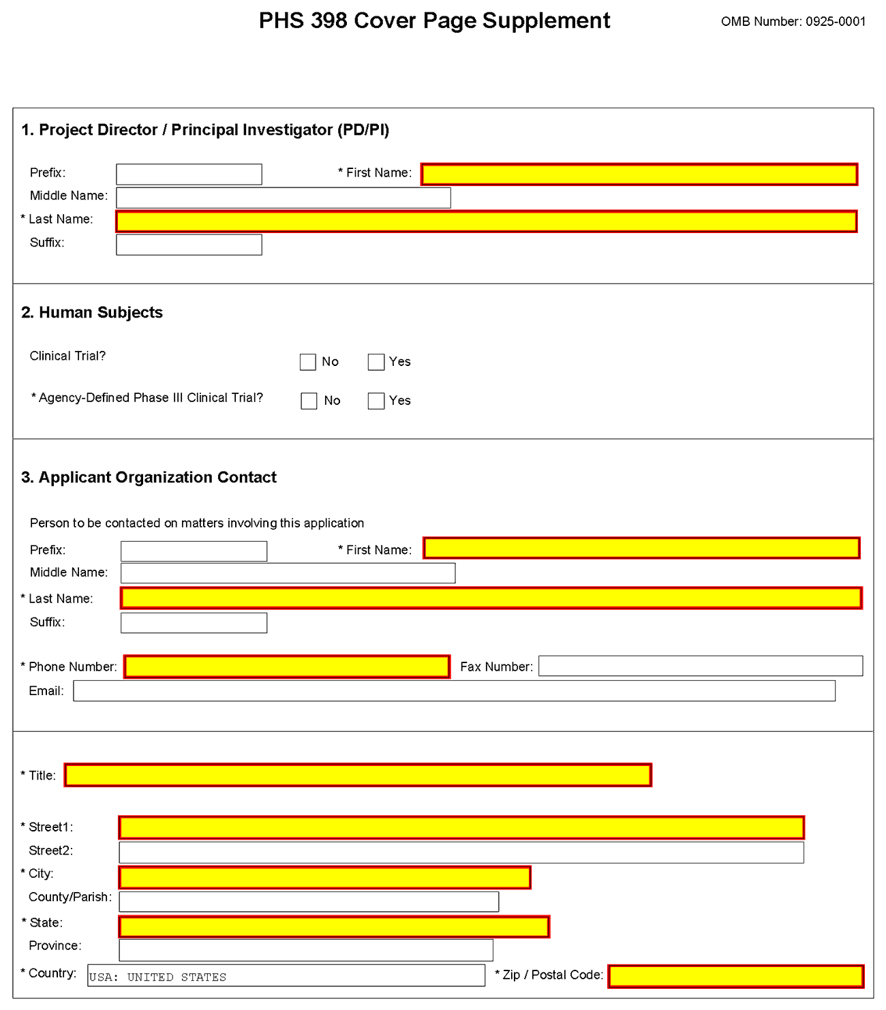
1. Program Director/Principal Investigator (PD/PI)
Field Name | Instructions
Prefix | Pre-populated from the SF424 (R&R). The prefix (for example, Mr., Mrs., Rev.) for the name of the PD/PI.
First Name | Pre-populated from the SF424 (R&R). The first (given) name of the PD/PI. This field is required.
Middle Name | Pre-populated from the SF424 (R&R). The middle name of the PD/PI.
Last Name | Pre-populated from the SF424 (R&R). The last (family) name of the PD/PI. This field is required.
Suffix | Pre-populated from the SF424 (R&R). The suffix (for example, Jr., Sr., PhD) for the name of the PD/PI.
2. Human Subjects
Field Name | Instructions
Clinical Trial | Check the Yes or No box to indicate whether the project is a clinical trial. The NIH defines a clinical trial as a prospective biomedical or behavioral research study of human subjects that is designed to answer specific questions about biomedical or behavioral interventions (drugs, treatments, devices, or new ways of using known drugs, treatments, or devices). Note that Public Law 110-85, enacted 09/27/2007, mandates registration and results reporting of applicable clinical trials in ClinicalTrials.gov (see Part II and Part III).
Agency-Defined Phase III Clinical Trial | Check the Yes or No box to indicate whether the project is an NIH-defined Phase III clinical trial. An NIH-defined Phase III clinical trial is a broadly based prospective Phase III clinical investigation, usually involving several hundred or more human subjects, for the purpose of either evaluating an experimental intervention in comparison with a standard or control intervention or of comparing two or more existing treatments. Often the aim of such investigation is to provide evidence leading to a scientific basis for consideration of a change in health policy or standard of care. The definition includes pharmacologic, non-pharmacologic, and behavioral interventions given for disease prevention, prophylaxis, diagnosis, or therapy. Community trials and other population-based intervention trials are also included.
3. Applicant Organization Contact
Person to be contacted on matters involving this application
Field Name | Instructions
Prefix | Pre-populated from the SF424 (R&R). The prefix (e.g., Mr., Mrs., Rev.) for the person to contact on matters related to this application.
First Name | Pre-populated from the SF424 (R&R). The first (given) name for the person to contact on matters related to this application. This field is required.
Middle Name | Pre-populated from the SF424 (R&R). The middle name for the person to contact on matters related to this application.
Last Name | Pre-populated from the SF424 (R&R). The last (family) name for the person to contact on matters related to this application. This field is required.
Suffix | Pre-populated from the SF424 (R&R). The suffix (e.g., Jr., Sr., PhD) for the person to contact on matters related to this application.
Phone Number | Pre-populated from the SF424 (R&R). The daytime phone number for the person to contact on matters related to this application. This field is required.
Fax Number | Pre-populated from the SF424 (R&R). The fax number for the person to contact on matters related to this application.
E-mail | Pre-populated from the SF424 (R&R). The e-mail address for the person to contact on matters related to this application.
Title | Enter the title for the person to contact on matters related to this application. This field is required.
Street1 | Enter first line of the street address for the person to contact on matters related to this application. This field is required.
Street2 | Enter second line of the street address for the person to contact on matters related to this application. This field is optional.
City | Enter the city for address for the person to contact on matters related to this application. This field is required.
County | Enter the county for address for the person to contact on matters related to this application.
State | Enter the state for address for the person to contact on matters related to this application.
Province | Enter the province.  If “Country” is not Canada, please leave blank.
Country | Select the country for the person to contact on matters related to this application. This field is required.
Zip Code | Enter the Postal Code (e.g., ZIP code) for the person to contact on matters related to this application.

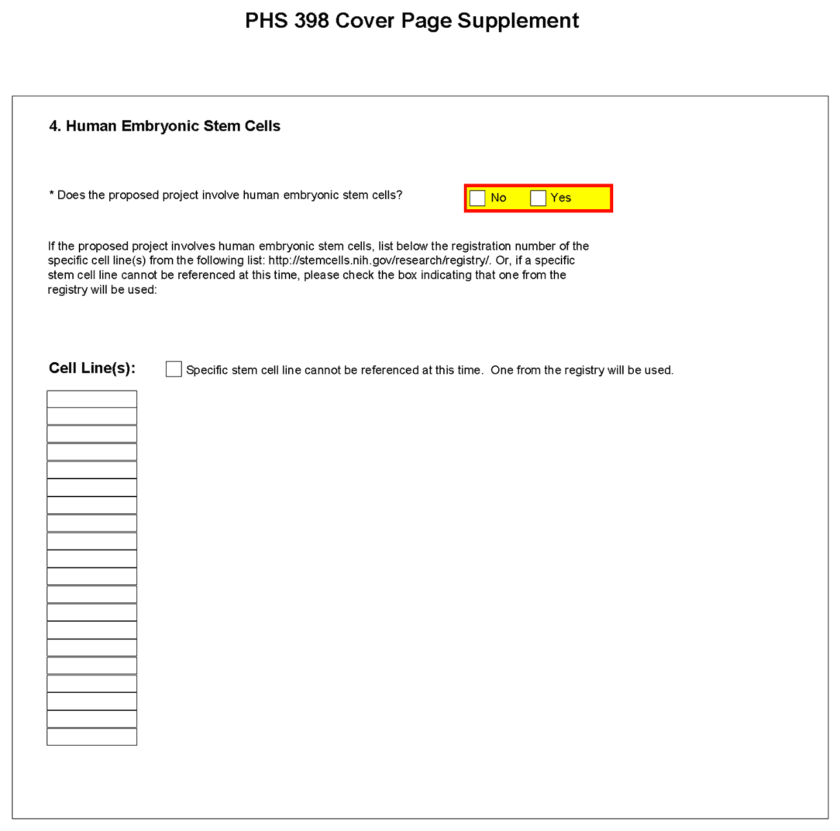
4. Human Embryonic Stem Cells
Field Name | Instructions
Does the proposed project involve human embryonic stem cells? | If the proposed project does not involve human embryonic stem cells, check the No box. If the proposed project involves human embryonic stem cells, check the Yes box, and then complete the section below.
Cell Line(s) | List in this section the 4-digit NIH Registration Number of the specific cell line(s) from the NIH Human Embryonic Stem Cell Registry.
Specific stem cell line cannot be referenced at this time. One from the registry will be used. | If a specific line cannot be referenced at the time of application submission, check this box.

Once all data have been entered use the scroll bar to scroll up. You will be returned to the Grant Application Package screen. To remove a document from the Submission box, click the document name to select it and then click the Move Form to Delete button. This will return the document to the Mandatory Documents Submission List or Optional Documents Submission List.

5.4 Modular Budget Component
Selecting the Appropriate Budget Component
The application forms package associated with most NIH funding opportunities includes two optional budget components—(1) R&R Budget Component; and, (2) PHS 398 Modular Budget Component. NIH applications will include either the R&R Budget Component or the PHS 398 Modular Budget Component, but not both. (Note AHRQ does not accept modular budgets.)
To determine which budget component to use for NIH applications, consult the modular budget guidelines below. Additional guidance may also be provided in the specific funding opportunity announcement.
Modular Budget Guidelines
Modular budgets are applicable to certain research grant applications from domestic organizations requesting $250,000 or less per year for direct costs. International organizations and others that do not fall under this definition should use the detailed budget forms described in Section 4.7. Note, consortium/contractual F&A costs are not factored into the direct cost limit. They may be requested in addition to the $250,000 limit. Modular budgets are simplified; therefore, detailed categorical information is not to be submitted with the application.
For all modular budgets, request total direct costs (in modules of $25,000), reflecting appropriate support for the project. There will be no future year escalations. A typical modular grant application will request the same number of modules in each year. Provide an additional narrative budget justification for any variation in the number of modules requested.
NIH may request (prior to award) additional budget justification in exceptional circumstances. For further information, see http://grants.nih.gov/grants/funding/modular/modular.htm and http://grants.nih.gov/grants/funding/modular/modular_review.htm.
Using the Modular Budget Component
The Modular Budget Component provides budget fields for up to 5 years of support (e.g., budget periods 1 - 5). If requesting less than 5 years of support, complete only those years requested and leave the others blank.

5.4.1 Periods 1 through 4
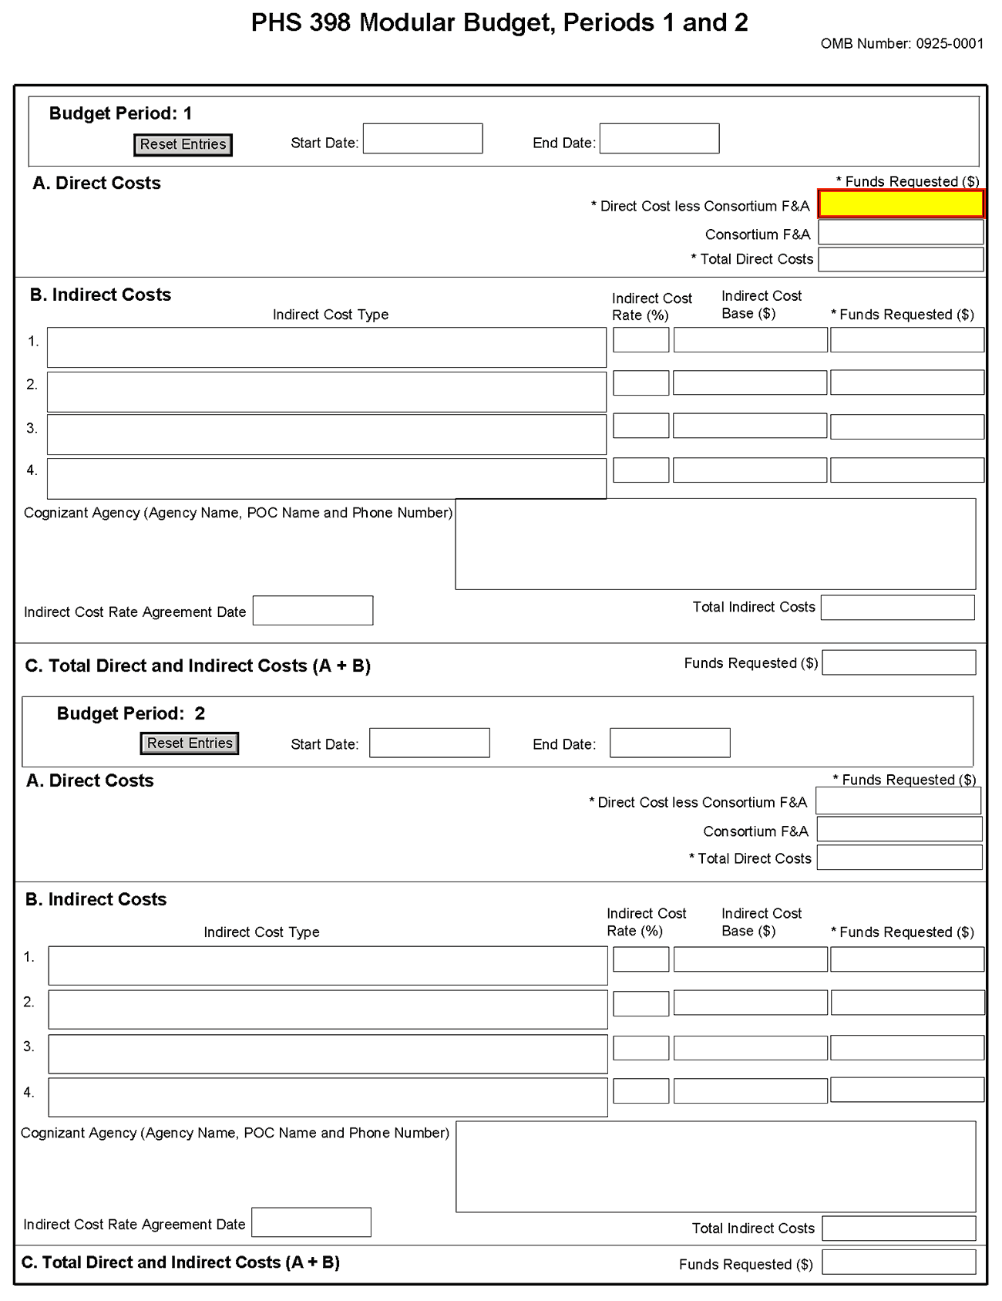
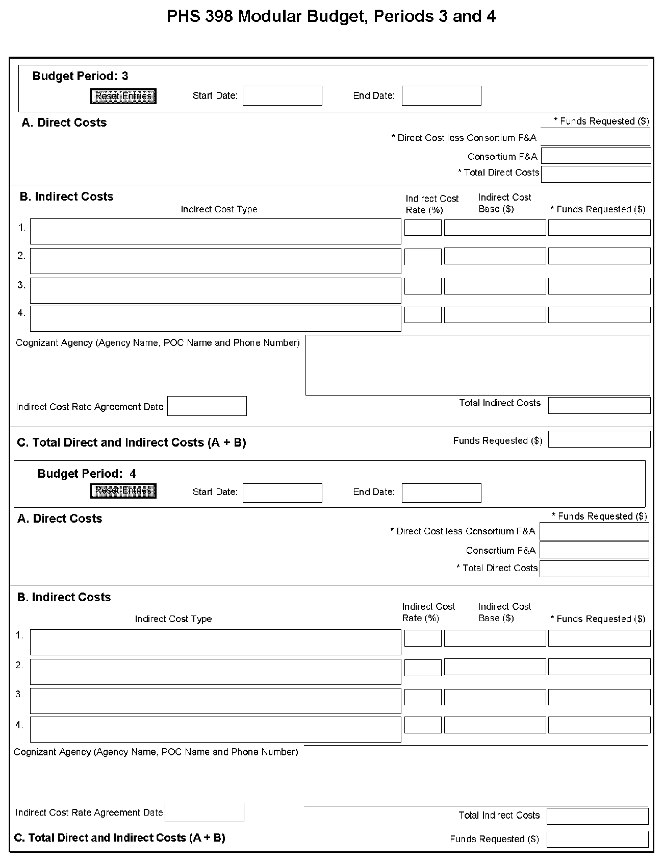
NOTE: The fields are the same for budget periods 1 through 5, the following instructions can be used for each.
Budget Period
Field Name | Instructions
Start Date | Enter the requested/proposed start date of the budget period. Use the following format: MM/DD/YYY.
End Date | Enter the requested/proposed end date of the budget period. Use the following format: MM/DD/YYY.
A. Direct Costs
Field Name | Instructions
Direct Cost less Consortium F&A | Enter the amount of direct costs, less actual consortium F&A costs for this budget period. This figure must be in $25,000 increments, and it may not exceed $250,000. Actual consortium F&A costs are excluded from this figure.
Consortium F&A | If this project involves a consortium, enter the actual consortium F&A costs for this budget period. If this project does not involve a consortium, leave blank.
Total Direct Costs | The total direct costs. This field auto-calculates.
B. Indirect Costs
Field Name | Instructions
Indirect Cost Type | Indicate the type of base (for example, Salary & Wages, Modified Total Direct Costs, Other [explain]), and indicate if Off-site. If more than one rate/base is involved, use separate lines for each. If you do not have a current indirect rate(s) approved by a Federal agency, indicate, “None—will negotiate” and include information for a proposed rate. Use the budget justification if additional space is needed.
Indirect Cost Rate (%) | Indicate the most recent Indirect Cost rate(s) (also known as Facilities & Administrative Costs [F&A]) established with the cognizant Federal office, or in the case of for-profit organizations, the rate(s) established with the appropriate agency. If you have a cognizant/oversight agency and are selected for an award, you must submit your indirect rate proposal to that office for approval. If you do not have a cognizant/oversight agency, contact the awarding agency.  Currently this field will not allow a figure greater than 100% to be entered. If the Indirect Cost Rate exceeds 100%, use 2 lines to show the entire calculation.
Indirect Cost Base ($) | Enter the amount of the base for each indirect cost type.
Funds Requested ($) | Enter funds requested for each indirect cost type.
Cognizant Agency (Agency Name, POC Name and Phone Number) | Enter the name of the cognizant Federal Agency, name, and phone number of the individual responsible for negotiating your rate. If no cognizant agency is known, enter “None.”
Indirect Cost Rate Agreement Date | If you have a negotiated rate agreement, enter the agreement date.
Total Indirect Costs | The total funds requested for indirect costs. This field auto-calculates.
C. Total Direct and Indirect Costs (A+B) Funds Requested ($)
The total funds requested for direct and indirect costs. This field auto-calculates.

Once you have entered all required information for budget periods 1 and 2, press the Next button or scroll down to enter information for subsequent budget periods.

5.4.2 Period 5 and Cumulative
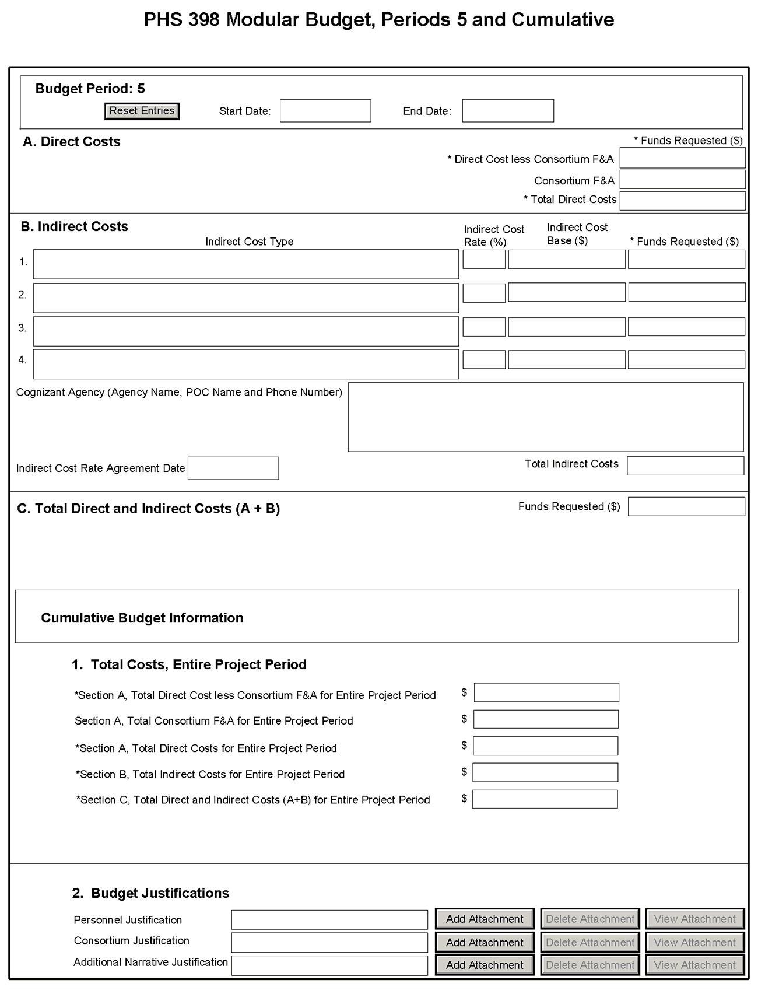
Cumulative Budget Information
All values for the Cumulative Budget Information are calculated automatically. They equal the summations of the amounts that you have entered previously for each of the individual budget periods. Therefore, no data entry is allowed or required, in order to complete this “Cumulative Budget” section.
If any of the amounts displayed on this form appears to be incorrect, you may correct it by adjusting one or more of the values that contribute to that total. To make any such adjustments, you will need to revisit the appropriate budget period form(s), to enter corrected values.
Modular Budget Justifications
Field Name | Instructions
Personnel Justification | List all personnel, including names, number of person months devoted to the project (indicate academic, calendar, and/or summer) and roles on the project. Do not provide individual salary information. Since the modules should be a reasonable estimate of costs allowable, allocable, and appropriate for the proposed project, you must use the current legislatively imposed salary limitation when estimating the number of modules. For guidance on current salary limitations contact your office of sponsored programs.  NIH grants also limit the compensation for graduate students. Compensation includes salary or wages, fringe benefits, and tuition remission. This limit should also be used when estimating the number of modules. See: http://grants.nih.gov/grants/guide/notice-files/NOT-OD-02-017.html.  Save this information in a single file in a location you remember. Click Add Attachment, browse to where you saved the file, select the file, and then click Open.
Consortium Justification | Provide an estimate of total costs (direct plus facilities and administrative) for each year, rounded to the nearest $1,000. When more than one consortium is involved, provide this estimate for each. List the individuals/organizations with whom consortium or contractual arrangements have been made, along with all personnel, including percent of effort (in person months) and roles on the project. Do not provide individual salary information. Indicate whether the collaborating institution is foreign or domestic. While only the direct cost for a consortium/contractual arrangement is factored into eligibility for using the modular budget format, the total consortium/contractual costs must be included in the overall requested modular direct cost amount.  Save this information in a single file in a location you remember. Click Add Attachment, browse to where you saved the file, select the file, and then click Open.
Additional Narrative Justification | If the requested budget requires any additional justification, such as variations in the number of modules requested, or explanation of exclusions applied to the F&A base calculation, save this information in a single file in a location you remember. Click Add Attachment, browse to where you saved the file, select the file, and then click Open.

Once all data have been entered use the scroll bar to scroll up. You will be returned to the Grant Application Package screen. To remove a document from the Submission box, click the document name to select it and then click the Move Form to Delete button. This will return the document to the Mandatory Documents Submission List or Optional Documents Submission List.

5.5 PHS 398 Research Plan Component
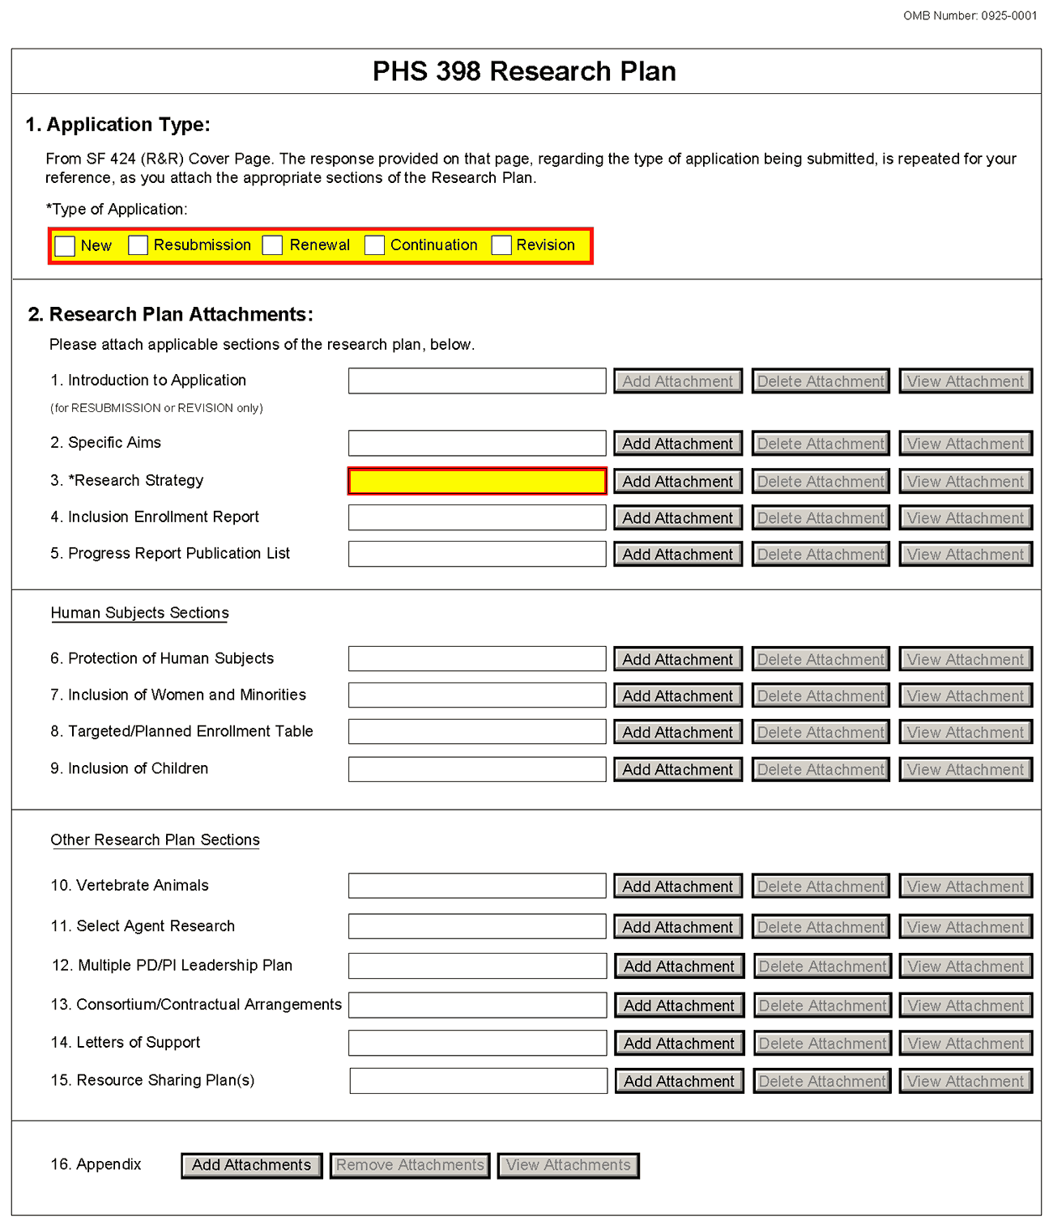
The Research Plan should include sufficient information needed for evaluation of the project, independent of any other document (e.g., previous application). Be specific and informative, and avoid redundancies.
1. Application Type
This field is pre-populated from the SF424 (R&R) Cover Component. Corrections to this field must be made in that component.
2. Research Plan Attachments (See also Section 2.3.2 Creating PDFs for Text Attachments)
Although many of the sections of this application are separate PDF attachments, page limits referenced in the instructions and/or funding opportunity announcement must still be followed. Agency validations will include checks for page limits (and use of appropriate font). Some accommodation will be made for sections that, when combined, must fit within a specified limitation.
Text attachments should be generated using word processing software and then converted to PDF using PDF generating software. Avoid scanning text attachments to convert to PDF since that causes problems for the agency handling the application. In addition, be sure to save files with descriptive file names.
Do not include any information in a header or footer of the attachments. A header will be system-generated that references the name of the PD/PI. Page numbers for the footer will be system-generated in the complete application, with all pages sequentially numbered.
Since a number of reviewers will be reviewing applications as an electronic document and not a paper version, applicants are strongly encouraged to use only a standard, single-column format for the text. Avoid using a two-column format since it can cause difficulties when reviewing the document electronically.
Full-sized glossy photographs of material such as electron micrographs or gels must only be included within the page limits of the Research Strategy. The maximum size of images to be included should be approximately 1200 x 1500 pixels using 256 colors. Figures must be readable as printed on an 8.5 x 11 inch page at normal (100%) scale.
Investigators must use image compression such as JPEG or PNG. Do not include figures or photographs as separate attachments either in the Appendix or elsewhere in the application.
Separate Attachments
Separate attachments have been designed for the Research Plan sections to maximize automatic validations conducted by the eRA system. When the application is received by the agency, all of the Research Plan sections will be concatenated in the appropriate order so that reviewers and agency staff will see a single cohesive Research Plan.
When attaching a PDF document to the actual forms, please note you are attaching an actual document, not just pointing to the location of an externally stored document. Therefore, if you revise the document after it has been attached, you must delete the previous attachment and then reattach the revised document to the application form. Use the View Attachment button to determine if the correct version has been attached.
Page Limits
Applicants must follow the page limits described in table 2.6.1 unless the FOA specifies otherwise. All tables, graphs, figures, diagrams, and charts must be included within the Research Strategy page limit. If PAs or RFAs contain specific page limits, those instructions always supersede these instructions.
All applications and proposals for NIH funding must be self-contained within specified page limits. Agency validations will include checks for page limits. Note that while these computer validations will help minimize incomplete and/or non-compliant applications, they do not replace the validations conducted by NIH staff. Applications found not to comply with the requirements may be delayed in the review process. Unless otherwise specified in an NIH solicitation, Internet Web site addresses (URLs) may not be used to provide information necessary to the review because reviewers are not obligated to view the Internet sites. Moreover, reviewers are cautioned that they should not directly access an Web site (except to review publications cited in the Biographical Sketch or Progress Report publication list) as it could compromise their anonymity.
Applicants are prohibited from using the Appendix to circumvent page limitations in any section of the application for which a page limit applies. For additional information regarding Appendix material and page limits, please refer to the NIH Guide Notice NOT-OD-11-080, http://grants.nih.gov/grants/guide/notice-files/NOT-OD-11-080.html.

Notice of Proprietary Information
Applicants are discouraged from submitting information considered proprietary unless it is deemed essential for proper evaluation of the application. However, when the application contains information that constitutes trade secrets, or information that is commercial or financial, or information that is confidential or privileged, make sure you have checked the “Yes” box of question #3 in the “Other Project Information” component. Identify the pages in the application that contain this information by marking those paragraphs or lines with an asterisk (*) in the left-hand margin. Include at the beginning of the Research Plan which pages contain asterisks and a note stating “The following sections marked with an asterisk contain proprietary/privileged information that (name of Applicant) requests not be released to persons outside the Government, except for purposes of review and evaluation.”
When information in the application constitutes trade secrets or information that is commercial or financial, or information that is confidential or privileged, it is furnished to the Government in confidence with the understanding that the information shall be used or disclosed only for evaluation of this application. If a grant is awarded as a result of or in connection with the submission of this application, the Government shall have the right to use or disclose the information to the extent authorized by law. This restriction does not limit the Government’s right to use the information if it is obtained without restriction from another source.
Begin each text section of the Research Plan with a section header (e.g., Introduction, Specific Aims, Research Strategy, etc).
Field Name | Instructions
1. Introduction to Application (for Resubmission or Revision only) | See specific instructions in Part I Section 2.7, Resubmission Applications and Part I Section 2.8, Revision Applications on the content of the Introduction. First time (new) applications should not include an Introduction.  The Introduction is a required attachment for Resubmissions and Revisions. The Introduction is limited to one page unless specified in the FOA, except that the Introduction of Resubmission applications is limited to 3 pages for R25 applications.  Save this information in a single file in a location you remember. Click Add Attachment, browse to where you saved the file, select the file, and then click Open.
2. Specific Aims | State concisely the goals of the proposed research and summarize the expected outcome(s), including the impact that the results of the proposed research will exert on the research field(s) involved.  List succinctly the specific objectives of the research proposed, e.g., to test a stated hypothesis, create a novel design, solve a specific problem, challenge an existing paradigm or clinical practice, address a critical barrier to progress in the field, or develop new technology.  The Specific Aims attachment is required unless otherwise specified in the FOA. Specific Aims are limited to one page.  Save this information in a single file in a location you remember. Click Add Attachment, browse to where you saved the file, select the file, and then click Open.
3. Research Strategy | Organize the Research Strategy in the specified order and using the instructions provided below. Start each section with the appropriate section heading – Significance, Innovation, Approach. Cite published experimental details in the Research Strategy section and provide the full reference in the Bibliography and References Cited section (Part I Section 4.4.9).  Follow the page limits for the Research Strategy in the table of page limits (Table 2.6-1), unless specified otherwise in the FOA. Note that the page limit for this attachment will be validated as a single file.  - Significance  - Explain the importance of the problem or critical barrier to progress in the field that the proposed project addresses.  - Explain how the proposed project will improve scientific knowledge, technical capability, and/or clinical practice in one or more broad fields.  - Describe how the concepts, methods, technologies, treatments, services, or preventative interventions that drive this field will be changed if the proposed aims are achieved.  - Innovation  - Explain how the application challenges and seeks to shift current research or clinical practice paradigms.  - Describe any novel theoretical concepts, approaches or methodologies, instrumentation or interventions to be developed or used, and any advantage over existing methodologies, instrumentation, or interventions.  - Explain any refinements, improvements, or new applications of theoretical concepts, approaches or methodologies, instrumentation, or interventions.  - Approach  - Describe the overall strategy, methodology, and analyses to be used to accomplish the specific aims of the project. Unless addressed separately in Item 15 (Resource Sharing Plan), include how the data will be collected, analyzed, and interpreted as well as any resource sharing plans as appropriate.  - Discuss potential problems, alternative strategies, and benchmarks for success anticipated to achieve the aims.  - If the project is in the early stages of development, describe any strategy to establish feasibility, and address the management of any high risk aspects of the proposed work.  - Point out any procedures, situations, or materials that may be hazardous to personnel and precautions to be exercised. A full discussion on the use of select agents should appear in Item 11, below.  If an applicant has multiple Specific Aims, then the applicant may address Significance, Innovation and Approach for each Specific Aim individually, or may address Significance, Innovation and Approach for all of the Specific Aims collectively.  As applicable, also include the following information as part of the Research Strategy, keeping within the three sections listed above: Significance, Innovation, and Approach.  Preliminary Studies for New Applications: For new applications, include information on Preliminary Studies. Discuss the PD/PI’s preliminary studies, data, and or experience pertinent to this application. Except for Exploratory/Developmental Grants (R21/R33), Small Research Grants (R03), and Academic Research Enhancement Award (AREA) Grants (R15), preliminary data can be an essential part of a research grant application and help to establish the likelihood of success of the proposed project. Early Stage Investigators should include preliminary data (however, for R01 applications, reviewers will be instructed to place less emphasis on the preliminary data in application from Early Stage Investigators than on the preliminary data in applications from more established investigators).  Progress Report for Renewal and Revision Applications. For renewal/revision applications, provide a Progress Report. Provide the beginning and ending dates for the period covered since the last competitive review. Summarize the specific aims of the previous project period and the importance of the findings, and emphasize the progress made toward their achievement. Explain any significant changes to the specific aims and any new directions including changes to the specific aims and any new directions including changes resulting from significant budget reductions. A list of publications, patents, and other printed materials should be included in Item 5 (Progress Report Publication List); do not include that information here.  Save this information in a single file in a location you remember. Click Add Attachment, browse to where you saved the file, select the file, and then click Open.
4. Inclusion Enrollment Report | If the renewal or revision application involves clinical research, then you must report on the enrollment of research subjects and their distribution by ethnicity/race and sex/gender.  See Part II, Section 4.3 for more detailed instructions on which Target and Enrollment Report or Table to use.
5. Progress Report Publication List (Renewal Applications Only) | List the titles and complete references to all appropriate publications, manuscripts accepted for publication, patents, and other printed materials that have resulted from the project since it was last reviewed competitively. When citing articles that fall under the Public Access Policy, were authored or co-authored by the applicant and arose from NIH support, provide the NIH Manuscript Submission reference number (e.g., NIHMS97531) or the PubMed Central (PMC) reference number (e.g., PMCID234567) for each article. If the PMCID is not yet available because the Journal submits articles directly to PMC on behalf of their authors, indicate “PMC Journal – In Process.” A list of these journals is posted at: http://publicaccess.nih.gov/submit_process_journals.htm.  Citations that are not covered by the Public Access Policy, but are publicly available in a free, online format may include URLs or PubMed ID (PMID) numbers along with the full reference (note that copies of these publications are not accepted as appendix material, see Part I Section 5.5.15 for more information).
Human Subjects Sections
Field Name | Instructions
6. Protection of Human Subjects | Refer to Part II, Supplemental Instructions for Preparing the Human Subjects Section of the Research Plan.  This section is required for applicants answering “yes” to the question “Are human subjects involved?” on the R&R Other Project Information form. If the answer is “No” to the question but the proposed research involves human specimens and/or data from subjects applicants must provide a justification in this section for the claim that no human subjects are involved.  Do not use the protection of human subjects section to circumvent the page limits of the Research Strategy.  Save this information in a single file in a location you remember. Click Add Attachment, browse to where you saved the file, select the file, and then click Open.
7. Inclusion of Women and Minorities | Refer to Part II, Supplemental Instructions for Preparing the Human Subjects Section of the Research Plan. This section is required for applicants answering “yes” to the question “Are human subjects involved?” on the R&R Other Project Information form and the research does not fall under Exemption 4.  Save this information in a single file in a location you remember. Click Add Attachment, browse to where you saved the file, select the file, and then click Open.
8. Targeted/Planned Enrollment | If this application involves the Inclusion of Women and Minorities, applicants must complete the Targeted/Planned Enrollment Table for each protocol; see Part II, Supplemental Instructions for Preparing the Human Subjects Section of the Research Plan, Section 4.3. For applicants answering “Yes” to the question “Are human subjects involved?” on the R&R Other Project Information Form and the research does not fall under Exemption 4, complete the Targeted/Planned Enrollment Table for each protocol.  Save this information in a single file in a location you remember. Click Add Attachment, browse to where you saved the file, select the file, and then click Open.
9. Inclusion of Children | Refer to Supplemental Instructions for Preparing the Human Subjects Section of the Research Plan, Sections 4.4 and 5.7. For applicants answering “Yes” to the question “Are human subjects involved” on the R&R Other Project Information Form and the research does not fall under Section 4, this section is required .  Save this information in a single file in a location you remember. Click Add Attachment, browse to where you saved the file, select the file, and then click Open.
Other Research Plan Sections
Field Name | Instructions
10. Vertebrate Animals | This section is required for applicants answering “yes” to the question “Are vertebrate animals involved?” on the R&R Other Project Information form.  If Vertebrate Animals are involved in the project, address each of the five points below. This section should be a concise, complete description of the animals and proposed procedures. While additional details may be included in the Research Strategy, the responses to the five required points below must be cohesive and include sufficient detail to allow evaluation by peer reviewers and NIH staff. If all or part of the proposed research involving vertebrate animals will take place at alternate sites (such as project/performance or collaborating site(s)), identify those sites and describe the activities at those locations. Although no specific page limitation applies to this section of the application, be succinct. Failure to address the following five points will result in the application being designated as incomplete and will be grounds for the PHS to defer the application from the peer review round. Alternatively, the application’s impact/priority score may be negatively affected.  If the involvement of animals is indefinite, provide an explanation and indicate when it is anticipated that animals will be used. If an award is made, prior to the involvement of animals the grantee must submit to the NIH awarding office detailed information as required in points 1-5 above and verification of IACUC approval. If the grantee does not have an Animal Welfare Assurance then an appropriate Assurance will be required (See Part III, Section 2.2 Vertebrate Animals for more information).  The five points are as follows:  1. Provide a detailed description of the proposed use of the animals in the work outlined in the Research Strategy section. Identify the species, strains, ages, sex, and numbers of animals to be used in the proposed work.  2. Justify the use of animals, the choice of species, and the numbers to be used. If animals are in short supply, costly, or to be used in large numbers, provide an additional rationale for their selection and numbers.  3. Provide information on the veterinary care of the animals involved.  4. Describe the procedures for ensuring that discomfort, distress, pain, and injury will be limited to that which is unavoidable in the conduct of scientifically sound research. Describe the use of analgesic, anesthetic, and tranquilizing drugs and/or comfortable restraining devices, where appropriate, to minimize discomfort, distress, pain, and injury.  5. Describe any method of euthanasia to be used and the reasons for its selection. State whether this method is consistent with the recommendations of the American Veterinary Medical Association (AVMA) Guidelines on Euthanasia. If not, include a scientific justification for not following the recommendations.  Do not use the vertebrate animal section to circumvent the page limits of the Research Strategy.  Save this information in a single file in a location you remember. Click Add Attachment, browse to where you saved the file, select the file, and then click Open.
11. Select Agent Research | Select agents are hazardous biological agents and toxins that have been identified by DHHS or USDA as having the potential to pose a severe threat to public health and safety, to animal and plant health, or to animal and plant products. CDC maintains a list of these agents. See http://www.cdc.gov/od/sap/docs/salist.pdf.  If the activities proposed in the application involve only the use of a strain(s) of select agents which has been excluded from the list of select agents and toxins as per 42 CFR 73.3, the select agent requirements do not apply. Use this section to identify the strain(s) of the select agent that will be used and note that it has been excluded from this list. The CDC maintains a list of exclusions at http://www.cdc.gov/od/sap/sap/exclusion.htm.  If the strain(s) is not currently excluded from the list of select agents and toxins but you have applied or intend to apply to DHHS for an exclusion from the list, use this section to indicate the status of your request or your intent to apply for an exclusion and provide a brief justification for the exclusion.  If any of the activities proposed in your application involve the use of select agents at any time during the proposed project period, either at the applicant organization or at any other performance site, address the following three points for each site at which select agent research will take place. Although no specific page limitation applies to this section, be succinct.  1. Identify the select agent(s) to be used in the proposed research.  2. Provide the registration status of all entities* where select agent(s) will be used.  - If the performance site(s) is a foreign institution, provide the name(s) of the country or countries where select agent research will be performed.  *An “entity” is defined in 42 CFR 73.1 as “any government agency (Federal, State, or local), academic institution, corporation, company, partnership, society, association, firm, sole proprietorship, or other legal entity.”  3. Provide a description of all facilities where the select agent(s) will be used.  - Describe the procedures that will be used to monitor possession, use and transfer of the select agent(s).  - Describe plans for appropriate biosafety, biocontainment, and security of the select agent(s).  - Describe the biocontainment resources available at all performance sites.  If you are responding to a specific funding opportunity announcement (e.g., PA or RFA), address any requirements specified by the FOA.  Reviewers will assess the information provided in this Section, and any questions associated with select agent research will need to be addressed prior to award.  Save this file in a location you remember. Click Add Attachment, browse to where you saved the file, select the file, and then click Open.
12. Multiple PD/PI Leadership Plan | For applications designating multiple PD/PIs, a leadership plan must be included. For applications designating multiple PD/PIs, all such individuals must be assigned the PD/PI role on the Senior/Key Profile form, even those at organizations other than the applicant organization. A rationale for choosing a multiple PD/PI approach should be described. The governance and organizational structure of the leadership team and the research project should be described, including communication plans, process for making decisions on scientific direction, and procedures for resolving conflicts. The roles and administrative, technical, and scientific responsibilities for the project or program should be delineated for the PD/PIs and other collaborators. Do not submit a leadership plan if you are not submitting a Multiple PD/PI application.  If budget allocation is planned, the distribution of resources to specific components of the project or the individual PD/PIs should be delineated in the Leadership Plan. In the event of an award, the requested allocations may be reflected in a footnote on the Notice of Grant Award.  Save this file in a location you remember. Click Add Attachment, browse to where you saved the file, select the file, and then click Open.
13. Consortium/Contractual Arrangements | Explain the programmatic, fiscal, and administrative arrangements to be made between the applicant organization and the consortium organization(s). If consortium/contractual activities represent a significant portion of the overall project, explain why the applicant organization, rather than the ultimate performer of the activities, should be the grantee. The signature of the Authorized Organization Representative on the SF424 (R&R) cover component (Item 17) signifies that the applicant and all proposed consortium participants understand and agree to the following statement:  The appropriate programmatic and administrative personnel of each organization involved in this grant application are aware of the agency’s consortium agreement policy and are prepared to establish the necessary inter-organizational agreement(s) consistent with that policy.  Save this information in a single file in a location you remember. Click Add Attachment, browse to where you saved the file, select the file, and then click Open.
14. Letters of Support  (e.g., Consultants) | Attach all appropriate letters of support, including any letters necessary to demonstrate the support of consortium participants and collaborators such as senior/key personnel and Other Significant Contributors included in the grant application. Letters are not required for personnel (such as research assistants) not contributing in a substantive, measurable way to the scientific development or execution of the project. For consultants, letters should include rate/charge for consulting services.  Save this information in a single file in a location you remember. Click Add Attachment, browse to where you saved the file, select the file, and then click Open.
15. Resource Sharing Plan(s) | NIH considers the sharing of unique research resources developed through NIH-sponsored research an important means to enhance the value and further the advancement of the research. When resources have been developed with NIH funds and the associated research findings published or provided to NIH, it is important that they be made readily available for research purposes to qualified individuals within the scientific community. See Part III, 1.5 Sharing Research Resources.  1. Data Sharing Plan: Investigators seeking $500,000 or more in direct costs (exclusive of consortium F&A) in any year are expected to include a brief 1-paragraph description of how final research data will be shared, or explain why data-sharing is not possible. Specific Funding Opportunity Announcements may require that all applications include this information regardless of the dollar level. Applicants are encouraged to read the specific opportunity carefully and discuss their data-sharing plan with their program contact at the time they negotiate an agreement with the Institute/Center (IC) staff to accept assignment of their application. See Data-Sharing Policy or http://grants.nih.gov/grants/guide/notice-files/NOT-OD-03-032.html.  2. Sharing Model Organisms: Regardless of the amount requested, all applications where the development of model organisms is anticipated are expected to include a description of a specific plan for sharing and distributing unique model organisms or state why such sharing is restricted or not possible. See Sharing Model Organisms Policy, and NIH Guide NOT-OD-04-042.  3. Genome Wide Association Studies (GWAS): Applicants seeking funding for a genome-wide association study are expected to provide a plan for submission of GWAS data to the NIH-designated GWAS data repository, or an appropriate explanation why submission to the repository is not possible. GWAS is defined as any study of genetic variation across the entire genome that is designed to identify genetic associations with observable traits (such as blood pressure or weight) or the presence or absence of a disease or condition. For further information see Policy for Sharing of Data Obtained in NIH Supported or Conducted Genome-Wide Association Studies, NIH Guide NOT-OD-07-088, and http://gwas.nih.gov/.  Save this information in a single file in a location you remember. Click Add Attachment, browse to where you saved the file, select the file, and then click Open.
16. Appendix | Only one copy of appendix material is necessary. Use the Add Attachments button to the right of this field to complete this entry.  A maximum of 10 PDF attachments is allowed in the Appendix. If more than 10 appendix attachments are needed, combine the remaining information into attachment #10. Note that this is the total number of appendix items, not the total number of publications. When allowed there is a limit of 3 publications that are not publicly available (see below for further details and check the FOA for any specific instructions), though not all grant activity codes allow publications to be included in the appendix.  Do not use the appendix to circumvent the page limits of the Research Strategy or any other section of the application for which a page limit applies. For additional information regarding Appendix material and page limits, please refer to the NIH Guide Notice NOT-OD-11-080, http://grants.nih.gov/grants/guide/notice-files/NOT-OD-11-080.html.  Appendix material may not appear in the assembled application in the order attached, so it is important to use filenames for attachments that are descriptive of the content. A summary sheet listing all of the items included in the appendix is also encouraged but not required. When including a summary sheet, it should be included in the first appendix attachment. Applications that do not follow the appendix requirements may be delayed in the review process.  New, resubmission, renewal, and revision applications may include the following materials in the Appendix (note, however, that some FOAs do not permit publications):  - Publications – No longer allowed as appendix materials except in the circumstances noted below. Applicants may submit up to 3 of the following types of publications:  - Manuscripts and/or abstracts accepted for publication but not yet published: The entire article should be submitted as a PDF attachment.  - Manuscripts and/or abstracts published, but a free, online, publicly available journal link is not available: The entire article should be submitted as a PDF attachment.  - Patents directly relevant to the project: The entire document should be submitted as a PDF attachment.  (Do not include unpublished theses, or abstracts/manuscripts submitted (but not yet accepted) for publication.)  - Surveys, questionnaires, and other data collection instruments; clinical protocols and informed consent documents may be submitted in the Appendix as necessary.  - For materials that cannot be submitted electronically or materials that cannot be converted to PDF format (e.g., medical devices, prototypes, DVDs, CDs), applicants should contact the Scientific Review Officer for instructions following notification of assignment of the application to a SRG. Applicants are encouraged to be as concise as possible and submit only information essential for the review of the application.  Items that must not be included in the appendix:  - Photographs or color images of gels, micrographs, etc., are no longer accepted as Appendix material. These images must be included in the Research Strategy PDF. However, images embedded in publications are allowed.  - Publications that are publicly accessible. For such publications, the URL or PMC submission identification numbers along with the full reference should be included as appropriate in the Bibliography and References cited section, the Progress Report Publication List section, and/or the Biographical Sketch section.

Once all data have been entered use the scroll bar to scroll up. You will be returned to the Grant Application Package screen. To remove a document from the Submission box, click the document name to select it and then click the Move Form to Delete button. This will return the document to the Mandatory Documents Submission List or Optional Documents Submission List.

5.6 Checklist Component
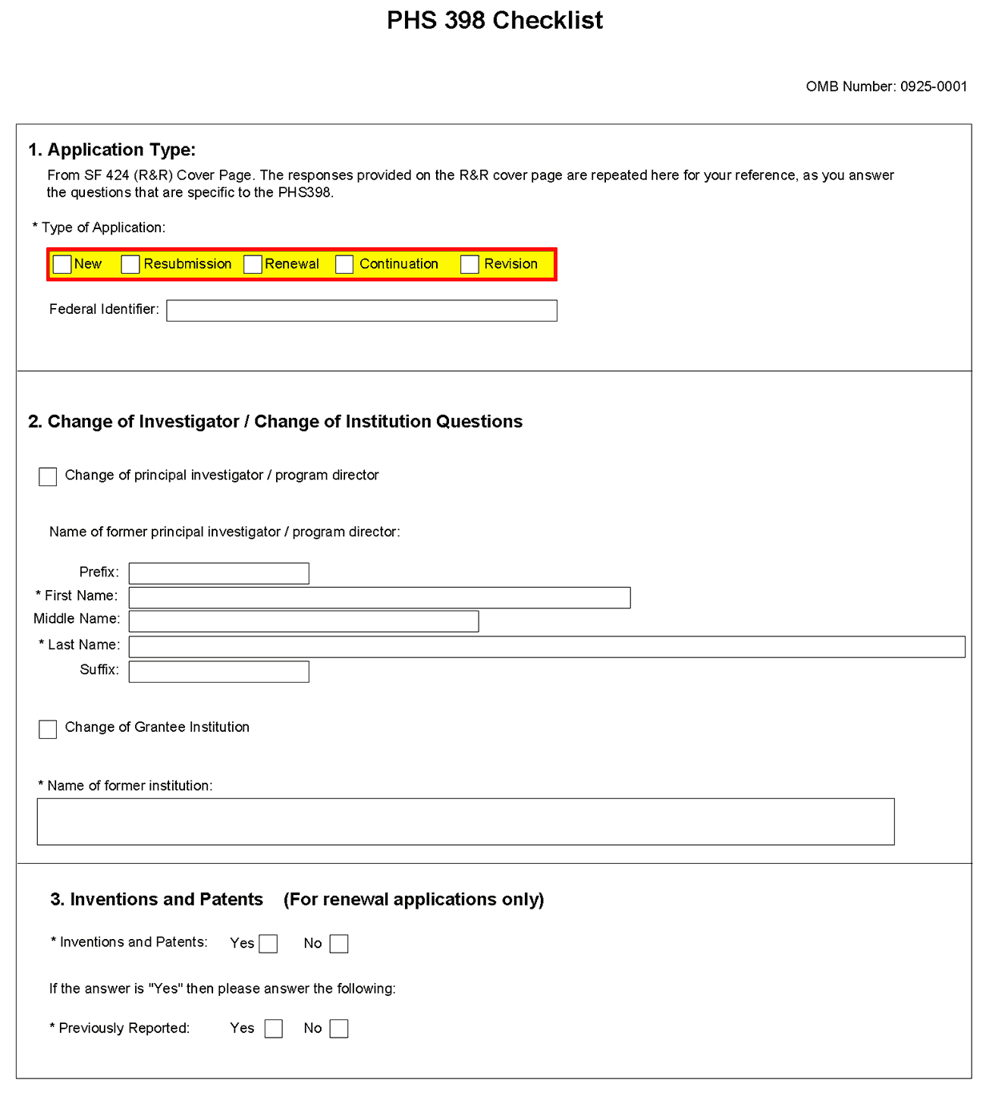
1. Application Type
Field Name | Instructions
Type of Application | This field is pre-populated from the SF424 (R&R) Cover Component. Corrections to this field must be made in that component.
Federal Identifier | This field is pre-populated from the SF424 (R&R). Corrections to this field must be made in that component. For New applications this field will be blank.
2. Change of Investigator/Change of Institution Questions
Field Name | Instructions
Change of Program Director/Principal Investigator | Check this box if this application reflects a change in PD/PI from the one who was indicated on a previous application. This is not generally applicable to a “New” application.
Prefix | If this application reflects a change in PD/PI, enter the name prefix (for example, Mr., Mrs., Rev.) of the former PD/PI.
First Name | If this application reflects a change in PD/PI, enter the first name of the former PD/PI.
Middle Name | If this application reflects a change in PD/PI, enter the middle name of the former PD/PI.
Last Name | If this application reflects a change in PD/PI, enter the last name of the former PD/PI.
Suffix | If this application reflects a change in PD/PI, provide the suffix (for example, Jr., Sr., PhD) of the former PD/PI.
Change of Grantee Institution | Check this box if this application reflects a change in grantee institution from the one that was indicated on a previous application. This is not generally applicable to a “New” application.
Name of Former Institution | If this application reflects a change in grantee institution, enter the name of the former institution.
3. Inventions and Patents (For renewal applications only)
Field Name | Instructions
Inventions and Patents | This block need only be completed if submitting an R&R “Renewal” application. If no inventions were conceived or reduced to practice during the course of work under this project, check the No box. The remaining parts of the item are then not applicable. If any inventions were conceived or reduced to practice during the previous period of support, check the Yes box.
Previously Reported | If you checked the Yes box for Inventions and Patents, above, indicate whether this information has been reported previously to the PHS or to the applicant organization official responsible for patent matters.

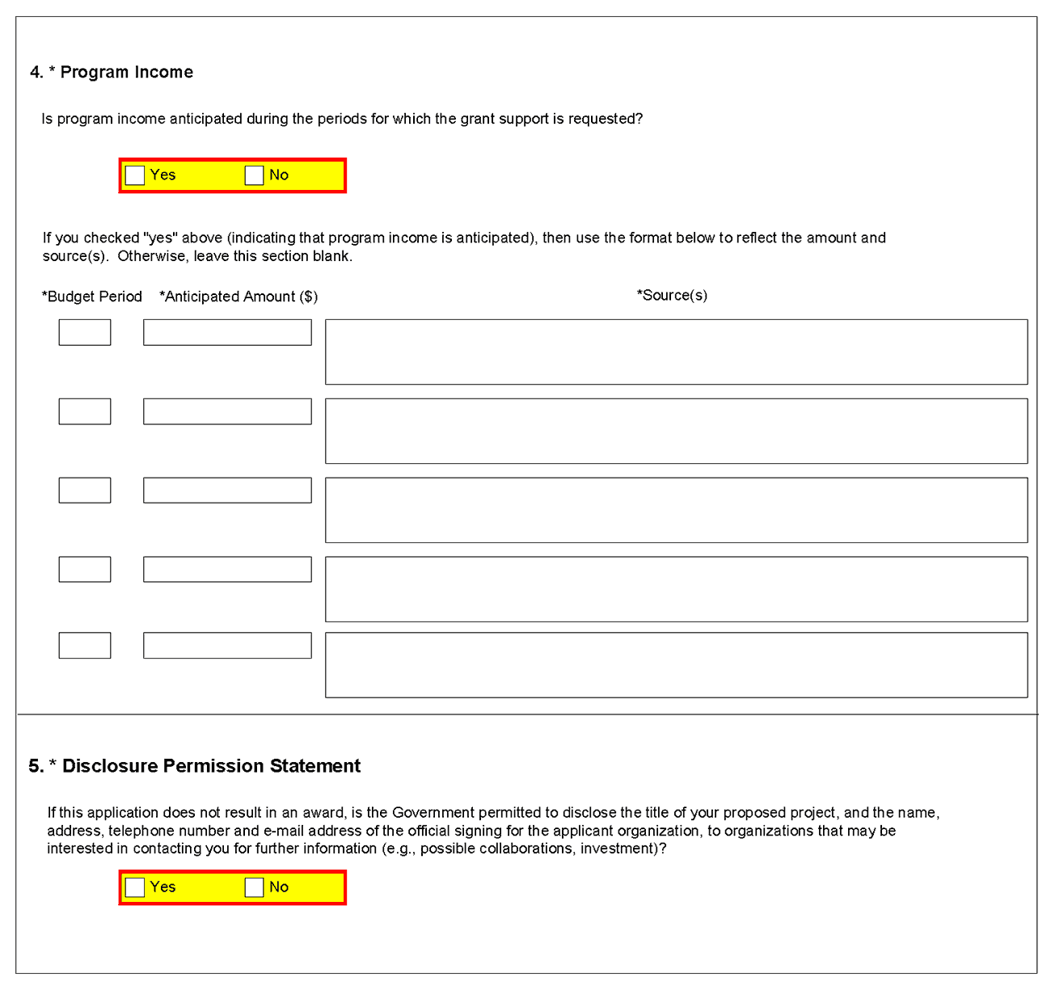
4. Program Income
Field Name | Instructions
Is program income anticipated during the periods for which the grant support is requested? | If program income is anticipated during the periods for which the grant support is requested, check the Yes box, and then complete the section below. If no program income is anticipated, check the No box and leave the following section blank.
Budget Period | If program income is anticipated, enter the budget periods. If the application is funded, the Notice of Award will provide specific instructions regarding the use of such income.
Anticipated Amount ($) | If program income is anticipated, enter the amount anticipated for each budget period listed.
Source(s) | If program income is anticipated, enter the source for each budget period listed.
5. Disclosure Permission Statement
If this application does not result in an award, and the Government is permitted to disclose the title of your proposed project, and the name, address, telephone number, and e-mail address of the official signing for the applicant organization, to organizations that may be interested in contacting you for further information (e.g., possible collaborations, investment), check the Yes box. Otherwise check the No box. A selection is required.
Your response will not affect any peer review or funding decisions.

Once all data have been entered use the scroll bar to scroll up. You will be returned to the Grant Application Package screen. To remove a document from the Submission box, click the document name to select it and then click the Move Form to Delete button. This will return the document to the Mandatory Documents Submission List or Optional Documents Submission List.

6. Peer Review Process

Overview
NIH policy is intended to ensure that applications for funding submitted to the NIH are evaluated on the basis of a process that is fair, equitable, timely, and conducted in a manner free of bias. The NIH dual peer review system is mandated by statute in accordance with section 492 of the Public Health Service Act and federal regulations governing "Scientific Peer Review of Research Grant Applications and Research and Development Contract Proposals" (42 CFR part 52h).
The first level of review is carried out by a Scientific Review Group (SRG) composed primarily of non-federal scientists who have expertise in relevant scientific disciplines and current research areas. The second level of review is performed by Institute and Center (IC) National Advisory Councils or Boards. Councils composed of both scientific and lay members are chosen for their expertise, interest, or activity in matters related to health and disease. Only applications that are favorably recommended by both the SRG and the Advisory Council may be recommended for funding. Only the NIH Institute or Center may make actual funding decisions.
A detailed description of what happens to a research project grant application after it is received for peer review can be found at the following location: http://grants.nih.gov/grants/peer_review_process.htm. Additional information about charters and membership of SRGs, Councils, and Boards can be obtained from the appropriate agency. Information on CDC review procedures is located at http://www.cdc.gov/phpr/science/erp_policies.htm.

Discussed and Nondiscussed Applications
The initial scientific peer review of most applications will also include a process in which only those applications deemed by the reviewers to have the highest scientific and technical merit, generally the better half of the applications under review, will be discussed at the SRG meeting, assigned an impact score, and receive a second level review. Applications in the lower half are reviewed by SRG members but they are not discussed or scored at the SRG meeting. This process allows the reviewers to focus their discussion on the most meritorious applications.
Before the review meeting, each reviewer and discussant assigned to an application will give a separate score for each of the five core review criteria and a preliminary impact score for that application (see below). The preliminary impact scores will be used to determine which applications will be discussed.

Scoring
SRG members are instructed to evaluate research applications by addressing the five core review criteria (see below) and additional review criteria as applicable for the application. However, Requests for Applications (RFAs) and other types of funding opportunities (e.g., construction grants and fellowship applications) may list different and/or additional review criteria and considerations.
For each application that is discussed, a final overall impact/priority score will be given by each eligible committee member (without conflicts of interest) following the panel discussion. Each member’s impact score will reflect his/her evaluation of the overall impact of the project in its entirety, rather than an arithmetic formula applied to the reviewer’s scores given to each criterion. The final impact score for each discussed application will be determined by calculating the arithmetic average of all the eligible members’ impact scores, and multiplying the average by 10.
As part of the initial merit review, and regardless of whether an application is discussed or not discussed (streamlined), all applicants will receive a written critique, called a Summary Statement, unless stated otherwise in the FOA. The Summary Statement represents a combination of the reviewers' written comments and scores for individual criteria. The Summary Statement for discussed applications includes the Scientific Review Officer's summary of the members' discussion during the SRG meeting; the final impact score; the recommendations of the SRG, including budget recommendations; and administrative notes of special considerations. For applications that are not discussed by the full committee, the scores of the assigned reviewers and discussants for the five core criteria will be reported individually on the Summary Statement. Final impact scores are not given for applications that are not discussed.

Research Project Evaluation Criteria
Overall Impact. Reviewers will provide an overall impact/priority score to reflect their assessment of the likelihood for the project to exert a sustained, powerful influence on the research field(s) involved, in consideration of the following five core review criteria, and additional review criteria (as applicable for the project proposed).
Core Review Criteria. Reviewers will consider each of the five review criteria below in the determination of scientific and technical merit, and give a separate score for each. An application does not need to be strong in all categories to be judged likely to have major scientific impact. For example, a project that by its nature is not innovative may be essential to advance a field.
Significance: Does the project address an important problem or a critical barrier to progress in the field? If the aims of the project are achieved, how will scientific knowledge, technical capability, and/or clinical practice be improved? How will successful completion of the aims change the concepts, methods, technologies, treatments, services, or preventative interventions that drive this field?
Investigator(s): Are the PD/PIs, collaborators, and other researchers well suited to the project? If Early Stage Investigators or New Investigators, do they have appropriate experience and training? If established, have they demonstrated an ongoing record of accomplishments that have advanced their field(s)? If the project is collaborative or multi-PD/PI, do the investigators have complementary and integrated expertise; are their leadership approach, governance and organizational structure appropriate for the project?
Innovation: Does the application challenge and seek to shift current research or clinical practice paradigms by utilizing novel theoretical concepts, approaches or methodologies, instrumentation, or interventions? Are the concepts, approaches or methodologies, instrumentation, or interventions novel to one field of research or novel in a broad sense? Is a refinement, improvement, or new application of theoretical concepts, approaches or methodologies, instrumentation, or interventions proposed?
Approach: Are the overall strategy, methodology, and analyses well-reasoned and appropriate to accomplish the specific aims of the project? Are potential problems, alternative strategies, and benchmarks for success presented? If the project is in the early stages of development, will the strategy establish feasibility and will particularly risky aspects be managed?
If the project involves clinical research, are the plans for 1) protection of human subjects from research risks, and 2) inclusion of minorities and members of both sexes/genders, as well as the inclusion of children, justified in terms of the scientific goals and research strategy proposed?
Environment: Will the scientific environment in which the work will be done contribute to the probability of success? Are the institutional support, equipment and other physical resources available to the investigators adequate for the project proposed? Will the project benefit from unique features of the scientific environment, subject populations, or collaborative arrangements?
Additional Review Criteria. As applicable for the project proposed, reviewers will consider the following additional items in the determination of scientific and technical merit, but will not give separate scores for these items.
Protections for Human Subjects: For research that involves human subjects but does not involve one of the six categories of research that are exempt under 45 CFR part 46, the committee will evaluate the justification for involvement of human subjects and the proposed protections from research risk relating to their participation according to the following five review criteria: 1) risk to subjects, 2) adequacy of protection against risks, 3) potential benefits to the subjects and others, 4) importance of the knowledge to be gained, and 5) data and safety monitoring for clinical trials.
For research that involves human subjects and meets the criteria for one or more of the six categories of research that are exempt under 45 CFR part 46, the committee will evaluate: 1) the justification for the exemption, 2) human subjects involvement and characteristics, and 3) sources of materials.
Inclusion of Women, Minorities, and Children: When the proposed project involves clinical research, the committee will evaluate the proposed plans for inclusion of minorities and members of both genders, as well as the inclusion of children.
Vertebrate animals: The committee will evaluate the involvement of live vertebrate animals as part of the scientific assessment according to the following five points: 1) proposed use of the animals, and species, strains, ages, sex, and numbers to be used; 2) justifications for the use of animals and for the appropriateness of the species and numbers proposed; 3) adequacy of veterinary care; 4) procedures for limiting discomfort, distress, pain and injury to that which is unavoidable in the conduct of scientifically sound research including the use of analgesic, anesthetic, and tranquilizing drugs and/or comfortable restraining devices; and 5) methods of euthanasia and reason for selection if not consistent with the AVMA Guidelines on Euthanasia. For additional information, see http://grants.nih.gov/grants/olaw/VASchecklist.pdf.
Biohazards: Reviewers will assess whether materials or procedures proposed are potentially hazardous to research personnel and/or the environment, and if needed, determine whether adequate protection is proposed.
Resubmission Applications: When reviewing a Resubmission application the committee will evaluate the application as now presented, taking into consideration the response to comments from the previous scientific review group and changes made to the project.
Renewal Applications: When reviewing a Renewal application, the committee will consider the progress made in the last funding period.
Revision Applications: When reviewing a Revision application, the committee will consider the appropriateness of the proposed expansion of the scope of the project. If the Revision application relates to a specific line of investigation presented in the original application that was not recommended for approval by the committee, then the committee will consider whether the responses to comments from the previous scientific review group are adequate and whether substantial changes are clearly evident.
Additional Review Considerations. As applicable for the project proposed, reviewers will address each of the following items, but will not give scores for these items and should not consider them in providing an overall impact score.
Applications from Foreign Organizations. Reviewers will assess whether the project presents special opportunities for furthering research programs through the use of unusual talent, resources, populations, or environmental conditions that exist in other countries and either are not readily available in the United States or augment existing U.S. resources.
Select Agent Research. Reviewers will assess the information provided in this section of the application, including 1) the select agent(s) to be used in the proposed research, 2) the registration status of all entities where select agent(s) will be used, 3) the procedures that will be used to monitor possession use and transfer of select agent(s), and 4) plans for appropriate biosafety, biocontainment, and security of the select agent(s).
Resource Sharing Plans. Reviewers will comment on whether the following Resource Sharing Plans, or the rationale for not sharing the following types of resources, are reasonable: 1) Data Sharing Plan (http://grants.nih.gov/grants/policy/data_sharing/data_sharing_guidance.htm); 2) Sharing Model Organisms (http://grants.nih.gov/grants/guide/notice-files/NOT-OD-04-042.html); and 3) Genome Wide Association Studies (GWAS) (http://grants.nih.gov/grants/guide/notice-files/NOT-OD-07-088.html).
Budget and Period of Support. Reviewers will consider whether the budget and the requested period of support are fully justified and reasonable in relation to the proposed research

Dual-Level Peer Review
The second level of review will usually be performed by the Advisory Council or Board of the potential awarding component (Institute, Center, or other unit). Council or Board recommendations are based not only on considerations of scientific merit, as judged by the SRGs, but also on the relevance of the proposed study to an Institute/Center’s mission, programs and priorities.

7. Supplemental Instructions to the SF 424(R&R) for Preparing an Individual Research Career Development Award (CDA) Application (“K” Series)

7.1 Introduction
All applicants must use the SF 424 R&R Application for Federal Assistance, following the instructional information in this Application Guide. The supplemental instructions found in this section (I.7) are for Individual Career Development Award (CDA) series applications and include guidance and instructional information only when there is a difference in the required information to be submitted or there is a need for more specificity for the individual K program. Therefore, these supplemental instructions must be used along with the information found in Parts I.1 – I.6 of this document.
These instructions do not cover applications for K12 and other institutional career development programs. Institutions planning such applications should consult the applicable Funding Opportunity Announcement (FOA) concerning eligibility, award criteria, and application procedures. Some K-series funded through Requests for Applications (RFAs) may have special instructions.
It is imperative that applicants become familiar with the K activity code for which support is being requested. Before applying for a K award, applicants should carefully review the applicable FOA for the career award of interest, noting especially the eligibility requirements, requirements for a mentor, review criteria, award provisions, and any special application instructions. Each FOA contains more specific information associated with the award mechanism and includes names of individuals that may be contacted prior to submission of an application for additional or clarifying information.
The eligibility criteria, support levels, and other important aspects of specific career awards, including availability, may vary among NIH Institutes or Centers and other PHS agencies. For this reason, it is strongly recommended that applicants consult with the NIH Scientific/Research contact of the appropriate awarding component prior to submitting an application. FOAs and other guidelines are available on the NIH K-Kiosk Web site http://grants.nih.gov/training/careerdevelopmentawards.htm. Announcements for various career award opportunities are issued periodically in the NIH Guide for Grants and Contracts, a weekly electronic publication (http://grants.nih.gov/grants/guide/index.html).
Note: A few individual K-series programs supported by the NIH include a delayed-award activation and/or two award phases (e.g., K22, K99/R00). NIH intramural researchers may be eligible to apply for these awards. The FOA will include any additional and/or specific instructions that must be followed when applying for such support.

7.2 Individual Career Development Award Programs
The following chart provides a summary of the existing Career Development programs. Since this information is subject to change, prospective applicants are encouraged to review the K-Kiosk for the most current program information. The K-Kiosk includes information on NIH-wide Parent FOAs as well as IC-specific FOAs for a particular K program.

Summary of Research Career Development Award Programs
program | description | mentor | reference letters
K01 | Mentored Research Scientist Development Award (see K Kiosk) | Yes | Yes
K02 | Independent Scientist Award (see K Kiosk) | No | No
K05 | Senior Scientist Award (see K Kiosk) | No | No
K07 | Academic Career Award (see K Kiosk) | * | *
K08 | Mentored Clinical Scientist Development Award (see K Kiosk) | Yes | Yes
K18 | Career Enhancement Award (see K Kiosk) | Yes | Yes
K22 | Career Transition Award (see K Kiosk) | * | Yes
K23 | K23 Mentored Patient-Oriented Research Career Development Award (see K Kiosk) | Yes | Yes
K24 | Mid-Career Investigator Award in Patient Oriented Research (see K Kiosk) | No | No
K25 | Mentored Quantitative Research Career Development Award (see K Kiosk) | Yes | Yes
K26 | Midcareer Investigator Award in Mouse Pathobiology Research (see K Kiosk) | No | No
K99/R00 | NIH Pathways to Independence (PI) Award (see K Kiosk) | Yes | Yes
*Varies with career status and source of award. Check the Funding Opportunity Announcement (FOA).

7.3 Letters of Reference (must be submitted electronically through the eRA Commons)
At least three (but no more than 5) Letters of Reference are required for all applications defined as New and Resubmissions (see Note below) for mentored support as indicated in the table above. The letters should be from individuals not directly involved in the application, but who are familiar with the applicant’s qualifications, training, and interests. The mentor/co-mentor(s) of the application cannot be counted toward the three required references. It is important for the applicant to include the names of those individuals in the application so that the NIH staff will be aware of planned reference letter submissions. Within the application, the list of referees (including name, departmental affiliation, and institution) is included in the Other Project Information Component, Item 12. Other Attachments (see special K instructions in Section 7.4.3). In addition, applicants must include the same list and information in the PHS Cover Letter.
The reference letters are critically important and should address the candidate's competence and potential to develop into an independent biomedical or behavioral investigator. Only those individuals who can make the most meaningful comments about the candidate's professional training and qualifications for a research career should be used as referees. Where possible, some referees who are not from the candidate's current department or organization, but are knowledgeable about their qualifications, should be selected.
Letters of Reference are due by the application receipt deadline date. Although previously NIH provided a 5 business days grace period for the receipt of letters of reference after the application receipt due date, the new policy eliminates the grace period. More information can be found in NIH Guide Notice NOT-OD-11-079.
The candidate should request reference letters only from individuals who will be able to submit them to the NIH by the application submission due date.
Applications that are missing the required letters of reference may be delayed in review or may not be accepted.
Note: For resubmission applications, it is critical that NEW Letters of Reference be submitted providing up-to-date evaluation of the applicant’s potential to become an independent researcher, and the continued need for additional supervised research experience.
Electronic submission of a letter of reference is a separate process from submitting an application electronically. Reference letters are submitted directly through the eRA Commons and do not use Grants.gov. Therefore, this process requires that the referee be provided information including (a) the PI’s (candidate’s) eRA Commons user name, (b) the PI’s first and last name as they appear on the PI’s eRA Commons account, and (c) the number assigned to this Funding Opportunity Announcement.
Confirmation e-mails will be sent to both the referee and the candidate following reference letter submission. The confirmation sent to the candidate will include the referee’s name and the date the letter was submitted. The confirmation sent to the referee will include the referee and applicant’s names, a confirmation number, and the date the letter was submitted.
The candidate may check the status of submitted letters by logging into their Commons account and accessing the “check status” screen for this application. The candidate is responsible for reviewing the status of submitted reference letters and contacting referees to ensure that letters are submitted by the receipt deadline. While the candidate is able to check on the status of the submitted letters, the letters are confidential and he/she will not have access to the letters themselves. Note: Because e-mail can be unreliable, it is the candidate’s responsibility to check the status of his/her letters of reference in the Commons.
Candidates should provide the following instructions to their referees.
Instructions for Referees: (these instructions are also found at: http://grants.nih.gov/grants/funding/424/Referee_Instructions_Mentored_Career_Awards.doc)
Name of Candidate (First & Last Name as shown in the eRA Commons): _______________
Candidate’s eRA Commons UserName: _______________
FOA Number: __________________________
The candidate is applying to the NIH for a Career Development Award. The purpose of this award is to develop the research capabilities and career of the candidate. These awards provide salary support and guarantee them the ability to devote at least 9 person months (75% of their total professional effort) to research for the duration of the award. Many of these awards also provide funds for research and career development costs. The award is available to persons who have demonstrated considerable potential to become independent researchers, but who need additional supervised research experience in a productive scientific setting, as well as to newly independent researchers.
In two pages or less (PDF format), describe the qualities and potential of the candidate for the career development award program for which support is being requested. This should include your evaluation with special reference to:
- potential for conducting research;
- evidence of originality;
- adequacy of scientific background;
- quality of research endeavors or publications to date, if any;
- commitment to health-oriented research; and
- need for further research experience and training
- any additional related comments that the referee may wish to provide
Please put the name of the candidate at the top of the letter. Also, be sure to include your name and title in the letter.
Submitting Reference Letters
Letters must be submitted directly to the eRA Commons at: https://commons.era.nih.gov/commons/ reference/submitRefereeInformation.jsp and must be submitted by the application receipt deadline date. More information can be found in NIH Guide Notice NOT-OD-11-079.
You will be requested to enter the following information on-line at the time of submission:
Referee Information:
- Referee First Name (Required)
- Referee Last Name Required)
- Referee MI Name (Not Required)
- Referee e-mail (Required)
- Referee institution/affiliation (Required)
- Referee department (Required)
Candidate Information:
- PI Commons User ID (Required)
- PI’s last name, as it appears on the PI’s Commons account (Required) (will be validated to ensure they match)
- Funding Opportunity Announcement (FOA) Number (Required)
- Reference letter confirmation number (Required only if resubmitting a letter; not required otherwise)
- Reference letter – two pages maximum; PDF format
After you have submitted your letter, both you and the candidate will receive a confirmation of receipt by e-mail. The confirmation sent to the candidate will include your name and the date your letter was submitted. However, the letters are confidential and the candidate will not be able to access the letters themselves. Your e-mail confirmation will include a Reference Letter Submission Confirmation Number. The Confirmation Number will be required when resubmitting letters for the current round. Please print the confirmation e-mail for your records.
Revised reference letters must be submitted by the application receipt date.

7.4 K- Specific Instructions for K Applications using the SF424 (R&R) Application
Standard Instructions found in Parts I.1 – I.6 should be followed with the exceptions found in this section. Section numbers referenced below (e.g. 4.2 – 5.6) reflect those found in Part I.

7.4.1 Special Instructions for 4.2 Cover Component
Item 8. Type of Application: Unless stated in the applicable FOA, individual K awards are usually not renewable nor are they supplemented/revised (contact awarding component staff if clarification is needed). Therefore, the applicant should generally check “new” or “resubmission.” “Renewal” applications are accepted only for a few K programs; thus this value should only be checked if a specific FOA states Renewals are accepted.
Item 12. Proposed Project (Start and Ending Dates): The requested period of support must be within specified limits for the type of K award requested.
Item 14. Project Director/Principal Investigator (PD/PI) Contact Information: Provide the name of the individual candidate (considered the PD/PI for K award programs). If the candidate is not located at the applicant organization at the time the application is submitted, the information in Item 14 should reflect where the candidate can be reached prior to the requested award start date in item 12. If the PD/PI is not located at the applicant organization at the time of submission, the Commons account for the PD/PI must be affiliated with the applicant organization. For additional information on creating affiliations for users in the eRA Commons, see: https://commons.era.nih.gov/commons-help/175.htm.
Note: For some career transition award programs (e.g., K22) the applicant may apply WITHOUT an institutional affiliation. These individuals should refer to the specific funding opportunity announcement (FOA) for application instructions.

7.4.2 Special Instructions for 4.3 Research & Related Project/Performance Site Locations Component
Indicate where the work described in the Research and Career Development Plans will be conducted.

7.4.3 Special Instructions for 4.4 Other Project Information Component
Item 7. Project Summary/Abstract (Do not exceed 1 page): Provide an abstract of the entire application (candidate, environment, and research). Include the candidate's immediate and long-term career goals, key elements of the research career development plan, and a description of the research project, as indicated in Part I.4.4.6.
Item 10. Facilities & Other Resources: Provide in the Attachment a detailed description of the institutional facilities and resources available to the candidate, following the instructions in Part I.4.4.10. The information provided is of major importance in establishing the feasibility of the goals of the career development plan.
Item 12. Other Attachments: All mentored K applications must include a list of Referees here. The list should include the name of the referee, departmental affiliation and institution. This same list must also be provided in the Cover Letter Component.

7.4.4 Special Instructions for 4.5 Senior/Key Person Profile(s) Component

7.4.4.1 The Candidate
For all K applications the K candidate is considered the Project Director/Principal Investigator (PD/PI). Therefore the candidate must be registered in the eRA Commons and be assigned the PI role within the Commons. Follow the instructions in Part I.2 which provides information regarding required registration in the eRA Commons.
Note that agency policies concerning “Multiple PIs” are not applicable to K applications. Therefore, do not use the PD/PI role for any other senior/key personnel.

Candidate’s Biographical Sketch
A biographical sketch attachment (limited to 4 pages) is required for the K candidate.
A biosketch for the K applicant should follow the instructions below:
Position Title: If the candidate is not currently located at the applicant organization, include both “current” and “projected” position titles, labeling each accordingly.
Education: Complete the educational block at the top of the format page beginning with the baccalaureate or other initial professional education, such as nursing, and include postdoctoral training; separately referencing residency training when applicable. For each entry provide the name and location of the institution;, the degree received (if applicable); the month and year the degree was received, and the field of study. For residency entries, the Field of Study section should reflect the area of residency. For non-degree education, indicate the time period covered. List professional certifications received within the last 10 years.
Personal Statement: Briefly describe why your experience and qualifications make you particularly well-suited to receive the K award for which you are applying.

Research and/or Professional Experience:
Use the headings given below instead of the instructions on the Biographical Sketch Format Page. Identify each heading.

Employment
Start with the first position held following the baccalaureate and give a consecutive record to date. Indicate the department and organization, department head or supervisor, rank, tenured or non-tenured, status (full- or part-time), and inclusive dates (month and year). When applicable, include information on military service, and, if not referenced under Education above, internships, residencies, research assistantships, fellowships, etc. If the candidate is not currently located at the applicant organization, include the projected employment position in this section as well.

Honors
List academic and professional honors chronologically, including research grants and competitive fellowships awarded to the candidate.

Professional Societies and Public Advisory Committees
Identify professional societies and related organizations in which membership has been held within the last 10 years, giving dates. Include present membership on any Federal Government public advisory committee.

Publications
NIH encourages applicants to limit the list of selected peer-reviewed publications or manuscripts in press to no more than 15. The individual may choose to include selected publications based on recency, importance to the field, and/or relevance to the candidate’s proposed research. Candidates without 15 publications may substitute the following in lieu of publications:
  - Original research and theoretical treatises;
  - Non-experimental articles, e.g., review of literature in field, book chapters, etc.;
  - Books, pamphlets, etc.
For each publication, list the authors in published sequence, full title of article, journal, volume number, page numbers, and year of publication. Indicate if you previously used another name that is reflected in any of the citations. URLs or NIH PubMed Central (PMC) submission identification numbers may be included along with the full reference. While there is no limit to the number of URLs or PMC submission identification numbers that can be cited, applicants should be both judicious and concise.
Do not include manuscripts submitted or in preparation.
When citing articles that fall under the Public Access Policy, were authored or co-authored by the applicant and arose from NIH support, provide the NIH Manuscript Submission reference number (e.g., NIHMS97531) or the PubMed Central (PMC) reference number (e.g., PMCID234567) for each article. If the PMCID is not yet available because the Journal submits articles directly to PMC on behalf of their authors, indicate "PMC Journal - In Process." A list of these Journals is posted at: http://publicaccess.nih.gov/submit_process_journals.htm. Citations that are not covered by the Public Access Policy, but are publicly available in a free, online format may include URLs or PubMed ID (PMID) numbers along with the full reference (note that copies of publicly available publications are not accepted as appendix material.)

Research Support
List both selected ongoing and completed (during the last three years) research projects (Federal or non-Federal support). Begin with the projects that are most relevant to the research proposed in this application. Briefly indicate the overall goals of the projects and responsibilities of the senior/key person identified on the Biographical Sketch. Do not include number of person months or direct costs.
Don’t confuse “Research Support” with “Other Support.” Though they sound similar, these parts of the application are very different. As part of the biosketch section of the application, “Research Support” highlights your accomplishments, and those of your colleagues, as scientists. This information will be used by the reviewers in the assessment of each individual’s qualifications for a specific role in the proposed project, as well as to evaluate the overall qualifications of the research team. In contrast, “Other Support” information is required for all applications that are selected to receive grant awards. NIH staff will request complete and up-to-date “other support” information from you after peer review. This information will be used to check that the proposed research has not already been Federally-funded.

7.4.4.2 Mentor, Co-mentor, and Other Senior/Key Persons
The mentored K awards require a primary mentor, and there may be co-mentor(s), consultants and contributors. All individuals who have committed to contribute to the scientific development and execution of the project, including mentors and co-mentors, should be identified as senior/key personnel, even if they are not committing any specified measurable effort to the proposed project. Mentors and co-mentors should be assigned the Project Role of “Other Professional” and then enter “Mentor” or “Co-mentor” in the Other Project Role Category field.
Consultants should also be assigned the “Other Professional” role even if they are not committing any specified measurable effort. Then, enter the specific project role under “Other Project Role Category.”
Any individuals identified as senior/key personnel who are committing specified measurable effort should be appropriately assigned under Project Role (and Other Project Role Category, if necessary). Additional information can be found in Section 4.5.1.
Current and Pending Support for Mentors/Co-mentors: For Mentored Career Development Awards, as part of the application submission modified Current and Pending Support pages must be submitted for the mentor and co-mentor(s), but not for the candidate, on the R&R Senior/Key Person Profile (Expanded) page. Provide information on the following selected items for the mentor’s and co-mentor’s current and pending research support relevant to the candidate’s research plan. Each attachment is limited to 4 pages. Note, Current and Pending Support for the Candidate will be requested on a Just-In-Time basis.

Special Instructions for Selected Items of Current & Pending Support for Mentor/Co-Mentors
Project Number: If applicable, include a code or identifier for the project.
Source: Identify the agency, institute, foundation, or other organization that is providing the support.
Major Goals: Provide a brief statement of the overall objectives of the project, subproject, or subcontract.
Dates of Approved/Proposed Project: Indicate the inclusive dates of the project as approved/proposed. For example, in the case of NIH support, provide the dates of the approved/proposed competitive segment.
Annual Direct Costs: In the case of an active project, provide the current year’s direct cost budget. For a pending project, provide the proposed direct cost budget for the initial budget period.
Do not include information on overlap and level of effort.
For non-mentored CDAs: Candidates for non-mentored CDAs should not submit Other Support Pages at the time of application unless specified to do so in the applicable FOA.
Updated information on all active support for the candidate, mentor(s), co-mentor(s), and senior/key personnel may be requested by the awarding component prior to award.
Biographical Sketch for Mentor/Co-mentor and Other Senior/Key Person: For the biographical sketch for all individuals other than the candidate, follow the biographical sketch instructions found in Part I.4.5.
Note: K22 and K99/R00 candidates should follow instruction in the specific FOA regarding senior/key personnel.

7.4.5 Special Instructions for 4.6 Selecting the Appropriate Budget Component
K award mechanisms are not modular; therefore, only the R&R budget component is applicable and only a few budget categories are actually used. Information regarding allowable costs for the candidate and any allowable research development or other costs is included in each K program FOA. Candidates are advised to contact the targeted awarding component if uncertain about allowable amounts for the applicable K award mechanism, keeping in mind that amounts vary with awarding components. The application forms package associated with CDA funding opportunities includes the R&R Budget Component.
Instructions for completing the R&R Budget Component are provided below. Additional guidance may also be provided in the specific funding opportunity announcement.
Note: NIH intramural candidates applying for transitional career award support (e.g., K22, K99/R00) should follow instructions in the applicable FOA. For the mentored phase of these awards, budgets are negotiated with the sponsoring intramural laboratory. For awardees who receive approval to transition to the extramural phase, a budget will be required as part of the extramural sponsored application.

7.4.6 Special Instructions for 4.7 R&R Budget Component
Follow the instructions provided in Part I.4.7 with the following exceptions:
4.7.1. A. Senior/Key Person: In general this section should include the name of the candidate only. Do not include the mentor(s) or any other senior/key persons. For the candidate, provide the base salary, person months, and requested salary and fringe benefits. For person months, be reminded that K programs include a minimum effort requirement, usually 75% or 9 academic person months. For the salary column, most NIH ICs limit the amount of salary provided for K programs. However, applicants should include information on actual institutional base salary and the actual amount of salary and fringe being requested. ICs may request updated salary information prior to award. Any adjustments based on policy limitations will be made at the time of the award.
4.7.1. B. Other Personnel: In general, leave this section blank.
4.7.2. C – E: Leave these sections blank.
4.7.3 F. Other Direct Costs: In the Material and Supplies field (F.1), enter the total research development support being requested for the initial year of the K award. Usually, a specific total amount is allowed for research development and other costs (tuition, fees, research supplies, equipment, computer time, travel, etc) that do not require individual cost category identification. Unless instructed differently in the applicable FOA, applicants should enter only the total requested research development support amount in this box. All remaining budget fields in this section should be left blank.
Please note that while this method of entering only the total requested research development support (RDS) costs in section F will be simplest for most applicants, some applicants, including some system-to-system applicants, may instead choose to enter those costs in the applicable detailed budget categories. Please note that when choosing this option it is still the applicant’s responsibility to make certain the total RDS costs do not exceed the allowable total. If there are no costs within the research development support costs that affect the Indirect Cost Base calculation, the total RDS should be entered in total in F.1.
4.7. 3. H. Indirect Costs: For all K applications, F&A/indirect costs are reimbursed at 8% of modified total direct costs (exclusive of tuition and fees and expenditures for equipment) rather than on the basis of a negotiated rate agreement. Follow the instructions in the chart below for completing this section.

Field Name | Instructions
Indirect Cost Type | Indicate the Indirect Cost type as Modified Total Direct Costs.
Indirect Cost Rate (%) | Indicate the indirect cost rate (also known as Facilities & Administrative Costs [F&A]) as 8%.
Indirect Cost Base ($) | Enter the amount of the base for the indirect cost type.
Funds Requested | Enter the funds requested for the indirect cost type.
Total Indirect Costs | The total funds requested for indirect costs.
Cognizant Federal Agency | Enter ‘Not Applicable.’ Alternatively, applicants may provide the name of the cognizant Federal agency, name, and phone number of the individual responsible for negotiating your rate. Either response is acceptable since indirect costs will be reimbursed as 8% of modified total direct costs rather than on the basis of a negotiated rate agreement.

4.7.3.K Budget Justification: Use this to provide a detailed description and justification for specific items within the Research Development Support costs; e.g., all equipment, supplies, and other personnel that will be used to help achieve the career development and research objectives of this award.

7.4.7 Special Instructions for 5. Completing PHS 398 Components

5.1 Overview
In conjunction with the SF424 (R&R) components, NIH and other PHS agencies grants applicants should also complete and submit additional components titled “PHS 398.” Note the PHS 398 components include additional data required by the agency for a complete application. While these are not identical to the PHS 398 application form pages, the PHS 398 reference is used to distinguish these additional data requirements from the data collected in the SF424 (R&R) components. A complete application to NIH and other PHS agencies will include SF424 (R&R) and PHS 398 components. The PHS 398 components for the individual K programs include:
- PHS Cover Letter Component (I.5.2): required for mentored K awards – must include a list of references; optional for independent K awards, however applicants are strongly encouraged to include this component
- PHS 398 Cover Page Supplement(I.5.3): this supplements the data requirements in the R&R Cover component. Note there are no K specific instructions for this component. Follow the instructions found in Part I.5.3.
- PHS 398 Checklist Component (I.5.6): See K specific instructions below.
- PHS 398 Career Development Award Supplemental Form (I.7.5)
Complete each component using the instructions found in Part I.5 and the K specific instructions provided below.

5.2 Cover Letter Component
Mentored CDA applicants must include a cover letter. Applicants for independent CDAs are encouraged to include a cover letter with the application. The cover letter is only for internal use and will not be shared with peer reviewers. For mentored CDA applications, the cover letter must contain the same list of Referees (including name, departmental affiliation, and institution) that is included in the Other Project Information Component Item 12. Other Attachment (see Part I Section 7.4.3).
For both mentored and non-mentored K applications, the cover letter can also include the information found in Part I.5.2.

5.6 Checklist Component
2. Change of Investigator / Change of Institution Questions: A change in PD/PI is not allowed for K awards.

7.5 PHS 398 Career Development Award Supplemental Form
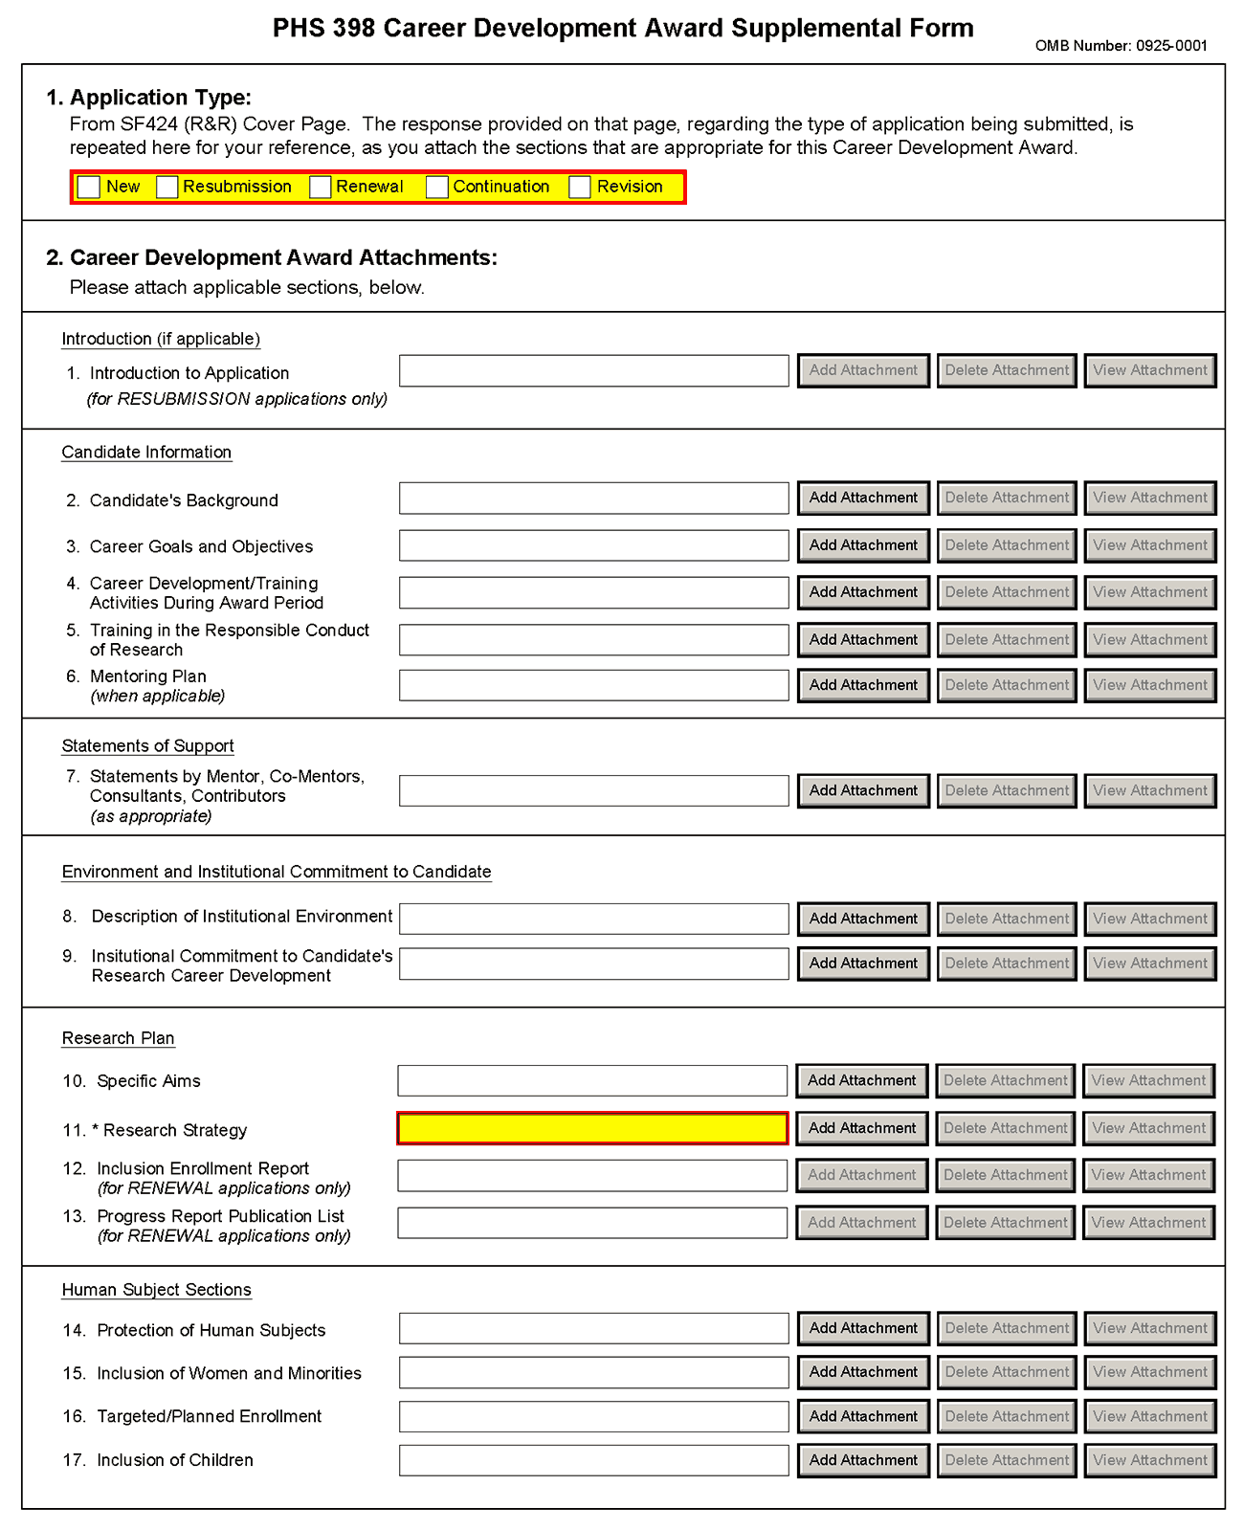
The PHS 398 CDA Supplemental Form should include sufficient information needed for evaluation of the project, independent of any other document (e.g., previous application). Be specific and informative, and avoid redundancies. Some sections are required for all K award applications and some sections are only to be used when required by the FOA. Be sure to read all instructions in the FOA before completing this section since errors could lead to incomplete or rejected applications.

1. Application Type
This field is pre-populated from the SF424 (R&R) Cover Component. Corrections to this field must be made in that component.
2. Career Development Award Attachments (See also Section 2.3.2 Creating PDFs for Text Attachments)
Although many of the sections of this application are separate PDF attachments, page limits referenced in the instructions and/or funding opportunity announcement must still be followed. Agency validations will include checks for page limits (and use of appropriate font). Some accommodation will be made for sections that, when combined, must fit within a specified limitation.
Text attachments should be generated using word processing software and then converted to PDF using PDF generating software. Avoid scanning text attachments to convert to PDF since that causes problems for the agency handling the application. In addition, be sure to save files with descriptive file names.
Do not include any information in a header or footer of the attachments. A header will be system-generated that references the name of the PD/PI. Page numbers for the footer will be system-generated in the complete application, with all pages sequentially numbered.
Since a number of reviewers will be reviewing applications as an electronic document and not a paper version, applicants are strongly encouraged to use only a standard, single-column format for the text. Avoid using a two-column format since it can cause difficulties when reviewing the document electronically.
Full-sized glossy photographs of material such as electron micrographs or gels must only be included within the page limits of the Career Development Award application. The maximum size of images to be included should be approximately 1200 x 1500 pixels using 256 colors. Figures must be readable as printed on an 8.5 x 11 inch page at normal (100%) scale.
Candidates must use image compression such as JPEG or PNG. Do not include figures or photographs as separate attachments either in the Appendix or elsewhere in the application.

Separate Attachments
Separate attachments have been designed for the Career Development Award Supplemental Form sections to maximize automatic validations conducted by the eRA system. When the application is received by the agency, all of the CDA Supplemental Form sections will be concatenated in the appropriate order so that reviewers and agency staff will see a single cohesive application.
When attaching a PDF document to the actual forms, please note you are attaching an actual document, not just pointing to the location of an externally stored document. Therefore, if you revise the document after it has been attached, you must delete the previous attachment and then reattach the revised document to the application form. Use the View Attachment button to determine if the correct version has been attached.

Page Limits
The total number of pages for Items 2 – 4 (Candidate’s Background, Career Goals and Objectives, and Career Development/Training Activities During Award Period) and Item 11 (Research Strategy) combined may not exceed 12 pages. Please note, Training in the Responsible Conduct of Research (Item 2.5) is not included in the 12 page limit. Rather, this section has its own separate page limit, and is limited to 1 page. All tables, graphs, figures, diagrams, and charts must be included within the 12-page limit (note that this may span to 15 pages in the eRA Commons application image due to white space inserted at the end of sections when separating files).
Follow page limitations as specified in Funding Opportunity Announcements (FOA).
All applications and proposals for NIH funding must be self-contained within specified page limits. Agency validations will include checks for page limits. Note that while these computer validations will help minimize incomplete and/or non-compliant applications, they do not replace the validations conducted by NIH staff. Applications found not to comply with the requirements may be delayed in the review process. Unless otherwise specified in an NIH solicitation, Internet Web site addresses (URLs) may not be used to provide information necessary to the review because reviewers are under no obligation to view the Internet sites. Moreover, reviewers are cautioned that they should not directly access an internet site as it could compromise their anonymity.
Applicants are prohibited from using the Appendix to circumvent page limitations in any section of the application for which a page limit applies.” For additional information regarding Appendix material and page limits, please refer to the NIH Guide Notice NOT-OD-11-080, http://grants.nih.gov/grants/guide/notice-files/NOT-OD-11-080.html.

Notice of Proprietary Information
Applicants are discouraged from submitting information considered proprietary unless it is deemed essential for proper evaluation of the application. However, when the application contains information that constitutes trade secrets, or information that is commercial or financial, or information that is confidential or privileged, make sure you have checked the “Yes” box of question #3 in the “Other Project Information” component. Identify the pages in the application that contain this information by marking those paragraphs or lines with an asterisk (*) in the left-hand margin. Include a legend at the beginning of Section 2, similar to “The following sections marked with an asterisk contain proprietary/privileged information that (name of Applicant) requests not be released to persons outside the Government, except for purposes of review and evaluation.”
When information in the application constitutes trade secrets or information that is commercial or financial, or information that is confidential or privileged, it is furnished to the Government in confidence with the understanding that the information shall be used or disclosed only for evaluation of this application. If a grant is awarded as a result of or in connection with the submission of this application, the Government shall have the right to use or disclose the information to the extent authorized by law. This restriction does not limit the Government’s right to use the information if it is obtained without restriction from another source.

Research Plan
A Research Plan is required for all types of individual K awards. The Research Plan is a major component of the research career development plan. It is important to relate the research to the candidate's scientific career goals. Describe how the research, coupled with other developmental activities, will provide the experience, knowledge, and skills necessary to achieve the objectives of the career development plan and launch and conduct an independent research career, or enhance an established research career. For mentored K awards, explain the relationship between the candidate’s research on the CDA and the mentor’s ongoing research program.
For most types of research, the plan should include: a specific hypothesis; a list of the specific aims and objectives that will be used to examine the hypothesis; a description of the methods/approaches/techniques to be used in each aim; a discussion of possible problems and how they will be managed; and, when appropriate, alternative approaches that might be tried if the initial approaches do not work.
The Research Plan of a CDA is expected to be appropriate for, and tailored to the experience level of the candidate, and allow him/her to develop the necessary skills needed for further career advancement, and reviewers will evaluate the plan accordingly. The plan should be achievable within the requested time period. Pilot or preliminary studies and routine data gathering are generally not appropriate as the sole component(s) of a CDA research plan. Although candidates for mentored K awards are expected to write the Research Plan, the mentor should review a draft of the plan and discuss it in detail with the candidate. Review by other knowledgeable colleagues is also helpful. Although it is understood that CDA applications do not require the extensive detail usually incorporated into regular research applications, a fundamentally sound Research Plan and a reasonably detailed Approach section should be provided.
In general, less detail will be expected in descriptions of research planned for the future years of the proposed CDA. However, sufficient detail should be provided to enable the peer reviewers to determine that the plans for those years, including the approach to be used, are worthwhile and are likely to enable the candidate to achieve the objectives of the Research Plan.
The PHS 398 Career Development Award Supplemental Form is comprised of sections for: Candidate Information; Statement of Support (Mentors); Environment & Institutional Commitment to the Candidate; and the Research Plan (including Human Subjects and Other Research Plan Sections).
Begin each text section of the Candidate Information and Research Plan with a section header (e.g., Introduction, Specific Aims, Background & Significance, etc). See Specific FOA for additional information.
Field Name | Instructions
1. Introduction to Application (for Resubmissions only) | There is no time limit for the submission of a resubmission application (A1). See NIH Notice NOT-OD-09-003 and NOT-OD-09-016 for additional information/clarification of NIH policy.  Resubmission applications must include an Introduction to Resubmission Application, not to exceed one page. The Introduction must include responses to the criticisms and issues raised in the Summary Statement. Summarize the substantial additions, deletions, and changes. In the body of the application, highlight paragraphs with significant changes by bracketing and changing typography.  Save this information in a single file in a location you remember. Click Add Attachment, browse to where you saved the file, select the file, and then click Open.

Candidate Information
Field Name | Instructions
2. Candidate’s Background | The total number of pages for Items 2 – 4 and Item 11 (Research Strategy) combined may not exceed 12 pages, unless the FOA specifies otherwise.  Use this section to provide any additional information not described in the Biographical Sketch Format Page such as research and/or clinical training experience.  Save this information in a single file in a location you remember. Click Add Attachment, browse to where you saved the file, select the file, and then click Open.
3. Career Goals and Objectives | The total number of pages for Items 2 – 4 and Item 11 (Research Strategy) combined may not exceed 12 pages, unless the FOA specifies otherwise.  Describe your past scientific history, indicating how the award fits into past and future research career development. If there are consistent themes or issues that have guided previous work, these should be made clear; if your work has changed direction, the reasons for the change should be indicated. It is important to justify the award and how it will enable you to develop or expand your research career. You may include a timeline, including plans to apply for subsequent grant support.  Save this information in a single file in a location you remember. Click Add Attachment, browse to where you saved the file, select the file, and then click Open.
4. Career Development/ Training Activities During Award Period | The total number of pages for Items 2 – 4 and Item 11 (Research Strategy) combined may not exceed 12 pages, unless the FOA specifies otherwise.  Stress the new enhanced research skills and knowledge you will acquire as a result of the proposed award. If you have considerable research experience in the same areas as the proposed research, reviewers may determine that the application lacks potential to enhance your research career. For mentored awards, describe structured activities, such as course work or technique workshops, which are part of the developmental plan. If course work is included, provide course numbers and descriptive titles. Briefly discuss each of the activities, except research, in which you expect to participate. Include a percentage of time involvement for each activity by year, and explain how the activity is related to the proposed research and the career development plan.  Note that recipients of mentored K awards may receive concurrent support from an NIH research grant award or cooperative agreement only under certain conditions (see NIH Notice NOT-OD-08-065).  Save this information in a single file in a location you remember. Click Add Attachment, browse to where you saved the file, select the file, and then click Open.
5. Training in the Responsible Conduct of Research | This attachment is required and is limited to one page.  For mentored career development awards, describe a plan to acquire instruction in the responsible conduct of research. For independent career awards, describe a plan to obtain or provide instruction in the responsible conduct of research. See Part III Section 1.16 for information on the NIH Policy on Training in the Responsible Conduct of Research (RCR).  Attach a description of plans for obtaining instruction in the responsible conduct of research. This section should document prior instruction or participation in RCR training during the applicant’s current career stage (including the date instruction was last completed) and propose plans to either receive instruction or participate as a course lecturer, etc., in order to meet the once every four-year requirement. The plan should address how applicants plan to incorporate the five instructional components outlined in the NIH Policy on Instruction in the Responsible Conduct of Research: format, subject matter, faculty participation, duration, and frequency. The plan may include career stage-appropriate individualized instruction or independent scholarly activities that will enhance the applicant’s understanding of ethical issues related to their specific research activities and the societal impact of that research. The role of the mentor in RCR instruction must be described.  Where applicable, Renewal applications must describe the RCR instruction activities undertaken during the project period as well as future plans.  Save this information in a single file in a location you remember. Click Add Attachment, browse to where you saved the file, select the file, and then click Open.
6. Mentoring Plan (Include only when required by the specific FOA, e.g., K24 and K05) | The plan should provide information about the candidate’s commitment to serve as a mentor to other investigators, and describe previous mentoring activities. The plan should describe the setting and provide information about the available pool of mentees with appropriate backgrounds and interests in the same field of science. It should also include information on the candidate’s past and proposed mentees sufficient to evaluate the quality of prior mentoring experiences, including the professional levels of mentees, and the frequency and kinds of mentoring interactions between the candidate and the mentees. Describe the productivity of the mentoring relationship for the scientific development of the new scientists as judged by their publications and current research activities. Senior level (K05) candidates should describe any financial and material support from their own funded research and research resources that will be available to their mentees. The candidate’s proposed percent effort commitment to the mentoring plan should also be stated.  This attachment must not exceed 6 pages. Save this information in a single file in a location you remember. Click Add Attachment, browse to where you saved the file, select the file, and then click Open.

Statement of Support
Field Name | Instructions
7. Statements by Mentor, Co-mentor(s), Consultants, Contributors | This section is to be completed by the mentor, co-mentor(s), consultant(s), and contributor(s), as appropriate. The letters must be appended together and uploaded as a single pdf file. This single pdf file is limited to 6 pages.  For mentored awards (see Summary of Career Development Award Mechanisms table), the mentor must explain how they will contribute to the development of the candidate's research career. This statement should include all of the following:  1. The plan for the candidate's training and research career development. This description must include not only research, but also other developmental activities, such as seminars, scientific meetings, training in the responsible conduct of research, and presentations. It should discuss expectations for publications over the entire period of the proposed project and define what aspects of the proposed research project the candidate will be allowed to take with him/her to start their own research program.  2. The source of anticipated support for the candidate’s research project for each year of the award period.  3. The nature and extent of supervision and mentoring of the candidate, and commitment to the candidate's development that will occur during the award period.  4. The candidate's anticipated teaching load for the period of the award (number and types of courses or seminars), clinical responsibilities, committee and administrative assignments, and the portion of time available for research.  5. A plan for transitioning the candidate from the mentored stage of his/her career to the independent investigator stage by the end of the project period of the award. The mentor should describe previous experience as a mentor, including type of mentoring (e.g., graduate students, career development awardees, postdoctoral students), number of persons mentored, and career outcomes.  All mentored career development applications should identify all co-mentors, consultants and collaborators involved with the proposed research and career development program. Briefly describe their roles and anticipated contributions. A co-mentor must specifically address the nature of his/her role in the career development plan and how the responsibility for the candidate’s development is shared with the mentor. Describe respective areas of expertise and how they will be combined to enhance the candidate’s development. Also describe the nature of any resources that will be committed to this CDA. Letters from the mentor(s), co-mentor(s), consultant(s), advisory committee members (if applicable), and contributor(s) documenting their role and willingness to participate in the project must be included in this section of the application. Do not place these letters in the Appendix.  Non-mentored career development award applications should list any contributors or consultants. Briefly describe research materials, data, guidance, or advice they will provide. Letters from consultant(s) and contributor(s), documenting their willingness to participate in the project and describing their roles, must be included in this section of the application.  This attachment must not exceed 6 pages. Save this information in a single file in a location you remember. Click Add Attachment, browse to where you saved the file, select the file, and then click Open.

Environment and Institutional Commitment to the Candidate
Field Name | Instructions
8. Description of Institutional Environment | The sponsoring institution must document a strong, well-established research program related to the candidate's area of interest, including the names of key faculty members relevant to the candidate's proposed developmental plan. Referring to the resources description (See section 4.4.10 Facilities and Other Resources), indicate how the necessary facilities and other resources will be made available for career enhancement as well as the research proposed in this application. Describe opportunities for intellectual interactions with other investigators, including courses offered, journal clubs, seminars, and presentations. This attachment is required and is limited to one page.  Save this information in a single file in a location you remember. Click Add Attachment, browse to where you saved the file, select the file, and then click Open.
9. Institutional Commitment to Candidate’s Research Career Development | Introduction  The institution should provide a document on institutional letterhead that describes its commitment to the candidate and the candidate’s career development, independent of the receipt of the CDA. The document should include the institution’s agreement to provide adequate time and support for the candidate to devote the proposed protected time to research and career development for the entire period of the proposed award. The institution should provide the equipment, facilities, and resources necessary for a structured research career development experience. It is essential to document the institution's commitment to the retention, development and advancement of the candidate during the period of the award.  Because of the diverse types of K awards, applicants should contact the appropriate awarding component Scientific/Research contact listed in the specific FOA to determine the level of commitment required for this application.  Agreement  The applicant organization must:  a. Agree to release the candidate from other duties and activities to devote the required percentage of time for development of a research career. For most K awards, commitment of at least 75 percent of time is required. Describe actions that will be taken to ensure this; e.g., reduction of the candidate's teaching load, committee and administrative assignments, and clinical or other professional activities for the current academic year. (For example, describe the actions that will be taken to compensate for the reduction in clinic responsibilities of the candidate, e.g., hiring of additional staff). Describe the candidate's academic appointment, bearing in mind that it must be full-time, and that the appointment (including all rights and privileges pertaining to full faculty status if in an academic setting) and the continuation of salary should not be contingent upon the receipt of this award. Describe the proportion of time currently available for the candidate's research experience and what the candidate's institutional responsibilities will be if an award is made.  b. Provide the candidate with appropriate office and laboratory space, equipment, and other resources and facilities (including access to clinical and/or other research populations) to carry out the proposed Research Plan.  c. Provide appropriate time and support for any proposed mentor(s) and/or other staff consistent with the career development plan.  Signatures  The institutional commitment must be dated and signed by the person who is authorized to commit the institution to the agreements and assurances listed above. In most cases, this will be the dean or the chairman of the department. The signature must appear over the signer's name and title at the end of the statement. If the candidate will be working away from the home institution, signatures from both the home and the host institution are required.  The sponsoring institution, through the submission of the application and in the institutional commitment section, certifies that all items outlined above will be provided and that the institution will abide by the applicable assurances and PHS policies. See: NOT-OD-06-054.  This attachment is required and is limited to one page. Create a single file of the institutional letter and save it in a location you remember. Click Add Attachment, browse to where you saved the file, select the file, and then click Open.

Research Plan
Field Name | Instructions
10. Specific Aims | State precisely the goals of the proposed research and summarize the expected outcome(s) including the impact that the results of the proposed research will exert on the research field(s) involved.  List succinctly the specific objectives of the research proposed, e.g., to test a stated hypothesis, create a novel design, solve a specific problem, challenge an existing paradigm or clinical practice, address a critical barrier to progress in the field, or develop new technology.  The Specific Aims attachment is required and is limited to one page.  Save this information in a single file in a location you remember. Click Add Attachment, browse to where you saved the file, select the file, and then click Open.
11. Research Strategy | The total number of pages for Items 2 – 4 and Item 11 (Research Strategy) combined may not exceed 12 pages, unless otherwise specified in the FOA.  Organize the Research Strategy in the specified order and using the instructions provided below. Start each section with the appropriate section heading – Significance, Innovation, Approach. Cite published experimental details in the Research Strategy section and provide the full reference in the Bibliography and References Cited section (Part I Section 4.4.9).  - Significance  - Explain the importance of the problem or critical barrier to progress in the field that the proposed project addresses.  - Explain how the proposed project will improve scientific knowledge, technical capability, and/or clinical practice in one or more broad fields.  - Describe how the concepts, methods, technologies, treatments, services, or preventative interventions that drive this field will be changed if the proposed aims are achieved.  - Innovation  - Explain how the application challenges current research or clinical practice paradigms.  - Describe any novel theoretical concepts, approaches or methodologies, instrumentation or interventions to be developed or used, and any advantage over existing methodologies, instrumentation, or interventions.  - Approach  - Describe the overall strategy, methodology, and analyses to be used to accomplish the specific aims of the project. Unless addressed separately in Item 21 (Resource Sharing Plan), include how the data will be collected, analyzed, and interpreted as well as any resource sharing plans as appropriate.  - Discuss potential problems, alternative strategies, and benchmarks for success anticipated to achieve the aims.  - If the project is in the early stages of development, describe any strategy to establish feasibility, and address the management of any high risk aspects of the proposed work.  - Point out any procedures, situations, or materials that may be hazardous to personnel and precautions to be exercised. A full discussion on the use of select agents should appear in Item 18 below.  If an applicant has multiple Specific Aims, then the applicant may address Significance, Innovation and Approach for each Specific Aim individually, or may address Significance, Innovation and Approach for all of the Specific Aims collectively.  As applicable, also include the following information as part of the Research Strategy, keeping within the three sections listed above: Significance, Innovation, and Approach.  Preliminary Studies for New Applications: For new applications, include information on Preliminary Studies. Discuss the PD/PI’s preliminary studies, data, and or experience pertinent to this application.  Progress Report for Renewal and Revision Applications. For renewal/revision applications, provide a Progress Report. Provide the beginning and ending dates for the period covered since the last competitive review. Summarize the specific aims of the previous project period and the importance of the findings, and emphasize the progress made toward their achievement. Explain any significant changes to the specific aims and any new directions including changes to the specific aims and any new directions including changes resulting from significant budget reductions. A list of publications, patents, and other printed materials should be included in Item 5 (Progress Report Publication List); do not include that information here.  Save this information in a single file in a location you remember. Click Add Attachment, browse to where you saved the file, select the file, and then click Open.
12. Inclusion Enrollment Report  (Renewal applications only) | If the renewal involves clinical research, then you must report on the enrollment of research subjects and their distribution by ethnicity/race and sex/gender.  Save this information in a single file in a location you remember. Click Add Attachment, browse to where you saved the file, select the file, and then click Open.  See Part II, Section 4.3 for more detailed instructions on which Target and Enrollment Report or Table to use
13. Progress Report Publication List  (Renewal applications only) | List the titles and complete references to all appropriate publications, manuscripts accepted for publication, patents, and other printed materials that have resulted from the project since it was last reviewed competitively. When citing articles that fall under the Public Access Policy, were authored or co-authored by the applicant and arose from NIH support, provide the NIH Manuscript Submission reference number (e.g., NIHMS97531) or the PubMed Central (PMC) reference number (e.g., PMCID234567) for each article. If the PMCID is not yet available because the Journal submits articles directly to PMC on behalf of their authors, indicate “PMC Journal – In Process.” A list of these journals is posted at: http://publicaccess.nih.gov/submit_process_journals.htm.  Citations that are not covered by the Public Access Policy, but are publicly available in a free, online format may include URLs or PubMed ID (PMID) numbers along with the full reference (note that copies of these publications are not accepted as appendix material).  Save this information in a single file in a location you remember. Click Add Attachment, browse to where you saved the file, select the file, and then click Open.

Human Subjects Sections
Field Name | Instructions
14. Protection of Human Subjects | Refer to Part II, Supplemental Instructions for Preparing the Human Subjects Section of the Research Plan. This section is required for applicants answering “yes” to the question “Are human subjects involved?” on the R&R Other Project Information form. If the answer is “No” to the question but the proposed research involves human specimens and/or data from subjects applicants must provide a justification in this section for the claim that no human subjects are involved.  Do not use the protection of human subjects section to circumvent the page limits of the Research Strategy.  Save this information in a single file in a location you remember. Click Add Attachment, browse to where you saved the file, select the file, and then click Open.
15. Inclusion of Women and Minorities | Refer to Part II, Supplemental Instructions for Preparing the Human Subjects Section of the Research Plan. This section is required for applicants answering “yes” to the question “Are human subjects involved?” on the R&R Other Project Information form and the research does not fall under Exemption 4.  Save this information in a single file in a location you remember. Click Add Attachment, browse to where you saved the file, select the file, and then click Open.
16. Targeted/Planned Enrollment | If this application involves the Inclusion of Women and Minorities, complete the Targeted/Planned Enrollment Table for each protocol, see Part II Supplemental Instructions for Preparing the Human Subjects Section of the Research Plan, Section 4.3. For applicants answering “Yes” to the question “Are human subjects involved?” on the R&R Other Project Information Form and the research does not fall under Exemption 4, complete the Targeted/Planned Enrollment Table for each protocol.  Save this information in a single file in a location you remember. Click Add Attachment, browse to where you saved the file, select the file, and then click Open.
17. Inclusion of Children | Refer to Part II Supplemental Instructions for Preparing the Human Subjects Section of the Research Plan, Sections 4.4 and 5.7. For applicants answering “Yes” to the question “Are human subjects involved” on the R&R Other Project Information Form and the research does not fall under Section 4, this section is required.  Save this information in a single file in a location you remember. Click Add Attachment, browse to where you saved the file, select the file, and then click Open.

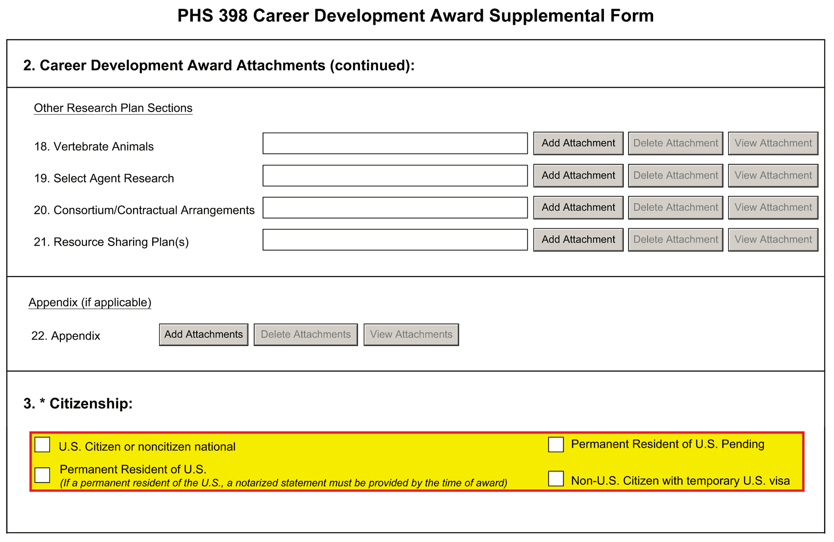

Other Research Plan Sections
Field Name | Instructions
18. Vertebrate Animals | This section is required for applicants answering “yes” to the question “Are vertebrate animals involved?” on the R&R Other Project Information form.  If you indicated that Vertebrate Animals are involved in this project, address the following five key points. In addition, when research involving vertebrate animals will take place at collaborating site(s) or other performance site(s), provide this information before discussing the five points. Although no specific page limitation applies to this section of the application, be succinct.  1. Provide a detailed description of the proposed use of the animals in the work outlined in the Research Strategy section. Identify the species, strains, ages, sex, and numbers of animals to be used in the proposed work.  2. Justify the use of animals, the choice of species, and the numbers to be used. If animals are in short supply, costly, or to be used in large numbers, provide an additional rationale for their selection and numbers.  3. Provide information on the veterinary care of the animals involved.  4. Describe the procedures for ensuring that discomfort, distress, pain, and injury will be limited to that which is unavoidable in the conduct of scientifically sound research. Describe the use of analgesic, anesthetic, and tranquilizing drugs and/or comfortable restraining devices, where appropriate, to minimize discomfort, distress, pain, and injury.  5. Describe any method of euthanasia to be used and the reasons for its selection. State whether this method is consistent with the recommendations of the American Veterinary Medical Association (AVMA) Guidelines on Euthanasia. If not, include a scientific justification for not following the recommendations.  If the involvement of animals is indefinite, provide an explanation and indicate when it is anticipated that animals will be used. If an award is made, prior to the involvement of animals the grantee must submit to the NIH awarding office detailed information as required in points 1-5 above and verification of IACUC approval. If the grantee does not have an Animal Welfare Assurance then an appropriate Assurance will be required (see Part III Section 2.2 Vertebrate Animals for more information).  Do not use the vertebrate animal section to circumvent the page limits of the research strategy.  Save this information in a single file in a location you remember. Click Add Attachment, browse to where you saved the file, select the file, and then click Open.
 | For those applicants familiar with the PHS 398, please note that the Literature Cited section of the Research Plan is now captured as “Bibliography & References Cited.” Refer to Item 8 in the Other Project Information Component for instructions.
19. Select Agent Research | Select agents are hazardous biological agents and toxins that have been identified by DHHS or USDA as having the potential to pose a severe threat to public health and safety, to animal and plant health, or to animal and plant products. CDC maintains a list of these agents. See http://www.cdc.gov/od/sap/docs/salist.pdf.  If the activities proposed in your application involve only the use of a strain(s) of select agents which has been excluded from the list of select agents and toxins as per 42 CFR 73.4(f)(5), the select agent requirements do not apply. Use this section to identify the strain(s) of the select agent that will be used and note that it has been excluded from this list. The CDC maintains a list of exclusions at http://www.cdc.gov/od/sap/sap/exclusion.htm.  If the strain(s) is not currently excluded from the list of select agents and toxins but you have applied or intend to apply to DHHS for an exclusion from the list, use this section to indicate the status of your request or your intent to apply for an exclusion and provide a brief justification for the exclusion.  If any of the activities proposed in your application involve the use of select agents at any time during the proposed project period, either at the applicant organization or at any other performance site, address the following three points for each site at which select agent research will take place. Although no specific page limitation applies to this section, be succinct.  1. Identify the select agent(s) to be used in the proposed research.  2. Provide the registration status of all entities* where select agent(s) will be used.  - If the performance site(s) is a foreign institution, provide the name(s) of the country or countries where select agent research will be performed.  *An “entity” is defined in 42 CFR 73.1 as “any government agency (Federal, State, or local), academic institution, corporation, company, partnership, society, association, firm, sole proprietorship, or other legal entity.”  3. Provide a description of all facilities where the select agent(s) will be used.  - Describe the procedures that will be used to monitor possession, use and transfer of the select agent(s).  - Describe plans for appropriate biosafety, biocontainment, and security of the select agent(s).  - Describe the biocontainment resources available at all performance sites.  If you are responding to a specific FOA, address any requirements specified by the FOA.  Reviewers will assess the information provided in this Section, and any questions associated with select agent research will need to be addressed prior to award.  Save this file in a location you remember. Click Add Attachment, browse to where you saved the file, select the file, and then click Open.
20. Consortium/Contractual Arrangements | Explain the programmatic, fiscal, and administrative arrangements to be made between the applicant organization and the consortium organization(s). If consortium/contractual activities represent a significant portion of the overall project, explain why the applicant organization, rather than the ultimate performer of the activities, should be the grantee. The signature of the Authorized Organization Representative on the SF424 (R&R) cover component (Item 17) signifies that the applicant and all proposed consortium participants understand and agree to the following statement:  The appropriate programmatic and administrative personnel of each organization involved in this grant application are aware of the agency’s consortium agreement policy and are prepared to establish the necessary inter-organizational agreement(s) consistent with that policy.  A separate statement is no longer required.  Save this information in a single file in a location you remember. Click Add Attachment, browse to where you saved the file, select the file, and then click Open.
21. Resource Sharing Plan(s) | NIH considers the sharing of unique research resources developed through NIH-sponsored research an important means to enhance the value and further the advancement of the research. When resources have been developed with NIH funds and the associated research findings published or provided to NIH, it is important that they be made readily available for research purposes to qualified individuals within the scientific community. See Part III, 1.5 Sharing Research Resources.  1. Data Sharing Plan: Investigators seeking $500,000 or more in direct costs (exclusive of consortium F&A) in any year are expected to include a brief 1-paragraph description of how final research data will be shared, or explain why data-sharing is not possible. Specific Funding Opportunity Announcements may require that all applications include this information regardless of the dollar level. Applicants are encouraged to read the specific opportunity carefully and discuss their data-sharing plan with their program contact at the time they negotiate an agreement with the Institute/Center (IC) staff to accept assignment of their application. See Data-Sharing Policy or http://grants.nih.gov/grants/guide/notice-files/NOT-OD-03-032.html.  2. Sharing Model Organisms: Regardless of the amount requested, all applications where the development of model organisms is anticipated are expected to include a description of a specific plan for sharing and distributing unique model organisms or state why such sharing is restricted or not possible. See Sharing Model Organisms Policy, and NIH Guide NOT-OD-04-042.  3. Genome Wide Association Studies (GWAS): Applicants seeking funding for a genome-wide association study are expected to provide a plan for submission of GWAS data to the NIH-designated GWAS data repository, or an appropriate explanation why submission to the repository is not possible. GWAS is defined as any study of genetic variation across the entire genome that is designed to identify genetic associations with observable traits (such as blood pressure or weight) or the presence or absence of a disease or condition. For further information see Policy for Sharing of Data Obtained in NIH Supported or Conducted Genome-Wide Association Studies, NIH Guide NOT-OD-07-088, and http://gwas.nih.gov/.  Save this information in a single file in a location you remember. Click Add Attachment, browse to where you saved the file, select the file, and then click Open.
22. Appendix | Do not use the appendix to circumvent the page limits of the Candidate Information (Items 2-4) and the Research Strategy (Item 11) or any other section of the application for which a page limit applies. For additional information regarding Appendix material and page limits, please refer to the NIH Guide Notice NOT-OD-11-080, http://grants.nih.gov/grants/guide/notice-files/NOT-OD-11-080.html.  Only one copy of appendix material is necessary. Use the Add Attachments button to the right of this field to complete this entry.  A maximum of 10 PDF attachments is allowed in the Appendix. If more than 10 appendix attachments are needed, combine the remaining information into attachment #10. Note that this is the total number of appendix items, not the total number of publications. When allowed there is a limit of 3 publications that are not publicly available (see below for further details and check the FOA for any specific instructions), though not all grant mechanisms allow publications to be included in the appendix.  Appendix material may not appear in the assembled application in the order attached, so it is important to use filenames for attachments that are descriptive of the content. A summary sheet listing all of the items included in the appendix is also encouraged but not required. When including a summary sheet, it should be included in the first appendix attachment. Applications that do not follow the appendix requirements may be delayed in the review process.  New, resubmission, renewal, and revision applications may include the following materials in the Appendix:  - Publications – No longer allowed as appendix materials except in the circumstances noted below. Applicants may submit up to 3 of the following types of publications:  - Manuscripts and/or abstracts accepted for publication but not yet published: The entire article should be submitted as a PDF attachment.  - Manuscripts and/or abstracts published, but a free, online, publicly available journal link is not available: The entire article should be submitted as a PDF attachment.  - Patents directly relevant to the project: The entire document should be submitted as a PDF attachment.  - Do not include unpublished theses, or abstracts/manuscripts submitted (but not yet accepted) for publication.)  - Surveys, questionnaires, and other data collection instruments; clinical protocols and informed consent documents may be submitted in the Appendix as necessary.  - For materials that cannot be submitted electronically or materials that cannot be converted to PDF format (e.g., medical devices, prototypes, DVDs, CDs), applicants should contact the Scientific Review Officer for instructions following notification of assignment of the application to a study section. Applicants are encouraged to be as concise as possible and submit only information essential for the review of the application.  Items that must not be included in the appendix:  - Photographs or color images of gels, micrographs, etc., are no longer accepted as Appendix material. These images must be included in the Research Plan PDF. However, images embedded in publications are allowed.  - Publications that are publicly accessible. For such publications, the URL or PMC submission identification numbers along with the full reference should be included as appropriate in the Bibliography and References cited section, the Progress Report Publication List section, and/or the Biographical Sketch section.

3. Citizenship
The candidate must provide information regarding citizenship status. Other than for the K99/R00 award program, the candidate must be a citizen or non-citizen national of the United States or its possessions and territories, or must have been lawfully admitted to the United States for permanent residence by the time of award.
For those K award programs with a citizenship requirement, an individual who has applied for Permanent Residence and expects to have obtained such status prior to the time award, may submit an application recognizing that no award will be made until legal verification of permanent resident status is provided. If a candidate’s citizenship status changes after submission of the application, the new status should be reported in the candidate’s Personal Profile in the eRA Commons. Before an award is issued, a permanent resident will be required to submit a notarized statement that a licensed notary has seen the candidate’s current and valid Permanent Resident Card or some other valid verification from the U.S. Immigration and Naturalization Service of legal admission to the U.S. as a permanent resident.
It is the responsibility of the sponsoring institution to determine and retain documentation indicating that the individual candidate’s visa will allow him/her to reside in the proposed research training/career development setting for the period of time necessary to complete the approved career development program. Information may be requested by the NIH prior to issuance of an award.
Each candidate must check the applicable box, check only one:
- U.S. Citizen or non-citizen national: Check this box if the candidate is a U.S. Citizen or Noncitizen national. Noncitizen nationals are people, who, although not citizens of the United States, owe permanent allegiance to the United States. They generally are people born in outlying possessions of the United States (e.g., American Samoa and Swains Island).;
- Permanent Resident of U.S.: Check this box if the candidate has been lawfully admitted for permanent residence; i.e., is in the possession of a current and valid Permanent Resident Card or other legal verification of such status. A notarized statement will be required as part of the pre-award process.
- Permanent Resident of U.S. Pending: Check this box if the candidate has applied for Permanent Residence and expects to have obtained such status prior to the time of award. A notarized statement will be required as part of the pre-award process.
- Non-U.S. citizen with temporary U.S. visa: This box is applicable only to specific programs that do not require U.S. citizenship or permanent residency; e.g. K99/R00. The NIH awarding component may request verifying information as part of the pre-award process.

Once all data have been entered use the scroll bar to scroll up. You will be returned to the Grant Application Package screen. To remove a document from the Submission box, click the document name to select it and then click the Move Form to Delete button. This will return the document to the Mandatory Documents Submission List or Optional Documents Submission List.

7.6 Career Development Award Peer Review Process
The goal of NIH-supported career development programs is to help ensure that diverse pools of highly trained scientists are available in adequate numbers and in appropriate research areas to address the Nation’s biomedical, behavioral, and clinical research needs. Each application must be tailored to the individual candidate.
The general process information (Overview, Streamlining, and Dual-Level Peer Review) found in Part I.6 applies to K applications as well. However, the actual review criteria and other review considerations are different. For K applications, the scientific review group will address individual career development award applications by considering information provided for each of the following elements in the application:
Review Criteria:
- Candidate
- Career Development Plan/Career Goals & Objectives/Plan to Provide Mentoring
- Research Plan
- Mentor(s), Co-Mentor(s), Consultant(s), Collaborator(s)
- Environment and Institutional Commitment to the Candidate
Additional Review Criteria include the following;
- Protection of Human Subjects from Research Risk
- Inclusion of Women, Minorities, and Children in Research
- Care and Use of Vertebrate Animals in Research
- Biohazards
- Resubmission Applications
- Renewal Applications (as applicable)
Additional Review Considerations include the following:
- Training in the Responsible Conduct of Research
- Select Agents
- Resource Sharing Plans
- Budget and Period of Support
Candidates should carefully review the applicable FOA for complete information associated with the peer review process. The FOA will describe essential information to be submitted for each of the above elements.

8. Supplemental Instructions to the SF424 (R&R) for Preparing Institutional Ruth L. Kirschstein National Research Service Award (NRSA) Application

8.1 Introduction
All applicants must use the SF 424 (R&R) Application for Federal Assistance, following the instructional information in this section. The supplemental instructions found in this section (8) are for Institutional National Ruth L. Kirschstein National Research Service Award (NRSA) applications and include guidance and instructional information only when there is a difference in the required information to be submitted or there is a need for more specificity for the institutional research training program. Therefore, these supplemental instructions must be used along with the information found in Part I.1 – I.6 (see specific training grant review process at the end of Section 8) of this document.
These instructions apply to NIH-supported NRSA institutional research training programs (e.g., T32, T34, T35, T90). Some training programs are funded through Requests for Applications (RFAs) and may have special instructions.
Additionally, there are non-NRSA programs (e.g. T15, T37, D43, D71) which include research training under different regulatory authorities, and, while some of the information may be the same, it is important for individuals interested in those programs to carefully read the applicable Funding Opportunity Announcement (FOA) for specific program information and special application instructions. These training programs may have different eligibility requirements, submission dates, award provisions, and review criteria.
It is imperative that applicants become familiar with the NIH Research Training Activity code for which support is being requested, and applicants should carefully review the applicable FOA which contains more specific information associated with the award mechanism and the names of individuals that may be contacted for additional or clarifying information prior to submission of an application. Announcements for various training programs are issued periodically in the NIH Guide for Grants and Contracts, a weekly publication (http://grants.nih.gov/grants/guide/index.html).
This section includes instructions to be used when applying for competing (New, Renewal, Resubmission or Revision) institutional training grants, including both PHS Institutional Ruth L. Kirschstein National Research Service Awards (Kirschstein-NRSA) and non-NRSA awards. The contents include substitute both budget pages, and instructions for the Research Training Program Plan. Begin by reading the previous Sections 4 and 5, and then follow both sets of instructions.
Prior to preparing an application, review the Funding Opportunity Announcement (FOA) to which you are responding and consult with the appropriate PHS awarding component identified in the FOA. Current NIH-wide T32, T34 or T35 Kirschstein-NRSA Program Announcements (PA) are available at (http://grants.nih.gov/training/nrsa.htm). Note especially the eligibility requirements, submission dates, review criteria, award provisions, and payback provisions (when applicable). PAs are also issued periodically by the individual NIH Institutes or Centers in the NIH Guide for Grants and Contracts. This information is available from the appropriate PHS agency, from grantee offices of sponsored programs, or equivalent offices.
Please note that for Kirschstein-NRSA programs that include postdoctoral trainees, the Program Director must explain the terms of the payback service requirement to all prospective postdoctoral training candidates. A complete description of the service payback obligation is available in the relevant NRSA Program Announcement or the NIH Grants Policy Statement.

8.2 Institutional Research Training Programs
Prospective applicants are encouraged to review the T Kiosk for the most current program information. The T Kiosk includes information on NIH-wide Parent FOAs as well as IC-specific FOAs for a particular T programs. In addition, non-NRSA training programs are described here: http://grants.nih.gov/training/F_files_non_nrsa.htm.

8.3 Reserved

8.4 Specific Instructions for Institutional Training Grant Applications using the SF424 (R&R) Application
Standard instructions found in Parts I.1 – I.6 should be followed with the exceptions found in this section. Section numbers referenced below (e.g. 4.2 - 5.6) reflect those found in Part I.

8.4.1 Special Instructions for 4.2 Cover Component

Item 12. Proposed Project Start and Ending Dates
The usual starting date for an institutional Kirschstein-NRSA is July 1, but there are other possible starting dates. Consult the webpage of Standard Due Dates for Competing Applications (http://grants.nih.gov/grants/funding/submissionschedule.htm). Many PHS awarding components restrict submission and review dates to once a year. Applicants are strongly encouraged to contact the appropriate awarding component staff before submitting an application.

8.4.2 Special Instructions for 4.3 Research & Related Project/Performance Site Locations
List all of the locations where training, program management, and the research training experiences described in the Research Training Program Plan (8.7) will be performed. If a Project/Performance Site will be engaged in research involving human subjects, it is the responsibility of the applicant organization to assure that all Project/Performance Sites comply with the human subject protection regulations in 45 CFR part 46 and NIH policies for the protection of human subjects. For research involving live vertebrate animals, the applicant organization must supply information for all training sites where animals will be used by trainees. The applicant organization is responsible for assuring that all Project/Performance Sites have a current Animal Welfare Assurance and comply with the PHS Policy on Humane Care and Use of Laboratory Animals.

8.4.3 Special Instructions for 4.4 Research & Related Other Project Information Component

Item 1. Are Human Subjects Involved?
Check “Yes” if training plans include or potentially will include involvement of trainees in projects that include human subjects as defined by 45 CFR 46. Check “Yes” even if the proposed project is exempt from Regulations for the Protection of Human Subjects. If no activities involving human subjects are planned, check the No box, and skip the rest of block 1. This field is required.
The institution must ensure that trainees who will be involved in the design or conduct of research involving human subjects receive training in human subjects protections. It is the institution’s responsibility to ensure that trainees are properly supervised when working with human subjects.
In many instances, trainees supported by institutional training grants will be participating in research supported by research project grants for which the IRB approval or a determination of exemption exists. Existing IRB approval is sufficient for trainees, provided that the IRB determines the research would not be substantially modified by the participation of a trainee. The appropriate grants must be identified along with their IRB approval dates or exemption designation in Section 7 of the Research Training Program Plan.
Note that IRB approval information for the full training grant application is not required at the time of submission, but will be requested as Just-in-time (JIT) information prior to award. If an award is made and the research is not exempt from requirements stipulated in 45 CFR 46, and trainees will participate in research for which IRB review and approval does not otherwise exist, human subjects may not be involved and trainees may not participate in research involving human subjects unless the engaged institution has an approved FWA on file with OHRP, certification of the date of IRB approval has been submitted to and accepted by the PHS agency, and NIH requirements for human subjects protections have been addressed (see instructions in Part II, Supplemental Instructions for Preparing the Human Subjects Section of the Research Plan, and the NIH Grants Policy Statement (http://grants.nih.gov/grants/policy/nihgps_2012/index.htm)).
These policies apply to all Performance Sites.

Item 2. Are Vertebrate Animals Used?
Check “Yes” if training plans include or potentially will include trainees in projects involving the use of live vertebrate animals at any time during the proposed project period, either at the applicant organization or at any other training site or collaborating institution.
Otherwise, check the No box, and skip the rest of block 2. This field is required.
In many instances, trainees supported by institutional training grants will be participating in research supported by research project grants for which the IACUC review and approval exists. This existing IACUC approval is sufficient for trainees, provided that the research would not be substantially modified by the participation of a trainee. The appropriate grants must be identified along with their IACUC approval dates in Section 8 of the Research Training Program Plan.
Note that vertebrate animal approval information for the full training grant application is not required at the time of submission, but will be requested as Just-in-time (JIT) information prior to award. If an award is made and trainees will participate in research for which IACUC approval does not otherwise exist, vertebrate animals may not be involved and trainees may not participate in research utilizing vertebrate animals unless the institution has an approved Assurance on file with OLAW, certification of the date of IACUC approval has been submitted to and accepted by the PHS agency, and NIH requirements for the use of vertebrate animals have been addressed.
The institution must ensure that trainees are enrolled in the institution's animal welfare training and occupational health and safety programs for personnel who have contact with animals. It is the institution's responsibility to ensure that trainees are properly supervised when working with live vertebrate animals.
These policies apply to all Performance Sites.

Item 7. Project Summary/Abstract
Summarize the objectives, rationale and design of the research training program. Provide information regarding the research areas and scientific disciplines encompassed by the program. Include a brief description of the level(s) (i.e., undergraduate, predoctoral, postdoctoral, faculty) and duration of the proposed training, the projected number of participating trainees and their anticipated levels of experience. This section must be no longer than 30 lines of text and must follow the required font and margin specifications.

Item 8. Project Narrative
Using no more than two or three sentences, describe the relevance of this research training program to public health. In this section, use plain language that can be understood by a general, lay audience.

Item 9. Bibliography & References Cited
This item should be used only to cite references supporting the need, rationale, and approach for the training program described in the PHS 398 Research Training Program Plan. Note that the Literature Cited section of the Research Plan is captured in this section (unlike the placement in the PHS 398). Do not include lists of publications of project directors, mentors or trainees in this section, as this information will be included in the biosketches and Data Tables.

Item 10. Facilities & Other Resources
Describe the facilities and resources that will be used in the proposed training program. Indicate in what ways the applicant organization will support the program, financial or otherwise (e.g., supplementation of stipends, protected time for mentoring, support for student activities). This could also include, for example, space, shared laboratory facilities and equipment, funds for curriculum development, release time for the PD/PI and participating faculty, support for additional trainees in the program, or any other creative ways to improve the climate for the establishment and growth of the research training program.

Item 12. Other Attachments
Leave blank, unless specifically requested in the FOA.

8.4.4 Special Instructions for 4.5 Senior/Key Person Profile (Expanded) Component
Complete the Profile for the Program Director according to instructions in Section 4.5.
If multiple PD/PIs are proposed, explain in the Program Plan your rationale for how this will facilitate program administration. If your application involves Multiple PD/PIs, follow the directions in Section 4.5 to designate the Contact PI and to assign the PD/PI role to other senior/key persons. Additionally, the application must include a Multi-PD/PI Leadership Plan emphasizing how it will benefit the program and the trainees. Do not submit a leadership plan if you are not submitting a Multiple PD/PI application. See Part I Section 8.7, Items 3 and 10 for information associated with Multiple Program Directors.
Complete the profiles for other senior/key persons according to instructions in Section 4.5.
The Program Director(s) (in case of multiple PD/PIs), training faculty and any other individuals whose contributions are critical to the development, management and execution of the Research Training Program Plan in a substantive, measurable way (whether or not salaries are reimbursed) should be identified as senior/key persons. These would include co-Director(s), if applicable, and program staff. Since these efforts are not project related research endeavors, they should not be identified in Other Support information. Do not include proposed mentors and training faculty members (other than senior/key persons) in this section. Biographical Sketches for mentors and participating faculty will be included in the PHS 398 Research Training Program Plan Component, Section 8.7 Item 12, Participating Faculty Biosketches.

8.4.5 Special Instructions for 4.7 Research & Related Budget
This form is required for use in conjunction with the PHS 398 Training Budget for the R90 portion of T90/R90 applications, and is the only budget form that should be used for K12 applications. Otherwise this form should only be used when allowed or required in an FOA or IC-specific notice or announcement. Follow instructions in Section 4.7.

8.4.6 Special Instructions for 4.6 PHS 398 Cover Page Supplement

Item 2. Human Subjects
If you checked “Yes” to Human Subjects on the R&R Other Project Information screen, you must answer either “Yes” or “No” to indicate whether training plans include, or potentially will include, trainee participation in a project defined as a Clinical Trial.
If you check “Yes” to Clinical Trial, you must check either “Yes” or “No” to indicate whether training plans include or potentially will include trainee participation in projects that are NIH-Defined Phase III Clinical Trials.

Item 4. Human Embryonic Stem Cells (HESC).
Check “Yes” if training plans include or potentially will include involvement of trainees in projects that include human embryonic stem cells.
If “Yes”, list the 4-digit NIH Registration Number of the specific cell line(s) from the NIH Human Embryonic Cell Registry, or check the box indicating that the specific stem cell line cannot be referenced at this time.
Note that individual project HESC information is not required at the time of application, but will be requested as Just-in-time (JIT) information prior to award. At that time, the NIH will require information regarding project title, mentor and specific cell line(s) from the registry (http://stemcells.nih.gov/research/registry/defaultpage.asp) for each trainee utilizing human embryonic stem cells in a research project. Trainees may not participate in human embryonic stem cell related research until this information is provided.

8.4.7 Special Instructions for 5.6 PHS 398 Checklist

Item 3. Inventions and Patents
Not applicable – leave blank.

Item 4. Program Income
Check “No”.

8.5 PHS 398 Training Budget
For NRSA training grant programs, use the PHS 398 Training Budget form pages and follow the instructions below. Refer to the relevant FOA or consult the PHS awarding component for current stipend levels and allowable costs.
For Non-NRSA training grant programs refer to the FOA for instructions regarding which Budget Form pages to use and how to complete them.

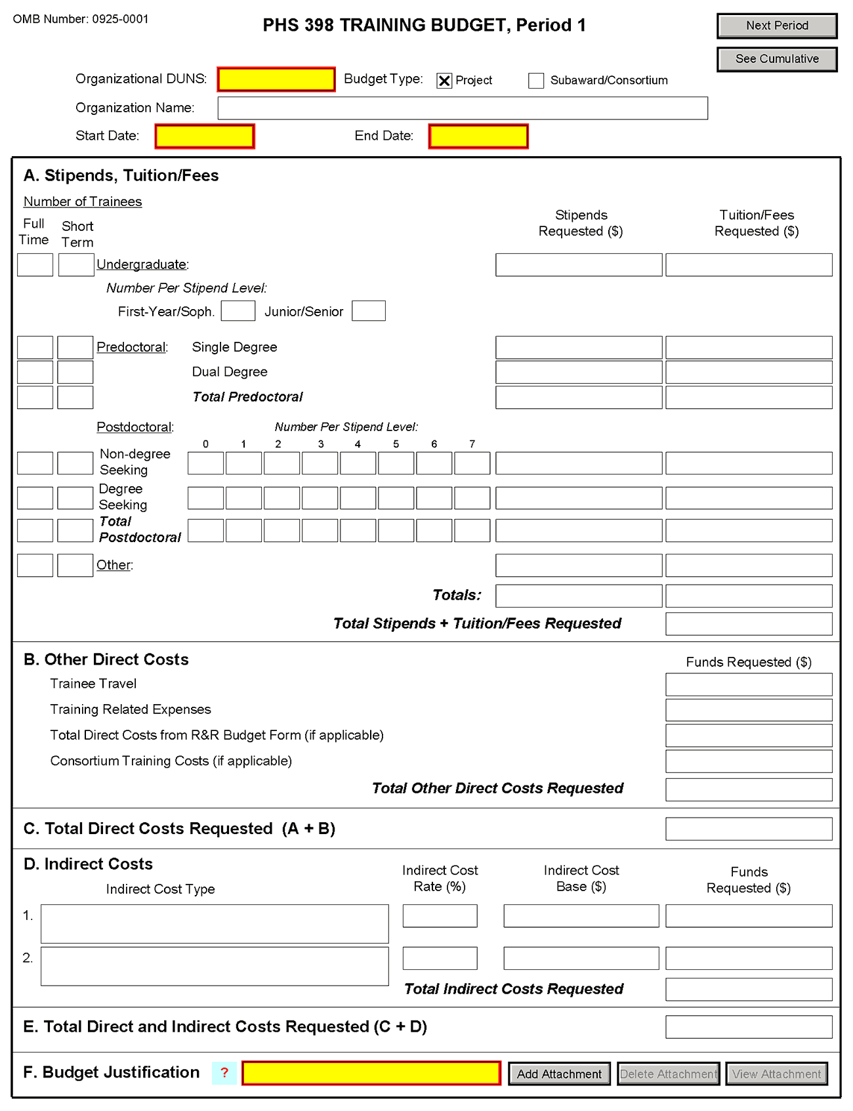

If you are requesting a budget of $500,000 direct costs or more for any year, contact the awarding component to determine whether you must obtain prior approval before submitting the application. Some Institutes/Centers do not require prior approval. (See Policy on the Acceptance for Review of Unsolicited Applications That Request $500,000 or More in Direct Costs.)

PHS 398 Training Budget, Periods 1 through 5

Part A. Stipends, Tuition/Fees
Enter the number of trainees, total stipend amount and total tuition/fees for each trainee category as appropriate. Use the current Institutional Kirschstein-NRSA stipend schedule, (http://grants.nih.gov/training/nrsa.htm). If a category contains different stipend levels, e.g., for varying levels of postdoctoral experience and/or varying appointment periods, itemize in the appropriate blocks. Enter the total stipends for all categories.
See http://grants.nih.gov/grants/guide/notice-files/NOT-OD-06-093.html for NIH policy regarding payment of tuition and fees. Tuition at the postdoctoral level is limited to that required for specified courses that are to be described in the Budget Justification (Part F.). Tuition and fees may be requested only to the extent that the same resident or nonresident tuition and fees are charged to regular non-Federally supported students and postdoctoral fellows. Where applicable, trainees should be divided into non-degree-seeking and degree-seeking categories. Note that health insurance is not included as part of this budget category. See the Training Related Expenses category below. Grantees should request full needs. The formula currently in effect will be applied by the NIH awarding component at the time an award is calculated.

Part B. Other Direct Costs
Enter the total costs for Trainee Travel, Training Related Expenses, Total Direct Costs from R&R Budget Form (if applicable) and Consortium Training Costs (if applicable).

Trainee Travel
Some NIH awarding components pay a flat rate per trainee for trainee travel for all long-term trainees. See the appropriate FOA and/or contact the awarding component to determine the amount provided for travel. In the budget justification, state the purpose of any travel, giving the number of trips involved, the destinations, and the number of trainees for whom funds are requested. PHS policy requires coach class air travel be used. Justify foreign travel in detail, describing its importance to the training experience. Enter the total amount requested in the Trainee Travel column.

Training Related Expenses (TRE)
Funds to defray other costs of training, such as health insurance (self-only or family), staff salaries, consultant costs, equipment, research supplies, staff travel, etc., are requested as a lump sum based on the amounts specified in the FOA and at http://grants.nih.gov/grants/guide/notice-files/NOT-OD-06-093.html for each predoctoral and postdoctoral trainee. Based on the number of trainees at the predetermined rate, enter the total dollar figure.
Health insurance (self-only or family, as applicable) is an allowable cost that may be requested as part of training related expenses, but only to the extent that the same health insurance fees are charged to regular non-Federally-supported students and postdoctoral fellows. The allowable TRE amount will be awarded as a lump sum. No further itemization or explanation is required.
The awarding Institute/Center will apply the Training Related Expenses level established for NRSA Institutional programs for the relevant fiscal year at the time of award.

Total Direct Costs from R&R Budget Form (if applicable)
Certain FOAs allow funds to cover costs for items other than those specified above. Use Research & Related Budget Pages, Sections A through I and K, to submit those costs. Total Direct Costs from the Research & Related Budget page should be inserted here. This line should not include any applicant indirect costs.

Consortium Training Costs (if applicable)
If training is occurring at more than one institution, and any transfer of funds between institutions occurs, the Training Subaward Budget Attachment Form should be used. (See Section 4.8). Total the direct costs from the Subaward Budget Attachment Forms and insert here. The applicant institution is responsible and accountable for any arrangements, expenditures, and submission of all required forms when more than one institution is involved in the research training program.

Part C. Total Direct Costs Requested
The sum of Sections A + B will be calculated automatically.

Part D. Indirect Costs
Facilities and Administrative (F&A) costs under Institutional Kirschstein-NRSAs, other than those issued to U.S., state, or local government agencies, will be awarded at 8%, excluding tuition/fees, equipment, and sub-grants and contracts in excess of $25,000. Equipment and consortium costs are also excluded from the F&A costs on those training grants where Training Related Expenses are not calculated and awarded on a lump-sum basis, such as the Minority Access to Research Careers Program (MARC) or Career Opportunities in Research (COR) Undergraduate Research Training Program. State and local government agencies will receive the full F&A cost rate.
Indirect Cost Type: Enter “F&A”
Indirect Cost Rate (%): Enter “8”
Indirect Cost Base ($): Enter the sum of Stipends and Total Other Direct Costs requested, regardless of whether those direct costs were listed on the PHS 398 Training Budget page or Research & Related Budget page. Indirect costs are not paid on Tuition/Fees, equipment, and sub-grants and contracts in excess of $25,000.
Funds Requested ($): Enter the product of Indirect Cost Rate multiplied by Indirect Cost Base.

Part E. Total Direct and Indirect Costs Requested (C+D)
The sum of Total Direct Costs Requested and Total Indirect Costs Requested will be calculated automatically.

Part F. Budget Justification
A detailed justification is to be attached only for the first budget period, but should reflect the entire budget period. Explain in detail the composition of any of the above items, as necessary. Itemize tuition and individual fees. If tuition varies, (e.g., in-state, out-of-state, student status) identify these separately. If tuition is requested for postdoctoral trainees, the specific courses must be described in the application. If trainee travel is not paid at a flat rate per trainee by the awarding component, state the purpose of any travel, giving the number of trips involved, the destinations, and the number of individuals for whom funds are requested, bearing in mind that PHS policy requires coach class air travel be used. For postdoctoral training slots, justify the stipend levels requested.
Any foreign travel must be justified in detail, describing its importance to the training experience and considering the type of opportunities available for training, how those opportunities differ from and complement those offered by the grantee institution, and the relationship of the proposed off-site training experience to the career stage of the grantee.
This budget justification should apply only to funds requested on the PHS 398 Training Budget form. When the Research & Related Budget Form is also used, two separate budget justifications are required, each covering the costs required in the particular budget component. Combining the information into a single upload is acceptable; however, each budget component requires a budget justification attachment so the same budget justification will need to be included in both budget components.

PHS 398 Training Budget, Cumulative Budget
All values on this form are calculated automatically. They present the summations of the amounts that you have entered previously, for each of the individual budget periods. Therefore, no data entry is allowed or required.
If any of the amounts displayed on this form appears to be incorrect, you may correct it by adjusting one or more of the values that contribute to that total. To make any such adjustments, you will need to revisit the appropriate budget period form(s) to enter corrected values.
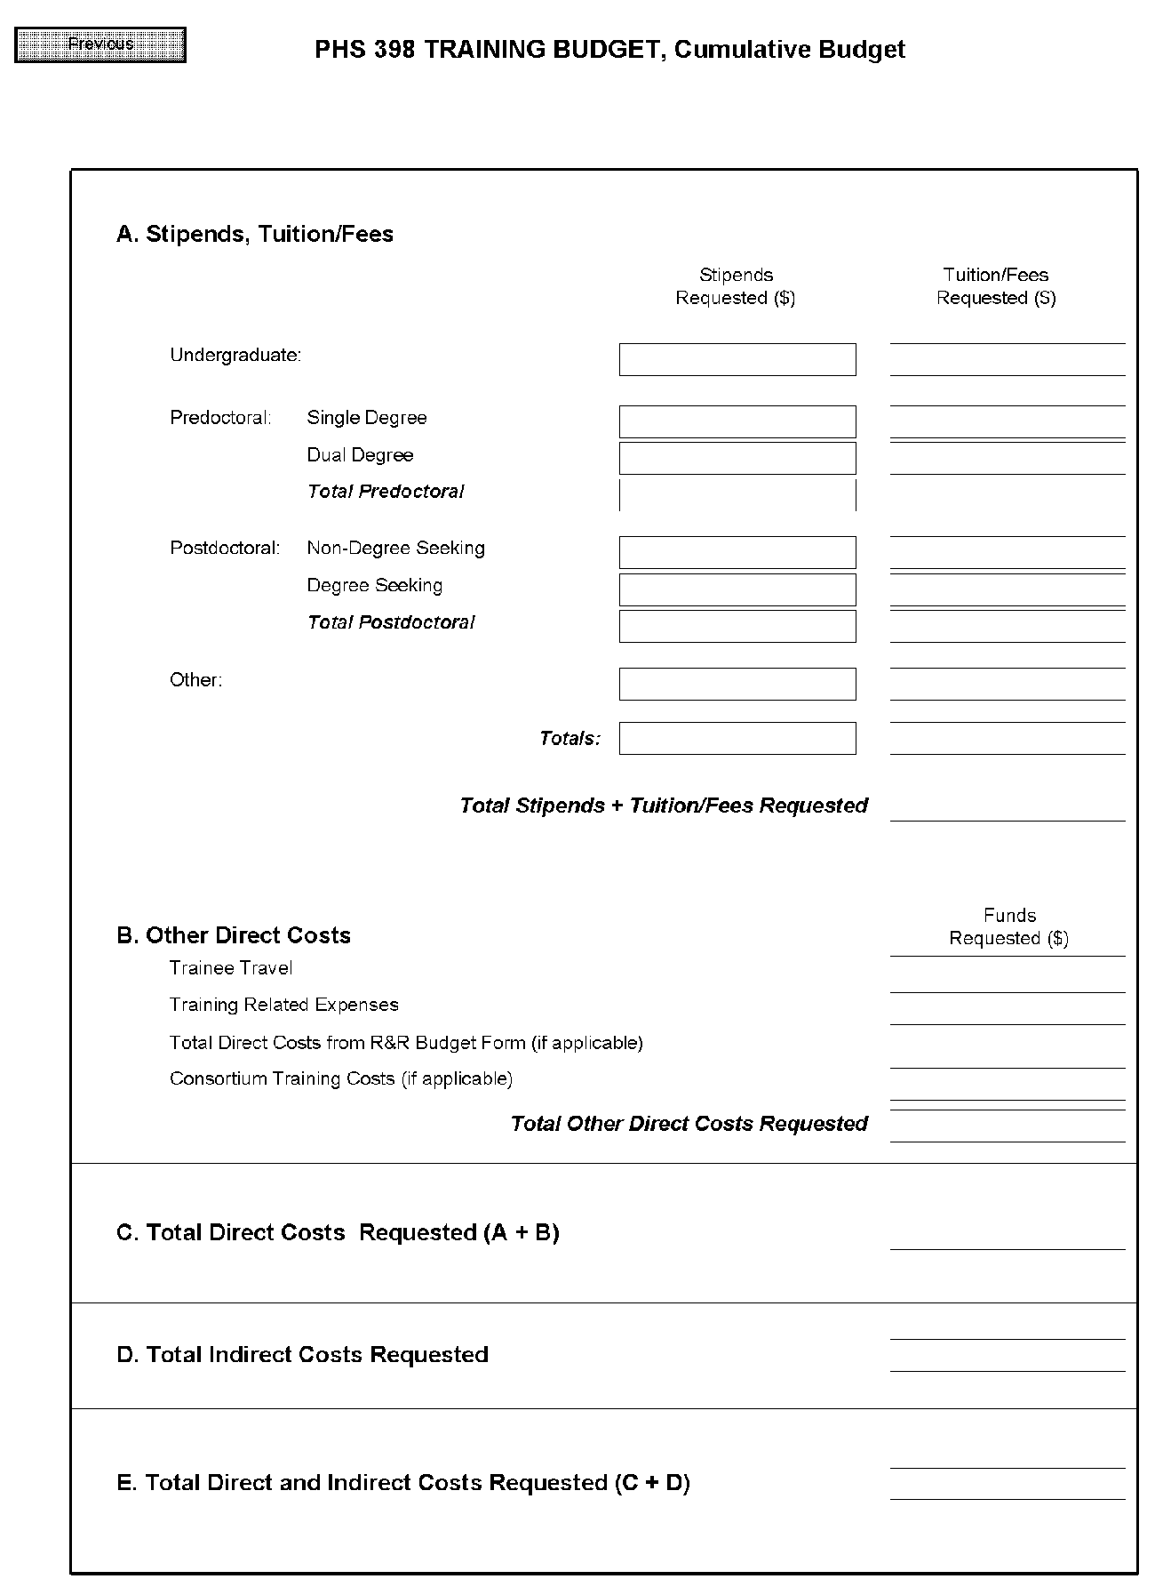

8.6 PHS 398 Training Subaward Budget Attachment(s) Form
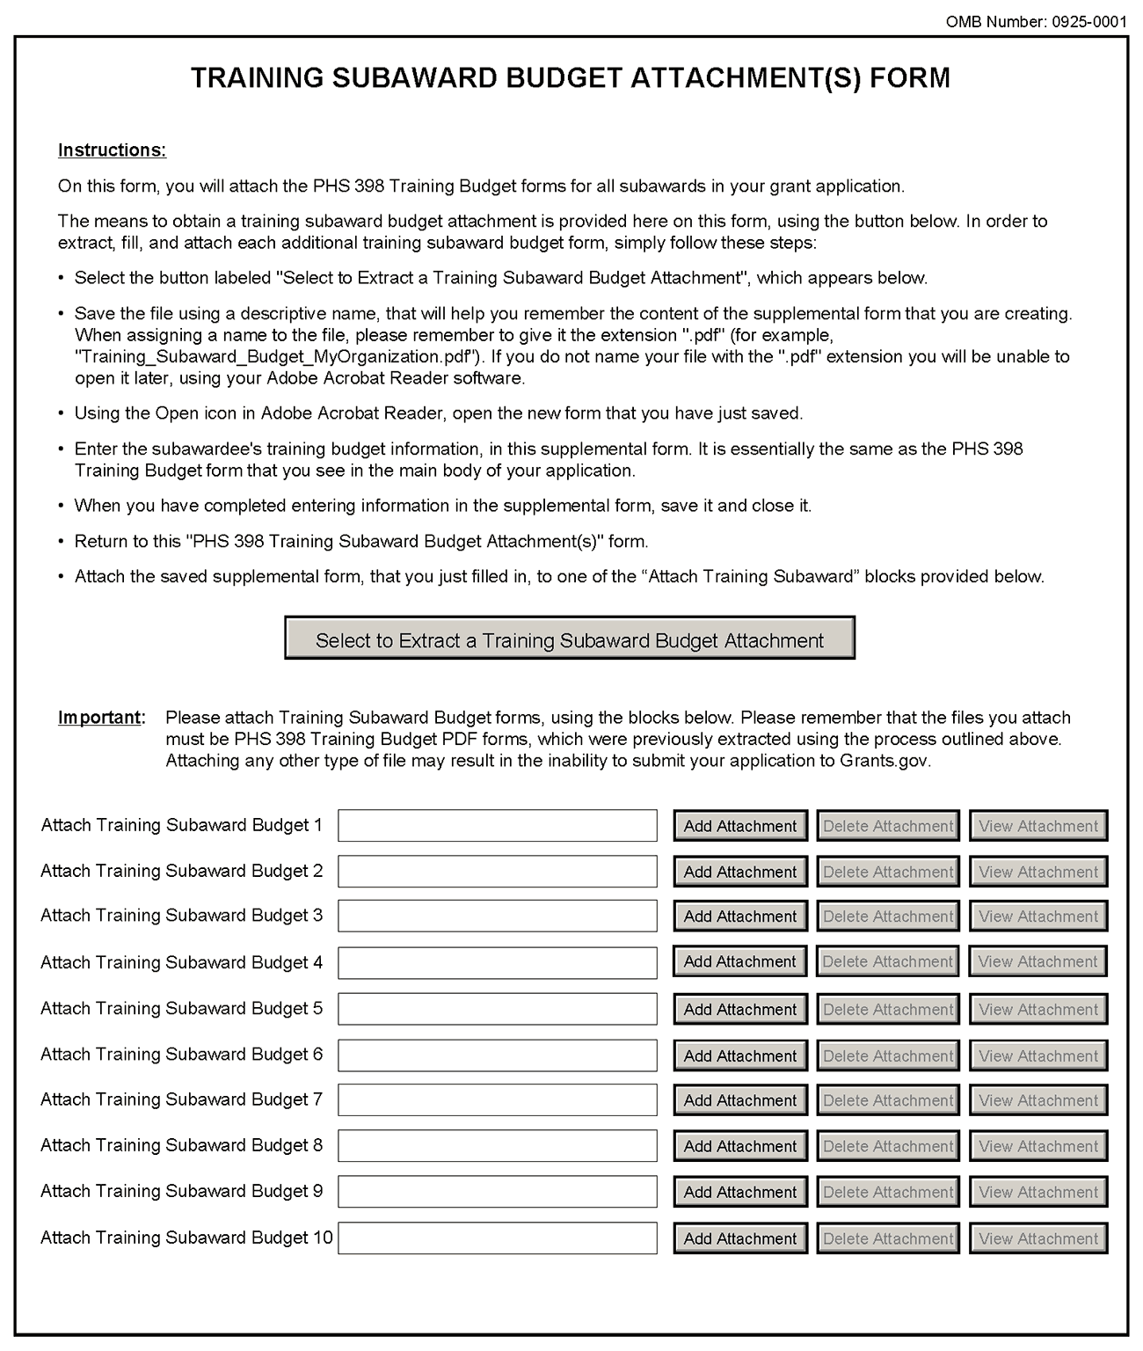
This form should be used when proposing subawards to other institutions. Complete the Subaward Budget for each contractor or collaborating institution. For NRSA programs, this is not common but is usually encountered when a portion of the training program takes place at a site other than the grantee institution via a collaborative or consortium arrangement. In such situations, the grantee institution is responsible and accountable for acceptable training arrangements, expenditure of funds and the submission of all required forms.
This component accommodates up to 10 separate subaward budgets. If you are submitting an application with >10 subaward budgets, budgets 11 and above should be converted to PDF and included as part of Section 8.5 Part F. Budget Justification, of the parent budget (PHS 398 Training Budget). Reminder, the sum of all subaward budgets; e.g., those attached separately and those provided as part of the budget justification, must be included in Part B. Consortium Training Costs on the PHS 398 Training Budget.
To start the process, the applicant organization should:
- Select the Subaward Budget Attachment Form from the Optional Documents in the Grant Application Package.
- Open the form, and click the “Select to Extract a Training Subaward Budget Attachment” button in the middle of the form. A “SAVE” dialog box appears.
- Save the file locally using the first ten letters of the consortium organization’s name and use “.pdf” as the file extension. (The extracted file is an Adobe PDF file.) Once you have saved the file there is no need to extract another budget attachment. Doing so may cause you to lose any data already stored in the saved file.
- E-mail the extracted, saved form to the consortium grantee. Note: consortium grantees must have installed Adobe Reader before they can complete the form. The consortium grantee should complete all the budget information as instructed in the R&R Budget component instructions in Section 4.7. Note: Organizational DUNS and Name of Organization fields must reflect that of the subaward/consortium grantee.
- The consortium grantee must complete the budget component and e-mail it back to the applicant organization.
- Return to the Subaward Budget Attachment Form and attach the consortium grantee’s budget to one of the blocks provided on the form.
Submitting Subaward Budgets that are not Active for all Periods of the Prime Grant
When submitting subaward budgets that are not active for all periods of the prime grant, fill out the subaward R&R Budget form and include only the number of periods for which the subaward is active. The budget period start/end dates reflected in each period should reflect the corresponding prime budget period start/end dates. This approach is the most workable solution to the limitations in existing forms that do not allow an “empty” budget period and do not allow submission of a subaward budget with zero effort to skip a budget period.
For example, suppose the prime has filled out a budget form with the following periods:
- period 1 Jan 1, 2010 – Dec 31, 2010
- period 2 Jan 1, 2011 – Dec 31, 2011
- period 3 Jan 1, 2012 – Dec 31, 2012
- period 4 Jan 1, 2013 – Dec 31, 2013
- period 5 Jan 1, 2014 – Dec 31, 2014
Now, suppose there is a subaward that performs in support year 1 and does not become active again until support year 4. The subaward can fill out the first two periods of their budget form as follows:
- period 1 Jan 1, 2010 – Dec 31, 2010 (dates correspond to prime period 1)
- period 2 Jan 1, 2013 – Dec 31, 2013 (dates correspond to prime period 4)
It is not necessary that the budget period numbers between the prime and subaward match; the correlation is reflected in the dates. Do be careful, however, that the dates exactly match what is listed for the period in the prime budget.
Note this approach may cause a validation warning regarding the NIH $500,000 per year limit on direct costs, therefore you should document in both the cover letter and the subaward budget justification that the subaward is only active for specific periods of the prime. Appropriate NIH staff has access to the cover letter and reviewers have access to the budget justification. This documentation will make the date correlation immediately apparent and will help avoid any confusion.

8.7 Research Training Program Plan Component
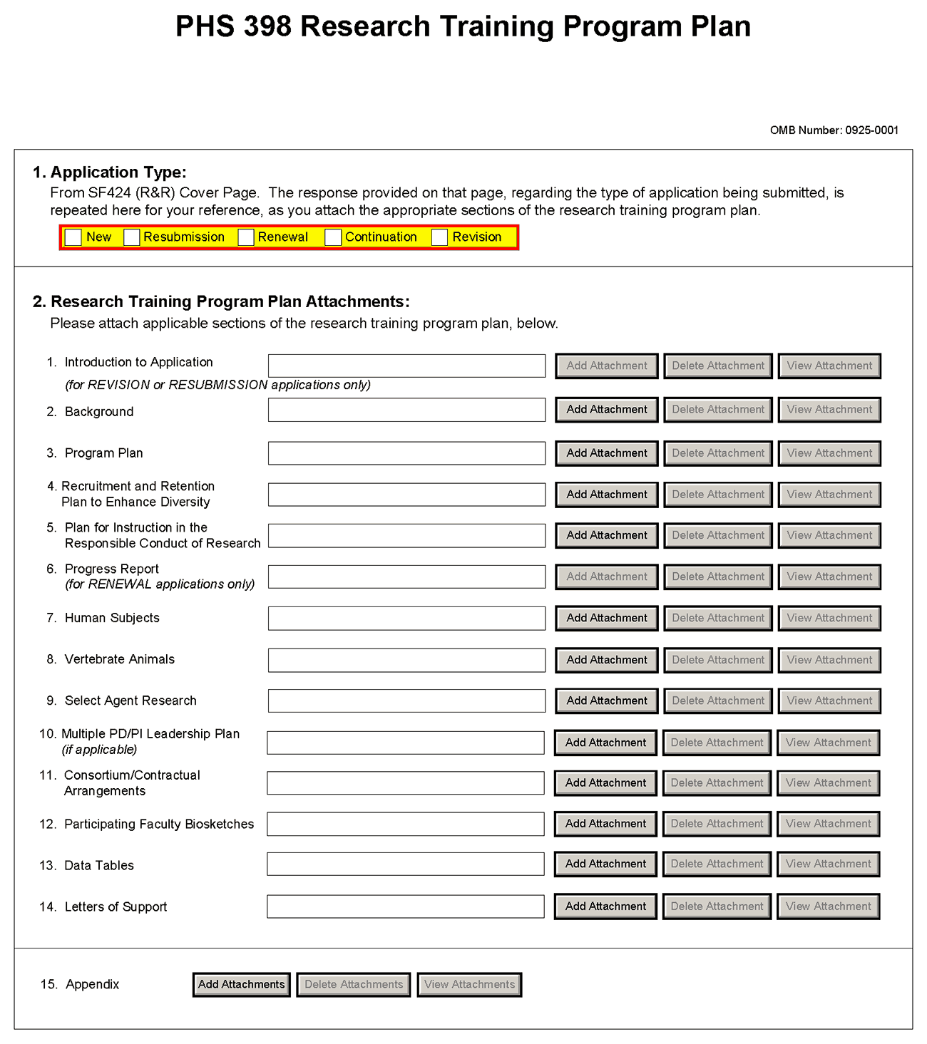
Before preparing the Research Training Program Plan, be sure to check the specific instructions in the Funding Opportunity Announcement (FOA) to which you are responding. Contact the appropriate PHS awarding component, which may have further advice or suggestions on completing your application, including the data tables mentioned below.
Note that there are page limits for certain sections. Information in Items 2.2 - 2.4, collectively, may not exceed 25 pages (note that this may span to 27 pages in the eRA Commons application image due to white space inserted at the end of sections when separating files). Information in items 2.5 - 2.14 is not part of the 25 page limitation. Please see NOT-OD-11-039 and NOT-OD-11-076. The information provided in required data tables (see below) will not be counted toward the page limitation. These tables should be numbered consecutively and titled as shown, even if some are not required by the PHS awarding component to which you are applying or in the FOA to which you are responding. Indicate by table number and title, those tables that are intentionally omitted. Additional tables that are not required may be included in the Research Training Program Plan, however, these tables will count as part of the 25 page limit. Additional tables not specified in these instructions should be identified by letter, rather than number to avoid confusion with the sequentially numbered required tables.
The instructions for Data Tables 1-12 are located on the OER Web site at http://grants.nih.gov/grants/ funding/424/index.htm#datatables. Please read the Introduction to the Data Tables before beginning to prepare your application. This section includes important definitions that should be used consistently both in the Data Tables and in all other parts of the application. The tables described in Item 2.13 should be included in the application at the point indicated and should not be inserted in the narrative for Items 2.2 – 2.5.
The Research Training Program Plan should include sufficient information needed for evaluation of the program, independent of any other document (e.g., previous application). Be specific and informative, and avoid redundancies.

Item 1 Application Type
This field is pre-populated from the SF424 (R&R) Cover Component. Corrections to this field must be made in that component.

Item 2 Research Training Program Plan Attachments
(See also Section 2.3.2 Creating PDFs for Text Attachments.)
Although many of the sections of this application are separate PDF attachments, page limitations referenced in the instructions and/or funding opportunity announcement must still be followed. Agency validations will include checks for page limits (and use of appropriate font). Some accommodation will be made for sections that, when combined, must fit within a specified limitation.
Text attachments should be generated using word processing software and then converted to PDF using PDF generating software. Avoid scanning text attachments to convert to PDF since that causes problems for the agency handling the application. In addition, be sure to save files with descriptive file names.
Do not include any information in a header or footer of the attachments. A header will be system-generated that references the name of the PD/PI. Page numbers for the footer will be system-generated in the complete application, with all pages sequentially numbered.
Since a number of reviewers will be reviewing applications as an electronic document and not a paper version, applicants are strongly encouraged to use only a standard, single-column format for the text. Avoid using a two-column format since it can cause difficulties when reviewing the document electronically.
Full-sized glossy photographs must only be included within the page limitations of the Research Training Plan. The maximum size of images to be included should be approximately 1200 x 1500 pixels using 256 colors. Figures must be readable as printed on an 8.5 x 11 inch page at normal (100%) scale.
Investigators must use image compression such as JPEG or PNG. Do not include figures or photographs as separate attachments either in the Appendix or elsewhere in the application.

Separate Attachments
Separate attachments have been designed for the Research Training Program Plan sections to maximize automatic validations conducted by the eRA system. When the application is received by the agency, all of the Research Training Program Plan sections will be concatenated in the appropriate order so that reviewers and agency staff will see a single cohesive Research Plan.
When attaching a PDF document to the actual forms, please note you are attaching an actual document, not just pointing to the location of an externally stored document. Therefore, if you revise the document after it has been attached, you must delete the previous attachment and then reattach the revised document to the application form. Use the “View Attachment” button to determine if the correct version has been attached.
Follow page limitations as specified in Funding Opportunity Announcements.
All applications and proposals for NIH funding must be self-contained within specified page limitations. Agency validations will include checks for page limits. Note that while these computer validations will help minimize incomplete and/or non-compliant applications, they do not replace the validations conducted by NIH staff. Applications found not to comply with the requirements may be delayed in the review process. Unless otherwise specified in an NIH solicitation, Internet Web site addresses (URLs) may not be used to provide information necessary to the review because reviewers are under no obligation to view the Internet sites. Moreover, reviewers are cautioned that they should not directly access an internet site as it could compromise their anonymity.

Notice of Proprietary Information
Applicants are discouraged from submitting information considered proprietary unless it is deemed essential for proper evaluation of the application. However, when the application contains information that constitutes trade secrets, or information that is commercial or financial, or information that is confidential or privileged, make sure you have checked the “Yes” box of question #3 in the “Other Project Information” component. Identify the pages in the application that contain this information by marking those paragraphs or lines with an asterisk (*) in the left-hand margin. Include a legend at the beginning of Section 2, similar to “The following sections marked with an asterisk contain proprietary/privileged information that (name of Applicant) requests not be released to persons outside the Government, except for purposes of review and evaluation.”
When information in the application constitutes trade secrets or information that is commercial or financial, or information that is confidential or privileged, it is furnished to the Government in confidence with the understanding that the information shall be used or disclosed only for evaluation of this application. If a grant is awarded as a result of or in connection with the submission of this application, the Government shall have the right to use or disclose the information to the extent authorized by law. This restriction does not limit the Government’s right to use the information if it is obtained without restriction from another source.
Begin each text section of the Research Training Program Plan with a section header (e.g., Introduction, Background, Program Plan, etc).
Field Name | Instructions
1. Introduction to Application (for Resubmission or Revision only) | Use only if you are submitting an R&R Resubmission or Revision (Cover Page Item 8). The Introduction may not exceed 3 pages for resubmissions (previously known as a revision or amendment) or 1 page for revisions (previously known as competing supplements). See specific instructions in Section 2.7 “Resubmission” Applications and 2.8 “Revision” Applications concerning the content of the Introduction.  Save this information in a single file in a location you remember. Click Add Attachment, browse to where you saved the file, select the file, and then click Open.
2. Background | The Background must fit within the combined 25-page limit for sections 2.2-2.4. Please see NOT-OD-11-039 and NOT-OD-11-076.  Provide the rationale for the proposed research training program, relevant background history, and the need for the research training proposed. Indicate how the proposed program relates to current training activities at the applicant institution.  Summarize the research training activities of the major participating unit(s) and department(s) represented in the proposed program. Complete and refer to the data reported in Tables 1-3:  Table 1. Membership of Participating Departments/Programs  Table 2. Participating Faculty Members  Table 3. Institutional Training Grant Support Available to Participating Faculty Members, Departments, or Programs  Use this data to document the environment in which the proposed training program will take place.  Save this information in a single file in a location you remember. Click Add Attachment, browse to where you saved the file, select the file, and then click Open.
3. Program Plan | The Program Plan must fit within the combined 25-page limit for sections 2.2-2.4. Please see NOT-OD-11-039 and NOT-OD-11-076.  a. Program Administration. Describe the Program Director's qualifications for providing leadership of the program, including relevant scientific background, current research areas, and experience in research training. Indicate the Program Director's percent effort in the proposed program.  Describe the administrative structure of the program and the distribution of responsibilities within it, including the means by which the program director will obtain continuing advice with respect to the operation of the program.  If multiple PD/PIs are proposed, explain in this section your rationale for how this will facilitate program administration. In addition, you must complete Item 2.10 Multiple PD/PI Leadership Plan.  b. Program Faculty. Refer to the data presented in Table 2. Participating Faculty Members and elaborate as necessary to describe each faculty member's research that is relevant to the program and indicate how trainees will participate in the research. Describe the extent to which participating faculty members cooperated, interacted, and collaborated in the past, including joint publications and joint sponsorship of student research. Complete and refer to data in Tables 4-6:  Table 4. Grant and Contract Support of the Participating Faculty Members  Table 5. Pre and Postdoctoral Trainees of Participating Faculty Members  Table 6. Publications of Research Completed by Trainees (or Potential Trainees)  Use these tables to document the ability of the faculty to support the research activities of the proposed trainees, the training record of the faculty members, and the success of their trainees in generating publishable research results.  For new applications, see the instructions for Table 6A or 6B, as applicable, and list publications for trainees who are representative of those who would be appointed if the grant is awarded. For Renewal applications, this data constitutes part of the Progress Report (see Item 2.6 Progress Report below).  c. Proposed Training. Describe the proposed training program. State the training level and number of trainees. For postdoctoral trainees, indicate the proposed distribution by degree (e.g., M.D., Ph.D.). Describe course work and research opportunities, the extent to which trainees will participate directly in research, and the duration of training, i.e., usual period of time required to complete the training offered.  Indicate how the individual disciplinary and/or departmental components of the program are integrated and coordinated and how they will relate to an individual trainee's experience.  For training programs that emphasize research training for clinicians, describe the interactions with basic science departments and scientists. Include plans for ensuring that the training of these individuals will provide a substantive foundation for a competitive research career. Generally, a minimum of 2 years of research training is required for all postdoctoral trainees with health professional degrees. Describe fully any trainee’s access to and responsibility for patients, including time commitment.  Provide representative examples of programs for individual trainees. Include curricula, degree requirements, didactic courses, laboratory experiences, qualifying examinations, and other training activities, such as seminars, journal clubs, etc. Describe how the preceptor and research problems are chosen, how each trainee's program will be guided, and how the trainee's performance will be monitored and evaluated. Include detailed mentoring plans as appropriate.  d. Training Program Evaluation. Describe an evaluation plan to review and determine the quality and effectiveness of the training program. This should include plans to obtain feedback from current and former trainees to help identify weaknesses in the training program and to provide suggestions for program improvements. In addition, describe plans for assessing trainee’s career development and progression, including publications, degree completion, and post-training positions. Evaluation results are to be included in renewal (competing continuation) applications and as part of the Final Progress Report.  e. Trainee Candidates. Describe recruitment plans, including the sources and availability of trainees; the qualifications of prospective trainees; and the criteria and procedures by which trainees will be selected.  f. Institutional Environment and Commitment to Training. The administration of the applicant institution as well as all participating units and departments should include information in the application that documents institutional support and commitment to the goals of the research training program. The application should include a description of support (financial and otherwise) to be provided to the proposed program. This could include, for example, space, shared laboratory facilities and equipment, funds for curriculum development, release time for the PD/PI and/or participating faculty, support for additional trainees in the program, or any other creative ways to improve the climate for the establishment and growth of the research training program.  Admissions and Completion Records  For programs that request only predoctoral trainee support, complete Table 7A. Admissions and Completion Records for the Participating Departments and Programs During the Past Five Years (Predoctoral Applicants).  For programs that request only postdoctoral trainee support, complete Table 7B. Admissions and Completion Records for the Participating Departments and Programs During the Past Five Years (Postdoctoral Applicants).  Programs requesting support for both predoctoral and postdoctoral trainees need to complete both Table 7A and Table 7B. Applicant institutions do not need to submit pre-enrollment data for individuals with disabilities and individuals from disadvantaged backgrounds in the first two data columns of these tables. However, all other information requested in the Table 7A and Table 7B must be provided as instructed.  Use these tables to document the ability of the participating departments/programs to recruit and retain predoctoral and/or postdoctoral trainees through the completion of their training, the selectivity of the admissions process, the success of the departments/programs in recruitment and retention of trainees from diverse backgrounds, and to defend the requested number of training positions to be awarded.  Qualifications of Applicants  For programs that request only predoctoral trainee support, complete Table 8A. Qualifications of Recent Predoctoral Applicants.  For programs that request only postdoctoral trainee support, complete Table 8B. Qualifications of Recent Postdoctoral Applicants.  Programs requesting support for both predoctoral and postdoctoral trainees need to complete both Table 8A and Table 8B.  Use these tables to document the quality and depth of the applicant pools, including both Kirschstein-NRSA training grant eligible and non-Kirschstein-NRSA eligible applicants; the selectivity of the admissions process; the competitiveness of the program; and to justify the number of number of training positions requested.  Current Trainee Qualifications  For programs that request only predoctoral trainee support, complete Table 9A. Qualifications of the Current Predoctoral Trainees Clearly Associated with the Training Program.  For programs that request only postdoctoral trainee support, complete Table 9B. Qualifications of the Current Postdoctoral Trainees Clearly Associated with the Training Program.  Programs that request both predoctoral and postdoctoral trainee support need to complete both Table 9A and Table 9B.  Use these tables to document the number and quality of all trainees currently enrolled in the program, and their distribution by department and mentor; the selectivity of enrollment appointments to the training grant over the time period represented by the current program participants; and to defend the number of training positions to be awarded.  Save this information in a single file in a location you remember. Click Add Attachment, browse to where you saved the file, select the file, and then click Open.
4. Recruitment and Retention Plan to Enhance Diversity | This section must fit within the combined 25-page limit for sections 2.2-2.4. Please see NOT-OD-11-039 and NOT-OD-11-076.  A Recruitment and Retention Plan to Enhance Diversity is required for all training grant activity codes except T34, T36, U2R, and all D-series activity codes.  The NIH recognizes a unique and compelling need to promote diversity in the biomedical, behavioral, clinical and social sciences workforce. The NIH expects efforts to diversify the workforce to lead to the recruitment of the most talented researchers from all groups; to improve the quality of the educational and training environment; to balance and broaden the perspective in setting research priorities; to improve the ability to recruit subjects from diverse backgrounds into clinical research protocols; and to improve the Nation’s capacity to address and eliminate health disparities.  Accordingly the NIH continues to encourage institutions to diversify their student and faculty populations and thus to increase the participation of individuals currently underrepresented in the biomedical, clinical, behavioral, and social sciences such as: individuals from underrepresented racial and ethnic groups, individuals with disabilities, and individuals from socially, culturally, economically, or educationally disadvantaged backgrounds that have inhibited their ability to pursue a career in health-related research. Institutions are encouraged to identify candidates who will increase diversity on a national or institutional basis.  Definition of Diversity Recruitment Groups  The NIH is particularly interested in encouraging the recruitment and retention of the following classes of candidates:  A. Individuals from racial and ethnic groups that have been shown by the National Science Foundation to be underrepresented in health-related sciences on a national basis (see data at http://www.nsf.gov/statistics/showpub.cfm?TopID=2&SubID=27 and the report Women, Minorities, and Persons with Disabilities in Science and Engineering, 2007, p. 262). The following racial and ethnic groups have been shown to be underrepresented in biomedical research: African Americans, Hispanic Americas, Native Americans, Alaskan Natives, Hawaiian Natives, and natives of the U.S. Pacific Islands. In addition, it is recognized that under-representation can vary from setting to setting and individuals from racial or ethnic groups that can be convincingly demonstrated to be underrepresented by the grantee institution should be included in the recruitment and retention plan.  B. Individuals with disabilities, who are defined as those with a physical or mental impairment that substantially limits one or more major life activities.  C. Individuals from disadvantaged backgrounds who are defined as:  1. Individuals who come from a family with an annual income below established low-income thresholds. These thresholds are based on family size, published by the U.S. Bureau of the Census; adjusted annually for changes in the Consumer Price Index; and adjusted by the Secretary for use in all health professions programs. The Secretary periodically publishes these income levels at http://aspe.hhs.gov/poverty/index.shtml. For individuals from low income backgrounds, the institution must be able to demonstrate that such candidates (a) have qualified for Federal disadvantaged assistance; or (b) have received any of the following student loans: Health Professional Student Loans (HPSL), Loans for Disadvantaged Student Program; or have received scholarships from the U.S. Department of Health and Human Services under the Scholarship for Individuals with Exceptional Financial Need.  2. Individuals who come from a social, cultural, or educational environment such as that found in certain rural or inner-city environments that have demonstrably and recently directly inhibited the individual from obtaining the knowledge, skills, and abilities necessary to develop and participate in a research career.  Recruitment and retention plans related to a disadvantaged background (C1 and C2) are most applicable to high school and perhaps undergraduate candidates, but would be more difficult to justify for individuals beyond that level of achievement. Under extraordinary circumstances the PHS may, at its discretion, consider an individual beyond the undergraduate level to be from a disadvantaged background. Such decisions will be made on a case-by-case basis, based on appropriate documentation.  New applications must include a description of plans to enhance recruitment of a diverse trainee pool and may wish to include data in support of past accomplishments. Renewal applications must include a detailed account of experiences in recruiting individuals from underrepresented groups during the previous funding period. Information should be included on both successful and unsuccessful recruitment strategies.  History and Achievements. Describe efforts to recruit trainees from Diversity groups A, B, and C into the existing training program. For competing continuation/renewal applications, also describe past efforts to recruit and retain underrepresented minority students into training grant funded positions. Refer to the data presented in Table 1 and Table 7A and Table 7B that provided statistics on applications and admissions of these groups in comparison to the overall trainee pool.  For Renewal applications, complete Table 10 Admissions and Completion Records for Underrepresented Minority (URM), Trainees with Disabilities, and Trainees from Disadvantaged Backgrounds Clearly Associated with the Training Program. New applicants may provide this data if they wish; however, it is not required of new applicants.  Use this data to document the success of the program in recruiting and retaining trainees who are under-represented minorities, provide analysis of their support, and begin to establish a record of NIH training of other Diversity Recruitment groups.  Proposed plans. Describe steps to be taken during the proposed award period regarding the identification, recruitment, and retention of graduate students and postdoctorates from underrepresented groups. Consider the success and/or failures of recruitment strategies used in the past. In particular, describe the specific efforts to be undertaken by the training program and how these might relate to the recruitment efforts of the medical school, graduate school, and/or the university at large. In most cases, institutional efforts alone will not satisfy the requirement to recruit individuals from underrepresented groups.  Applications without a description of diversity recruitment efforts will be considered incomplete and may be delayed in the peer review process.  Save this information in a single file in a location you remember. Click Add Attachment, browse to where you saved the file, select the file, and then click Open.
5. Plan for Instruction in the Responsible Conduct of Research | This section is limited to 3 pages. Please see NOT-OD-11-039.  A plan for Instruction in the Responsible Conduct of Research (RCR) is required for all training grant activity codes except T36. Every trainee must receive instruction in the responsible conduct of research. See Part III Section 1.16 for information on the NIH Policy on Training in the Responsible Conduct of Research (RCR).  New applications must include a plan for instruction in the responsible conduct of research. The plan should address how applicants plan to incorporate the five instructional components outlined in the NIH Policy on Training in the Responsible Conduct of Research: format, subject matter, faculty participation, duration, and frequency. In addition, the plan must describe how participation in RCR instruction will be monitored.  In addition, Renewal applications must describe any changes in formal instruction over the past project period and plans for the future that address any weaknesses in the current RCR instruction. All training faculty who served as course directors, speakers, lecturers, and/or discussion leaders during the past project period must be named in the application.  Save this information in a single file in a location you remember. Click Add Attachment, browse to where you saved the file, select the file, and then click Open.  This is a required attachment unless the FOA specifies otherwise.
6. Progress Report (Renewal Applications Only) | State the period covered and briefly describe the accomplishments of the training program. Describe any specific effects of this training program on curriculum and/or research directions. Describe how the funds provided under Training Related Expenses were used to benefit the program. For each trainee supported during the period covered, indicate their preceptor/mentor, and briefly summarize the research conducted by the trainee. For previous trainees appointed to the training grant and continuing in training, provide a brief statement of their status and progress toward completion of their training program. Refer to data presented in Table 6 Publications of Research Completed by Trainees (or Potential Trainees) and include in the table publications of trainees through the time that they complete their training for all trainees currently or previously supported by the training grant program regardless of whether support from this training grant is cited in the publication.  Complete Table 11 Appointments to the Training Grant For Each Year of the Past Award (Renewal Applications Only).  Use this table to document the utilization of awarded training positions. If any trainee positions were not filled, provide an explanation.  For programs that request only predoctoral trainee support, complete Table 12A Predoctoral Trainees Supported by this Training Grant (Renewal Applications Only).  For programs that request only postdoctoral trainee support, complete Table 12B Postdoctoral Trainees Supported by this Training Grant (Renewal Applications Only).  Programs requesting support (or reporting on prior support) for both predoctoral and postdoctoral trainees need to complete both Table 12A and Table 12B.  Use these tables to document how predoctoral training positions are used (i.e., distribution by mentor, year in program, years of support per trainee) and the success of the program in achieving the training objectives of the prior award period(s) for up to 10 years. Summarize this data in the text.  If any postdoctoral trainee with a health professional degree appointed to the grant during the most recent award period received less than 2 years of research training, explain why. Where possible for past trainees, describe the extent of their current involvement in research, including research grant support and representative recent publications. Use the progress report narrative to provide information that is not readily presented in the required tables.  Renewal applications must include a detailed account of experiences in recruiting individuals from underrepresented groups during the previous funding period. Information should be included on both successful and unsuccessful recruitment strategies.  Renewal applications must describe the type of instructions provided in the current project period, the degree of student participation, the results of any assessments, and other relevant information.  Save this information in a single file in a location you remember. Click Add Attachment, browse to where you saved the file, select the file, and then click Open.
7. Human Subjects | This section is required for applicants answering "yes" to the question "Are human subjects involved?" on the R&R Other Project Information form.  If trainee participation in research involving human subjects is solely as part of other research projects that have received or will receive IRB review and approval, and no portion of the Training Grant Award will be used to support this research; provide a list of previously approved research projects (grant number, PD/PI, and project title) and their IRB approval dates or exemption designations. If plans are indefinite provide an explanation and prior to trainee participation in other research project grants, provide a list as indicated.  If the training program involves definite plans for the participation of human subjects as defined in Part III.3, Human Subjects Research Definitions and Terms, outside of research projects that have received or will receive IRB review, follow the instructions in Part II, Supplemental Instructions for Preparing the Protection of Human Subjects Section of the Research Plan.  The appropriate grants must be identified along with their IRB approval dates or exemption designation.  Save this information in a single file in a location you remember. Click Add Attachment, browse to where you saved the file, select the file, and then click Open.
8. Vertebrate Animals | This section is required for applicants answering "yes" to the question "Are vertebrate animals involved?" on the R&R Other Project Information form.  If the training program involves the use of live vertebrate animals solely as part of other research project grants, and no portion of the Training Grant Award will be used to support the purchase, use, or husbandry of live vertebrate animals in this research; provide a list of previously approved research projects (grant number, PD/PI, and project title) and IACUC approval dates. If plans are indefinite provide an explanation and prior to trainee participation in other research project grants, provide a list as indicated.  If the training program involves definite plans to use live vertebrate animals outside of research projects that have received or will receive IACUC approval, follow the instructions in Part I, 5.5, (Research Plan Component), Item 10. Vertebrate Animals.  The appropriate grants must be identified along with their IACUC approval dates.  Save this information in a single file in a location you remember. Click Add Attachment, browse to where you saved the file, select the file, and then click Open.
9. Select Agent Research | If participating faculty proposed in the training program are conducting or plan to conduct research involving select agents in which trainees may participate, follow the instructions in Section 5.5, (Research Plan Component), Item 11. Select Agent Research.  Save this information in a single file in a location you remember. Click Add Attachment, browse to where you saved the file, select the file, and then click Open.
10. Multiple PD/PI Leadership Plan | If you wish to submit a multiple PD/PI application, you must provide a Leadership Plan. Do not submit a leadership plan if you are not submitting a Multiple PD/PI application. For applications designating multiple PD/PIs, all such individuals must be assigned the PD/PI role on the Senior/Key Profile form, even those at organizations other than the applicant organization. Refer to the instructions in Section 5.5 (Research Plan Component), Item 12. Multiple PD/PI Leadership Plan. However, the emphasis in a training grant multiple PD leadership plan should be on how it will benefit the program and the trainees. A single Contact PD must be designated for the purpose of communicating with the NIH, although other individuals may contact the NIH on behalf of the Contact PD when necessary. Because training programs are intended to be coherent, NIH will not allocate the budget or training positions between multiple PDs. A single award will be made. Multiple PD plans should include reasonable numbers of PDs and each should be included for a specific purpose. Multiple-PD applications should not include all mentors of the training grant as PDs, except in unusual cases.  For background information on the Multi-PD/PI initiative, see: http://grants.nih.gov/grants/multi_pi/index.htm.  Save this information in a single file in a location you remember. Click Add Attachment, browse to where you saved the file, select the file, and then click Open.
11. Consortium and Contractual Arrangements | Describe any programmatic, fiscal, or administrative arrangements between the applicant organization and other participating organizations. See Section 5.5, Item 13, Consortium/Contractual Arrangements for additional guidance.  Save this information in a single file in a location you remember. Click Add Attachment, browse to where you saved the file, select the file, and then click Open.
12. Participating Faculty Biosketches | Faculty Biosketches for participating faculty should follow the Additional NIH and other PHS Agencies Instructions for a Biographical Sketch, except that a personal statement is not required for participating faculty. These should be attached as a single document to avoid having to upload large numbers of separate documents. However, the Biosketches of the Program Director and other Senior/key Personnel should also be entered as described under SF424 (R&R) Section 4.5 Senior/Key Person Profile (Expanded) Component.  Save this information in a single file in a location you remember. Click Add Attachment, browse to where you saved the file, select the file, and then click Open.
13. Data Tables | Instructions for Data Tables 1-12 mentioned above are located on the OER Web site at the following URL http://grants.nih.gov/grants/funding/424/index.htm#datatables. These instructions include an Introduction to the Data Tables that provides instructions applicable to all tables, specific instructions for each table, and Sample Data Tables. The Sample Data Tables illustrate the kind of data to include in each table for Kirschstein-NRSA training grant applications. Be sure to choose the Instruction and Blank Data Table set that corresponds to the type of application you are submitting, e.g., New, Renewal, or Revision Application, and the kind of training to be provided, e.g., predoctoral only, postdoctoral only, or pre and postdoctoral mixed. Modification of these instructions for use in non-Kirschstein-NRSA training grant applications will be included in relevant FOAs.  Save this information in a single file in a location you remember. Start each numbered table on a new page. Bookmark the first page of each table by its table number (Table 1, Table 2, etc.) before you upload the file. Click Add Attachment, browse to where you saved the file, select the file, and then click Open.
14. Letters of Support | Attach appropriate letters here from all individuals confirming their roles in the project. Letters documenting any agreements between the Program Director(s) and senior administration officials or other institutional officials are not required but may be included. For consultants, letters should include rate/charge for consulting services.  The Program Director should check the FOA (particularly for non-NRSA programs) to determine if any program-specific letters of support are required.  Save this information in a single file in a location you remember. Click Add Attachment, browse to where you saved the file, select the file, and then click Open.
15. Appendix | Do not use the appendix to circumvent the page limitations of the Training Plan. All appendix material must be submitted as PDF attachments. A summary listing all of the items included in the appendix is required, and should be the first PDF file of the Appendix. Applications that do not follow the appendix requirements may be delayed in the review process.  Research publications of trainees and mentors are not normally included as part of the Training Grant applications, but are allowed. Other types of publications reflecting on the activities of the program as a whole may also be included. When publications are allowed, appendix materials should be limited to those which are not publicly available, such as:  - Manuscripts and/or abstracts accepted for publication but not yet published.  - Published manuscripts and/or abstracts where a free, online, publicly available journal link is not available.  - Patents directly relevant to the project.  Publications that are publicly accessible must not be included in the appendix. For such publications, the URL or PMC submission identification numbers along with the full reference should be included as appropriate in the Progress Report section of the Research Training Program Plan, and/or in the Biographical Sketch.  Do not include unpublished theses or abstracts/manuscripts submitted but not yet accepted for publication.  Some materials other than publications that are unique to training grant applications (but not typically included in research grant applications) may be included as appendices. In general, the appendix may be used to provide samples of materials that are referred to in the body of the application, but are too cumbersome to include in the Research Training Program Plan without disrupting the narrative flow. Examples include:  i. Syllabi for key courses, core courses and electives, including courses in Responsible Conduct of Research, Survival Skills for Research, etc.;  ii. Retreat, seminar series, and other program activity agendas, rosters, and schedules;  iii. Examples of forms used to document trainee progress and monitoring by the program;  iv. Examples of materials used in recruitment and particularly recruitment and retention to enhance diversity of the student pool;  v. Lists of meetings attended by students and their presentations; and  vi. Student biosketches.  As a reminder, tables other than the required Data Tables 1-12, must be incorporated into the 25 page limit of the Research Training Program Plan (items 2-4). These additional tables must not be included in the appendix materials.

Once all data have been entered use the scroll bar to scroll up. You will be returned to the Grant Application Package screen. From this main screen, click on the form/document that you have just completed, and then click the => button. This will move the form/document to the Completed Documents box. To remove a form/document from the Completed Documents box, click the form/document name to select it, and then click the <= button. This will return the form/document to the Mandatory Documents or Optional Documents box.

8.8 Training Grant Peer Review Process
The goals of NIH-supported research training are to help ensure that a diverse pool of highly trained scientists is available in adequate numbers and in appropriate research areas to address the Nation’s biomedical, behavioral, and clinical research needs. The scientific review group will address and consider each of criteria below in assigning the application’s overall score, weighting them as appropriate for each application. Reviewers will first determine the quality of the proposed research training program, including information presented in the data tables and appendix, and then consider whether the requested number of trainee positions is appropriate for the program.
The general process information (Overview, Streamlining, and Dual-Level Peer Review) found in Part I.6 applies to training grant applications as well. However, the actual review criteria and other review considerations are different.

Review Criteria:
- Training Program and Environment
- Training Program Director/Principal Investigator (PD/PI)
- Preceptors/Mentors
- Trainees
- Training Record

Additional Review Criteria:
- Protection of Human Subjects from Research Risk
- Inclusion of Women, Minorities and Children in Research
- Care and Use of Vertebrate Animals in Research
- Biohazards
- Resubmission Applications
- Renewal Applications

Additional Review Considerations:
- Training in the Responsible Conduct of Research
- Recruitment and Retention Plan to Enhance Diversity
- Budget and Period of Support
Applicants should carefully review the applicable FOA for complete information associated with the peer review process. The FOA will describe essential information to be submitted for each of the above elements.

PART II
Supplemental Instructions for Preparing the Human Subjects Section of the Research Plan

1. Introduction
A Protection of Human Subjects section of the Research Plan is required for certain applications submitted using the SF424 R&R instructions and forms. The information provided in the section on Protection of Human Subjects should be consistent with the information provided on the face page of the application.
For all research involving human subjects, the Scientific Review Group (SRG) will assess the adequacy of protections for research participants against research risks, and the appropriate inclusion of women, minorities, and children, based on the information provided in the application.
To assist in preparing the section on Protection of Human Subjects, six possible scenarios are provided in Section 2 below. All research projects will fall into one of these six scenarios (to help determine whether research that involves the use of human data or biological specimens is human subjects research, refer to this Web site http://grants.nih.gov/grants/policy/hs). Determine which scenario the proposed research falls into, then go to the specific instructions applicable to that scenario in Section 3. Where appropriate, Section 3 provides instructions on addressing the Inclusion of Women and Minorities, the Targeted/Planned Enrollment Table, and the Inclusion of Children (items 7, 8, and 9 of the Research Plan or, for K applicants, items 15, 16, and 17 of the PHS Career Development Award Supplemental Form). All definitions related to human subjects research are linked to text found in Part III.3 under Human Subjects Research Definitions and Terms. Section 5 of this Part includes descriptions of and links to the DHHS Human Subjects Protections regulations and NIH policies that apply to clinical research.
Do not use the human subjects section to circumvent the page limit of the Research Strategy.

2. Scenarios

Scenario A. No Human Subjects Research
If no human subjects research is proposed in the application, you will have designated No in Item 1 on the SF424 R&R Other Project Information page. If your proposed research involves the use of human data and/or biological specimens, you must provide a justification for your claim that no human subjects are involved in the Protection of Human Subjects section of the Research Plan.
See the instructions for Scenario A.
Unless you are providing a special justification as described above, no additional information is necessary if no human subjects are involved.

Scenario B. Non-Exempt Human Subjects Research
If research involving human subjects is anticipated to take place under the award, you will have designated Yes in Item 1 on the SF424 R&R Other Project Information page and entered your OHRP assurance number in Item 1a. In the Protection of Human Subjects section of the Research Plan, you must provide sufficient information for reviewers to determine that the proposed research meets (1) the requirements of the DHHS regulations to protect human subjects from research risks (45 CFR part 46), and (2) the requirements of NIH policies on inclusion of women, minorities, and children. Research involving a clinical trial will fall under either Scenario E or F below.
See the instructions for Scenario B.

Scenario C. Exempt Human Subjects Research
If all of the proposed human subjects research meets the criteria for one or more of the exemptions from the requirements in the DHHS regulations (46.101(b)), Yes should be designated in Item 1 on the SF424 R&R Other Project Information page, the appropriate exemption number checked in Item 1a, and “NA” entered for the Human Subject Assurance Number since no OHRP assurance number is required for exempt research. In the section on Protection of Human Subjects in the Research Plan, provide a justification for the exemption(s) containing sufficient information about the involvement of the human subjects to allow a determination by peer reviewers and NIH staff that claimed exemption(s) is/are appropriate.
The PHS will make a final determination as to whether the proposed activities are covered by the regulations or are in an exempt category, based on the information provided in the Research Plan. When in doubt, consult with the Office for Human Research Protections (OHRP), Department of Health and Human Services by accessing their Web site http://www.hhs.gov/ohrp/ for guidance and further information.
The exemptions appear in Part III under Human Subjects Research Definitions and Terms.
Please note: If the proposed research involves only the use of human data or biological specimens, you should first determine whether the research involves human subjects. The exemptions do not apply if the research does not involve human subjects. For help determining whether research that involves the use of human data or biological specimens is human subjects research, please refer to this Web site http://grants.nih.gov/grants/policy/hs/.
See the instructions for Scenario C.

Scenario D. Delayed-Onset Human Subjects Research
If human subjects research is anticipated within the period of the award but plans for involvement of human subjects cannot be described in the application as allowed by the DHHS regulations (45 CFR part 46.118), you will have designated Yes in Item 1 on the SF424 R&R Other Project Information page and entered your OHRP assurance number in Item 1a. In the section on Protection of Human Subjects in the Research Plan, you should either include an explanation of anticipated protections for human subjects or an explanation of why protections cannot be described.
Examples of delayed-onset of human subjects research include:
- Human subjects research is dependent upon the completion of animal or other studies; or
- Human subjects research protocols to be included will undergo an independent decision-making process (often defined by a FOA).
See instructions for Scenario D.

Scenario E. Human Subjects Research Involving a Clinical Trial
If research involving human subjects is anticipated to take place under the award, and you intend to conduct a clinical trial during the project period, you will have designated Yes in Item 1 on the SF424 R&R Other Project Information page, entered your OHRP assurance number in Item 1a, and checked “Yes” to Clinical Trial in Item 2 on the PHS 398 Cover Page Component.
In the section on Protection of Human Subjects in the Research Plan, you must provide sufficient information for reviewers to determine that the proposed research meets:
1) the requirements of the DHHS regulations to protect human subjects from research risks (45 CFR part 46);
2) NIH policy requirements for Data and Safety Monitoring for Clinical Trials;
3) the ClinicalTrials.gov requirements if applicable;
4) the requirements of NIH policies on inclusion of women, minorities, and children; and
5) the requirements of NIH policy on reporting race and ethnicity data for human subjects in clinical research.
See instructions for Scenario E.

Scenario F. Human Subjects Research Involving an NIH-Defined Phase III Clinical Trial
If research involving human subjects is anticipated to take place under the award, and you intend to conduct an NIH-defined Phase III clinical trial during the project period, you will have designated Yes in Item 1 on the SF424 R&R Other Project Information page, entered your OHRP assurance number in Item 1a, and checked “Yes” to Agency-Defined Phase III Clinical Trial in Item 2 on the PHS 398 Cover Page Component. In the section on Protection of Human Subjects in the Research Plan, you must provide sufficient information for reviewers to determine that the proposed research meets:
1) the requirements of the DHHS regulations to protect human subjects from research risks (45 CFR part 46);
2) NIH policy requirements for Data and Safety Monitoring for Clinical Trials;
3) the ClinicalTrilas.gov requirements if applicable;
4) the requirements of NIH policies on inclusion of women, minorities, and children;
5) the requirements of NIH policy on reporting race and ethnicity data for subjects in clinical research; and
6) additional requirements for NIH-defined Phase III clinical trials.
See instructions for Scenario F.

3. Instructions for Preparing the Section on Protection of Human Subjects

Scenario A. No Human Subjects Research Proposed

Criteria
Human Subjects Research No
Exemption Claimed No
Clinical Trial N/A
NIH-Defined Phase III Clinical Trial N/A

Instructions and Required Information
If proposed studies using human data or biological specimens do not involve human subjects as described in the OHRP Guidance on Research Involving Coded Private Information or Biological Specimens (http://www.hhs.gov/ohrp/policy/cdebiol.html), provide an explanation of why the proposed studies do not constitute research involving human subjects. Save this explanation as a .pdf file entitled “Human Subjects Research.pdf” and attach in line 6 of the PHS 398 Research Plan (for K applicants, line 14 of the PHS 398 Career Development Award Supplemental Form).
The explanation could include: a description of the source of the data/biological specimens, and whether there is any intervention or interaction with the subjects in order to obtain the specimens and data; what identifiers will be associated; the role(s) of providers of the data/biological specimens in the proposed research; and the manner by which the privacy of research participants and confidentiality of data will be protected.
Research that does not involve intervention or interaction with living individuals, or identifiable private information, is not human subjects research (see Definitions in Part III.3). Research involving the use of coded private information or biological specimens may not constitute human subjects research if the conditions of the OHRP Guidance on Research Involving Coded Private Information or Biological Specimens have been met (http://www.hhs.gov/ohrp/policy/cdebiol.html).
Research that only proposes the use of cadaver specimens is not human subjects research because human subjects are defined as “living individuals.” The use of cadaver specimens is not regulated by 45 CFR part 46, but may be governed by other Federal, State or local laws.

Scenario B. Non-Exempt Human Subjects Research

Criteria
Human Subjects Research Yes
Exemption Claimed No
Clinical Trial No
NIH-Defined Phase III Clinical Trial No

Instructions and Required Information
Although no specific page limitation applies to this section of the application, be succinct.
In the application narrative, provide the required information for each of the following topics below as a separate file. Save each of the four files as a .pdf file and attach in lines 6-9 of the PHS 398 Research Plan (for K applicants, lines 14-17 of the PHS 398 Career Development Award Supplemental Form).
Protections of Human Subjects - Section 4.1 - 4.1.4
C:\Users\kboehne1\Downloads\HumanSubjects.doc - Human_Subjects_Research_RisksToSubInclusion of Women and Minorities - Section 4.2
Targeted/Planned Enrollment Table(s) - Section 4.3
Inclusion of Children - Section 4.4
If the research involves collaborating sites or subprojects, provide the information identified above for each participating site.

Scenario C: Human Subjects Research Claiming Exemption 1, 2, 3, 4, 5, or 6

Criteria
Human Subjects Research Yes
Exemption Claimed 1, 2, 3, 4, 5, or 6
Clinical Trial Yes or No
NIH-Defined Phase III Clinical Trial No

Instructions and Required Information
Although no specific page limitation applies to this section of the application, be succinct. The exemptions appear in Part III under Human Subjects Research Definitions and Terms.
Although the research may be exempt from the DHHS regulatory requirements, it is still research involving human subjects and the application must follow the instructions that are identified for each of the following topics and provide the information that is requested.
In the application narrative, provide the required information for each of the following topics below as a separate files. Save each of the four files as a .pdf file and attach in lines 6-9 of the PHS 398 Research Plan (for K applicants, lines 14-17 of the PHS 398 Career Development Award Supplemental Form).
Protections for Human Subjects – Include the following statement: ‘This Human Subjects Research falls under Exemption(s) … .’ Clearly identify which exemption(s) (1, 2, 3, 4*, 5, 6) you are claiming, and justify why the research meets the criteria for exemption that you have claimed. If the research will include a clinical trial, even if exempt, include a Data and Safety Monitoring Plan – Section 4.1.5, and address the ClinicalTrials.gov requirements if applicable – Section 4.1.6.
Inclusion of Women and Minorities - Section 4.2
Targeted/Planned Enrollment Table(s) - Section 4.3
Inclusion of Children - Section 4.4
*NOTE: If all the proposed research meets the criteria for Exemption 4, then the requirements for inclusion of women and minorities, targeted/planned enrollment table, and inclusion of children, do not need to be addressed.

Scenario D: Delayed-Onset Human Subjects Research

Criteria
Human Subjects Research Yes
Exemption Yes or No
Clinical Trial Yes or No
NIH-Defined Phase III Clinical Trial Yes or No

Instructions and Required Information
In rare situations, applications are submitted with the knowledge that human subjects will be involved during the period of support, but plans are so indefinite that it is not possible to describe the involvement of human subjects in the application. The kinds of activities that lack definite plans are often institutional awards where the selection of specific projects is the institution's responsibility, research training grants, and projects in which the involvement of human subjects depends upon completion of instruments, animal studies, or purification of compounds.
If the involvement of human subjects cannot be fully described, create a heading entitled “Protection of Human Subjects” and provide a detailed explanation why it is not possible to develop definite plans at this time. The explanation should be specific and directly related to the Specific Aims in the application. If the involvement of human subjects depends upon information that is not presently available (e.g., completion of instruments, animal studies, purification of compounds), be explicit about the information and the factors affecting the availability of the information. Describe the information that will be necessary in order to develop definite plans for the involvement of human subjects, why that information is not currently available, and when the information is expected to become available during the course of the project.
If an award is made, prior to the involvement of human subjects the grantee must submit to the NIH awarding office for prior approval either (1) detailed information as required in the Research Plan, Protection of Human Subjects (addressing risks to the subjects, adequacy of protection against risks, potential benefits of the proposed research, importance of the knowledge to be gained, and data and safety monitoring plan if applicable) and certification of IRB approval, OR (2) if all of the research meets the criteria for one or more exemptions, identification of which exemption(s) is/are applicable to the research, and a justification for the exemption with sufficient information about the involvement of human subjects to allow a determination that the claimed exemption is appropriate. For clinical research, the request for prior approval must also address the inclusion of women and minorities, the inclusion of children, and provide completed targeted/planned enrollment tables as required in the Research Plan.
Under no circumstance may human subjects be involved in research until approval is granted by the awarding entity, and certification of IRB approval has been accepted by the agency.
In the application narrative, provide the required information for each of the following topics below as a separate file. Save each of the four files as a .pdf file and attach in lines 6-9 of the PHS 398 Research Plan (for K applicants, lines 14-17 of the PHS 398 Career Development Award Supplemental Form). Follow the instructions that are identified for each of the following topics and EITHER provide as much of the information that is requested as possible; OR describe why it is not possible to provide the information due to delayed-onset of human subjects research:
Protection of Human Subjects - Section 4.1. If the research will include a clinical trial, even if exempt, include a Data and Safety Monitoring Plan as described in Section 4.1.5, and address the ClinicalTrials.gov requirements if applicable – Section 4.1.6.
Inclusion of Women and Minorities - Section 4.2
Targeted/Planned Enrollment Table(s) - Section 4.3
Inclusion of Children - Section 4.4

Scenario E: Clinical Trial

Criteria
Human Subjects Research Yes
Exemption Yes or No
Clinical Trial Yes
NIH-Defined Phase III Clinical Trial No

Instructions and Required Information
In the application narrative, provide the required information for each of the following topics below as a separate file. Save each of the four files as a .pdf file and attach in lines 6-9 of the PHS 398 Research Plan (for K applicants, lines 14-17 of the PHS 398 Career Development Award Supplemental Form).
Protection of Human Subjects - Section 4.1 - 4.1.6
Inclusion of Women and Minorities - Section 4.2
Targeted/Planned Enrollment Table(s) - Section 4.3
Inclusion of Children - Section 4.4
If the research involves collaborating sites or subprojects, provide the information identified above for each participating site.

Scenario F: NIH Defined Phase III Clinical Trial

Criteria
Human Subjects Research: Yes
Exempt: No
Clinical Trial: Yes
NIH-Defined Phase III Clinical Trial: Yes

Instructions and Required Information
In the application narrative, provide the required information for each of the following topics below as a separate file. Save each of the four files as a .pdf file and attach in lines 6-9of the PHS 398 Research Plan (for K applicants, lines 14-17 of the PHS 398 Career Development Award Supplemental Form).
Protection of Human Subjects - Section 4.1 - 4.1.6. Also include the statement that ‘This Human Subjects Research involves an NIH-Defined Phase III Clinical Trial.’
Inclusion of Women and Minorities - Section 4.2 - 4.2.1
Targeted/Planned Enrollment Table(s) - Section 4.3
Inclusion of Children - Section 4.4
If the research involves collaborating sites or subprojects, provide the information identified above for each participating site.

4. Instructions Pertaining to Non-Exempt Human Subjects Research
In your PHS 398 Research Plan Component, include attachments for Items 6 through 9, if required. Although no specific page limitation applies to this section of the application, be succinct. Scientific Review Groups will assess each application as being acceptable or unacceptable with regard to the protection of human subjects. DHHS regulations and policies governing human subjects research are described and referenced in Section 5 below. Use subheadings to address the issues listed under items 4.1-4.4 below. If your research includes a clinical trial, include a subheading "Data and Safety Monitoring Plan" and follow the instructions in 4.2 below. If your research includes an NIH-Defined Phase III Clinical Trial, follow the additional instructions in 4.2.1 below.

4.1 Protection of Human Subjects

4.1.1 Risks to Human Subjects
a. Human Subjects Involvement, Characteristics, and Design
- Describe the proposed involvement of human subjects in the work outlined in the Research Strategy section.
- Describe and justify the characteristics of the subject population, including their anticipated number, age range, and health status if relevant.
- Describe and justify the sampling plan, as well as the recruitment and retention strategies and the criteria for inclusion or exclusion of any subpopulation.
- Explain the rationale for the involvement of special vulnerable populations, such as fetuses, neonates, pregnant women, children, prisoners, institutionalized individuals, or others who may be considered vulnerable populations. Note that 'prisoners' includes all subjects involuntarily incarcerated (for example, in detention centers) as well as subjects who become incarcerated after the study begins.
- If relevant to the proposed research, describe procedures for assignment to a study group. As related to human subjects protection, describe and justify the selection of an intervention’s dose, frequency, and administration.
- List any collaborating sites where human subjects research will be performed, and describe the role of those sites and collaborating investigators in performing the proposed research. Explain how data from the site(s) will be obtained, managed, and protected.
b. Sources of Materials
- Describe the research material obtained from living individuals in the form of specimens, records, or data.
- Describe any data that will be collected from human subjects for the project(s) described in the application.
- Indicate who will have access to individually identifiable private information about human subjects.
- Provide information about how the specimens, records, and/or data are collected, managed, and protected as well as whether material or data that include individually identifiable private information will be collected specifically for the proposed research project.
c. Potential Risks
- Describe the potential risks to subjects (physical, psychological, financial, legal, or other), and assess their likelihood and seriousness to the human subjects.
- Where appropriate, describe alternative treatments and procedures, including the risks and potential benefits of the alternative treatments and procedures, to participants in the proposed research.

4.1.2 Adequacy of Protection Against Risks
a. Recruitment and Informed Consent
- Describe plans for the recruitment of subjects (where appropriate) and the process for obtaining informed consent. If the proposed studies will include children, describe the process for meeting requirements for parental permission and child assent.
- Include a description of the circumstances under which consent will be sought and obtained, who will seek it, the nature of the information to be provided to prospective subjects, and the method of documenting consent. If a waiver of some or all of the elements of informed consent will be sought, provide justification for the waiver. Informed consent document(s) need not be submitted to the PHS agencies unless requested.
b. Protections Against Risk
- Describe planned procedures for protecting against or minimizing potential risks, including risks to privacy of individuals or confidentiality of data, and assess their likely effectiveness.
- Research involving vulnerable populations, as described in the DHHS regulations, Subparts B-D must include additional protections. Refer to DHHS regulations, and OHRP guidance:
- Additional Protections for Pregnant Women, Human Fetuses and Neonates: http://www.hhs.gov/ohrp/humansubjects/guidance/45cfr46.html#subpartb
- Additional Protections for Prisoners: http://www.hhs.gov/ohrp/humansubjects/guidance/45cfr46.html#subpartc
- OHRP Subpart C Guidance: http://www.hhs.gov/ohrp/policy/index.html#prisoners
- Additional Protections for Children: http://www.hhs.gov/ohrp/humansubjects/guidance/45cfr46.html#subpartd
- OHRP Subpart D Guidance: http://www.hhs.gov/ohrp/policy/index.html#children
- Where appropriate, discuss plans for ensuring necessary medical or professional intervention in the event of adverse effects to the subjects. Studies that involve clinical trials (biomedical and behavioral intervention studies) must include a general description of the plan for data and safety monitoring of clinical trials and adverse event reporting to the IRB, the NIH and others, as appropriate, to ensure the safety of subjects.

4.1.3 Potential Benefits of the Proposed Research to Human Subjects and Others
- Discuss the potential benefits of the research to research participants and others.
- Discuss why the risks to subjects are reasonable in relation to the anticipated benefits to research participants and others.

4.1.4 Importance of the Knowledge to be Gained
- Discuss the importance of the knowledge gained or to be gained as a result of the proposed research.
- Discuss why the risks to subjects are reasonable in relation to the importance of the knowledge that reasonably may be expected to result.
NOTE: Test articles (investigational new drugs, devices, or biologics) including test articles that will be used for purposes or administered by routes that have not been approved for general use by the Food and Drug Administration (FDA) must be named. State whether the 30-day interval between submission of applicant certification to the FDA and its response has elapsed or has been waived and/or whether use of the test article has been withheld or restricted by the FDA, and/or the status of requests for an Investigational New Drug (IND) or Investigational Device Exemption (IDE) covering the proposed use of the test article in the Research Plan.

4.1.5 Data and Safety Monitoring Plan
The NIH Data and Safety Monitoring Plan Policy is described and referenced in Section 5.3.
- If the proposed research includes a clinical trial, create a heading entitled "Data and Safety Monitoring Plan."
- Provide a general description of a monitoring plan that you plan to establish as the overall framework for data and safety monitoring. Describe the entity that will be responsible for monitoring and the process by which Adverse Events (AEs) will be reported to the Institutional Review Board (IRB), the funding I/C, the NIH Office of Biotechnology Activities (OBA), and the Food and Drug Administration (FDA) in accordance with Investigational New Drug (IND) or Investigational Device Exemption (IDE) regulations. Be succinct. Contact the FDA (http://www.fda.gov/) and also see the following Web sites for more information related to IND and IDE requirements:
http://www.access.gpo.gov/nara/cfr/waisidx_01/21cfr312_01.html (IND)
http://www.access.gpo.gov/nara/cfr/waisidx_01/21cfr812_01.html (IDE)
- The frequency of monitoring will depend on potential risks, complexity, and the nature of the trial; therefore, a number of options for monitoring trials are available. These can include, but are not limited to, monitoring by a:
a. PD/PI (required)
b. Institutional Review Board (IRB) (required)
c. Independent individual/safety officer
d. Designated medical monitor
e. Internal Committee or Board with explicit guidelines
f. Data and Safety Monitoring Board (DSMB). NIH specifically requires the establishment of Data and Safety Monitoring Boards (DSMBs) for multi-site clinical trials involving interventions that entail potential risk to the participants, and generally for Phase III clinical trials. Although Phase I and Phase II clinical trials may also need DSMBs, smaller clinical trials may not require this oversight format, and alternative monitoring plans may be appropriate.
- A detailed Data and Safety Monitoring Plan must be submitted to the applicant's IRB and subsequently to the funding IC for approval prior to the accrual of human subjects. For additional guidance on creating this Plan, see http://grants.nih.gov/grants/guide/notice-files/NOT-OD-00-038.html.

4.1.6 ClinicalTrials.gov Requirements
Public Law 110-85 (also known as the FDA Amendments Act (FDAAA) of 2007) mandates registration and results reporting of certain "applicable clinical trials" in ClinicalTrials.gov. Under the statute these trials generally include: (1) Trials of Drugs and Biologics: Controlled, clinical investigations, other than Phase 1 investigations, of a product subject to FDA regulation; and (2) Trials of Devices: Controlled trials with health outcomes, other than small feasibility studies, and pediatric postmarket surveillance. Review the statutory definition of applicable clinical trial to identify if registration is required to comply with the law (See PL 110-85, Section 801(a), adding new 42 U.S.C. 282(j)(1)(A)).
NIH encourages registration of ALL clinical trials whether required under the law or not.
Registration is accomplished at the ClinicalTrials.gov Protocol Registration System Information Web site (http://prsinfo.clinicaltrials.gov/). A unique identifier called an NCT number, or ClinicalTrials.gov registry number, will be generated during the registration process.
The NIH implementation of FDAAA requires:
- the registration of applicable clinical trials in ClinicalTrials.gov no later than 21 days after the first subject is enrolled,
- the reporting of summary results information (including adverse events) no later than 1 year after the completion date for registered applicable clinical trials involving drugs that are approved under section 505 of the Food, Drug and Cosmetic Act (FDCA) or licensed under section 351 of the PHS Act, biologics, or of devices that are cleared under section 510k of FDCA, and
- if an “applicable clinical trial” is funded in whole or in part by an NIH grant or cooperative agreement, grant and progress report forms shall include a certification that the responsible party has made all required submissions to ClinicalTrials.gov.
For competing (new and renewal) applications that include applicable clinical trials which require registration and, in certain cases, require results reporting under FDAAA, provide the NCT number/s, Brief Title/s (protocol title intended for the lay public – see Definitions), and the identity (name, organization) of the responsible party and their contact information (e-mail address is required for internal administrative use only) in the human subjects section of the Research Plan under a section heading entitled ClinicalTrials.gov. If a new applicable clinical trial is proposed, or if the grant will support an applicable clinical trial that is ongoing but not yet required to register under FDAAA (e.g. less than 21 days have passed since enrollment of the first patient), the human subjects section of the Research Plan must include a clear statement, under the heading ClinicalTrials.gov, that the project includes an applicable clinical trial which will require registration in ClinicalTrials.gov.
The entity responsible for registering the trial is the “responsible party”. The statute defines the responsible party as:
(1) the sponsor of the clinical trial (as defined in 21 CFR 50.3) (http://www.accessdata.fda.gov/scripts/cdrh/cfdocs/cfcfr/CFRSearch.cfm?fr=50.3), or
(2) the principal investigator of such clinical trial if so designated by a sponsor, grantee, contractor, or awardee (provided that “the principal investigator is responsible for conducting the trial, has access to and control over the data from the clinical trial, has the right to publish the results of the trial, and has the ability to meet all of the requirements” for submitting information under the law) (http://frwebgate.access.gpo.gov/cgi-bin/getdoc.cgi?dbname=110_cong_public_laws& docid=f:publ085.110.pdf). See PL 110-85, Section 801(a), (adding new 42 U.S.C. 282(j)(1)(A)(ix)).
For the complete statutory definitions of “responsible party” and “applicable clinical trial”, refer to Elaboration of Definitions of Responsible Party and Applicable Clinical Trial.
The signature on the application of the Authorized Organization Representative assures compliance with FDAAA.
Additional information can be found on the ClinicalTrials.gov Web site (http://grants.nih.gov/ClinicalTrials_fdaaa).

4.2 Inclusion of Women and Minorities
In the attachment for Item 7, include a heading entitled “Inclusion of Women and Minorities.” Although no specific page limitation applies to this section of the application, be succinct. The NIH Policy on the Inclusion of Women and Minorities in Clinical Research is described and referenced in Section 5.6.
Scientific Review Groups will assess each application as being acceptable or unacceptable with regard to the inclusion of women and minorities in clinical research.
In this section of the Research Plan, address, at a minimum, the following four points:
1. The targeted/planned distribution of subjects by sex/gender and racial/ethnic groups for each proposed study or protocol using the format in the Targeted/Planned Enrollment Table. (Instructions for completing this table are provided below in 4.3.) If using existing specimens and/or data without access to information on the distribution of women and minorities, so state and explain the impact on the goals of the research as part of the rationale that inclusion cannot be described (item 3 below). Alternatively, describe the gender and minority composition of the population base from whom the specimens and/or data will be obtained. Include the Targeted/Planned Enrollment Tables in this section.
2. A description of the subject selection criteria and rationale for selection of sex/gender and racial/ethnic group members in terms of the scientific objectives and proposed study design. The description may include, but is not limited to, information on the population characteristics of the disease or condition under study.
3. A compelling rationale for proposed exclusion of any sex/gender or racial/ethnic group (see examples below).
4. A description of proposed outreach programs for recruiting sex/gender and racial/ethnic group members as subjects.
Below are examples of acceptable justifications for the exclusion of:
A. One gender:
1. One gender is excluded from the study because:
- inclusion of these individuals would be inappropriate with respect to their health;
- the research question addressed is relevant to only one gender;
- evidence from prior research strongly demonstrates no difference between genders; or
- sufficient data already exist with regard to the outcome of comparable studies in the excluded gender, and duplication is not needed in this study.
2. One gender is excluded or severely limited because the purpose of the research constrains the applicant's selection of study subjects by gender (e.g., uniquely valuable stored specimens or existing datasets are single gender; very small numbers of subjects are involved; or overriding factors dictate selection of subjects, such as matching of transplant recipients, or availability of rare surgical specimens).
3. Gender representation of specimens or existing datasets cannot be accurately determined (e.g., pooled blood samples, stored specimens, or data-sets with incomplete gender documentation are used), and this does not compromise the scientific objectives of the research.
B. Minority groups or subgroups:
1. Some or all minority groups or subgroups are excluded from the study because:
- inclusion of these individuals would be inappropriate with respect to their health;
- the research question addressed is relevant to only one racial or ethnic group;
- evidence from prior research strongly demonstrates no differences between racial or ethnic groups on the outcome variables;
- a single minority group study is proposed to fill a research gap; or
- sufficient data already exists with regard to the outcome of comparable studies in the excluded racial or ethnic groups and duplication is not needed in this study.
2. Some minority groups or subgroups are excluded or poorly represented because the geographical location of the study has only limited numbers of these minority groups who would be eligible for the study, and the investigator has satisfactorily addressed this issue in terms of:
- the size of the study;
- the relevant characteristics of the disease, disorder or condition; or
- the feasibility of making a collaboration or consortium or other arrangements to include representation.
3. Some minority groups or subgroups are excluded or poorly represented because the purpose of the research constrains the applicant's selection of study subjects by race or ethnicity (e.g., uniquely valuable cohorts, stored specimens or existing datasets are of limited minority representation, very small numbers of subjects are involved, or overriding factors dictate selection of subjects, such as matching of transplant recipients or availability of rare surgical specimens).
4. Racial or ethnic origin of specimens or existing datasets cannot be accurately determined (e.g., pooled blood samples, stored specimens or data sets with incomplete racial or ethnic documentation are used) and this does not compromise the scientific objectives of the research.

4.2.1 Additional Instructions and Requirements When NIH-Defined Phase III Clinical Trials Are Proposed
If the proposed research includes an NIH-Defined Phase III Clinical Trial, the section on Inclusion of Women and Minorities also must address whether clinically important sex/gender and/or race/ethnicity differences are expected from the intervention effect. The discussion may include supporting evidence and/or data derived from animal studies, clinical observations, metabolic studies, genetic studies, pharmacology studies, and observational, natural history, epidemiology and other relevant studies. The discussion of expected sex/gender and/or race/ethnicity differences in intervention effect must include selection and discussion of one of the following analysis plans:
- Plans to conduct valid analyses to detect significant differences in intervention effect among sex/gender and/or racial/ethnic subgroups when prior studies strongly support these significant differences among subgroups, or
- Plans to include and analyze sex/gender and/or racial/ethnic subgroups when prior studies strongly support no significant differences in intervention effect between subgroups. (Representation of sex/gender and racial/ethnic groups is not required as subject selection criteria, but inclusion is encouraged.), or
- Plans to conduct valid analyses of the intervention effect in sex/gender and/or racial/ethnic subgroups (without requiring high statistical power for each subgroup) when the prior studies neither support nor negate significant differences in intervention effect among subgroups.

4.3 Instructions for Completing the Targeted/Planned Enrollment Tables for Reporting Race and Ethnicity Data for Subjects in Clinical Research
If your application includes Targeted/Planned Enrollment tables, save all as a single PDF file and attach them using section 8. Targeted/Planned Enrollment of the PHS 398 Research Plan Component.
The NIH Policy on Reporting Race and Ethnicity Data for Subjects in Clinical Research is described and referenced in Section 5.8.
A. New Applications
All new clinical research studies should collect and report information on participants with respect to two categories of ethnicity and five categories of race. The Inclusion Enrollment Report (http://grants.nih.gov/grants/funding/424/SF424R-R_enrollmentreport.doc) for reporting summary data on participants to NIH includes two categories of ethnicity and five categories of race and is based on the Office of Management and Budget (OMB) reporting standards for data on race and ethnicity. Investigators should review the instructions and Frequently Asked Questions about using the Enrollment Table format at http://grants.nih.gov/grants/guide/notice-files/NOT-OD-01-053.html.
When reporting these data in the aggregate, investigators should report: (a) the number of research participants in each ethnic category; (b) the number of research participants who selected only one category for each of the five racial categories; (c) the total number of research participants who selected multiple racial categories reported as the “number selecting more than one race,” and (d) the number of research participants in each racial category who are Hispanic or Latino. Investigators may provide the detailed distributions, including all possible combinations, of multiple responses to the racial designations as additional information. However, more detailed data should be compiled in a way that they can be reported using the required categories.
Instructions for Completing Targeted/Planned Enrollment Table (http://grants.nih.gov/grants/funding/424/SF424R-R_enrollment.doc)
Attach the Targeted/Planned Enrollment Table as Item 8. Provide the study title. If the application involves subprojects, provide Targeted Enrollment Tables for each subproject description.
The “Total Planned Enrollment” means the number of subjects that are expected to be enrolled in the study, consistent with the definition in ClinicalTrials.gov.
The “Total Planned Enrollment” will be reported in two ways in the table: by “Ethnic Category” and by “Racial Categories.”
“Ethnic Category”: Provide the numeric distribution of the Total Planned Enrollment according to ethnicity and sex/gender in the top part of the table.
“Racial Categories”: Provide the numeric distribution of the Total Planned Enrollment, this time by racial categories and sex/gender, in the bottom part of the table. Note that Hispanic is an ethnic, not a racial, category.
If there is more than one study/protocol, provide a separate table for each.
List any proposed racial/ethnic subpopulations below the table.
Submitting Applications or Proposals Using Existing Data in Clinical Research with No Plans for Collecting New/Additional Data:
Investigators are instructed to provide plans for the total number of subjects proposed for the study and to provide the distribution by ethnic/racial categories and sex/gender using the Targeted/Planned Enrollment Tables. Under these circumstances, investigators are not required to re-contact subjects solely to comply with the newly revised categories.
If Data Collection is Ongoing, Such that New Human Subjects Will be Enrolled and/or Additional Data Will be Collected from Human Subjects:
Investigators should report ethnicity/race and sex/gender sample composition using the Inclusion Enrollment Report.
If Data Collection is Complete, Such that No New/Additional Subject Contact is Planned:
Investigators should use the Inclusion Enrollment Report.
Research Conducted at Foreign Sites:
If proposed studies involve a foreign site, investigators are encouraged to design culturally sensitive and appropriate data collection instruments that allow research participants to self-identify their racial and ethnic affiliation. However, these items should be designed in a way that they can be aggregated into the OMB-required categories. Also, the investigator can report on any racial/ethnic subpopulations by listing this information in an attachment to the required table. This may be particularly useful when distinctive subpopulations are relevant to the scientific hypotheses being studied.
When completing the Targeted/Planned Enrollment Tables that describe research in foreign sites, investigators should asterisk and footnote the table indicating that data include research participants in foreign sites. If the aggregated data only includes participants in foreign research sites, the investigator should provide information in one table with an asterisk and footnote. However, if the study includes both domestic and foreign sites, the investigator should complete two separate tables – one for domestic and another for foreign participants.
B. Renewal Application and Progress Reports
The Inclusion Enrollment Report (http://grants.nih.gov/grants/funding/424/SF424R-R_ enrollmentreport.doc) must be used for reporting accrual data to the NIH. For Revision applications, any proposed additions to the Targeted/Planned Enrollment Tables should be provided, in addition to the Inclusion Enrollment Report. In annual progress reports, investigators conducting clinical research are required to provide the cumulative total enrollment of subjects to-date, showing the distribution by ethnic/racial categories and sex/gender on the Inclusion Enrollment Report, and must update the Targeted/Planned Enrollment Table as needed.

4.4 Inclusion of Children
The NIH Policy on Inclusion of Children is referenced and described in Section 5.7. Instructions for Item 9 of the Research Plan are as follows:
- Create a section entitled “Inclusion of Children” and place it immediately following the Targeted/Planned Enrollment Table.
- For the purpose of implementing these guidelines, a child is defined as an individual under the age of 21 years (for additional information see http://grants.nih.gov/grants/funding/children/children.htm and http://grants.nih.gov/grants/guide/notice-files/not98-024.html).
- Provide either a description of the plans to include children, or, if children will be excluded from the proposed research, application, or proposal, present an acceptable justification for the exclusion (see below).
- If children are included, the description of the plan should include a rationale for selecting a specific age range of children. The plan also must include a description of the expertise of the investigative team for working with children at the ages included, of the appropriateness of the available facilities to accommodate the children, and the inclusion of a sufficient number of children to contribute to a meaningful analysis relative to the purpose of the study.
- Scientific Review Groups will assess each application as being acceptable or unacceptable with regard to the age-appropriate inclusion or exclusion of children in the proposed research project.
- When children are involved in research, the Additional Protections for Children Involved as Subjects in Research (45 CFR part 46 Subpart D) apply and must be addressed under the Protections Against Risk subheading (4.1.2.b).
Justifications for Exclusion of Children
For the purposes of this policy, all individuals under 21 are considered children; however, exclusion of any specific age group, such as individuals under 18, should be justified in this section. It is expected that children will be included in all clinical research unless one or more of the following exclusionary circumstances apply:
1. The research topic to be studied is not relevant to children.
2. Laws or regulations bar the inclusion of children in the research.
3. The knowledge being sought in the research is already available for children or will be obtained from another ongoing study, and an additional study will be needlessly redundant. Documentation of other studies justifying the exclusions should be provided. NIH program staff can be contacted for guidance on this issue if the information is not readily available.
4. A separate, age-specific study in children is warranted and preferable. Examples include:
a. The condition is relatively rare in children, as compared to adults (in that extraordinary effort would be needed to include children, although in rare diseases or disorders where the applicant has made a particular effort to assemble an adult population, the same effort would be expected to assemble a similar child population with the rare condition); or
b. The number of children is limited because the majority are already accessed by a nationwide pediatric disease research network; or
c. Issues of study design preclude direct applicability of hypotheses and/or interventions to both adults and children (including different cognitive, developmental, or disease stages or different age-related metabolic processes). While this situation may represent a justification for excluding children in some instances, consideration should be given to taking these differences into account in the study design and expanding the hypotheses tested, or the interventions planned, to allow inclusion of children rather than excluding them.
5. Insufficient data are available in adults to judge potential risk in children (in which case one of the research objectives could be to obtain sufficient adult data to make this judgment). Although children usually should not be the initial group to be involved in research studies, in some instances, the nature and seriousness of the illness may warrant their participation earlier based on careful risk and benefit analysis.
6. Study designs are aimed at collecting additional data on pre-enrolled adult study subjects (e.g., longitudinal follow-up studies that did not include data on children).
7. Other special cases can be justified by the investigator and found acceptable to the review group and the Institute/Center Director.

5. Human Subjects Research Policy
Human Subjects Research Policy includes DHHS regulations for the protection of human subjects and the following NIH policies related to human subjects research.

5.1 Protection of Human Subjects
The Department of Health and Human Services (DHHS) regulations for the Protection of Human Research Subjects provide a systematic means, based on established, internationally recognized ethical principles, to safeguard the rights and welfare of individuals who participate as subjects in research activities supported or conducted by the DHHS. The regulations stipulate that the awardee organization, whether domestic or foreign, bears responsibility for safeguarding the rights and welfare of human subjects in DHHS-supported research activities. The regulations require that all organizations engaged in nonexempt human subjects research supported or conducted by the DHHS hold a Federalwide Assurance (FWA) with the Office for Human Research Protections (OHRP), and establish appropriate policies and procedures for the protection of human subjects. These regulations, 45 CFR part 46, Protection of Human Subjects, are available from OHRP, Department of Health and Human Services, The Tower Building, 1101 Wootton Parkway, Suite 200, Rockville, MD 20852; telephone: 1-866-447-4777 (toll-free) or (240) 453-6900; E-mail: ohrp@osophs.dhhs.gov. In general, OHRP considers organizations that receive direct support from DHHS for the conduct of nonexempt human subjects research to be engaged in human subjects research (for more information on whether an institution is engaged in human subjects research, refer to: http://www.hhs.gov/ohrp/policy/engage08.html). When a research project is conducted by multiple organizations, each organization that is engaged in nonexempt human subjects research must hold an FWA and comply with the regulations at 45 CFR 46.
Nonexempt research involving human subjects may only be conducted under a DHHS award if the engaged organization(s) is operating in accord with an approved FWA and provides verification that an Institutional Review Board (IRB) that is registered under the specific FWA has reviewed and approved the proposed activity in accordance with the DHHS regulations. No award to an individual will be made unless that individual is affiliated with an assured organization that accepts responsibility for compliance with the DHHS regulations. Foreign applicant organizations must also comply with the provisions of the regulations unless a determination of equivalent protections is made in accord with 45 CFR 46.101(h).
Under DHHS regulations to protect human subjects, certain research areas are exempt. However, if an applicant makes inappropriate designations of the noninvolvement of human subjects or of exempt categories of research, this may result in delays in the review of an application or an application not being reviewed. The PHS will make a final determination as to whether the proposed activities are covered by the regulations or are in an exempt category, based on the information provided in the Research Plan. With the exception of research projects that meet the criteria for Exemption 4, studies that are exempt from the human subjects regulatory requirements must still address the inclusion of women, minorities and children in the study design.
Regulations of the Food and Drug Administration (21 CFR 50, 21 CFR 56) generally apply to biomedical research involving an unapproved drug, device or biologic and may apply to certain studies of approved products. Additional information on FDA regulations is available at http://www.accessdata.fda.gov/scripts/cdrh/cfdocs/cfcfr/cfrsearch.cfm. If work falls under FDA's regulatory requirements, the grantee must follow both DHHS and FDA human subject protection regulations.
The National Institutes of Health Guidelines for Research Involving Recombinant DNA Molecules (NIH Guidelines) apply to all projects (NIH-funded and non NIH-funded) involving recombinant DNA molecules that are conducted at or sponsored by an institution that receives NIH support for recombinant DNA research. See Part III, 2.9. Research Involving Recombinant DNA, including Human Gene Transfer Research.
Federal requirements to protect human subjects apply to most research on human specimens (such as cells, blood, and urine), residual diagnostic specimens, and medical information. Research involving existing data, documents, records, pathological specimens, diagnostic specimens, or tissues that are individually identifiable is considered “research involving human subjects.” The NIH Office of Extramural Research Human Subjects Web site contains additional information and Frequently Asked Questions to help investigators understand how these federal requirements apply to their research. See http://grants.nih.gov/grants/policy/hs/index.htm.
The DHHS regulations require the NIH to evaluate all applications and proposals involving human subjects (http://www.hhs.gov/ohrp/humansubjects/guidance/45cfr46.html#46.120). This independent evaluation is conducted at the NIH through the peer review system and NIH staff review, and, as required, will take into consideration the risks to the subjects, the adequacy of protection against these risks, the potential benefits of the research to the subjects and others, and the importance of the knowledge gained or to be gained. On the basis of this evaluation, the NIH may approve or disapprove the application or proposal, or enter into negotiations to develop an approvable one.

5.2 Vulnerable Populations
Investigators who conduct research involving pregnant women, human fetuses and neonates, prisoners (or subjects who become prisoners after the research has started) or children, must follow the provisions of the regulations in Subparts B, C, and D of 45 CFR part 46, respectively. The subparts describe the additional protections required for conducting research involving these populations. Relevant information may be obtained at the OHRP Web site (http://www.hhs.gov/ohrp/policy/index.html).
Exemptions 1-6 do not apply to research involving prisoners or subjects who become prisoners (see Subpart C). Although Exemptions 1 and 3-6 apply to research involving children (see Subpart D), Exemption 2 can only be used for research involving educational testing or observations of public behavior when the investigator(s) do not participate in the activities being observed.

5.3 Data and Safety Monitoring Plans for Clinical Trials
For each proposed clinical trial, NIH requires a data and safety monitoring plan that describes oversight and monitoring to ensure the safety of participants and the validity and integrity of the data. The level of monitoring should be commensurate with the risks and the size and complexity of the clinical trial. Prior to the accrual of human subjects, a detailed data and safety monitoring plan must be submitted to the applicant’s IRB and to the funding entity for approval. Adverse Events must be reported to the IRB, the NIH funding Institute or Center, and other appropriate offices or agencies. This policy requirement is in addition to any monitoring requirements imposed by 45 CFR part 46. NIH policy specifically requires the establishment of a Data and Safety Monitoring Board (DSMB) for multi-site clinical trials involving interventions that entail potential risk to the participants, and generally for Phase III clinical trials. See also Part III, 2.1 Human Subjects Research.

5.4 IRB Approval
NIH does not require certification of IRB approval of the proposed research prior to NIH peer review of an application. See http://grants.nih.gov/grants/guide/notice-files/NOT-OD-00-031.html.
Following NIH peer review, applicants and their institutions will be notified of the need for review and approval of the proposed research by an IRB that is registered under the institutional assurance with OHRP. See http://www.hhs.gov/ohrp/ to register an IRB. Certification of IRB approval must be sent to the Grants Management Office identified in the notice requesting documentation. Certification of IRB review and approval must include: the PHS application number, title of the project, name of the program director /principal investigator, date of IRB approval, and appropriate signatures. Grantees may also use the optional form “Protection of Human Subjects - Assurance Identification/IRB Certification/Declaration of Exemption (Common Rule)” (OMB Form No. 0990-0263 http://www.hhs.gov/ohrp/assurances/forms/of310.rtf) to meet this requirement.
According to OHRP policy, in general, an institution is considered to be engaged in human subjects research when it receives an NIH award to support nonexempt human subjects research. See http://www.hhs.gov/ohrp/policy/engage08.html. All institutions engaged in human subjects research must obtain a Federal Wide Assurance (FWA) from OHRP. Instructions for applying for a Federal Wide Assurance (FWA) are available from the OHRP Web site at http://www.hhs.gov/ohrp/assurances/index.html.
DHHS human subject regulations at 45 CFR46.103(f) require that each application for non-exempt HHS-supported human subject research be reviewed and approved by an IRB (see also http://www.hhs.gov/ohrp/policy/conditionalapproval2010.html). Only the date of approval of the application should be submitted to NIH. However, the IRB must ensure that any corresponding protocol(s) are consistent with the application, and must maintain documentation of IRB approval of all corresponding protocols, including those reviewed by consortium participants. For multi-site research, the primary grantee is expected to collect the certification from each subrecipient.
Any modifications to the Research Plan in the application, required by either NIH or by the IRB, must be submitted with follow-up certification of IRB approval to the NIH before the competing award is made. It is the responsibility of the PD/PI and the applicant organization to submit the follow-up documentation.
If more than a year will have elapsed between the initial IRB review date and the anticipated award date, the awarding unit staff shall require re-review by the IRB prior to award.

5.5 Required Education in the Protection of Human Research Participants
NIH requires education on the protection of human research participants for all individuals identified in PHS applications as senior/key personnel who will be involved in the design or conduct of human subjects research, before funds are awarded for applications involving human subjects. For information relating to this requirement, see the following notices http://grants.nih.gov/grants/guide/notice-files/NOT-OD-08-054.html, http://grants.nih.gov/grants/guide/notice-files/NOT-OD-00-039.html and http://grants.nih.gov/grants/guide/notice-files/NOT-OD-01-061.html, and Frequently Asked Questions at: http://grants.nih.gov/grants/policy/hs_educ_faq.htm. Prior to award, applicants will be required to provide a description of education completed in the protection of human subjects for all senior/key personnel involved in the design or conduct of human subjects research. Although NIH does not endorse specific programs, curricula are available and provide guidance or can be modified to provide training in this area. See http://phrp.nihtraining.com for computer-based training developed for NIH that can be downloaded at no charge. For information on facilitating education and developing curricula, see http://www.nih.gov/sigs/bioethics.

5.6 NIH Policy on the Inclusion of Women and Minorities in Clinical Research
NIH policy requires that women and members of minority groups and their subpopulations must be included in all NIH-supported biomedical and behavioral research projects involving clinical research unless a clear and compelling rationale and justification establishes to the satisfaction of the funding IC Director that inclusion is inappropriate with respect to the health of the subjects or the purpose of the research. Exclusion under other circumstances must be designated by the Director, NIH, upon the recommendation of an IC Director based on a compelling rationale and justification. Cost is not an acceptable reason for exclusion except when the study would duplicate data from other sources. Women of childbearing potential should not be routinely excluded from participation in clinical research. All NIH-supported biomedical and behavioral research involving human subjects is defined as clinical research. This policy applies to research subjects of all ages.
The inclusion of women and members of minority groups and their subpopulations must be addressed in developing a research design appropriate to the scientific objectives of the study. The Research Plan should describe the composition of the proposed study population in terms of sex/gender and racial/ethnic group, and provide a rationale for selection of such subjects. Such a plan should contain a description of the proposed outreach programs for recruiting women and minorities as participants. See http://grants.nih.gov/grants/funding/women_min/women_min.htm.

5.7 NIH Policy on Inclusion of Children
Research involving children (see definition of “child”) must comply with the NIH Policy and Guidelines on the Inclusion of Children in Clinical Research. Investigators should obtain full copies of the Policy and Guidelines from NIH staff, or from http://grants.nih.gov/grants/funding/children/children.htm.
NIH policy requires that children (i.e., individuals under the age of 21) must be included in all clinical research, conducted or supported by the NIH unless there are clear and compelling reasons not to include them. Therefore, proposals for clinical research must include a description of plans for including children. If children will be excluded from the research, the application or proposal must present an acceptable justification for the exclusion.
The involvement of children as subjects in research must be in compliance with all applicable subparts of 45 CFR part 46 as well as with other pertinent Federal laws and regulations.
IRBs have special review requirements to protect the well-being of children who participate in research. These requirements relate to risk, benefit, parental/guardian consent, and assent by children, and to research involving children who are wards of the state or of another institution. The local IRB approves research that satisfies the conditions set forth in the regulations.

5.8 NIH Policy on Reporting Race and Ethnicity Data: Subjects in Clinical Research
The Office of Management and Budget (OMB) defines minimum standards for maintaining, collecting and presenting data on race and ethnicity for all Federal reporting agencies (including NIH) in OMB Directive 15, http://www.whitehouse.gov/omb/fedreg_1997standards. The standards were revised in 1997 and include two ethnic categories (Hispanic or Latino and Not Hispanic or Latino) and five racial categories (American Indian or Alaska Native, Asian, Black or African American, Native Hawaiian or Other Pacific Islander, and White). Reports of data on race and ethnicity shall use these categories. The categories in this classification are social-political constructs and should not be interpreted as being anthropological in nature. NIH is required to use these definitions to allow comparisons to other federal databases, especially the census and national health databases. The following definitions apply to the minimum standards for the ethnic and racial categories.

Ethnic Categories:
Hispanic or Latino: A person of Cuban, Mexican, Puerto Rican, South or Central American, or other Spanish culture or origin, regardless of race. The term, “Spanish origin,” can be used in addition to “Hispanic or Latino.”
Not Hispanic or Latino

Racial Categories:
American Indian or Alaska Native: A person having origins in any of the original peoples of North, Central, or South America, and who maintains tribal affiliation or community attachment.
Asian: A person having origins in any of the original peoples of the Far East, Southeast Asia, or the Indian subcontinent including, for example, Cambodia, China, India, Japan, Korea, Malaysia, Pakistan, the Philippine Islands, Thailand, and Vietnam. (Note: Individuals from the Philippine Islands have been recorded as Pacific Islanders in previous data collection strategies.)
Black or African American: A person having origins in any of the black racial groups of Africa. Terms such as “Haitian” or “Negro” can be used in addition to “Black or African American.”
Native Hawaiian or Other Pacific Islander: A person having origins in any of the original peoples of Hawaii, Guam, Samoa, or other Pacific Islands.
White: A person having origins in any of the original peoples of Europe, the Middle East, or North Africa.
Ethnic/Racial Subpopulations: In addition to OMB ethnic and racial categories, NIH uses the following definition for ethnic/racial subpopulations:
Subpopulations: Each ethnic/racial group contains subpopulations that are delimited by geographic origins, national origins, and/or cultural differences. It is recognized that there are different ways of defining and reporting racial and ethnic subpopulation data. The subpopulation to which an individual is assigned depends on self-reporting of specific origins and/or cultural heritage. Attention to subpopulations also applies to individuals who self identify with more than one race. These ethnic/racial combinations may have biomedical, behavioral, and/or social-cultural implications related to the scientific question under study.

Guidance on Collecting Race and Ethnicity Data from Human Subjects
When an investigator is planning to collect data on ethnicity and race, the categories identified above should be used. The collection of greater detail is encouraged, for example on ethnic/racial subpopulations. However, any collection that uses more detail must be designed in a way that data can be aggregated into these minimally required categories. Use self-report or self-identification to collect this information by asking two separate questions – one on ethnicity and one on race. Collect ethnicity information first followed by the question on race and provide subjects with the option to select more than one racial category.
See NIH Policy on Inclusion of Women and Minorities and http://grants.nih.gov/grants/funding/women_min/women_min.htm.

5.9 Research on Transplantation of Human Fetal Tissue
In checking the “I agree” box on line 18 of the SF424 (R&R) Cover component, the Authorized Organization Representative of the applicant organization certifies that if research on the transplantation of human fetal tissue is conducted, the applicant organization will make available, for audit by the Secretary, DHHS, the physician statements and informed consents required by section 498A (b)(2) and (c) of the Public Health Service Act, 42 U.S.C. 289g (b)(2) and (c), or ensure DHHS access to those records, if maintained by an entity other than the applicant organization.

5.10 Research Using Human Embryonic Stem Cells
By checking the “I agree” box on line 17 of the SF424 (R&R) Cover component, the Authorized Organization Representative of the applicant organization certifies that if research using human embryonic stem cells (hESCs) is proposed, the applicant organization will identify hESCs to be used from the NIH Registry (http://stemcells.nih.gov/research/registry/), or, if a specific cell line cannot be referenced at the time of application, certify that one from the NIH Registry will be used, in accord with the NIH Guidelines on Human Stem Cell Research (http://stemcells.nih.gov/policy/2009guidelines.htm). See http://stemcells.nih.gov/index.asp for additional information on stem cells, and http://stemcells.nih.gov/policy/guidelines.asp for Federal policy statements and guidelines on federally funded stem cell research.

5.11 ClinicalTrials.gov Requirements
In checking the “I agree” box on line 17 of the SF424 (R&R) Cover component, the Authorized Organization Representative of the applicant organization certifies that if the research includes an applicable clinical trial under Public Law 110-85, the applicant organization will be in compliance with the registration and reporting requirements of Public Law 110-85 (see Part III, Section 2.1.6).

PART III
Policies, Assurances, Definitions,
and Other Information

1. Policy

1.1 Applications That Include Consortium/Contractual Facilities and Administrative Costs
See: http://grants.nih.gov/grants/guide/notice-files/NOT-OD-05-004.html.
NIH broadens the scope of Notice OD-04-040 to apply to all applications involving consortium/contractual facilities and administrative (F&A) costs, regardless of budget amount or budget format (e.g., modular and non-modular).
This policy applies to all solicited and investigator-initiated applications. For solicited applications, this policy change now applies to all currently active announcements (Request for Applications and Program Announcements), regardless of the announcement issue date.
This policy is particularly relevant to all applications that include a limitation on direct costs. While consortium F&A costs will continue to be requested and awarded, applicants will now separate these costs when determining if a budget exceeds a direct cost limit.
This policy impacts eligibility to submit a modular budget. The modular budget format continues to be used for applications requesting $250,000 or less in direct costs per year. However consortium/contractual F&A costs are no longer factored into this direct cost limit. They may be requested in addition to the $250,000.
The policy also impacts applications requesting a budget of $500,000 or more direct costs for any year. These applications continue to require prior approval from Institute/Center staff; however this limit is now exclusive of any consortium F&A costs.
Note: The implications of this policy do not affect the Small Business Innovation Research (SBIR) and Small Business Technology Transfer (STTR) programs since the statutory budget guidelines are based on total costs, not direct costs.

1.2 Resubmission of Unpaid RFA Applications and Resubmission of Applications with a Changed Grant Activity Code
See http://grants.nih.gov/grants/guide/notice-files/NOT-OD-03-019.html.
The majority of grant applications submitted to NIH each year are investigator-initiated. However, the NIH Institutes and Centers also solicit grant applications on specific topics through the use of Requests for Applications (RFAs). Resubmissions of grant applications fall into the following categories:
1. Applications that were originally submitted in response to an RFA and then resubmitted as an investigator-initiated application.
2. Applications that were originally submitted as investigator-initiated applications and subsequently resubmitted in response to an RFA.
3. Applications that were originally submitted using one activity code and subsequently resubmitted using a different activity code (for example, an application that was originally an R01 and is resubmitted as an R21).
Since an RFA often has special considerations of eligibility, scientific scope, and review criteria, unfunded RFA applications must be resubmitted as new applications to another FOA. Similarly, a change of activity code (e.g., from an R01 to an R21, or from an R03 to an R01) usually involves a change of eligibility criteria, application characteristics, dollar limits, time limits, or review criteria. This also suggests that consideration as a new application is the most appropriate course. Because the application will be new, it will be easier to conform to the new application requirements, which should be an advantage to the applicant in the review process. Additionally, submission of a new application will allow the applicant to benefit fully from the NIH policy that allows an applicant one resubmission (see http://grants.nih.gov/grants/policy/amendedapps.htm).
NEW APPLICATIONS: The new application must be submitted on the scheduled due dates for new applications (see http://grants.nih.gov/grants/funding/submissionschedule.htm). Do not include an Introduction describing the changes and improvements made and do not mark text to indicate the changes. Although the investigator may still benefit from the previous review, the applicant should not explicitly address reviewers’ comments. The reviewers will not be provided with the previous Summary Statement. The investigator will be allowed to submit the new application and one resubmission of the application, should that be necessary.
POLICY: This general policy on application resubmission, stated below, applies to all grant applications that might be solicited via an RFA and to instances where there is a change in activity code. There may, however, be exceptions to this policy, which will be clearly identified in the original RFA or in a follow-up RFA.
1. When an application that was submitted in response to an RFA is not funded and the investigator wishes to resubmit an application on this topic as an investigator-initiated application, it is to be submitted as a new application, unless provision for a resubmission is clearly delineated in the RFA. In addition, if a subsequent RFA specifically solicits resubmissions of unfunded applications from a previous RFA, the instructions in the second RFA should be followed. In all other cases, an application submitted in response to an RFA and then resubmitted as an investigator-initiated application must be prepared as a new application.
2. When a previously unfunded application that was originally submitted as an investigator-initiated application is to be submitted in response to an RFA, it is to be prepared as a new application.
3. When an unfunded application that was reviewed for a particular research grant activity code (e.g., R01) is to be submitted for a different grant activity code (e.g., R03), it is to be prepared as a new application.

1.3 NIH Policy on Resubmission Applications
See: http://grants.nih.gov/grants/guide/notice-files/NOT-OD-09-003.html, http://grants.nih.gov/grants/guide/notice-files/NOT-OD-09-016.html, http://grants.nih.gov/grants/guide/notice-files/NOT-OD-10-080.html, and http://grants.nih.gov/grants/guide/notice-files/NOT-OD-10-140.html.
For all original new (i.e. never submitted) and competing renewal applications submitted for the January 25, 2009 due date and beyond, NIH will accept only a single amendment (A1) to the application (called a “resubmission” application). A lengthy hiatus after the initial submission may be marked by significant advances in the scientific field and the comments of the reviewers may no longer be relevant. Therefore, a resubmission application must be submitted within 37 months after the date of receipt ("receipt date") of the initial New, Renewal, or revision application (see NOT-OD-10-140). After 37 months, you may submit a New application. Any second resubmission will be administratively withdrawn and not accepted for review.
For original new and competing renewal applications submitted prior to January 25, 2009, applicants are permitted two resubmissions (A1 and A2). For these “grandfathered” applications, any second resubmission (A2) must be submitted no later than the appropriate due date for Cycle III; NIH will not accept any A2 resubmissions after that date. This resubmission policy applies to all NIH extramural applications. Refer to NOT-OD-10-080 for details concerning applicants eligible for continuous submission for R01, R21, and R34 whose original new or competing renewal application was submitted prior to January 25, 2009.
See NOT-OD-07-083 for special conditions and due dates for new investigator resubmission applications submitted for consecutive review cycles. Note this applies only to new investigator R01s submitted for standard receipt dates and reviewed in recurring study sections in CSR, and selected other study sections only (e.g., NOT-MH-08-002).
In the referral process, NIH staff look at all aspects of the application, not just the title and Description (abstract). Requesting review by a different review committee does not affect the implementation of this policy. When necessary, previous applications are analyzed for similarities to the present one. Thus, identical applications or those with only minor changes will not be accepted for review.

1.4 Policy on the Acceptance for Review of Unsolicited Applications That Request $500,000 or More in Direct Costs
Applicants must seek agreement to accept assignment from Institute/Center staff at least six weeks prior to the anticipated submission of any application requesting $500,000 or more in direct costs for any year. Note for the purposes of determining whether or not this policy applies, this $500,000 limit now excludes any consortium F&A costs.
The NIH supports research projects with large budgets but needs to consider such awards as early as possible in the budget and program planning process. Regardless of the merit of the application or the budget justification, unanticipated requests for unusually high amounts of direct costs are difficult for NIH to manage. It is in the best interest of all parties if applicants anticipating large direct costs contact the appropriate NIH program staff as early as possible to ensure that an Institute/Center (IC) would be willing to accept the application.
Applicants must seek agreement from IC staff at least six weeks prior to the anticipated submission of any application requesting $500,000 or more in direct costs for any year. Note for the purposes of determining whether or not this policy applies, this limit now excludes any consortium F&A costs. If the proposed budget excluding consortium F&A costs equals or exceeds the $500,000 level, then prior approval is required. If staff is contacted less than six weeks before submission, there may be insufficient time to make a determination about assignment prior to the intended submission date. If the requested dollars are significantly greater than $500,000, then approval should be sought even earlier.
This prior acceptance policy does not apply to applications submitted in response to RFAs or in response to other Announcements that include specific budgetary limits. Such applications must be responsive to any budgetary limits specified; however, any specified budgetary limit now excludes consortium F&A costs.
PROCEDURES
- An applicant planning to submit a grant application with $500,000 or more in direct costs for any year (excluding consortium F&A costs) is required to contact in writing or by telephone NIH IC program staff. This contact should be made during the development process of the application but no later than six weeks before the anticipated submission date. If the IC is willing to accept assignment of the application for consideration of funding, the staff will notify the Center for Scientific Review before the application is submitted.
- The PD/PI must include a cover letter with the application. That cover letter must identify the program staff member contacted and the Institute/Center that has agreed to accept assignment of the application.
- An application received without indication of prior staff concurrence and identification of program staff contacted will not be reviewed. Therefore, NIH strongly encourages applicants to contact appropriate IC staff at the earliest possible time.
For additional information about this policy, contact the program staff at any Institute/Center. Applicants who are uncertain about which IC may have the greatest interest in the research for which support is sought should contact the NIH CSR Receipt and Referral Office at (301) 435-0715.

1.5 Sharing Research Resources
Investigators conducting biomedical research frequently develop unique research resources. NIH considers the sharing of such unique research resources (also called research tools) an important means to enhance the value of NIH-sponsored research. Restricting the availability of unique resources can impede the advancement of further research. Therefore, when these resources are developed with NIH funds and the associated research findings have been published or after they have been provided to NIH, it is important that they be made readily available for research purposes to qualified individuals within the scientific community. At the same time NIH recognizes the rights of grantees and contractors to elect and retain title to subject inventions developed with federal funding pursuant to the Bayh Dole Act. See the NIH Grants Policy Statement, and the Office of Extramural Research, Division of Extramural Inventions & Technology Resources (DEITR), Intellectual Property Policy page: http://inventions.nih.gov.
The adequacy of resource sharing plans is considered by reviewers when a competing application is evaluated. Reviewers are asked to describe their assessment of the sharing plan(s) in an administrative note, and will not normally include their assessment in the overall impact priority score. Program staff are responsible for overseeing resource sharing policies and for assessing the appropriateness and adequacy of any proposed resource sharing plans.

1.5.1 Data Sharing Policy
All investigator-initiated applications with direct costs of $500,000 or greater (exclusive of consortium F&A) in any single year are expected to address data-sharing in their application. Applicants are encouraged to discuss data-sharing plans with their program contact at the time they negotiate an agreement with the Institute/Center (IC) staff to accept assignment of their application as described at http://grants.nih.gov/grants/guide/notice-files/NOT-OD-02-004.html.
Applicants are reminded that agreement to accept assignment of applications $500,000 or greater must be obtained at least six weeks in advance of the anticipated submission date. Instructions related to the data-sharing policy as it is applied to applications and proposals responding to a specific Request for Application (RFA) or Request for Proposals (RFP) will be described in the specific solicitation. In some cases, other Funding Opportunity Announcements (FOAs) may request data-sharing plans for applications that are less than $500,000 direct costs in any single year.
NIH recognizes that in some cases data-sharing may be complicated or limited by institutional policies, local IRB rules, as well as local, state and Federal laws and regulations, including the HIPAA Privacy Rule. The rights and privacy of individuals who participate in NIH-sponsored research must be protected at all times. Thus, data intended for broader use should be free of identifiers that would permit linkages to individual research participants and variables that could lead to deductive disclosure of the identity of individual subjects. When data-sharing is limited, applicants should explain such limitations in their data-sharing plans.
For more information on data-sharing, please see http://grants.nih.gov/grants/policy/data_sharing and the NIH Final Policy on Sharing Research Data, http://grants.nih.gov/grants/guide/notice-files/NOT-OD-03-032.html.

1.5.2 Sharing Model Organisms
All applications where the development of model organisms is anticipated are expected to include a description of a specific plan for sharing and distributing unique model organism research resources generated using NIH funding so that other researchers can benefit from these resources, or state appropriate reasons why such sharing is restricted or not possible. Model organisms include but are not restricted to mammalian models, such as the mouse and rat; and non-mammalian models, such as budding yeast, social amoebae, round worm, fruit fly, zebra fish, and frog. Research resources to be shared include genetically modified or mutant organisms, sperm, embryos, protocols for genetic and phenotypic screens, mutagenesis protocols, and genetic and phenotypic data for all mutant strains.
This expectation is for all applications where the development of model organisms is anticipated, regardless of funding amount.
For additional information on this policy, see the NIH Model Organism for Biomedical Research Web site at: http://www.nih.gov/science/models/ and NIH Guide Notices OD-04-042: http://grants.nih.gov/grants/guide/notice-files/NOT-OD-04-042.html, and OD-04-066: http://grants.nih.gov/grants/guide/notice-files/NOT-OD-04-066.html.

1.5.3 Policy for Genome-Wide Association Studies (GWAS)
NIH is interested in advancing genome-wide association studies (GWAS) to identify common genetic factors that influence health and disease through a centralized GWAS data repository. For the purposes of this policy, a genome-wide association study is defined as any study of genetic variation across the entire human genome that is designed to identify genetic associations with observable traits (such as blood pressure or weight), or the presence or absence of a disease or condition.
All applications, regardless of the amount requested, proposing a genome-wide association study are expected to provide a plan for submission of GWAS data to the NIH-designated GWAS data repository, or provide an appropriate explanation why submission to the repository is not possible. Data repository management (submission and access) is governed by the Policy for Sharing of Data Obtained in NIH Supported or Conducted Genome-Wide Association Studies, NIH Guide NOT-OD-07-088. For additional information see: http://gwas.nih.gov/.

1.6 Inventions and Patents
According to NIH Grants Policy and Federal law, NIH recipient organizations must promptly report all inventions that are either conceived or first actually reduced to practice using NIH funding. Invention reporting compliance is described at http://www.iedison.gov. Grantees are encouraged to submit reports electronically using Interagency Edison (http://www.iedison.gov). Information from these reports is retained by the NIH as confidential and submission does not constitute any public disclosure. Failure to report as described at 37 CFR Section 401.14 is a violation of 35 U.S.C. 202 and may result in loss of the rights of the recipient organization. Inquiries or correspondence should be directed to: Division of Extramural Inventions and Technology Resources, Office of Policy for Extramural Research Administration, OER, NIH, 6705 Rockledge Drive, Suite 310, MSC 7980, Bethesda, MD 20892-7980, Telephone: (301) 435-1986.

1.7 Just-In-Time Policy
Several elements of an application are no longer required at the time the application is submitted. Instead, this information will be requested later in the review cycle (i.e., “Just-in-Time”) to ensure that it is current. The information eligible for Just-in-Time submission includes:
- Current Other Support: See Other Support section for policy information. See Part II. Section 5.4 IRB Approval. For all senior/key personnel, provide details on how you would adjust any budgetary, scientific, or effort overlap if this application is funded.
- For Career Development Award applicants, information on all active support for the candidate, sponsor(s), co-sponsor(s), and senior/key personnel may be requested by the awarding component prior to award.
- Certifications:
  - If human subjects are involved, provide the Federalwide Assurance number (if not previously provided) and the Certification of IRB Review and Approval of the research proposed in the application, and any IRB imposed changes. Pending or out-of-date approvals are not acceptable. IRB approval must be dated within the last year to be valid. See Part II Section 5.4 IRB Approval for more information.
  - If vertebrate animals are involved, provide the Animal Welfare Assurance number of the applicant organization (if not previously provided), date of IACUC approval of the research proposed in the application, and any IACUC-imposed changes. Pending or out-of-date approvals are not acceptable. IACUC approval must be dated within the last three years to be valid. See Part III Section 2.2 Vertebrate Animals.
  - Human Subjects Education: For grants involving Human Subjects, provide certification that each person identified under senior/key personnel involved in the design or conduct of research involving human subjects has completed an educational program in the protection of human subjects. See Required Education in the Protection of Human Research Participants in Part II Section 5.5.
- Human Subject Assurance Number: For a temporary period of time, applicants who checked Yes to the question If no, is the IRB review Pending on the Other Project Information form should provide the appropriate Federal Wide Assurance number as a Just-in-Time submission.
Applicants are advised to submit this information (countersigned by an authorized business official) only when requested by the awarding component. Guidance for submitting this information will be provided at the time of the request. Alternatively, this information may now be submitted using the Just-In-Time feature of the eRA Commons found in the Status section. For information on the Commons see: https://commons.era.nih.gov/ commons/index.jsp.
NIH grant applicants are responsible for verifying the accuracy and validity of all information submitted through the Just-in-Time process and for promptly notifying NIH of any substantive changes to previously submitted Just-in-Time information up to the time of award.

1.8 Other Support
Do not submit information on Other Support with the application beyond that required in the biographical sketch. See Part III Section 1.7 Just-in-Time Policy.
Information on Other Support is required for all applications that are to receive grant awards, except Program Directors, training faculty, and other individuals involved in the oversight of Training grants. NIH will request complete and up to date information from applicants at an appropriate time after peer review. The Institute/Center scientific program and grants management staff will review this information prior to award.
Do not confuse Research Support with Other Support. Though they sound similar, these parts of the application are distinctly different. As part of the biosketch section of the application, Research Support highlights your accomplishments, and those of your colleagues, as scientists. This information will be used by the reviewers in the assessment of each individual’s qualifications for a specific role in the proposed project, as well as to evaluate the overall qualification of the research team. In contrast, Other Support information is required for all applications that are selected to receive grant awards and includes detailed financial information. NIH staff will request complete and up-to-date “other support” information after peer review. This information will be used to check that the proposed research is not already funded through other sources.

Other Support Policy
Other Support includes all financial resources, whether Federal, non-Federal, commercial or institutional, available in direct support of an individual’s research endeavors, including but not limited to research grants, cooperative agreements, contracts, and/or institutional awards. Training awards, prizes, or gifts are not included.
Information on Other Support assists awarding agency staff in the identification and resolution of potential overlap of support. Overlap, whether scientific, budgetary, or commitment of an individual’s effort greater than 100 percent or 12 person months, is not permitted. The goals in identifying and eliminating overlap are to ensure that sufficient and appropriate levels of effort are committed to the project; that there is no duplication of funding for scientific aims, specific budgetary items, or an individual’s level of effort; and that only funds necessary to the conduct of the approved project are included in the award.
Budgetary overlap occurs when duplicate or equivalent budgetary items (e.g., equipment, salary) are requested in an application but are already provided for by another source.
Commitment overlap occurs when a person’s time commitment exceeds 100 percent or 12 person months, whether or not salary support is requested in the application. While information on other support is only requested for senior/key personnel (excluding consultants), no individuals on the project may have commitments in excess of 100 percent.
Scientific overlap occurs when: (1) substantially the same research is proposed in more than one application or is submitted to two or more different funding sources for review and funding consideration, or (2) a specific research objective and the research design for accomplishing that objective are the same or closely related in two or more applications or awards, regardless of the funding source. Potential scientific overlap is to be addressed by the SRG only by its identification in an Administrative Note in the Summary Statement.
Resolution of Overlap. Resolution of overlap occurs at the time of award in conjunction with applicant institution officials, the PD/PI, and awarding agency staff.

Other Support Information
Information on Other Support should be submitted ONLY when requested by the NIH Institute/Center (IC).
There is no form page for Other Support. Follow the sample format provided below. The sample is intended to provide guidance regarding the type and extent of information requested.
The following instructions should be followed in completing the information:
- Information on active and pending Other Support is required for senior/key personnel, excluding consultants. For individuals with no active or pending support, indicate “None.” Neither the application under consideration nor the current PHS award for this project should be listed as Other Support. Do not include Other Support for individuals listed as “Other Significant Contributors” unless their involvement has changed so that they now meet the definition of “senior/key personnel.”
- If the support is provided under a consortium/contractual arrangement or is part of a multiproject award, indicate the project number, PD/PI, and source for the overall project, and provide all other information for the subproject only.

Instructions for Selected Items
Project Number: If applicable, include a code or identifier for the project.
Source: Identify the agency, institute, foundation, or other organization that is providing the support. Include institutional, federal, public, and private sources of support.
Major Goals: Provide a brief statement of the overall objectives of the project, subproject, or consortium/contractual arrangement.
Dates of Approved/Proposed Project: Indicate the inclusive dates of the project as approved/proposed. For example, in the case of NIH support, provide the dates of the approved/proposed competitive segment.
Annual Direct Costs: In the case of an active project, provide the current year’s direct cost budget. For a pending project, provide the proposed direct cost budget for the initial budget period.
Percent Effort/Person Months: For an active project, provide the level of actual effort in person months (even if unsalaried) for the current budget period. Person months should be classified as academic, calendar and/or summer. For a pending project, indicate the level of effort in person months as proposed for the initial budget period. In cases where an individual’s appointment is divided into academic and summer segments, indicate the proportion of each devoted to the project.
Overlap: After listing all support, summarize for each individual any potential overlap with the active or pending projects and this application in terms of the science, budget, or an individual’s committed effort.
Sample Format for Other Support
OTHER SUPPORT
Format
NAME OF INDIVIDUAL
ACTIVE/PENDING
Project Number (PD/PI)  Source  Title of Project (or Subproject)  The major goals of this project are… | Dates of Approved/Proposed Project  Annual Direct Costs | Person Months  (Cal/Acad/  Summer)
OVERLAP (summarized for each individual)
Samples
ANDERSON, R.R.
ACTIVE
2 R01 HL 00000-13 (Anderson) 3/1/1997 – 2/28/2002 3.60 calendar
NIH/NHLBI $186,529
Chloride and Sodium Transport in Airway Epithelial Cells
The major goals of this project are to define the biochemistry of chloride and sodium transport in airway epithelial cells and clone the gene(s) involved in transport.

5 R01 HL 00000-07 (Baker) 4/1/1994 – 3/31/2002 1.20 calendar
NIH/NHLBI $122,717
Ion Transport in Lungs
The major goal of this project is to study chloride and sodium transport in normal and diseased lungs.

R000 (Anderson) 9/1/1996 – 8/31/2002 1.20 calendar
Cystic Fibrosis Foundation $43,123
Gene Transfer of CFTR to the Airway Epithelium
The major goals of this project are to identify and isolate airway epithelium progenitor cells and express human CFTR in airway epithelial cells.

PENDING
DCB 950000 (Anderson) 12/01/2002 – 11/30/2004 2.40 calendar
National Science Foundation $82,163
Liposome Membrane Composition and Function
The major goals of this project are to define biochemical properties of liposome membrane components and maximize liposome uptake into cells.

OVERLAP
There is scientific overlap between aim 2 of NSF DCB 950000 and aim 4 of the application under consideration. If both are funded, the budgets will be adjusted appropriately in conjunction with agency staff.

RICHARDS, L.
NONE

HERNANDEZ, M.
ACTIVE
5 R01 CA 00000-07 (Hernandez) 4/1/1995 – 3/31/2002 3.60 academic
NIH/NCI $110,532
Gene Therapy for Small Cell Lung Carcinoma
The major goals of this project are to use viral strategies to express the normal p53 gene in human SCLC cell lines and to study the effect on growth and invasiveness of the lines.

5 P01 CA 00000-03 (Chen) 7/1/2000 – 6/30/2002 1.80 academic
NIH/NCI $104,428 (sub only) 3.00 summer
Mutations in p53 in Progression of Small Cell Lung Carcinoma
The major goals of this subproject are to define the p53 mutations in SCLC and their contribution to tumor progression and metastasis.

BE 00000 (Hernandez) 9/1/1996 – 8/31/2002 1.80 academic
American Cancer Society $86,732
P53 Mutations in Breast Cancer
The major goals of this project are to define the spectrum of p53 mutations in human breast cancer samples and correlate the results with clinical outcome.

OVERLAP
Potential commitment overlap for Dr. Hernandez between 5 R01 CA 00000-07 and the application under consideration. If the application under consideration is funded with Dr. Hernandez committed at 3.60 person months, Dr. Hernandez will request approval to reduce her months on the NCI grant.

BENNETT, P.
ACTIVE
Investigator Award (Bennett) 9/1/1999 – 8/31/2002 9.00 calendar
Howard Hughes Medical Institute $581,317
Gene Cloning and Targeting for Neurological Disease Genes
This award supports the PD/PI’s program to map and clone the gene(s) implicated in the development of Alzheimer’s disease and to target expression of the cloned gene(s) to relevant cells.

OVERLAP: None

Special Instructions for Joint University and Department of Veterans Affairs (VA) Appointments
Individuals with joint university and VA appointments may request the university’s share of their salary in proportion to the effort devoted to the research project. The individual’s salary with the university determines the base for computing that request. Signature by the Institutional official on the application certifies that: (1) the individual is applying as part of a joint appointment specified by a formal Memorandum of Understanding between the university and the VA; and (2) there is no possibility of dual compensation for the same work, or of an actual or apparent conflict of interest regarding such work. Additional information may be requested by the awarding component(s).

1.9 Graduate Student Compensation
The maximum amount awarded by the NIH for the support of a graduate student on a research grant or a cooperative agreement is tied to the National Research Service Award (NRSA) zero-level stipend in effect at the time the grant award is issued. The schedule for NRSA stipends can be found at http://grants.nih.gov/training/nrsa.htm. Consistent with cost principles for educational institutions described in Office of Management and Budget (OMB) Circular A-21 at section J.45.a (http://www.whitehouse.gov/omb/circulars_a021_2004/), the compensation of graduate students supported by research grants must be reasonable. These operating principles associated with the compensation of students performing necessary work on NIH funded research projects are described in detail in the NIH Grants Policy Statement at http://grants.nih.gov/grants/policy/nihgps_2012/nihgps_ch7.htm#students_compensation. As before, the amount provided for compensation includes salary or wages, fringe benefits, and tuition remission.
These guidelines apply to graduate students at the grantee institution who are supported by NIH research grants and cooperative agreements and not to individuals supported by NRSA training grants and fellowships. NIH has separate appropriations to support research training under the NRSA authorization at Section 487 of the Public Health Service Act.
The stipends provided to recipients of NRSA support offset the cost-of-living during the period of training and are not considered equivalent to salaries or other forms of compensation provided to individuals supported on research grants. Nevertheless, the entry-level postdoctoral NRSA stipend provides a useful benchmark for an award amount that approximates a reasonable rate of compensation for graduate students. Anticipated escalations in NRSA stipends (see http://grants.nih.gov/training/nas_report/NIHResponse.htm) in future years should permit annual increases in the maximum award amount for such individuals.
For all new and competing grant and cooperative agreement awards, the NIH will provide reasonable amounts for graduate compensation, consistent with the requested budget for the position(s) and up to the currently effective NRSA zero postdoctoral stipend level. NIH staff will review the compensation requested for graduate students on competing and cooperative agreement applications for which a detailed budget is submitted. NIH will neither request nor accept budgets for those applications using a modular budget format solely for the purpose of reviewing graduate student compensation. However, applicants should use this policy when estimating the number of modules.
When submitting detailed budgets that request support for a graduate student, grantees are reminded to request actual institutional-based compensation and to provide information justifying the requested compensation level. If this information is not provided, NIH staff will obtain this information from the institution’s business office for any request that appears excessive.
NIH Institutes and Centers will review the requested compensation level and, if considered reasonable, will award the actual amount requested, up to a maximum equal to the NRSA zero level postdoctoral stipend. Revised budgets submitted solely to adjust requested levels for graduate students will not be accepted.
Institutions may continue to rebudget funds to charge more than the awarded amount provided that OMB cost principles requiring reasonable compensation are observed. In general, graduate student compensation will not be considered reasonable if in excess of the amount paid to a first-year postdoctoral scientist at the same institution performing comparable work.

1.10 DUNS Number & CCR Registration
Applicant organizations must have a Dun and Bradstreet (D&B) Data Universal Numbering System (DUNS) number as the Universal Identifier when applying for Federal grants or cooperative agreements. The R&R Cover Component includes a field for the organization’s DUNS number. The DUNS number is a nine-digit number assigned by Dun and Bradstreet Information Services. An AOR should be consulted to determine the appropriate number. If the organization does not have a DUNS number, an AOR should complete the US D&B D-U-N-S Number Request Form or contact Dun and Bradstreet by telephone directly at 1-866-705-5711 (toll-free) to obtain one. A DUNS number will be provided immediately by telephone at no charge. Note this is an organizational number. Individual PD/PIs do not need to register for a DUNS number.
Additionally, all NIH grantees must notify potential first-tier subrecipients that no entity may receive a first-tier subaward unless the entity has provided its DUNS number to the prime grantee organization.
All applicant and grantee organizations must maintain an active registration in the Central Contractor Registry Database (CCR).
Organizations that have not registered with CCR will need to obtain a DUNS number first and then access the CCR online registration through the CCR home page at https://www.bpn.gov/ccr/default.aspx (U.S. organizations will also need to provide an Employer Identification Number from the Internal Revenue Service that may take an additional 2-5 weeks to become active). Completing and submitting the registration takes approximately one hour to complete and your CCR registration will take 3-5 business days to process.
For additional information regarding the use of DUNS numbers and maintaining an active CCR registration, please see NIH Guide Notice NOT-OD-11-004.

1.11 Public Access Policy
The Public Access Policy ensures that the public has access to the published results of NIH funded research at the NIH Library of Medicine’s (NLM) PubMed Central (PMC), a free digital archive of full-text biomedical and life sciences journal literature (http://www.pubmedcentral.nih.gov/). Under the policy NIH-funded investigators are required by Federal law to submit (or have submitted for them) to PMC an electronic version of the final, peer-reviewed manuscript upon acceptance for publication, to be made publicly available no later than 12 months after the official date of publication. The author’s final peer-reviewed manuscript is defined as the final version accepted for journal publication on or after 4/7/2008, and includes all modifications from the publishing peer review process, and all graphics and supplemental material associated with the article. Institutions and investigators are responsible for ensuring that any publishing or copyright agreements concerning submitted articles fully comply with this Policy. Applicants citing articles in NIH application, proposals, and progress reports that fall under the Policy, were authored or co-authored by the applicant and arose from the NIH support must include the PubMed Central reference number (PMCID) or NIH Manuscript Submission Number (NIHMS ID).
This policy applies to all peer-reviewed articles resulting from research supported in whole or in part with direct costs from NIH, including research grant and career development award activity codes, cooperative agreements, contracts, Institutional and Individual Ruth L. Kirschstein National Research Service Awards, SBIR/STTR awards, and NIH intramural research studies.
Additional information can be found at http://publicaccess.nih.gov/.

1.12 PHS Metric Program
Consistent with Government-wide implementing regulations, 15 CFR part 19, Subpart B and/or any other Government-wide requirements, PHS policy is to support Federal transition to the metric system and to use the metric system of measurement in all grants, cooperative agreements, and all other financial assistance awards. Likewise, measurement values in reports, publications, and other communications regarding grants will be in metric.

1.13 NIH Plans to Transition to the SF424 (R&R) Application and Electronic Submission through Grants.gov
As first announced in August 2005 (See NOT-OD-05-067), NIH is transitioning from the PHS 398 application to the SF424 (R&R) application and electronic submission through Grants.gov. This transition is being done by activity code. Applicants should refer to the Timeline to determine when a particular activity code has transitioned to the new form and electronic submission. Information on Transition Strategy and Timeline can be found at: http://grants.nih.gov/grants/ElectronicReceipt/files/timeline_NIH_transitions.pdf.
For more information on NIH’s transition plans, see the Web site for Electronic Submission of Grant Applications: http://grants.nih.gov/grants/ElectronicReceipt/.

1.14 Multiple Program Director/Principal Investigator Policy
Multiple Program Director/Principal Investigator (multiple PD/PI) awards are an opportunity for multidisciplinary efforts and collaboration through a team of scientists under a single grant award. The applicant organization may designate multiple individuals as PD/PIs who share the authority and responsibility for leading and directing the project, intellectually and logistically. Each PD/PI is responsible for and accountable to the applicant organization, or, as appropriate, to a collaborating organization, for the proper conduct of the project or program including the submission of all required reports. The presence of more than one identified PD/PI on an application or award diminishes neither the responsibility nor the accountability of any individual PD/PI.
Applications designating multiple PD/PIs must include a Multiple PD/PI Leadership Plan describing the rationale for choosing the multiple PD/PI approach, and the governance and organizational structure of the leadership team. Do not submit a leadership plan if you are not submitting a Multiple PD/PI application.
Applications submitted electronically through Grants.gov for most award activity codes permit multiple PD/PIs, with the exception of awards for which multiple PD/PIs would not be appropriate (e.g., career development and individual fellowship awards, R36, S10, and DP1). Application submitted on the paper PHS 398 Grant Application may only include multiple PD/PIs if the option is clearly specified in the FOA.
See http://grants.nih.gov/grants/multi_pi/index.htm and NOT-OD-07-017 (http://grants.nih.gov/grants/guide/notice-files/NOT-OD-07-017.html) for additional information.

1.15 New, Including Early Stage, Investigators
NIH encourages all New Investigators to apply for R01 awards. The involvement of New Investigators is considered essential to the vitality of health-related research and has been addressed by several important NIH programs and studies which are detailed on the New Investigator Web site at http://grants.nih.gov/grants/new_investigators/resources.htm. A New Investigator is one who has not previously competed successfully as a PD/PI for a significant NIH independent research award (see complete definition at http://grants.nih.gov/grants/new_investigators/resources.htm#definition).
To encourage earlier applications for NIH R01 grant support, NIH identifies Early Stage Investigators (ESIs). An ESI is a New Investigator who is within 10 years of completing his/her terminal research degree or is within 10 years of completing medical residency (or equivalent). Applications from New Investigators and ESIs are identified and their career stage is considered at the time of review and award. The procedures for requesting an extension of the ESI period and the conditions under which extensions will be considered are in NOT-OD-09-034 (http://grants.nih.gov/grants/guide/notice-files/NOT-OD-09-034.html).
See NOT-OD-08-121(http://grants.nih.gov/grants/guide/notice-files/NOT-OD-08-121.html), NOT-OD-09-013 (http://grants.nih.gov/grants/guide/notice-files/NOT-OD-09-013.html), and NOT-OD-09-021 (http://grants.nih.gov/grants/guide/notice-files/NOT-OD-09-021.html) for additional information.

1.16 Policy on Instruction in the Responsible Conduct of Research
NIH requires that all trainees, fellows, participants, and scholars receiving support through any NIH training, career development award (individual or institutional), research education grant, and dissertation research grant must receive instruction in responsible conduct of research. These mechanisms include: D43, D71, F05, F30, F31, F32, F33, F34, F37, F38, K01, K02, K05, K07, K08, K12, K18, K22, K23, K24, K25, K26, K30, K99/R00, KL1, KL2, R25, R36, T15, T32, T34, T35, T36, T37, T90/R90, TL1, TU2, and U2R. This policy also applies to any other NIH-funded programs supporting research training, career development, or research education that require instruction in responsible conduct of research as stated in the relevant FOA.
A. Instructional Components
NIH recognizes that instruction in responsible conduct of research occurs formally and informally in educational settings and that informal instruction occurs throughout the research training experience. The guidance provided below is directed at formal instruction in responsible conduct of research and describes the accumulated experiences and the best practices of the scientific community over the past two decades.
1. Format: Substantial face-to-face discussions among the participating trainees/fellows/scholars/participants; a combination of didactic and small-group discussions (e.g. case studies); and participation of research training faculty members in instruction in responsible conduct of research are highly encouraged. While on-line courses can be a valuable supplement to instruction in responsible conduct of research, online instruction is not considered adequate as the sole means of instruction. A plan that employs only online coursework for instruction in responsible conduct of research will not be considered acceptable, except in special instances of short-term training programs (see below), or unusual and well-justified circumstances.
2. Subject Matter: While there are no specific curricular requirements for instruction in responsible conduct of research, the following topics have been incorporated into most acceptable plans for such instruction:
a. conflict of interest – personal, professional, and financial
b. policies regarding human subjects, live vertebrate animal subjects in research, and safe laboratory practices
c. mentor/mentee responsibilities and relationships
d. collaborative research including collaborations with industry
e. peer review
f. data acquisition and laboratory tools; management, sharing and ownership
g. research misconduct and policies for handling misconduct
h. responsible authorship and publication
i. the scientist as a responsible member of society, contemporary ethical issues in biomedical research, and the environmental and societal impacts of scientific research
While courses related to professional ethics, ethical issues in clinical research, or research involving vertebrate animals may form a part of instruction in responsible conduct of research, they generally are not sufficient to cover all of the above topics.
3. Faculty Participation: Training faculty and sponsors/mentors are highly encouraged to contribute both to formal and informal instruction in responsible conduct of research. Informal instruction occurs in the course of laboratory interactions and in other informal situations throughout the year. Training faculty may contribute to formal instruction in responsible conduct of research as discussion leaders, speakers, lecturers, and/or course directors. Rotation of training faculty as course directors, instructors, and/or discussion leaders may be a useful way to achieve the ideal of full faculty participation in formal responsible conduct of research courses over a period of time.
4. Duration of Instruction: Instruction should involve substantive contact hours between the trainees/fellows/scholars/participants and the participating faculty. Acceptable programs generally involve at least eight contact hours. A semester-long series of seminars/programs may be more effective than a single seminar or one-day workshop because it is expected that topics will then be considered in sufficient depth, learning will be better consolidated, and the subject matter will be synthesized within a broader conceptual framework.
5. Frequency of Instruction: Reflection on responsible conduct of research should recur throughout a scientist’s career: at the undergraduate, post-baccalaureate, predoctoral, postdoctoral, and faculty levels. Institutional training programs and individual fellows/scholars are strongly encouraged to consider how to optimize instruction in responsible conduct of research for the particular career stage(s) of the individual(s) involved. Instruction must be undertaken at least once during each career stage, and at a frequency of no less than once every four years. It is highly encouraged that initial instruction during predoctoral training occurs as early as possible in graduate school. Individuals at the early career investigator level (including mentored K awardees and K12 scholars) must receive instruction in responsible conduct of research at least once during this career stage. Senior fellows and career award recipients (including F33, K02, K05, and K24 awardees) may fulfill the requirement for instruction in responsible conduct of research by participating as lecturers and discussion leaders. To meet the above requirements, instruction in responsible conduct of research may take place, in appropriate circumstances, in a year when the trainee, fellow or career award recipient is not actually supported by an NIH grant. This instruction can be documented as described below.
B. Special Considerations by Type of Award
Institutional training and institutional career development programs (for example, T15, T32, T34, T90/R90, TL1, K12, or K30 programs): Institutional programs are encouraged to provide instruction in responsible conduct of research for all individuals associated with the program of training regardless of their source of support.
Short-term training and research education programs (for example, T35 and R25 programs lasting six or fewer months, short-term trainees supported on T15, T32 and T34 programs, and short-term participants in R25 programs): The duration of RCR instruction within short-term institutional programs should be appropriate for the total duration of the program and should be justified in the application and is an instance where on-line instruction could be appropriate. Such programs may also use innovative strategies to incorporate instruction in responsible conduct of research and to relate instruction in responsible conduct of research to the scientific focus of the short-term program.
Individual awards: In keeping with the individual nature of these programs, fellows and scholars, along with their institutions and sponsors/mentors, are encouraged to tailor instruction in responsible conduct of research to the needs of the individual. Thus, instruction may go beyond formal institutional courses and provide opportunities for the individual to develop their own scholarly understanding of the ethical issues associated with their research activities and their impact on society. An individualized plan would be appropriate in the rare instances where an institution does not have an established formal mechanism for such instruction.
Applications lacking a plan for instruction in responsible conduct of research will be considered incomplete and may be delayed in the review process or not reviewed.
Additional information, including resources on Instruction in Responsible Conduct of Research, can be found in NOT-OD-10-019.

1.17 Transparency Act Reporting
The Federal Funding Accountability and Transparency Act of 2006 (FFATA), ensures that the public can access information on all entities and organizations receiving Federal funds. Central to the law was the development of www.USASpending.gov, a publicly available Web site with searchable information on each Federal grant and contract over $25,000. Moving one step further, reporting on executive compensation and first-tier subawards has been implemented as of October 1, 2010 with the development of the Federal Subaward Reporting System (FSRS). While NIH is responsible for providing award information to USASpending, grantees are responsible for entering their executive compensation and subaward information into FSRS.gov.
For additional information regarding subaward and executive compensation reporting requirements, please see NIH Guide Notice NOT-OD-11-005.

2. Assurances and Certifications
Each application to the PHS requires that the following assurances and certifications be verified by checking the “I agree” box on line 17 of the SF424 (R&R) Cover Component.

PI and SO Verification
After the PI and SO successfully submit an application, they will receive an automatically generated e-mail requesting them to view and verify (or reject) the application on-line in the Commons. To do this, the PI and SO need to:
1. Make sure they can log onto the eRA Commons. Before they receive the e-mail, they should be sure to know their Commons account names and passwords.
2. Verify the electronic grant application via the eRA Commons. Complete instructions on the verification process are in the Applicant Package.
The assurances listed and explained below may or may not be applicable to your project, program, or type of applicant organization. Applicants and grantees must comply with a number of additional public policy requirements. Refer to the NIH Grants Policy Statement for additional information.

2.1 Human Subjects Research
(See also Part II: Supplemental Instructions for Preparing the Human Subjects Section of the Research Plan.)
The DHHS regulations for the protection of human subjects provide a systematic means, based on established, internationally recognized ethical principles, to safeguard the rights and welfare of individuals who participate as subjects in research activities supported or conducted by the DHHS. The regulations stipulate that the awardee organization, whether domestic or foreign, bears responsibility for safeguarding the rights and welfare of human subjects in DHHS-supported research activities. The regulations require that all organizations engaged in non-exempt human subjects research supported or conducted by the DHHS hold a Federalwide Assurance (FWA) with the Office for Human Research Protections (OHRP), and establish appropriate policies and procedures for the protection of human subjects. These regulations, 45 CFR part 46, Protection of Human Subjects, are available from the OHRP, Department of Health and Human Services, The Tower Building, 1101 Wootton Parkway, Suite 200, Rockville, MD 20852; telephone: 1-866-447-4777 (toll-free) or (240) 453-6900; E-mail: ohrp@osophs.dhhs.gov. In general OHRP considers organizations that receive direct support from DHHS for the conduct of nonexempt human subjects research to be engaged in human subjects research (for more information on whether an institution is engaged in human subjects research, refer to http://www.hhs.gov/ohrp/policy/engage08.html). When a research project is conducted by multiple organizations each organization that is engaged in human subjects research must hold an FWA and comply with the regulations at 45 CFR 46.
Non-exempt research involving human subjects may only be conducted under a DHHS award if the engaged organization(s) is operating in accord with an approved FWA and provides verification that an Institutional Review Board (IRB) that is registered under the specific FWA has reviewed and approved the proposed activity in accordance with the DHHS regulations. No award to an individual will be made unless that individual is affiliated with an assured organization that accepts responsibility for compliance with the DHHS regulations. Foreign applicant organizations must also comply with the provisions of the regulations unless a determination of equivalent protections is made in accord with 45 CFR 46.101(h).
Under DHHS regulations to protect human subjects, certain research areas are exempt. (See Exemption Categories). With the exception of research projects that meet the criteria for Exemption 4, studies that are exempt from the human subjects regulatory requirements must still address the inclusion of women, minorities and children in the study design.
Regulations of the Food and Drug Administration (21 CFR 50; 21 CFR 56) generally apply to biomedical research involving an unapproved drug, device or biologic, and may apply to certain studies of approved products. Additional information on FDA regulations is available at http://www.accessdata.fda.gov/scripts/cdrh/cfdocs/cfcfr/cfrsearch.cfm. If work falls under FDA’s regulatory requirements, the grantee must follow both DHHS and FDA human subject protection regulations.
Research involving the use of coded private information or biological specimens may not constitute human subjects research. Refer to the OHRP Guidance on Research Involving Coded Private Information or Biological Specimens to clarify when such research is or is not research involving human subjects (available at http://www.hhs.gov/ohrp/policy/cdebiol.html). For additional help determining whether research that involves the use of human data or biological specimens is human subjects research, please refer to this Web site: http://grants.nih.gov/grants/policy/hs/.

Vulnerable Populations
Investigators who conduct research involving pregnant women, human fetuses and neonates, prisoners (including subjects who become prisoners after the research has started), or children, must follow the provisions of the regulations in Subparts B, C, and D of 45 CFR part 46, respectively. The subparts describe the additional protections required for conducting research involving these populations. Relevant information may be obtained at the OHRP Web site (http://www.hhs.gov/ohrp/policy/index.html).
REMINDER: DHHS regulations at 45 CFR part 46, Subpart C describe requirements for additional protections for research involving prisoners as subjects or individuals who become prisoners after the research has started. Refer to: http://www.hhs.gov/ohrp/policy/prisoner.html for complete instructions.
Exemptions 1-6 (see Exemptions under Human Subjects Research Definitions and Terms, Part III.3) do not apply to research involving prisoners or subjects who become prisoners (see Subpart C). Although Exemptions 1 and 3-6 apply to research involving children (see Subpart D), Exemption 2 can only be used for research involving educational testing or observations of public behavior when the investigator(s) do not participate in the activities being observed.

Data and Safety Monitoring
For each proposed clinical trial, NIH requires a data and safety monitoring plan that describes oversight and monitoring to ensure the safety of participants and the validity and integrity of the data. The level of monitoring should be commensurate with the risks and the size and complexity of the clinical trial. Prior to the accrual of human subjects, a detailed data and safety monitoring plan must be submitted to the applicant’s IRB and to the funding entity for approval. Adverse Events must be reported to the IRB, the NIH funding Institute or Center, and other appropriate offices or agencies. This policy requirement is in addition to any monitoring requirements imposed by 45 CFR part 46.
NIH Policy specifically requires the establishment of Data and Safety Monitoring Boards (DSMBs) for multi-site clinical trials involving interventions that entail potential risk to the participants, and generally for Phase III clinical trials. A DSMB also may be appropriate for clinical trials if the studies are blinded (masked), employ high-risk interventions, or involve vulnerable populations.
Summary reports of adverse events must be provided to the NIH funding IC and to individual IRBs in order for them to address reports related to the site for which they have responsibility. Grantees should address questions on this subject to the NIH Program Official.
Further information concerning these requirements is contained in several NIH Guide for Grants and Contracts notices (http://grants.nih.gov/grants/guide/notice-files/not98-084.html and http://grants.nih.gov/grants/guide/notice-files/NOT-OD-00-038.html).

Required Education in the Protection of Human Research Participants
NIH requires education on the protection of human research participants for all individuals identified in PHS applications as senior/key personnel who will be involved in the design or conduct of human subjects research, before funds are awarded for applications or contract proposals involving human subjects. For information relating to this requirement, see the following notices: http://grants.nih.gov/grants/guide/notice-files/NOT-OD-00-039.html and http://grants.nih.gov/grants/guide/notice-files/NOT-OD-01-061.html, and Frequently Asked Questions at http://grants.nih.gov/grants/policy/hs_educ_faq.htm. Prior to award, applicants will be required to provide a description of education completed in the protection of human subjects for all senior/key personnel involved in the design or conduct of human subjects research. Although NIH does not endorse specific programs, curricula are available and provide guidance or can be modified to provide training in this area. See http://cme.cancer.gov/clinicaltrials/learning/humanparticipant-protections.asp for computer-based training developed for NIH that can be downloaded at no charge. For information on facilitating education and developing curricula, see http://www.nih.gov/sigs/bioethics.

2.1.1 Research on Transplantation of Human Fetal Tissue
In checking the “I agree” box on line 17 of the SF424 (R&R) Cover Component, the Authorized Organization Representative of the applicant organization certifies that if research on the transplantation of human fetal tissue is conducted, the applicant organization will make available, for audit by the Secretary, DHHS, the physician statements and informed consents required by section 498A (b)(2) and (c) of the Public Health Service Act, 42 U.S.C. 289g (b)(2) and (c), or ensure DHHS access to those records, if maintained by an entity other than the applicant organization.

2.1.2 Research Using Human Embryonic Stem Cells
By checking the “I agree” box on line 17 of the SF424 (R&R) Cover component, the Authorized Organization Representative of the applicant organization certifies that if research using human embryonic stem cells (hESCs) is proposed, the applicant organization will identify hESCs to be used from the NIH Registry (http://stemcells.nih.gov/research/registry/), or, if a specific cell line cannot be referenced at the time of application, certify that one from the NIH Registry will be used, in accord with the NIH Guidelines on Human Stem Cell Research (http://stemcells.nih.gov/policy/2009guidelines.htm). The AOR further certifies that the hESCs will be used in accordance with any restrictions associated with the line as cited on the Registry (http://grants.nih.gov/grants/guide/notice-files/NOT-OD-10-029.html). See also http://stemcells.nih.gov/index.asp for additional guidance on stem cells and http://stemcells.nih.gov/policy/guidelines.asp for Federal policy statements and guidelines on federally funded stem cell research.

2.1.3 NIH Policy on the Inclusion of Women and Minorities as Subjects in Clinical Research
NIH policy requires that women and members of minority groups and their subpopulations must be included in all NIH-supported biomedical and behavioral research projects involving clinical research unless a clear and compelling rationale and justification establishes to the satisfaction of the relevant IC Director that inclusion is inappropriate with respect to the health of the subjects or the purpose of the research. Exclusion under other circumstances may be made by the Director, NIH, upon the recommendation of an IC Director based on a compelling rationale and justification. Cost is not an acceptable reason for exclusion except when the study would duplicate data from other sources. Women of childbearing potential should not be routinely excluded from participation in clinical research. All NIH-supported biomedical and behavioral research involving human subjects is defined as clinical research. This policy applies to research subjects of all ages.
The inclusion of women and members of minority groups and their subpopulations must be addressed in developing a research design appropriate to the scientific objectives of the study. The Research Plan should describe the composition of the proposed study population in terms of sex/gender and racial/ethnic group, and provide the rationale for selection of such subjects. Such a plan should contain a description of the proposed outreach programs for recruiting women and minorities as participants. See http://grants.nih.gov/grants/funding/women_min/women_min.htm.

2.1.4 NIH Policy on Reporting Race and Ethnicity Data: Subjects in Clinical Research
See NIH Policy on Reporting Ethnicity/Race and Sex/Gender in Clinical Research in Part II, 5.8.
The Office of Management and Budget (OMB) defines minimum standards for maintaining, collecting, and presenting data on race and ethnicity for all grant, contract, and intramural proposals and for all active research grants, cooperative agreements, contracts, and intramural projects. The minimum standards are described in the 1997 OMB Directive 15, http://www.whitehouse.gov/omb/fedreg_1997standards.
The standards were revised in 1997 and include two ethnic categories (Hispanic or Latino, and Not Hispanic or Latino) and five racial categories (American Indian or Alaska Native, Asian, Black or African American, Native Hawaiian or Other Pacific Islander, and White). The categories in this classification are social-political constructs and should not be interpreted as being anthropological in nature. NIH is required to use these definitions to allow comparisons to other Federal databases, especially the census and national health databases. Federal agencies will not present data on detailed categories if doing so would compromise data quality or confidentiality standards.
Collection of this information and use of these categories is required for research that meets the NIH definition of clinical research. See Part II, 5.8 for additional information.

2.1.5 NIH Policy on Inclusion of Children
Research involving children (see definition of “child”) must comply with the NIH Policy and Guidelines on the Inclusion of Children in Clinical Research. Investigators should obtain full copies of the Policy and Guidelines from NIH staff, or from http://grants.nih.gov/grants/funding/children/children.htm.
NIH policy requires that children (i.e., individuals under the age of 21) must be included in all clinical research, conducted or supported by the NIH unless there are clear and compelling reasons not to include them. Therefore, proposals for clinical research must include a description of plans for including children. If children will be excluded from the research, the application or proposal must present an acceptable justification for the exclusion.
The involvement of children as subjects in research must be in compliance with all applicable subparts of 45 CFR part 46 as well as with other pertinent Federal laws and regulations.
IRBs have special review requirements to protect the well-being of children who participate in research. These requirements relate to risk, benefit, parental/guardian consent, and assent by children, and to research involving children who are wards of the state or of another institution. The local IRB approves research that satisfies the conditions set forth in the regulations.

2.1.6 ClinicalTrials.gov
In checking the “I agree” box on line 17 of the SF424 (R&R) Cover Component, the Authorized Organization Representative of the applicant organization assures compliance with Public Law 110-85, enacted 09/27/2007, if applicable (http://frwebgate.access.gpo.gov/cgi-bin/getdoc.cgi?dbname=110_cong_public_laws&docid=f:publ085.110.pdf). The law amends the Public Health Service Act to expand the scope of clinical trials that must be registered in ClinicalTrials.gov. It also increases the number of registration fields that must be submitted, requires certain results information to be included, and sets penalties for noncompliance.
The trials that must be registered are called “applicable clinical trials.” Under the statute these trials generally include: (1) Trials of Drugs and Biologics: Controlled, clinical investigations, other than Phase 1 investigations, of a product subject to FDA regulation; and (2) Trials of Devices: Controlled trials with health outcomes, other than small feasibility studies, and pediatric postmarket surveillance. NIH encourages registration of ALL trials whether required under the law or not.
When registering clinical trials in the ClinicalTrials.gov Protocol Registration System, if applicable, enter the NIH Grant Number associated with the trial in the “Secondary ID” field; include activity code, institute code and 6-digit serial number (example: R01CA054321).
The entity responsible for registering the trial is the “responsible party.”
For the complete statutory definitions of “responsible party” and “applicable clinical trial,” refer to Elaboration of Definitions of Responsible Party and Applicable Clinical Trial.
Additional information can be found on the ClinicalTrials.gov Web site (http://grants.nih.gov/ClinicalTrials_fdaaa/).

2.2 Vertebrate Animals
The PHS Policy on Humane Care and Use of Laboratory Animals (PHS Policy) mandates that an approved Animal Welfare Assurance must be on file with the Office of Laboratory Animal Welfare (OLAW), at the time of award for all grantee organizations receiving PHS support to conduct research using live vertebrate animals. The PHS Policy requires grantee organizations to establish appropriate policies and procedures to ensure the humane care and use of animals. The PHS policy stipulates that the grantee organization, whether domestic or foreign, bears responsibility for the humane care and use of animals in PHS-supported research activities. This policy implements and supplements the U.S. Government Principles for the Utilization and Care of Vertebrate Animals Used in Testing, Research, and Training and requires that institutions base their animal care and use programs on the Guide for the Care and Use of Laboratory Animals. This policy does not supersede state or local laws or regulations that impose more stringent standards for the care and use of laboratory animals. All institutions are required to comply with the applicable regulations (9 CFR, Subchapter A) issued by the U.S. Department of Agriculture (USDA) under the Animal Welfare Act, and other Federal statutes and regulations relating to animals. These documents are available from the Office of Laboratory Animal Welfare, National Institutes of Health, Bethesda, MD 20892, (301) 496-7163 (http://grants.nih.gov/grants/olaw/olaw.htm).
The PHS policy defines animal as any live, vertebrate animal used or intended for use in research, research training, experimentation or biological testing or for related purposes including custom antibody preparation.
In addition to an approved Animal Welfare Assurance, the grantee organization must provide verification that the Institutional Animal Care and Use Committee (IACUC) has reviewed and approved the proposed activity. IACUC approval must be dated within the last three years in order to be valid. IACUCs are not authorized to administratively extend approval beyond three years. Verification of IACUC approval is requested under Just-in-Time policy (prior to award) (see 1.7). Foreign grantees receiving direct support are not required to provide IACUC approval, but must have an approved Assurance. See sample Animal Welfare Assurance for foreign institutions at: http://grants.nih.gov/grants/olaw/sampledoc/foreign.htm.
Under consortium (subaward) agreements in which the grantee collaborates with one or more other organizations, the grantee, as the direct and primary recipient of NIH grant funds, is accountable for the performance of the project, the appropriate expenditure of grant funds by all parties, and all other obligations of the grantee as specified in the NIHGPS (See NIH GPS, Part II, Terms and Conditions of NIH Grant Awards, Consortium Agreements). The animal welfare requirements that apply to grantees also apply to consortium participants and subprojects. The prime grantee is responsible for including these requirements in its agreements with collaborating organizations, and for ensuring that all sites engaged in research involving the use of live vertebrate animals have an approved Animal Welfare Assurance and that the activity has a valid IACUC approval.
If the prime grantee does not have an Animal Welfare Assurance and the animal work will be conducted at an institution with an Assurance, the grantee must obtain an Inter-institutional Assurance from OLAW. When the grantee is a domestic institution and there is a foreign Project/Performance Site using animals, the grantee must ensure that the Project/Performance Site has an approved Assurance and must provide verification of IACUC approval by the domestic grantee’s IACUC. This is to certify to NIH that the activity as conducted at the foreign Project/Performance Site is acceptable to the grantee organization. Foreign applicant organizations applying for PHS awards for activities involving vertebrate animals must comply with the Council for International Organizations of Medical Sciences’ International Guiding Principles for Biomedical Research Involving Laboratory Animals (http://cioms.ch/publications/guidelines/1985_texts_of_guidelines.htm) and all laws, regulations and policies governing the care and use of laboratory animals in the jurisdiction in which the research will be conducted.
For additional details regarding completion of the Vertebrate Animals Section of the Research Plan, see NIH Guide Notice NOT-OD-10-027.

2.3 Debarment and Suspension
Executive Order 12549, “Debarment and Suspension,” mandated development of a Government-wide debarment and suspension system for nonprocurement transactions with Federal agencies. Executive Order 12689 and Section 2455 of the Federal Acquisition Streamlining Act of 1994 further required Federal agencies to establish regulations for reciprocal Government-wide effect across procurement and nonprocurement debarment and suspension actions. This reciprocity rule is effective for any debarment, suspension or other Government-wide exclusion initiated on or after August 25, 1995.
DHHS regulations implementing Executive Orders 12549 and 12689 and Section 2455 of the Federal Acquisition Regulation are provided in 45 CFR 76, “Government-wide Debarment and Suspension (Nonprocurement).” Changes in this Government-wide requirement (adopted in the November 26, 2003 Federal Register Notice) now implement this as a term and condition of an award.

2.4 Drug-Free Workplace
DHHS regulations implementing the Drug-Free Workplace Act of 1988 (Public Law 100-690, Title V, Subtitle D) are now provided in 45 CFR 82, “Government-wide Requirements for Drug-Free Workplace (Financial Assistance).” Changes in this Government-wide requirement (adopted in the November 26, 2003 Federal Register Notice) now implement this as a term and condition of an award.

2.5 Lobbying
Title 31, United States Code, Section 1352, entitled “Limitation on Use of Appropriated Funds to Influence Certain Federal Contracting and Financial Transactions,” generally prohibits recipients of Federal grants and cooperative agreements from using Federal (appropriated) funds for lobbying the Executive or Legislative Branches of the Federal Government in connection with a specific grant or cooperative agreement. Section 1352 also requires that each person who requests or receives a Federal grant or cooperative agreement must disclose lobbying undertaken with non-Federal (nonappropriated) funds. These requirements apply to grants and cooperative agreements exceeding $100,000 in total costs. DHHS regulations implementing Section 1352 are provided in 45 CFR part 93, “New Restrictions on Lobbying.”
The complete Certification Regarding Lobbying is provided below.
“The undersigned (authorized official signing for the applicant organization) certifies, to the best of his or her knowledge and belief that:
“(1) No Federal appropriated funds have been paid or will be paid, by or on behalf of the undersigned, to any person for influencing or attempting to influence an officer or employee of any agency, a Member of Congress, an officer or employee of Congress, or an employee of a Member of Congress in connection with the awarding of any Federal contract, the making of any Federal grant, the making of any Federal loan, the entering into of any cooperative agreement, and the extension, continuation, renewal, amendment, or modification of any Federal contract, grant, loan, or cooperative agreement.
“(2) If any funds other than Federally appropriated funds have been paid or will be paid to any person for influencing or attempting to influence an officer or employee of any agency, a Member of Congress, an officer or employee of Congress, or an employee of a Member of Congress in connection with this Federal contract, grant, loan, or cooperative agreement, the undersigned shall complete and submit Standard Form LLL, “Disclosure of Lobbying Activities,” in accordance with its instructions.
“(3) The undersigned shall require that the language of this certification be included in the award documents for all subawards at all tiers (including subcontracts, subgrants, and contracts under grants, loans and cooperative agreements) and that all subrecipients shall certify and disclose accordingly.
“This certification is a material representation of fact upon which reliance was placed when this transaction was made or entered into. Submission of this certification is a prerequisite for making or entering into this transaction imposed by section 1352, U.S. Code. Any person who fails to file the required certification shall be subject to a civil penalty of not less than $10,000 and not more than $100,000 for each such failure.”
Standard Form LLL, “Disclosure of Lobbying Activities,” its instructions, and continuation sheet are available at http://www.whitehouse.gov/omb/grants/sflllin.pdf and from GrantsInfo, National Institutes of Health, E-mail: GrantsInfo@nih.gov, (301) 435-0714.

Prohibition on Awards to 501(c)4 Organizations That Lobby
Organizations described in section 501(c)4 of the Internal Revenue Code of 1968 that engage in lobbying are not eligible to receive grant/cooperative agreement awards. This is not to be confused with 45 CFR part 93, Section 1352, “New Restrictions on Lobbying.”

2.6 Non-Delinquency on Federal Debt
The Federal Debt Collection Procedure Act, 28 U.S.C. 3201 (e), provides that an organization or individual that is indebted to the United States, and has a judgment lien filed against it, is ineligible to receive a Federal grant. NIH cannot award a grant unless the Authorized Organization Representative of the applicant organization (or individual as in the case of an individual Ruth L. Kirschstein National Research Service Award) certifies, by means of his/her signature on the application, that the organization is not delinquent in repaying any Federal debt. If the applicant discloses delinquency on a debt owed to the Federal Government, NIH may not award the grant until the debt is satisfied or satisfactory arrangements are made with the agency to which the debt is owed.

2.7 Research Misconduct
Each institution that receives or applies for a research, research training, or research-related grant or cooperative agreement under the Public Health Service Act must certify that the institution has established administrative policies as required by 42 CFR part 93, “Public Health Service Policies on Research Misconduct.”
In checking the “I agree” box on line 18 of the SF424 (R&R) Cover Component, the Authorized Organization Representative of the applicant organization certifies that:
1. The institution will comply with the requirements of the PHS regulations for dealing with reporting possible scientific misconduct under 42 CFR part 50, Subpart A, and for protecting research misconduct whistleblowers under 42 CFR part 94;
2. The institution has established policies and procedures incorporating the provisions set forth in 42 CFR part 50, Subpart A, and 42 CFR part 94;
3. The institution will provide its policies and procedures to the Office of Research Integrity upon request; and
4. The institution will submit an Annual Report on Possible Research Misconduct (Form 6349). A copy of Form 6349, covering the previous year, will be automatically sent to all PHS awardees by the Office of Research Integrity each January.
Research Misconduct is defined by the Public Health Service as “fabrication, falsification or plagiarism in proposing, performing, or reviewing research, or in reporting research results.”
(a) Fabrication is making up data or results and recording or reporting them.
(b) Falsification is manipulating research materials, equipment, or processes, or changing or omitting data or results such that the research is not accurately represented in the research record.
(c) Plagiarism is the appropriation of another person’s ideas, processes, results, or words without giving appropriate credit.
(d) Research misconduct does not include honest error or differences of opinion.
For further information, please contact:
U.S. Department of Health and Human Services
Office of Research Integrity
1101 Wootton Parkway, Suite 750
Rockville, MD 20852
AskORI@osophs.dhhs.gov
Phone: (240) 453-8200
Fax: (301) 443-5351.

2.8 Assurance of Compliance (Civil Rights, Handicapped Individuals, Sex Discrimination, Age Discrimination)
Before a grant award can be made, a domestic applicant organization must certify that it has filed with the DHHS Office for Civil Rights: an Assurance of Compliance (Form HHS 690) with Title VI of the Civil Rights Act of 1964 (P.L. 88352, as amended), which prohibits discrimination on the basis of race, color, or national origin; Section 504 of the Rehabilitation Act of 1973 (P.L. 93-112, as amended), which prohibits discrimination on the basis of handicaps; Title IX of the Education Amendments of 1972 (P.L. 92-318, as amended), which prohibits discrimination on the basis of sex; and the Age Discrimination Act of 1975 (P.L. 94-135), which prohibits discrimination on the basis of age.
The Assurance of Compliance Form HHS 690 is available from http://www.hhs.gov/forms/HHS690.pdf.
Assurance of Compliance Form HHS 690 is now used in lieu of individual assurances: Form HHS 441, Civil Rights; Form HHS 641, Handicapped Individuals; Form HHS 639-A, Sex Discrimination; and Form HHS 680, Age Discrimination.

2.9 Research Involving Recombinant DNA, including Human Gene Transfer Research
The National Institutes of Health Guidelines for Research Involving Recombinant DNA Molecules (NIH Guidelines) apply to all projects (NIH-funded and non-NIH-funded) involving recombinant DNA molecules that are conducted at or sponsored by an institution that receives NIH support for recombinant DNA research. As defined by the NIH Guidelines, recombinant DNA molecules are either: (1) molecules that are constructed outside living cells by joining natural or synthetic DNA segments to DNA molecules that can replicate in a living cell; or (2) DNA molecules that result from the replication of those described in (1). The NIH Guidelines set forth principles and standards for safe and ethical conduct of recombinant DNA research and apply to both basic and clinical research studies. The NIH Guidelines should be carefully reviewed and implemented to ensure that proper biosafety and containment practices are employed for all projects involving recombinant DNA research, including review by an Institutional Biosafety Committee that meets the requirements of the NIH Guidelines. Further, the NIH Guidelines include special review and reporting requirements for the conduct of human gene transfer studies (under Appendix M). Failure to comply with the NIH Guidelines may result in suspension, limitation, or termination of NIH funds for recombinant DNA research at the organization or a requirement for NIH prior approval of any or all recombinant DNA projects at the organization. A copy of the NIH Guidelines is posted at the following URL: http://oba.od.nih.gov/rdna/nih_guidelines_oba.html and may be obtained from the NIH Office of Biotechnology Activities, 6705 Rockledge Drive, Suite 750, Bethesda, MD 20892, 301-496-9838.

2.10 Financial Conflict of Interest
NIH requires grantees and investigators (except Phase I SBIR/STTR applicants) to comply with the requirements of 42 CFR part 50, Subpart F, “Responsibility of Applicants for Promoting Objectivity in Research for which PHS Funding is Sought.” These requirements promote objectivity in research by establishing standards to ensure there is no reasonable expectation that the design, conduct, or reporting of research funded under PHS grants or cooperative agreements will be biased by any conflicting financial interest of an investigator.
In checking the “I agree” box on line 18 of the SF424 (R&R) Cover Component, the Authorized Organization Representative of the applicant organization certifies compliance with the requirements of 42 CFR part 50, Subpart F, including that:
1. There is in effect at the organization a written and enforced administrative process to identify and manage, reduce, or eliminate conflicting financial interests with respect to research projects for which NIH funding is sought.
2. Prior to the expenditure of any NIH funds awarded under a new award, the organization will inform NIH of the existence of any conflicting financial interests of the type covered by 42 CFR 50.605 and assure that the interest has been managed, reduced, or eliminated in accordance with the regulations.
3. The Institution will continue to make similar reports on subsequently identified conflicts within 60 days of identification.
4. When the Institution determines that a financial conflict of interest exists (see #2 and #3 above), the Institution must notify the NIH through the FCOI module in the eRA Commons of its existence and provide the following information:
- Grant number and Principal Investigator;
- Name of Investigator with FCOI; and
- Distinguish which method was used to protect the involved PHS funded research from bias (i.e., managed, reduced, or eliminated).
5. When requested, the Institution will make information available to NIH regarding all identified conflicting interests and how those interests have been managed, reduced, or eliminated to protect the research from bias.

2.11 Smoke-Free Workplace
The PHS strongly encourages all grant recipients to provide a smoke-free workplace and to promote the non-use of all tobacco products. In addition, Public Law 103-227, the Pro-Children Act of 1994, prohibits smoking in certain facilities (or in some cases, any portion of a facility) in which regular or routine education, library, day care, health care, or early childhood development services are provided to children. This is consistent with the PHS mission to protect and advance the physical and mental health of the American people.

2.12 Prohibited Research

BAN ON FUNDING OF HUMAN EMBRYO RESEARCH (Section 509)
This section continues the current ban that prohibits NIH from using appropriated funds to support human embryo research. Grant, cooperative agreement, and contract funds may not be used for: “(a)…(1) the creation of a human embryo or embryos for research purposes; or (2)research in which a human embryo or embryos are destroyed, discarded, or knowingly subjected to risk of injury or death greater than that allowed for research on fetuses in utero under 45 CFR part 46.208(a)(2) and section 498(b) of the Public Health Service Act (42 U.S.C. 289g(b)). (b) For purposes of this section, the term ‘human embryo or embryos’ includes any organism not protected as a human subject under 45 CFR part 46 as of the date of the enactment of this Act, that is derived by fertilization, parthenogenesis, cloning, or any other means from one or more human gametes or human diploid cells.”
The NIH has published final guidelines on the allowability of Federal funds to be used for research on human embryonic stem cell lines. The URL is http://stemcells.nih.gov/index.asp.

LIMITATION ON USE OF FUNDS FOR PROMOTION OF LEGALIZATION OF CONTROLLED SUBSTANCES (Section 510)
“(a) None of the funds made available in this Act may be used for any activity that promotes the legalization of any drug or other substance included in schedule I of the schedules of controlled substances established by section 202 of the Controlled Substances Act (21 U.S.C.812). (b)The limitation in subsection (a) shall not apply when there is significant medical evidence of a therapeutic advantage to the use of such drug or other substance or that Federally sponsored clinical trials are being conducted to determine therapeutic advantage.”

RESTRICTION ON DISTRIBUTION OF STERILE NEEDLES (Section 505)
“None of the funds contained in this Act may be used to distribute any needle or syringe for the purpose of preventing the spread of blood borne pathogens in any location that has been determined by the local public health or local law enforcement authorities to be inappropriate for such distribution.”

RESTRICTION ON ABORTIONS (Section 507)
“(a) None of the funds appropriated under this Act, and none of the funds in any trust fund to which funds are appropriated under this Act, shall be expended for any abortion.”
(b) None of the funds appropriated in this Act, and none of the funds in any trust fund to which funds are appropriated in this Act, shall be expended for health benefits coverage that includes coverage of abortion.
(c) The term “health benefits coverage” means the package of services covered by a managed care provider or organization pursuant to a contract or other arrangement.”

EXCEPTION TO RESTRICTION ON ABORTIONS (Section 508)
“(a) The limitations established in the preceding section shall not apply to an abortion—
(1) if the pregnancy is the result of an act of rape or incest; or
(2) in the case where a woman suffers from a physical disorder, physical injury, or physical illness, including a life endangering physical condition caused by or arising from the pregnancy itself, that would, as certified by a physician, place the woman in danger of death unless an abortion is performed.
(b) Nothing in the preceding section shall be construed as prohibiting the expenditure by a State, locality, entity, or private person of State, local, or private funds (other than a State’s or locality’s contribution of Medicaid matching funds).
(c) Nothing in the preceding section shall be construed as restricting the ability of any managed care provider from offering abortion coverage or the ability of a State or locality to contract separately with such a provider for such coverage with State funds (other than a State’s or locality’s contribution of Medicaid matching funds).
(d) (1) None of the funds made available in this Act may be made available to a Federal agency or program, or to a State or local government, if such agency, program, or government subjects any institutional or individual health care entity to discrimination on the basis that the health care entity does not provide, pay for, provide coverage of, or refer for abortions.
(2) In this subsection, the term ‘‘health care entity’’ includes an individual physician or other health care professional, a hospital, a provider-sponsored organization, a health maintenance organization, a health insurance plan, or any other kind of health care facility, organization, or plan.

2.13 Select Agent Research
The Public Health Security and Bioterrorism Preparedness and Response Act of 2002 (P.L. 107-188) is designed to provide protection against misuse of select agents and toxins whether inadvertent or the result of terrorist acts against the United States homeland or other criminal acts. The Act was implemented, in part, through regulations published by CDC at 42 CFR 73 <http://www.cdc.gov/od/sap/docs/ 42cfr73.pdf>, Select Agents and Toxins.
As a term of award, grantees who conduct research involving select agents (see 42 CFR 73 for the list; and 7 CRF 331 and 9 CFR 121 for the relevant animal and plant pathogens) are reminded that they must complete registration with CDC (or USDA, depending on the agent) before using NIH funds. No funds can be used for research involving select agents if the final registration certificate is denied.
In addition to the above requirements, research involving both select agents and recombinant DNA is also subject to the NIH Guidelines for Research Involving DNA Molecules (NIH Guidelines) (see Section 2.9 Research Involving Recombinant DNA, including Human Gene Transfer Research in this subsection for applicability of these guidelines).
For additional information regarding select agent research, see the following Web sites maintained by NIH, CDC, and USDA:
NIH Office of Extramural Research Select Agent Information: http://grants.nih.gov/grants/policy/select_agent/
Center for Disease Control Select Agent Program: http://www.cdc.gov/od/sap/index.htm
Center for Disease Control Select Agent Program Guidelines: http://www.cdc.gov/od/sap/guidelines.htm
Center for Disease Control Select Agent Program Public Laws and Regulations: http://www.cdc.gov/od/sap/regulations.htm
Center for Disease Control Select Agent Program Related Links: http://www.cdc.gov/od/sap/regulations.htm
Animal and Plant Health Inspection Service (APHIS) Select Agent Program: http://www.aphis.usda.gov/programs/ag_selectagent/

2.14 Program Director/Principal Investigator Assurance
It is a compliance requirement that the applicant organization must secure and retain a written assurance from the Principal Investigator (PI) prior to submitting an application to the PHS. Therefore, organizations must retain a unique signature and date for each submitted application. This assurance must be available to the sponsoring agency or other authorized DHHS or Federal officials upon request. Such an assurance must include at least the following certifications: 1) that the information submitted within the application is true, complete and accurate to the best of the PI’s knowledge; 2) that any false, fictitious, or fraudulent statements or claims may subject the PI to criminal, civil, or administrative penalties; and 3) that the PI agrees to accept responsibility for the scientific conduct of the project and to provide the required progress reports if a grant is awarded as a result of the application. If multiple PIs are proposed in an application, this assurance must be retained for all named PIs.

2.15 Impact of Grant Activities on the Environment and Historic Properties
All NIH grants, whether or not they include construction or major alteration and renovation activities, are subject to the requirements of the National Environmental Policy Act of 1969 (NEPA), as amended. This Act requires Federal agencies to consider the probable environmental consequences of all grant-supported activities. As part of NIH’s implementation of this Act, grantees are required to promptly notify NIH of any probable impacts on the environment from grant-supported activities, or certify that no such activities exist upon receipt of a grant award. In addition, NIH has determined that most NIH research grants are not expected to individually or cumulatively have a significant effect on the environment unless any part of the proposed research and/or project includes one or more of the following categorical exclusions listed below:
1. The potential environmental impacts of the proposed research may be of greater scope or size than other actions included within a category.
2. The proposed research threatens to violate a Federal, State, or local law established for the protection of the environment or for public health and safety.
3. Potential effects of the proposed research are unique or highly uncertain.
4. Use of especially hazardous substances or processes is proposed for which adequate and accepted controls and safeguards are unknown or not available.
5. The proposed research may overload existing waste treatment plants due to new loads (volume, chemicals, toxicity, additional hazardous wasted, etc.)
6. The proposed research may have a possible impact on endangered or threatened species.
7. The proposed research may introduce new sources of hazardous/toxic wastes or require storage of wastes pending new technology for safe disposal.
8. The proposed research may introduce new sources of radiation or radioactive materials.
9. Substantial and reasonable controversy exists about the environmental effects of the proposed research.
This requirement is in addition to other public policy requirements for grants for construction and alteration and renovation activities discussed more fully in the NIH Grants Policy Statement: Construction Grants – Public Policy Requirements and Objectives.
Additionally, all NIH grant awards should not involve activities that violate provisions of the National Historic Preservation Act of 1966 or other statutory requirements. All grantees are subject to the requirements of Executive Order 13287 – Preserve America, requiring notification to NIH of all activities that would affect any historic property, or certification that no impact will occur upon receipt of the grant award or in a post-award action without NIH prior approval. For the purposes of the Order, historic property is defined to include any prehistoric or historic district, site, or object included in, or eligible for inclusion in, the National Register of Historic Places maintained by the Secretary of the Interior. This term includes artifacts, records, and remains that are related to and located within such properties. The term includes properties of traditional religious and cultural importance to an Indian tribe or Native Hawaiian organization and that meet the National Register criteria.

2.16 Institutions Receiving Awards for Training of Graduate Students for Doctoral Degrees
As required by Section 403C of the Public Health Services Act, each institution receiving an NIH award for the training of graduate students for doctoral degrees must provide information on completion rates and time to degree for all applicants to doctoral programs supported by NIH training awards. Specifically, institutions must provide applicants with the following information for the programs to which they apply:
- The percentage of students admitted for study who successfully attain a doctoral degree; and
- The average time (not including any leaves of absence) between the beginning of graduate study and the receipt of a doctoral degree.
Institutions affected by this Assurance and information disclosure requirement are doctoral degree granting institutions that receive any of the following institutional training grant awards or cooperative agreements from the NIH for the doctoral training of graduate students: D43, TU2, T15, T32, T37, T90, U2R, U90, and U54/TL1.
Institutions are not affected by this requirement if they:
- Receive only individual NIH fellowship awards.
- Provide training only to undergraduate or master’s level students supported through one of the activity codes listed above.
- Provide only short-term training to doctoral-level health professional students through one of the activity codes listed above.
- Receive an award for one or more of the activity codes for doctoral training of graduate students, but do not confer doctoral degrees themselves (e.g., teaching hospitals).
- Receive an institutional training grant award for doctoral training of graduate students from a Public Health Service Agency other than NIH.
In complying with this Assurance and information disclosure requirement, institutions may decide how best to present the required information to applicants and may wish to consider consolidating data by department or broad program to which candidates apply, or providing additional information in order to provide context.
Grantees with awards for any of the activity codes listed above are also required to provide corresponding information on trainees supported by each of their awards in Table 12A – Predoctoral Trainees Supported by this Training Grant when submitting a Renewal application or Non-Competing Continuation Progress Report (PHS 2590).

3. Definitions
Activity Code. A 3-character code used to identify a specific category of extramural research activity, applied to various funding activity codes. NIH uses three funding activity codes for extramural research awards: grants, cooperative agreements and contracts. Within each funding activity code, NIH uses 3-character activity codes (e.g., F32, K08, P01, R01, T32, etc.). to differentiate the wide variety of research-related programs NIH supports. A comprehensive list of activity codes is on the NIH Web site at http://grants.nih.gov/grants/funding/ac_search_results.htm.
AIDS Related. Includes: (1) projects relating to the etiology, epidemiology, natural history, diagnosis, treatment, or prevention of AIDS; (2) various sequelae specifically associated with the syndrome; and (3) preparation and screening of anti-AIDS agents as well as vaccine development, including both preclinical and clinical studies. Not all applications examining various influences on T-lymphocytes or retroviruses will be appropriate for the expedited AIDS review process. Applications only indirectly related to AIDS will be evaluated by established Scientific Review Groups (SRGs) appropriate to the scientific discipline during regular NIH review cycles and should not be submitted in response to the expedited AIDS receipt dates. Applicants are urged to take note of the yearly NIH Plan for HIV-Related Research and indicate how their application addresses the NIH priorities set forth in that Plan. The Plan can be found on the NIH Office of AIDS Research homepage.
Animal. Any live, vertebrate animal used or intended for use in research, research training, experimentation, or biological testing or for related purposes at the applicant organization or any collaborating site or other performance site.

Applicant Organization Types.
Federal: A cabinet-level department or independent agency of the Executive Branch of the Federal Government or any component part of such a department or agency that may be assigned the responsibility for carrying out a grant-supported program.
State: Any agency or instrumentality of a state government of any of the United States or its territories.
Local: Any agency or instrumentality of a political subdivision of government below the State level.
Nonprofit: An institution, corporation, or other legal entity no part of whose net earnings may lawfully inure to the benefit of any private shareholder or individual.
For profit: An institution, corporation, or other legal entity, which is organized for the profit or benefit of its shareholders or other owners. A “for profit” organization is considered to be a small business if it is independently owned and operated, if it is not dominant in the field in which research is proposed, and if it employs no more than 500 persons. Also see definition for Small Business Concern.
Small Business Concern: A concern that, on the date of award for both Phase I and Phase II funding agreements:
1. is organized for profit, with a place of business located in the United States, which operates primarily within the United States or which makes a significant contribution to the United States economy through payment of taxes or use of American products, materials or labor;
2. is in the legal form of an individual proprietorship, partnership, limited liability company, corporation, joint venture, association, trust or cooperative, except that where the form is a joint venture, there can be no more than 49 percent participation by business entities in the joint venture;
3. is at least 51 percent owned and controlled by one or more individuals who are citizens of, or permanent resident aliens in, the United States, except in the case of a joint venture, where each entity to the venture must be 51 percent owned and controlled by one or more individuals who are citizens of, or permanent resident aliens in, the United States; and
4. has, including its affiliates, not more than 500 employees.
Control can be exercised through common ownership, common management, and contractual relationships. The term “affiliates” is defined in greater detail in 13 CFR part 121, as is the process for calculating “number of employees.”
Business concerns include, but are not limited to, any individual (sole proprietorship), partnership, corporation, joint venture, association, or cooperative. Further information may be obtained by contacting the Small Business Administration Size District Office at http://www.sba.gov/size/.
Socially and Economically Disadvantaged Small Business Concern: A socially and economically disadvantaged small business concern is one that is at least 51% owned by (a) an Indian tribe or a native Hawaiian organization, or (b) one or more socially and economically disadvantaged individuals; and whose management and daily business operations are controlled by one or more socially and economically disadvantaged individuals.
Women-Owned Small Business Concern: A small business concern that is at least 51% owned by a woman or women who also control and operate it. “Control” in this context means exercising the power to make policy decisions. “Operate” in this context means being actively involved in the day-to-day management.
Clinical Research. See Human Subjects Research Definitions and Terms.
Coded. See Human Subjects Research Definitions and Terms.
Co-Investigator. An individual involved with the Program Director/Principal Investigator (PD/PI) in the scientific development or execution of a project. The Co-Investigator (collaborator) may be employed by, or be affiliated with, the applicant/grantee organization or another organization participating in the project under a consortium agreement. A Co-Investigator typically devotes a specified percent of effort to the project and is considered senior/key personnel. The designation of a Co-Investigator, if applicable, does not affect the PD/PI’s roles and responsibilities as specified in the Grants Policy Statement.
Commercialization. The process of developing markets and producing and delivering products for profit (whether by the originating party or by others). As used here, commercialization includes both government and private sector markets.
Consortium Agreement. A formalized agreement whereby a research project is carried out by the grantee and one or more other organizations that are separate legal entities. Under the agreement, the grantee must perform a substantive role in the conduct of the planned research and not merely serve as a conduit of funds to another party or parties. These agreements typically involve a specific percent of effort from the consortium organization’s PD/PI and a categorical breakdown of costs, such as personnel, supplies, and other allowable expenses, including Facilities and Administrative costs.
Consultant. An individual who provides professional advice or services for a fee, but normally not as an employee of the engaging party. In unusual situations, an individual may be both a consultant and an employee of the same party, receiving compensation for some services as a consultant and for other work as a salaried employee. To prevent apparent or actual conflicts of interest, grantees and consultants must establish written guidelines indicating the conditions of payment of consulting fees. Consultants may also include firms that provide paid professional advice or services.
Consulting fees. The fee paid by an institution to a salaried member of its faculty is allowable only in unusual cases and only if both of the following conditions exist: (1) the consultation crosses departmental lines or involves a separate operation; and (2) the work performed by the consultant is in addition to his or her regular workload.
In all other cases, consulting fees paid to employees of recipient or cost-type contractor organizations in addition to salary may be charged to PHS grant-supported projects only in unusual situations and when all of the following conditions exist: (1) the policies of the recipient or contractor permit such consulting fee payments to its own employees regardless of whether Federal grant funds are received; (2) the consulting services are clearly outside the scope of the individual’s salaried employment; and (3) it would be inappropriate or not feasible to compensate the individual for these services through payment of additional salary.
For additional clarification on the allowance and appropriateness of consulting fees, refer to the NIH Grants Policy Statement.
Cooperative Agreement. A financial assistance instrument under which substantial Federal scientific and/or programmatic involvement is anticipated between the Federal agency and the recipient during the performance of the contemplated project or activity. “Substantial involvement” means that the recipient can expect Federal programmatic collaboration or participation in carrying out the effort under the award.
Early Stage Investigator. An individual who qualifies as a New Investigator and is within 10 years of completing his/her terminal research degree or is within 10 years of completing medical residency (or the equivalent). See NOT-OD-09-034 (http://grants.nih.gov/grants/guide/notice-files/NOT-OD-09-034.html) for information concerning an extension of ESI status.
Equipment. An article of tangible, nonexpendable, personal property that has a useful life of more than one year and an acquisition cost of $5,000 or more, or the capitalization threshold established by the organization, whichever is less.
Essentially Equivalent Work. This term is meant to identify “scientific overlap,” which occurs when (1) substantially the same research is proposed for funding in more than one contract proposal or grant application submitted to the same Federal agency; or (2) substantially the same research is submitted to two or more different Federal agencies for review and funding consideration; or (3) a specific research objective and the research design for accomplishing that objective are the same or closely related in two or more proposals or awards, regardless of the funding source.
Feasibility. The extent to which a study or project may be done practically and successfully.
Foreign Component. The performance of any significant scientific element or segment of a project outside of the United States, either by the grantee or by a researcher employed by a foreign organization, whether or not grant funds are expended. Activities that would meet this definition include, but are not limited to, (1) the involvement of human subjects or animals; (2) extensive foreign travel by grantee project staff for the purpose of data collection, surveying, sampling, and similar activities; or (3) any activity of the grantee that may have an impact on U.S. foreign policy through involvement in the affairs or environment of a foreign country. Foreign travel for consultation is not considered a foreign component.
Full-Time Appointment. The number of days per week and/or months per year representing full-time effort at the applicant/grantee organization, as specified in organizational policy. The organization’s policy must be applied consistently regardless of the source of support.
Grant. A financial assistance mechanism providing money, property, or both to an eligible entity to carry out an approved project or activity. A grant is used whenever the NIH Institute or Center anticipates no substantial programmatic involvement with the recipient during performance of the financially assisted activities.
Human Subjects Research Definitions and Terms.
Autopsy Materials. The use of autopsy materials is governed by applicable Federal, state and local law and is not directly regulated by 45 CFR part 46.
Child. The NIH Policy on Inclusion of Children defines a child as an individual under the age of 21 years. The intent of the NIH policy is to provide the opportunity for children to participate in research studies when there is a sound scientific rationale for including them, and their participation benefits children and is appropriate under existing Federal guidelines. Thus, children must be included in NIH conducted or supported clinical research unless there are scientific or ethical reasons not to include them.
DHHS Regulations (45 CFR part 46, Subpart D, Sec.401-409) provide additional protections for children involved as subjects in research, based on this definition: “Children are persons who have not attained the legal age for consent to treatments or procedures involved in research, under the applicable law of the jurisdiction in which the research will be conducted.” Generally, state laws define what constitutes a “child.” Consequently, the age at which a child's own consent is required and sufficient to participate in research will vary according to state law. For example, some states consider a person age 18 to be an adult and therefore one who can provide consent without parental permission.
Clinical Research. NIH defines human clinical research as research with human subjects that is:
(1) Patient-Oriented Research.
Research Conducted with human subjects (or on material of human origin such as tissues, specimens, and cognitive phenomena) for which an investigator (or colleague) directly interacts with human subjects. Excluded from this definition are in vitro studies that utilize human tissues that cannot be linked to a living individual. Patient-oriented research includes (a) mechanisms of human disease, (b) therapeutic interventions, (c) clinical studies, or (d) development of new technologies.
(2) Epidemiologic and Behavioral Studies.
(3) Outcomes Research and Health Services Research.
Note: Studies falling under Exemption 4 for human subjects research are not considered clinical research by this definition.
Clinical Trial. The NIH defines a clinical trial as a prospective biomedical or behavioral research study of human subjects that is designed to answer specific questions about biomedical or behavioral interventions (drugs, treatments, devices, or new ways of using known drugs, treatments, or devices).
Clinical trials are used to determine whether new biomedical or behavioral interventions are safe, efficacious, and effective.
Behavioral human subjects research involving an intervention to modify behavior (diet, physical activity, cognitive therapy, etc.) fits this definition of a clinical trial.
Human subjects research to develop or evaluate clinical laboratory tests (e.g. imaging or molecular diagnostic tests) might be considered to be a clinical trial if the test will be used for medical decision making for the subject or the test itself imposes more than minimal risk for subjects.
Biomedical clinical trials of experimental drug, treatment, device or behavioral intervention may proceed through four phases:
Phase I clinical trials test a new biomedical intervention in a small group of people (e.g., 20-80) for the first time to evaluate safety (e.g., to determine a safe dosage range and to identify side effects).
Phase II clinical trials study the biomedical or behavioral intervention in a larger group of people (several hundred) to determine efficacy and to further evaluate its safety.
Phase III studies investigate the efficacy of the biomedical or behavioral intervention in large groups of human subjects (from several hundred to several thousand) by comparing the intervention to other standard or experimental interventions as well as to monitor adverse effects, and to collect information that will allow the intervention to be used safely.
Phase IV studies are conducted after the intervention has been marketed. These studies are designed to monitor effectiveness of the approved intervention in the general population and to collect information about any adverse effects associated with widespread use.
NIH-Defined Phase III Clinical Trial. For the purpose of the Guidelines an NIH-defined Phase III clinical trial is a broadly based prospective Phase III clinical investigation, usually involving several hundred or more human subjects, for the purpose of evaluating an experimental intervention in comparison with a standard or controlled intervention or comparing two or more existing treatments. Often the aim of such investigation is to provide evidence leading to a scientific basis for consideration of a change in health policy or standard of care. The definition includes pharmacologic, non-pharmacologic, and behavioral interventions given for disease prevention, prophylaxis, diagnosis, or therapy. Community trials and other population-based intervention trials are also included.
Coded. With respect to private information or human biological specimens, coded means that:
(1) identifying information (such as name or social security number) that would enable the investigator to readily ascertain the identity of the individual to whom the private information or specimens pertain has been replaced with a number, letter, symbol or combination thereof (i.e., the code); and
(2) a key to decipher the code exists, enabling linkage of the identifying information with the private information or specimens.
Research that involves only coded private information/data or coded human biological specimens may not constitute human subjects research under the DHHS human subjects regulations (45 CFR 46) if:
- the specimens and/or information/data are not obtained from an interaction/intervention with the subject specifically for the research; and
- the investigator(s) cannot readily ascertain the identity of the individual(s) to whom the coded private information or specimens pertain (e.g., the researcher's access to subject identities is prohibited).
Individuals who provide coded information or specimens for proposed research and who also collaborate on the research involving such information or specimens are considered to be involved in the conduct of human subjects research.
(See the following guidance from the Office for Human Research Protections (OHRP) for additional information and examples: http://www.hhs.gov/ohrp/policy/cdebiol.html.)
Data and Safety Monitoring Plan. For each clinical trial, NIH requires a data and safety monitoring plan that will provide oversight and monitoring to ensure the safety of participants and the validity and integrity of the data. The level of monitoring should be commensurate with the risks and the size and complexity of the clinical trial. A detailed data and safety monitoring plan must be submitted to the applicant’s IRB and subsequently to the funding IC for approval prior to the accrual of human subjects. The reporting of Adverse Events must be reported to the IRB, the NIH funding Institute or Center, and other required entities. This policy requirement is in addition to any monitoring requirements imposed by 45 CFR part 46.
Data and Safety Monitoring Board (DSMB). NIH requires the establishment of a Data and Safety Monitoring Board (DSMB) for multi-site clinical trials involving interventions that entail potential risk to the participants, and generally for Phase III clinical trials.
Exemptions. The six categories of research exempt from the DHHS human subject regulations are:
Exemption 1: Research conducted in established or commonly accepted educational settings, involving normal educational practices, such as (i) research on regular and special education instructional strategies, or (ii) research on the effectiveness of or the comparison among instructional techniques, curricula, or classroom management methods.
Exemption 2: Research involving the use of educational tests (cognitive, diagnostic, aptitude, achievement), survey procedures, interview procedures, or observation of public behavior, unless:
(i) information obtained is recorded in such a manner that human subjects can be identified directly or through identifiers linked to the subjects and (ii) any disclosure of the human subjects' responses outside the research could reasonably place the subjects at risk of criminal or civil liability or be damaging to the subjects' financial standing, employability, or reputation.
Exemption 2 for research involving survey or interview procedures or observation of public behavior, does not apply to research with children (see 45 CFR part 46, Subpart D), except for research involving observations of public behavior when the investigator(s) do not participate in the activities being observed.
Exemption 3: Research involving the use of educational tests (cognitive, diagnostic, aptitude, achievement), survey procedures, interview procedures, or observation of public behavior that is not exempt under paragraph (b)(2) of this section if: (i) the human subjects are elected or appointed public officials or candidates for public office; or (ii) Federal statute(s) require(s) without exception that the confidentiality of the personally identifiable information will be maintained throughout the research and thereafter.
Exemption 4: Research involving the collection or study of existing data, documents, records, pathological specimens, or diagnostic specimens, if these sources are publicly available or if the information is recorded by the investigator in such a manner that subjects cannot be identified, directly or through identifiers linked to the subjects.
The humans subjects regulations decision charts (http://www.hhs.gov/ohrp/policy/checklists/decisioncharts.html) of the Office for Human Research Protection (OHRP) will determine whether the research falls under the human subjects regulations and if so, whether it meets the criteria for Exemption 4. The NIH Office of Extramural Research Web site also contains information that is helpful for determining whether human subjects research meets the criteria for Exemption 4. See http://grants.nih.gov/grants/policy/hs/index.htm.
Research that meets the criteria for Exemption 4 is not considered “clinical research” as defined by NIH. Therefore the NIH policies for inclusion of women, minorities and children in clinical research, and targeted/planned enrollment tables, do not apply to research projects covered by Exemption 4.
Exemption 5: Research and demonstration projects that are conducted by or subject to the approval of Department or Agency heads and that are designed to study, evaluate, or otherwise examine: (i) public benefit or service programs (ii) procedures for obtaining benefits or services under those programs (iii) possible changes in or alternatives to those programs or procedures or (iv) possible changes in methods or levels of payment for benefits or services under those programs. Note: It is uncommon for investigators applying for an NIH grant to qualify for this exemption. Please seek guidance from the relevant NIH IC or from the OER Human Subject Protection staff if you think your project is eligible for Exemption 5.
Exemption 6: Taste and food quality evaluation and consumer acceptance studies (i) if wholesome foods without additives are consumed or (ii) if a food is consumed that contains a food ingredient at or below the level and for a use found to be safe, or agricultural, chemical, or environmental contaminant at or below the level found to be safe, by the Food and Drug Administration or approved by the Environmental Protection Agency or the Food Safety and Inspection Service of the U.S. Department of Agriculture.
Gender. Refers to the classification of research subjects into either or both of two categories: male and female. In some cases, representation is unknown, because gender composition cannot be accurately determined (e.g., pooled blood samples or stored specimens without gender designation).
Human Subjects. The DHHS regulations “Protection of Human Subjects” (45 CFR 46, administered by OHRP) define a human subject as a living individual about whom an investigator conducting research obtains:
- data through intervention or interaction with the individual or
- identifiable private information
Investigator. The OHRP considers the term investigator to include anyone involved in conducting the research. OHRP does not consider the act of solely providing coded private information or specimens (for example, by a tissue repository) to constitute involvement in the conduct of the research. However, if the individuals who provide coded information or specimens also collaborate on other activities related to the conduct of the research with the investigators who receive such information or specimens, they will be considered to be involved in the conduct of the research. (See OHRP’s Guidance on Research Involving Coded Private Information on Biological Specimens: http://www.hhs.gov/ohrp/policy/cdebiol.html.)
Research. DHHS regulations define research at 45 CFR 46.102(d) as follows:
Research means a systematic investigation, including research development, testing and evaluation, designed to develop or contribute to generalizable knowledge. Activities which meet this definition constitute research for purposes of this policy, whether or not they are conducted or supported under a program which is considered research for other purposes. For example, some demonstration and service programs may include research activities.
Obtains. In general, obtaining identifiable private information or identifiable specimens includes, but is not limited to:
- observing or recording private behavior;
- using studying, or analyzing for research purposes identifiable private information or identifiable specimens provided to investigators from any source; and
- using, studying, or analyzing for research purposes identifiable private information or identifiable specimens already in the possession of the investigators.
Intervention includes both physical procedures by which data are gathered (for example, venipuncture) and manipulations of the subject or the subject's environment that are performed for research purposes. (45 CFR 46.102(f))
Interaction includes communication or interpersonal contact between investigator and subject. (45 CFR 46.102(f))
Private information includes information about behavior that occurs in a context in which an individual can reasonably expect that no observation or recording is taking place, and information that has been provided for specific purposes by an individual and that the individual can reasonably expect will not be made public (for example, a medical record). Private information must be individually identifiable (i.e., the identity of the subject is or may readily be ascertained by the investigator or associated with the information) in order for obtaining the information to constitute research involving human subjects. (45 CFR 46.102(f))
Individually Identifiable Private Information. According to its guidance for use of coded specimens, OHRP generally considers private information or specimens to be individually identifiable as defined at 45 CFR 46.102(f) when they can be linked to specific individuals by the investigator(s) either directly or indirectly through coding systems. Conversely, OHRP considers private information or specimens not to be individually identifiable when they cannot be linked to specific individuals by the investigator(s) either directly or indirectly through coding systems.
Significant Difference. For purposes of NIH policy, a “significant difference” is a difference that is of clinical or public health importance, based on substantial scientific data. This definition differs from the commonly used “statistically significant difference,” which refers to the event that, for a given set of data, the statistical test for a difference between the effects in two groups achieves statistical significance. Statistical significance depends upon the amount of information in the data set. With a very large amount of information, one could find a statistically significant, but clinically small difference that is of very little clinical importance. Conversely, with less information one could find a large difference of potential importance that is not statistically significant.
Valid Analysis. This term means an unbiased assessment. Such an assessment will, on average, yield the correct estimate of the difference in outcomes between two groups of subjects. Valid analysis can and should be conducted for both small and large studies. A valid analysis does not need to have a high statistical power for detecting a stated effect. The principal requirements for ensuring a valid analysis of the question of interest are: allocation of study participants of both sexes/genders (males and females) and from different racial/ethnic groups to the intervention and control groups by an unbiased process such as randomization; unbiased evaluation of the outcome(s) of study participants; and use of unbiased statistical analyses and proper methods of inference to estimate and compare the intervention effects among the gender and racial/ethnic groups.
Innovation. Something new or improved, including research for (1) development of new technologies, (2) refinement of existing technologies, or (3) development of new applications for existing technologies. For the purposes of PHS programs, an example of “innovation” would be new medical or biological products for improved value, efficiency, or costs.
Institutional Base Salary. The annual compensation paid by an organization for an employee’s appointment, whether that individual’s time is spent on research, teaching, patient care, or other activities. Base salary excludes any income that an individual may be permitted to earn outside of duties to the applicant/grantee organization. Base salary may not be increased as a result of replacing institutional salary funds with NIH grant funds.
Some PHS grant programs are currently subject to a legislatively imposed salary limitation. Any adjustment for salary limits will be made at time of award. Applicants are encouraged to contact their offices of sponsored programs or see the NIH Guide for Grants and Contracts for current guidance on salary requirements.
Mechanisms. Extramural research awards are divided into three main funding activity mechanisms: grants, cooperative agreements, and contracts. A funding mechanism is the type of funded application or transaction used at the NIH. Programs are areas within the funding mechanisms. Activity codes identify categories applied to the various funding mechanisms. Also known as award mechanism or support mechanism.
New Investigator. A PD/PI who has not previously competed successfully as a PD/PI for a significant independent research award is considered a New Investigator. For example, a PD/PI who has received a competing NIH R01 research grant is no longer considered a New Investigator. However, a PD/PI who has received a Small Grant (R03) or an Exploratory/Developmental Grant Award (R21) retains his or her status as a New Investigator. A complete definition of New Investigator along with a list of NIH grants that do not disqualify a PD/PI from being considered a New Investigator can be found at http://grants.nih.gov/grants/new_investigators/resources.htm.
See also the definition of Early Stage Investigator.
Other Significant Contributors. Individuals who have committed to contribute to the scientific development or execution of the project, but are not committing any specified measurable effort (e.g., person months) to the projects. These individuals are typically presented at “zero percent” effort or “as needed.” Individuals with measurable effort may not be listed as Other Significant Contributors. Consultants should be included if they meet this definition.
Person Months. The metric for expressing the effort (amount of time) that PD/PIs, faculty and other senior/key personnel devote to a specific project. The effort is based on the type of appointment of the individual with an organization, e.g., calendar year (CY), academic year (AY), and/or summer term (SM); and the organization’s definition of such. The effort is expressed as a percentage of the total institutional appointment.
Postdoctoral Scholar. An individual who has received a doctoral degree (or equivalent) and is engaged in a temporary and defined period of mentored advanced training to enhance the professional skills and research independence needed to pursue his or her chosen career path.
Principal Investigator, Program Director, or Project Director (PD/PI). The individual(s) designated by the applicant organization to have the appropriate level of authority and responsibility to direct the project or program to be supported by the award. The applicant organization may designate multiple individuals as principal investigators (PD/PIs) who share the authority and responsibility for leading and directing the project, intellectually and logistically. When multiple principal investigators are named, each is responsible and accountable to the applicant organization, or as appropriate, to a collaborating organization for the proper conduct of the project or program including the submission of all required reports. The presence of more than one PD/PI on an application or award diminishes neither the responsibility nor the accountability of any individual PD/PI.
Program Income. Gross income earned by the applicant organization that is directly generated by a supported activity or earned as a result of the award. The NIH Grants Policy Statement contains a detailed explanation of program income, the ways in which it may be generated and accounted for, and the various options for its use and disposition.
Examples of program income include:
- Fees earned from services performed under the grant, such as those resulting from laboratory drug testing;
- Rental or usage fees, such as those earned from fees charged for use of computer equipment purchased with grant funds;
- Third party patient reimbursement for hospital or other medical services, such as insurance payments for patients when such reimbursement occurs because of the grant-supported activity;
- Funds generated by the sale of commodities, such as tissue cultures, cell lines, or research animals;
- Patent or copyright royalties (exempt from reporting requirements); and
- Registration fees generated from grant-supported conferences.
Prototype. A model of something that is to be further developed and includes designs, protocols, questionnaires, software, and devices.
Research or Research and Development (R/R&D). Any activity that is:
- A systematic, intensive study directed toward greater knowledge or understanding of the subject studied; or
- A systematic study directed specifically toward applying new knowledge to meet a recognized need; or
- A systematic application of knowledge toward the production of useful materials, devices, and systems or methods, including design, development, and improvement of prototypes and new processes to meet specific requirements.
Research Institution. A United States research organization that is:
- A nonprofit college or university or
- A nonprofit research institution, including nonprofit medical and surgical hospitals. (A “nonprofit institution” is defined as an organization that is owned and operated exclusively for scientific or educational purposes, no part of the net earnings of which inures to the benefit of any private shareholder or individual.) or
- A contractor-operated, Federally funded research and development center, as identified by the National Science Foundation in accordance with the Government-wide Federal Acquisition Regulation issued in accordance with section 35(c)(1) of the Office of Federal Procurement Policy Act (or any successor legislation thereto).
(Laboratories staffed by Federal employees do not meet the definition of “research institution” for purposes of the STTR program.)
Senior/Key Personnel. The PD/PI and other individuals who contribute to the scientific development or execution of the project in a substantive, measurable way, whether or not salaries or compensation are requested under the grant.
Typically these individuals have doctoral or other professional degrees, although individuals at the masters or baccalaureate level should be included if their involvement meets the definition of senior/key personnel. Consultants and those with a postdoctoral role should also be included if they meet the definition of senior/key personnel. Senior/key personnel must devote measurable effort to the project whether or not salaries or compensation are requested – “zero percent” effort or “as needed” are not acceptable levels for those designated as senior/key personnel.
Socially and Economically Disadvantaged Individual. A member of any of the following groups: Black Americans; Hispanic Americans; Native Americans; Asian-Pacific Americans; Subcontinent Asian Americans; other groups designated from time to time by the Small Business Administration (SBA) to be socially disadvantaged; or any other individual found to be socially and economically disadvantaged by SBA pursuant to Section 8(a) of the Small Business Act, 15 U.S.C. 637(a).
United States. The 50 states, territories and possessions of the U.S., Commonwealth of Puerto Rico, Trust Territory of the Pacific Islands, and District of Columbia.

4. General Information

4.1 Research Grant Activity Codes
The following table summarizes the major activity codes NIH uses to fund research grants. For more detailed information, visit the OER Grants Web site http://grants.nih.gov/grants/oer.htm.
Over the next several years, NIH will transition all the activity codes listed below to electronic submission through Grants.gov. Initial plans are announced in the NIH Guide Notice, OD-05-067: http://grants.nih.gov/grants/guide/notice-files/NOT-OD-05-067.html. Additional notices will be posted in the Guide giving the community several months notice of the transition of a specific activity code. Specific funding opportunity announcements will also be posted in the NIH Guide and on Grants.gov, Apply for Grants, when a particular activity code is transitioned.

Research Grants
type (activity code) | description
Basic Research Grant (R01) | Basic Research Grants are awarded to eligible institutions on behalf of a PD/PI to support a discrete project related to the investigator’s area of interest and competence. These grants make up the largest category of NIH funding.
Small Research Grant (R03)  http://grants.nih.gov/grants/funding/r03.htm | Small Research Grants support small research projects that can be carried out in a short period of time with limited resources for projects such as pilot or feasibility studies; secondary analysis of existing data; small, self-contained research projects; development of research methodology and/or development of new research technology. Not all awarding components accept investigator-initiated R03 applications.  Applicants interested in the small research grant program of PHS-awarding components other than NIH should contact an official of the appropriate PHS-awarding component.
Academic Research Enhancement Award (AREA) (R15)  http://grants.nih.gov/grants/funding/area.htm | Academic Research Enhancement Awards provide support to scientists at eligible domestic institutions for small-scale health-related research projects, such as pilot research projects and feasibility studies; development, testing, and refinement of research techniques; and similar discrete research projects that demonstrate research capability. This award is directed toward those smaller public and private colleges and universities that provide undergraduate training for a significant number of the U.S. research scientists.
Exploratory/Developmental Research Grant (R21/R33)  http://grants.nih.gov/grants/funding/r21.htm | Exploratory/Developmental Research Grants seek to broaden the base of inquiry in fundamental biomedical research by encouraging applications for research projects that involve an especially high degree of innovation and novelty. NIH provides pilot-scale support for potentially ground-breaking ideas, methods, and systems that meet the following criteria: they lack sufficient preliminary data for feasibility to be established, their successful demonstration would have a major impact on biomedical research, and they fall within the areas supported by the awarding I/C. Not all awarding components accept R21/R33 applications.
Small Business Innovation Research Grant (SBIR: R43/R44)  Small Business Technology Transfer Grant (STTR: R41/R42)  http://grants.nih.gov/grants/funding/sbir.htm | SBIR and STTR grants are made to eligible domestic for-profit small business concerns conducting innovative research that has the potential for commercialization.  SBIR/STTR awards are intended to stimulate technological innovation, use small business to meet Federal research and development needs, increase private sector commercialization of innovations derived from Federal research and development, and foster and encourage participation by minority and disadvantaged persons in technological innovation.
Program Project Grant (P01) | Program Project Grants are more complex in scope and budget than the individual basic research (R01) grant. While R01s are awarded to support the work of one PD/PI who, with supporting staff, is addressing a scientific problem, program project grants are available to a group of several investigators with differing areas of expertise who wish to collaborate in research by pooling their talents and resources. Program project grants represent synergistic research programs that are designed to achieve results not attainable by investigators working independently. Not all awarding components accept P01 applications.
Research Center Grant (P50/P60) | Research Center Grants serve varying scientific and IC-specific purposes, but they have elements in common. The grants are multidisciplinary in scope and may focus more on an area or discipline of science than on a specific theme or goal. Independent investigators direct the projects and cores. Center grants offer a greater opportunity for scientific interactions and overall progress than with individually-funded projects. Not all awarding components accept P50/P60 applications.
Scientific Meeting Support (R13)  http://grants.nih.gov/grants/funding/r13/index.htm | Most NIH ICs provide support for scientific meetings, conferences, and workshops that are relevant to its scientific mission. Any U.S. institution or organization, including an established scientific or professional society, is eligible to apply. For more information and guidelines, see http://grants.nih.gov/grants/guide/pa-files/PAR-03-176.html. Applicants must obtain IC approval prior to submission.
Research Project Cooperative Agreement (U01) | Research Project Cooperative Agreements support discrete, specified, circumscribed projects to be performed by investigator(s) in an area representing their specific interests and competencies. They are used when substantial programmatic involvement is anticipated between the awarding Institute and Center. A U01 is one of many types of cooperative agreements. There is no specific dollar limit unless specified in the FOA.

Training, Fellowships and Career Development Programs
type (activity code) | description
NIH Institutional Ruth L. Kirschstein National Research Service Award (T32/ T34/T35)  http://grants.nih.gov/training/nrsa.htm | These awards are made to domestic institutions that have the facilities and faculty to provide for research training programs in scientific specialties. Grant funds may be used for personnel, equipment, supplies, trainee stipends (both pre- and postdoctoral), and related costs.
Individual Ruth L. Kirschstein National Research Service Award Fellowships) (NRSA: F30/F31/F32/F33)  http://grants.nih.gov/training/nrsa.htm | These fellowships are awarded to qualified individuals at the predoctoral, postdoctoral, or senior investigator level to pursue full-time research training in designated biomedical or behavioral science areas.
Career Development Award (K Award)  http://grants.nih.gov/training/careerdevelopmentawards.htm | Among NIH components, several types of career development awards are available to research and academic institutions on behalf of scientists who require additional independent or mentored experience in a productive scientific environment in order to further develop their careers in independent biomedical or behavioral research.

Applications Available From Other Offices
application | contact
Nonresearch Training Grant Application (PHS 6025) | Health Resources and Services Administration (HRSA)  (301) 443-6960
Health Services Project Application  (5161-1) | Substance Abuse and Mental Health Services Administration (SAMHSA)  (301) 436-8451

4.2 Government Use of Information Under Privacy Act
The Privacy Act of 1974 (5 U.S.C. 552a) is a records management statute and regulates the collection, maintenance, use, and dissemination of personal information by Federal agencies. In accordance with the Act, the PHS is required to provide the following notification to each individual whom it asks to supply information.
The PHS maintains applications and grant records pursuant to its statutory authority for awarding grants. The purpose of the information collection is to aid in the review, award, and administration of PHS programs. Provision of information is voluntary; however, a lack of sufficient information may hinder the ability of the PHS to review applications, monitor grantee performance, or perform overall management of grant programs. The PHS requests the last four digits of the Social Security Number under Section 301(1) and 487 of the PHS Act as amended (42 U.S.C. 241a and U.S.C. 288). Please be aware that no individual will be denied any right, benefit, or privilege provided by law because of refusal to disclose this section of the Social Security Number. All analyses conducted on the date of birth, gender, race, and/or ethnic origin data will report aggregate statistical findings only and will not identify individuals. If you decline to provide this information, it will in no way affect consideration of your application.
The Privacy Act authorizes discretionary disclosure of this information within the Department of Health and Human Services and outside the agency to the public, as required by the Freedom of Information Act and the associated DHHS regulations (45 CFR 5), including the Congress acting within its legislative authority, the National Archives, the General Accounting Office, the Bureau of Census, law enforcement agencies, and pursuant to a court order. Information also may be disclosed outside the Department, if necessary, for the following purposes:
1. To a Congressional office at the request of the record subject;
2. To the Department of Justice as required for litigation;
3. To the cognizant audit agency for auditing;
4. To qualified experts not within the definition of Department employees as prescribed in Department Regulations (45 CFR 5b.2) for opinions as part of the application review/award process;
5. For an authorized research purpose under specified conditions;
6. To contractors for the purpose of processing, maintaining, and refining records in the system. Contractors will be required to maintain Privacy Act safeguards with respect to such records;
7. To a Federal agency, in response to its request, in connection with the letting of a contract, or the issuance of a license, grant, or other benefit by the requesting agency, to the extent that the records are relevant and necessary to the requesting agency’s decision on the matter; and
8. To the applicant organization in connection with the review of an application or performance or administration under the terms and conditions of the award, or in connection with problems that might arise in performance or administration if an award is made.

4.3 Information Available to the PD/PI(s)
Under the provisions of the Privacy Act, PD/PIs may request copies of records pertaining to their grant applications from the PHS component responsible for funding decisions. PD/PIs are given the opportunity under established procedures to request that the records be amended if they believe they are inaccurate, untimely, incomplete, or irrelevant. If the PHS concurs, the records will be amended.

4.4 Information Available to the General Public
The PHS makes information about awarded grants available to the public, including the title of the project, the grantee institution, the PD/PI, and the amount of the award. The Project Summary/Abstract, from Item 6 on the Other Project Information Component, of a funded research grant application is sent to the National Technical Information Service (NTIS), U.S. Department of Commerce, where the information is used for the dissemination of scientific information and for scientific classification and program analysis purposes. These descriptions are available to the public from the NTIS.
NIH also routinely places information about awarded grants, including project title, name of the PD/PI, and project description (abstract) in the Research Portfolio Online Reporting Tool (RePORT) system.

Freedom of Information Act Requirements
The Freedom of Information Act and implementing DHHS regulations (45 CFR part 5) require the release of certain information about grants upon request, regardless of the intended use of the information. Generally available for release, upon request are: all funded grant applications and progress reports including their derivative funded noncompeting supplemental grant progress reports; pending and funded noncompeting continuation progress reports; progress reports of grantees; and final reports of any review or evaluation of grantee performance conducted or caused to be conducted by the DHHS. Generally not available for release to the public are: competing grant progress reports (new, resubmission, renewal, and revisions) for which awards have not been made; evaluative portions of site visit reports; and summary statements of findings and recommendations of review groups. Trade secrets and commercial, financial, or otherwise proprietary information may be withheld from disclosure. Information, which, if disclosed, would be a clearly unwarranted invasion of personal privacy, may also be withheld from disclosure. Although the grantee institution and the PD/PI will be consulted about any such release, the PHS will make the final determination. If a requested document contains both disclosable and nondisclosable information, the nondisclosable information will be deleted and the balance of the document will be released.

4.5 Access to Research Data
As required by regulation 45 CFR 74.36, grantees that are institutions of higher education, hospitals, or non-profit organizations must release “research data” first produced in a project supported in whole or in part with Federal funds if they are cited publicly and officially by a Federal agency in support of an action that has the force and effect of law (i.e., regulations and administrative orders). The term “research data” is defined as the recorded factual material commonly accepted in the scientific community as necessary to validate research findings. It does not include preliminary analyses; drafts of scientific papers; plans for future research; peer reviews; communications with colleagues; physical objects (e.g., laboratory samples, audio or video tapes); trade secrets; commercial information; materials necessary to be held confidential by a researcher until publication in a peer-reviewed journal; information that is protected under the law (e.g., intellectual property); personnel and medical files and similar files, the disclosure of which would constitute an unwarranted invasion of personal privacy; or information that could be used to identify a particular person in a research study.
This requirement to release research data does not apply to commercial organizations or to research data produced by state or local governments. However, if a state or local governmental grantee contracts with an educational institution, hospital or non-profit organization, and the contract results in covered research data, those data are subject to these disclosure requirements. See http://grants.nih.gov/grants/policy/data_sharing/index.htm.

