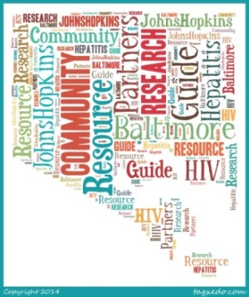

Frequently Asked Questions

Questions from Research Coordinators

What should I do if I have an IRB-approved flier I want to include in the next edition of the Guide?
If you have an IRB-approved research study flier related to HIV, hepatitis, and/or tuberculosis which you would like to submit for the next edition of the guide, please email Crystal (cstone12@jhu.edu).

Who should I contact if my study is no longer recruiting participants?
If your study flier was included in an edition of the Guide and you are no longer recruiting, or you have made changes to the flier, please email Crystal (cstone12@jhu.edu). This way we can ensure that Community Partners have access to accurate information at all times.

Why is it important to track participants who are referred to us from the community?
In order to gauge the Guide’s effectiveness—whether the Guide is successfully improving enrollment into research studies and keeping community members informed about research opportunities—we are interested in gathering data on how new participants heard about your study. Hopefully, this information will allow us to improve our service to ensure that our efforts are benefitting all parties involved.

I have some ideas that would improve the Guide, who should I contact?
If you have any ideas or suggestions regarding the Guide, we would love to hear from you! Please email Crystal (cstone12@jhu.edu).

How can I learn more information about the Guide?
To learn more about the Research Resource Guide for Community Partners, please visit our website at http://hopkinscfar.org/resources/community-resource-guide/ .

Questions from Community Members

What is the role of the Guide’s Community Partners?
Community Partners are individual representatives from service agencies throughout Baltimore, many of which have clients who are living with or at risk for HIV, hepatitis, and/or tuberculosis though some provide basic community supportive services. These Community Partners gave consent to receive the Guide electronically, and are encouraged to share it with their clients and colleagues.

How often will the guide be distributed to community partners?
The pilot edition of the guide was shared on August 19, 2014. The guide will be distributed electronically on a quarterly basis or when a collection of new or updated fliers are available for the public.

How do I join the mailing list to receive future editions of the guide?
To be added to the Research Resource for Community Partners electronic mailing list and receive future editions of the guide, please e-mail Crystal (cstone12@jhu.edu).

